PERSONAL FINANCE

RENTING YOUR FIRST APARTMENT - LEASES, DEPOSITS & ROOMMATES
ANSWER KEY ACTIVITY

PART 1

Renting Reference Guide - Complete the Missing Terms

Term | Definition
Lease | A binding contract between a landlord and tenant that sets the rent, term, and rules for renting a home
Rental application | A form a landlord uses to check your income, rental history, and credit before renting to you
Security deposit | Money paid up front that the landlord holds and returns if you leave the place undamaged
Credit check | A review of your credit report a landlord runs to decide whether to approve your application
Move-in cost | The total up-front money to move in: first month's rent plus the security deposit plus any fees
Lease term | The length of time the lease lasts, such as 12 months, during which the rent is locked in
Joint lease | A lease all roommates sign together, making each person responsible for the whole rent
Late fee | An extra charge the lease adds when rent is paid after the due date or grace period
Roommates | People who share a rented home and split the rent, deposit, and household costs
Tenant rights | Legal protections a renter has, such as a habitable home and the return of a fair deposit

PART 2

Apply the Terms - Renting Vocabulary in Context
WORD BANK lease · move-in cost · roommates · joint lease · security deposit
1. The binding contract between a landlord and tenant that sets the rent, term, and rules for renting a home is a lease.
lease
2. The money you pay up front that the landlord holds and returns if you leave the place undamaged is the security deposit.
security deposit
3. The total up-front money to move in - first month's rent plus the security deposit plus any fees - is the move-in cost.
move-in cost
4. A lease all roommates sign together, which makes each person responsible for the whole rent, is a joint lease.
joint lease
5. People who share a rented home and split the rent, deposit, and household costs are roommates.
roommates

PART 3

Calculate Move-In Cost and the Roommate Split - Use the Labeled Models
1. As Jordan Lee, work Sam's move-in cost alone (renting solo). The sample lease has monthly rent $1,200, a security deposit of $1,200, and a $50 application fee.
(a) Using MOVE-IN COST = first month's rent + security deposit + application fee, how much cash does Sam need to move in? Show your addition.
(b) In one sentence, explain to Sam why this is so much more than one month's rent.
(1) MOVE-IN COST = $1,200 + $1,200 + $50 = $2,450. (2) It is far more than one month's rent because Sam pays the first month's rent AND the security deposit (another full month) AND the application fee all up front - so moving in costs more than double the $1,200 monthly rent. Accept $2,450 as the move-in cost and a more-than-one-month explanation.
2. As Jordan Lee, work the ROOMMATE SPLIT. Sam decides to rent the same $1,200/month apartment with one roommate (2 people total) on a joint lease; the security deposit is $1,200.
(a) Using ROOMMATE SPLIT = total monthly rent / number of roommates, what is each person's share of the monthly rent?
(b) What is each person's share of the $1,200 security deposit? Show your division for both.
(1) ROOMMATE SPLIT (rent) = $1,200 / 2 = $600 each per month. (2) Deposit split = $1,200 / 2 = $600 each. Accept $600 each for rent and $600 each for the deposit, with the division shown.
3. As Jordan Lee, show Sam how much cheaper it is to move in with a roommate. Use your answers from A3-Q1 and A3-Q2.
(a) The total move-in cost is $2,450. Split two ways, how much does EACH roommate pay to move in? Show your division.
(b) How much LESS is each roommate's move-in share than the $2,450 Sam would pay renting solo? Show your subtraction.
(c) In one sentence, explain the tradeoff of splitting with a roommate.
(1) Each roommate's move-in share = $2,450 / 2 = $1,225 each ($600 rent + $600 deposit + $25 half of the $50 application fee). (2) Each roommate pays $2,450 - $1,225 = $1,225 LESS than renting solo. (3) The tradeoff is that splitting with a roommate cuts the up-front cost and the monthly rent roughly in half, but on a joint lease each roommate is legally responsible for the WHOLE rent if the other stops paying. Accept $1,225 each to move in, $1,225 less than solo, and a tradeoff explanation that mentions the joint-lease risk.

PART 4

Read the Sample Residential Lease - Pull the Terms and Do the Move-In Math
As Jordan Lee, study the Sample Residential Lease shown on this page. It puts every lease term on one document - the monthly rent, the security deposit, the application fee, the late fee, the lease term, and Sam's obligations (pay rent on time, keep the unit clean and undamaged, and do not sublet without the landlord's approval). The same values are listed in the reference table below so you can read them clearly. Use the lease and the table to answer A4-Q1 to A4-Q3, then connect the terms to Sam's agreement in A4-Q4.
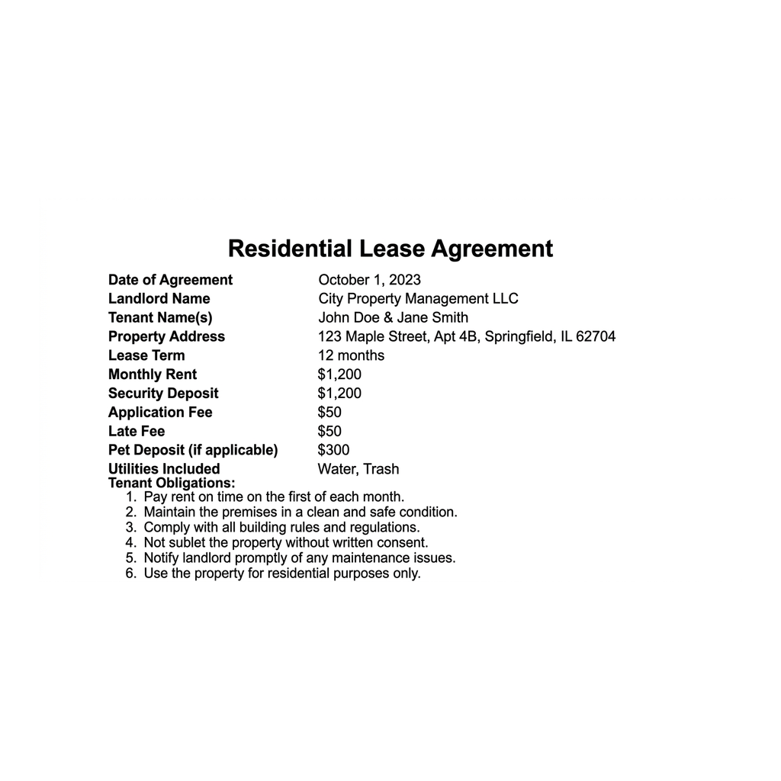

Lease field | Value
Monthly rent | $1,200
Security deposit | $1,200
Application fee | $50
Late fee | $50
Lease term | 12 months

Analysis

1. A4-Q1. As Jordan Lee, study the Sample Residential Lease shown on this page. Read the lease and write each value: (a) the monthly rent, (b) the security deposit, (c) the application fee, (d) the late fee, and (e) the lease term.
(a) Monthly rent = $1,200. (b) Security deposit = $1,200. (c) Application fee = $50. (d) Late fee = $50. (e) Lease term = 12 months. Accept these five values read directly off the sample lease.

2. A4-Q2. As Jordan Lee, use the values from the Sample Residential Lease to compute Sam's move-in cost. (a) Using MOVE-IN COST = first month's rent + security deposit + application fee, add the rent, deposit, and application fee off the lease. Show your addition. (b) In one sentence, tell Sam how the move-in cost compares to the $1,200 monthly rent.
(1) MOVE-IN COST = $1,200 + $1,200 + $50 = $2,450. (2) The move-in cost ($2,450) is more than double the $1,200 monthly rent, because Sam pays the first month's rent, the full security deposit, and the application fee all up front. Accept $2,450 and a more-than-double comparison.

3. A4-Q3. As Jordan Lee, use the same lease to plan for a roommate. Sam will split this $1,200/month apartment with one roommate (2 people). (a) Using ROOMMATE SPLIT = total monthly rent / number of roommates, what is each person's monthly rent share? (b) In one sentence, warn Sam what a JOINT LEASE means if the roommate stops paying.
(1) ROOMMATE SPLIT = $1,200 / 2 = $600 each per month. (2) On a joint lease both roommates sign together, so if the roommate stops paying, Sam is legally responsible for the WHOLE $1,200 rent, not just the $600 share. Accept $600 each and a joint-lease whole-rent warning.

4. A4-Q4. As Jordan Lee, connect the lease terms to what Sam is agreeing to. (a) The $1,200 security deposit on the lease is money the landlord does what with - holds and returns, or keeps for good? (b) Name one thing on this lease that Sam owes if the rent is paid late. (c) In one sentence, name one obligation the lease puts on Sam as the tenant.
(1) The landlord HOLDS the $1,200 security deposit and returns it if Sam leaves the place clean and undamaged and pays all rent - the landlord does not keep it for good. (2) If rent is paid late, Sam owes the $50 late fee. (3) One tenant obligation on the lease is to pay rent on time (accept also: keep the unit clean and undamaged, or do not sublet without permission). Accept the deposit is held and returned, the $50 late fee, and any listed obligation.

PART 5

Advise a First-Time Renter - Help Sam Rent on Purpose
1. As Jordan Lee, answer Sam's first question: 'What is a lease, and what do I need to read on it before I sign?'
(a) In one to two sentences, explain what a lease is and why signing it matters.
(b) In one sentence, name at least four things Sam must find and read on the lease before signing.
(1) A lease is a binding contract between the landlord and the tenant that sets the rent, the lease term, the deposit, the fees, and the rules; it matters because once Sam signs, every term is legally binding for the whole term. (2) Before signing, Sam must find and read the monthly rent, the lease term, the security deposit, the application fee, the late fee, and the tenant obligations (accept any four or more of these). Accept a binding-contract definition and at least four lease terms to read.
2. As Jordan Lee, walk Sam through the money. The lease has $1,200 rent, a $1,200 deposit, and a $50 application fee.
(a) Use MOVE-IN COST to tell Sam how much cash it takes to move in solo, naming the model.
(b) Then Sam asks what it costs with one roommate - use ROOMMATE SPLIT to give each person's rent share and each person's move-in share.
(c) In one sentence, explain how the security deposit can come back to Sam.
(1) MOVE-IN COST = first month's rent + security deposit + application fee = $1,200 + $1,200 + $50 = $2,450 to move in solo. (2) With one roommate (2 people), ROOMMATE SPLIT = $1,200 / 2 = $600 each per month, and each person's move-in share is $2,450 / 2 = $1,225 each. (3) Sam gets the $1,200 security deposit back if Sam leaves the place clean and undamaged, pays all rent, and gives proper notice before moving out. Accept the $2,450 move-in cost, the $600 rent share and $1,225 move-in share, and a leave-it-clean deposit-return explanation.
3. As Jordan Lee, help Sam decide about a roommate and a joint lease.
(a) In one to two sentences, explain the upside of renting with a roommate, using the numbers.
(b) In one sentence, warn Sam about the risk of a joint lease and give one way to reduce that risk.
(1) The upside is that a roommate cuts the cost roughly in half: the rent drops from $1,200 to $600 each per month and the move-in cost drops from $2,450 to $1,225 each, which makes the apartment affordable on an entry-level income. (2) The risk is that a joint lease makes each roommate legally responsible for the WHOLE $1,200 rent, so if the roommate stops paying, Sam owes it all; Sam can reduce the risk by only rooming with someone trustworthy and putting the split in writing between them. Accept the half-cost upside with numbers, and the whole-rent joint-lease risk with one protection.
FINAL RENTING ADVICE FOR SAM
4. FINAL RENTING ADVICE FOR SAM. As Jordan Lee, put your advice in writing for Sam. Write a 5-7 sentence explanation (120-180 words) that explains what a lease is and names the key terms Sam must read, uses MOVE-IN COST to work the up-front cost off the sample lease ($1,200 + $1,200 + $50 = $2,450), uses ROOMMATE SPLIT to show the two-roommate rent share ($600 each) and move-in share ($1,225 each), explains how Sam gets the security deposit back, and warns Sam about the joint-lease risk. Check off each required element as you include it.
YOUR RESPONSE MUST:
☐ EXPLAIN THE LEASE - a lease is a binding contract that sets the rent, lease term, security deposit, fees, and obligations; read every term before signing because it is binding.
☐ USE MOVE-IN COST - show MOVE-IN COST = first month's rent + security deposit + application fee = $1,200 + $1,200 + $50 = $2,450 to move in solo.
☐ USE ROOMMATE SPLIT - show the rent splits $1,200 / 2 = $600 each and the move-in cost splits $2,450 / 2 = $1,225 each with one roommate.
☐ EXPLAIN THE SECURITY DEPOSIT - the $1,200 deposit comes back if Sam leaves the place clean and undamaged, pays all rent, and gives proper notice.
☐ WARN ABOUT THE JOINT LEASE - on a joint lease each roommate is responsible for the WHOLE rent, so Sam owes it all if the roommate stops paying.
GRADING RUBRIC
Grade the evidence and reasoning, not the conclusion — any defensible position is valid. Score against the 5 requirements above.
FULL CREDIT — clear position; meets all 5 requirements with accurate, specific numbers and evidence from the lesson.
PARTIAL — position stated, but misses 1-2 requirements or uses vague / incorrect numbers.
MINIMAL — no clear position, or missing most requirements and numbers.
WHAT TO LOOK FOR IN THIS LESSON
Sample full-credit explanation:
Sam - here is how to rent your first apartment. A LEASE is a binding contract between you and the landlord that sets the monthly rent, the lease term (12 months), the security deposit, the fees, and your obligations - so read every term before you sign, because it is all binding. On this lease, the rent is $1,200, the deposit is $1,200, and the application fee is $50, so your up-front MOVE-IN COST = first month's rent + security deposit + application fee = $1,200 + $1,200 + $50 = $2,450 - more than double the monthly rent, so save it before you sign. If you rent with one roommate, the ROOMMATE SPLIT cuts it down: rent is $1,200 / 2 = $600 each per month, and the move-in cost splits to $2,450 / 2 = $1,225 each. You get your $1,200 SECURITY DEPOSIT back if you leave the place clean and undamaged, pay all your rent, and give proper notice - so take move-in photos and keep it clean. One warning: on a JOINT LEASE you and your roommate each sign for the WHOLE rent, so if your roommate stops paying, the landlord can make you pay all $1,200 - only room with someone you trust.
REQUIRED-ELEMENT CHECKLIST (award credit per item): [1] explains the lease is a binding contract and names key terms to read; [2] uses MOVE-IN COST = $1,200 + $1,200 + $50 = $2,450; [3] uses ROOMMATE SPLIT - $600 each rent and $1,225 each move-in; [4] explains the $1,200 deposit comes back if the place is left clean and undamaged with notice; [5] warns that a joint lease makes each roommate liable for the WHOLE rent.
MORE LESSONS LESS PLANNING
Thank You!
If you enjoyed this product, please do not forget to rate and review to assist other teachers.

Looking for future discounts? Earn TPT credits by reviewing purchased products.

Please contact me if you have any issues with this product. Just like our students, I am always looking for opportunities to grow.

