Renting vs Buying: Which Makes Sense When?
STUDENT ACTIVITY
Name: | Date: | Period:
ESSENTIAL QUESTION
How do you compare renting and buying for a real situation, how do the total cost of renting and the total cost of buying grow differently over time, what is equity and how does buying build it while renting does not, and how do you use the crossover year and the 5-year rule to recommend rent or buy?
THE SCENARIO
You are RENATA VEGA, a housing counselor who helps clients compare renting and buying for their real life situation and figure out which one actually costs less over time. DEVON MARSH is 24, and his apartment lease is ending.
BY THE END, YOU CAN:
✓ Compare renting and buying for a given life situation
✓ Calculate the total cost of renting and the total cost of buying over time
✓ Explain equity and how buying builds it while renting does not
✓ Use the crossover year and the 5-year rule to recommend rent or buy
HOW IT WORKS (do Parts 1–5 in order)
Part 1 — Rent-vs-Buy Reference Guide - Complete the Missing Terms
Part 2 — Apply the Terms - Rent-vs-Buy Vocabulary in Context
Part 3 — Calculate the Total Cost of Renting, Buying, and Equity - Use the Labeled Models
Part 4 — Read the Chart - Total Cost of Renting vs Buying Over Time
Part 5 — Recommend Rent or Buy - Advise a New Client
TIME about 45 minutes YOU’LL NEED the lesson slides and your Guided Notes.

PART 1

Rent-vs-Buy Reference Guide - Complete the Missing Terms
Fill in the missing term for each blank row — the definition is your clue. Your Guided Notes and the lesson slides have every term.

Term | Definition
___________ | The full amount you pay to rent over a number of years, with no equity back
Renters insurance | A small monthly policy that protects a renter's belongings
___________ | The portion of a home you actually own, equal to home value minus loan balance
Down payment | The large up-front amount you pay when you buy a home
___________ | The full cost of owning over a number of years after subtracting equity and appreciation
Ownership cost | The monthly cost of owning a home: mortgage plus taxes, insurance, and maintenance
___________ | The year buying's total cost first drops below renting's total cost
Appreciation | The rise in a home's value over time
___________ | How easily you can move, which renting protects and buying reduces
Five-year rule | The guideline that buying usually pays off only if you stay long enough to pass the crossover

PART 2

Apply the Terms - Rent-vs-Buy Vocabulary in Context
WORD BANK equity · flexibility · total cost of buying · crossover year · total cost of renting
1. Q1. The full amount you pay to rent over a number of years, with no equity back, is the .

2. Q2. The portion of a home you actually own, equal to home value minus loan balance, is your .

3. Q3. The full cost of owning over a number of years after subtracting equity and appreciation is the .

4. Q4. The year buying's total cost first drops below renting's total cost is the .

5. Q5. How easily you can move, which renting protects and buying reduces, is your .

PART 3

Calculate the Total Cost of Renting, Buying, and Equity - Use the Labeled Models
1. As Renata Vega, work Devon's total cost of renting and his equity. Devon's MONTHLY RENT is $1,500 and his RENTERS INSURANCE is $20 a month; he is looking at a 5-year stay.
(a) Using TOTAL COST OF RENTING = (MONTHLY RENT + RENTERS INSURANCE) x 12 x YEARS, what is Devon's total cost of renting for 5 years?

(b) If Devon buys instead and at year 5 his condo is worth $272,500 while he still owes a LOAN BALANCE of $215,000, use EQUITY = HOME VALUE - LOAN BALANCE to find his equity.

(c) In one sentence, explain what the renter gets back at the end of 5 years compared with what the buyer's equity represents.

2. As Renata Vega, work Devon's total cost of buying over 5 years. Devon's DOWN PAYMENT is $20,000; his OWNERSHIP COST is mortgage $1,300 + taxes $250 + insurance $100 + maintenance $150 a month; he builds $3,000 of EQUITY per year (principal) and his home gains $4,500 per year in value (HOME VALUE CHANGE).
(a) First, what is Devon's monthly OWNERSHIP COST?

(b) Using TOTAL COST OF BUYING = DOWN PAYMENT + (OWNERSHIP COST x 12 x YEARS) - EQUITY BUILT - HOME VALUE CHANGE, what is his total cost of buying for 5 years?

(c) In one sentence, compare it to his 5-year renting cost of $91,200 and say which is cheaper at 5 years.

3. As Renata Vega, check a second client, Maya. Maya is fairly sure she will move in about 2 years for a new job. In the same market, her TOTAL COST OF RENTING for 2 years is $36,480 and her TOTAL COST OF BUYING for 2 years is $48,200.
(a) How much MORE would buying cost Maya than renting over her 2-year stay? Show your subtraction.

(b) In one sentence, explain why the numbers point Maya toward renting.

(c) In one sentence, name the one thing that would have to change about Maya's plans to make buying the better choice.

PART 4

Read the Chart - Total Cost of Renting vs Buying Over Time
As Renata Vega, study the line chart titled "Total Cost of Renting vs Buying Over Time" (it appears with A4-Q1). It plots the cumulative total cost of renting (coral) and buying (teal) over 10 years. The same values are listed in the data table below. Use the chart and table to answer A4-Q1 to A4-Q3, then connect the crossover to Devon's own decision in A4-Q4. Notice where the two lines CROSS - that crossover year is the whole point.

Year | Total cost of renting | Total cost of buying
1 | $18,240 | $34,100
2 | $36,480 | $48,200
3 | $54,720 | $62,300
4 | $72,960 | $76,400
5 | $91,200 | $90,500
6 | $109,440 | $104,600
7 | $127,680 | $118,700
8 | $145,920 | $132,800
9 | $164,160 | $146,900
10 | $182,400 | $161,000

Analysis

1. A4-Q1. As Renata Vega, study the line chart on this page titled "Total Cost of Renting vs Buying Over Time." It plots the cumulative total cost of renting (coral line) and buying (teal line) over 10 years. Read the chart and write both totals at: (a) year 1 (rent and buy), (b) year 5 (rent and buy), and (c) year 10 (rent and buy).
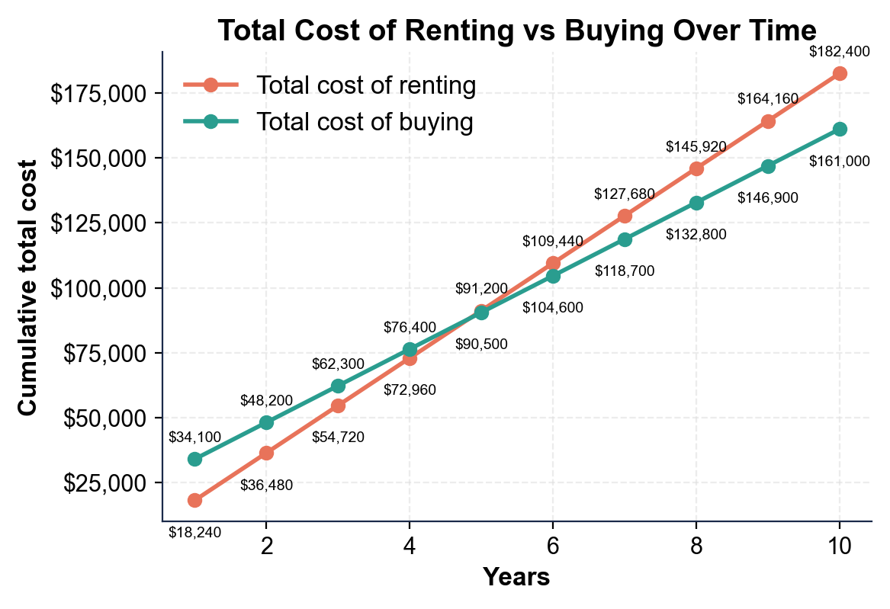

2. A4-Q2. As Renata Vega, find and use the crossover. (a) In what YEAR do the renting and buying lines cross (the first year buying's total cost is below renting's)? (b) At year 4, renting is $72,960 and buying is $76,400 - which is cheaper, and by how much? (c) At year 5, renting is $91,200 and buying is $90,500 - which is cheaper, and by how much? Show your subtraction for (b) and (c).

3. A4-Q3. As Renata Vega, use the chart to show the tradeoff over a longer stay. (a) At year 8, renting is $145,920 and buying is $132,800 - how much does buying SAVE by year 8? Show your subtraction. (b) In one sentence, describe what happens to the GAP between the two lines after the crossover year. (c) In one sentence, state the 5-year rule this chart illustrates.

4. A4-Q4. As Renata Vega, connect the chart to Devon's real decision. (a) If Devon is confident he will stay in the condo for 8 years, does the chart say rent or buy - and why, using the numbers? (b) If Devon thinks he may move in about 3 years, does the chart say rent or buy - and why? (c) In one sentence, state the general rule the crossover gives you for making a rent-or-buy decision.

PART 5

Recommend Rent or Buy - Advise a New Client
1. As Renata Vega, take on a new client, Theo. Theo's TOTAL COST OF RENTING for 7 years works out to $123,480, and his TOTAL COST OF BUYING for 7 years works out to $112,300. Theo is confident he will stay in the same city for at least 8-10 years.
(a) Over his 7-year horizon, how much cheaper is buying than renting for Theo? Show your subtraction.

(b) State whether Theo is before or after his crossover at 7 years, and how you can tell.

(c) What is your first-glance recommendation for Theo - rent or buy?

2. As Renata Vega, price Theo's equity. At year 7 Theo's condo is worth a HOME VALUE of $238,000 and he still owes a LOAN BALANCE of $177,500.
(a) Using EQUITY = HOME VALUE - LOAN BALANCE, what is Theo's equity at year 7?

(b) A renter over those same 7 years builds how much equity?

(c) In one sentence, explain to Theo what his equity really represents.

3. As Renata Vega, weigh Theo's flexibility against his commitment. Theo has a stable job he expects to keep, plans to stay in the city 8-10 years, and has enough saved for the down payment.
(a) In one sentence, explain why the FLEXIBILITY that renting protects matters less for Theo than it would for a short-timer.

(b) In one sentence, explain why buying's COMMITMENT is a reasonable fit for Theo's plans.

RECOMMEND RENT OR BUY - FINAL REPORT FOR THEO
4. RECOMMEND RENT OR BUY - FINAL REPORT FOR THEO. As Renata Vega, put your recommendation in writing for Theo. Write a 5-7 sentence recommendation (120-180 words) that: compares his 7-year total cost of renting ($123,480) and buying ($112,300) and states how much buying saves, states whether he is before or after his crossover, prices his equity using the labeled model (EQUITY = HOME VALUE - LOAN BALANCE = $238,000 - $177,500 = $60,500), makes a clear rent-or-buy recommendation, ties the recommendation to how long he plans to stay (8-10 years) using the crossover / 5-year rule, and addresses flexibility vs commitment for his situation. Check off each required element as you include it.
YOUR RESPONSE MUST:
☐ COMPARE THE TOTAL COSTS - state Theo's 7-year total cost of renting ($123,480) vs buying ($112,300) and that buying saves $11,180.
☐ PLACE HIM ON THE CROSSOVER - state that at 7 years Theo is AFTER his crossover, because buying already costs less than renting.
☐ PRICE THE EQUITY - show EQUITY = HOME VALUE - LOAN BALANCE = $238,000 - $177,500 = $60,500, and note a renter builds $0.
☐ MAKE THE RECOMMENDATION - clearly recommend BUY, tied to his plan to stay 8-10 years (well past the crossover / the 5-year rule).
☐ ADDRESS FLEXIBILITY VS COMMITMENT - note that buying's commitment is a reasonable fit because Theo is unlikely to need the flexibility to move soon.

