PERSONAL FINANCE

RENTING VS BUYING: WHICH MAKES SENSE WHEN?
ANSWER KEY ACTIVITY - ANSWER KEY

PART 1

Rent-vs-Buy Reference Guide - Complete the Missing Terms

Term | Definition
Total cost of renting | The full amount you pay to rent over a number of years, with no equity back
Renters insurance | A small monthly policy that protects a renter's belongings
Equity | The portion of a home you actually own, equal to home value minus loan balance
Down payment | The large up-front amount you pay when you buy a home
Total cost of buying | The full cost of owning over a number of years after subtracting equity and appreciation
Ownership cost | The monthly cost of owning a home: mortgage plus taxes, insurance, and maintenance
Crossover year | The year buying's total cost first drops below renting's total cost
Appreciation | The rise in a home's value over time
Flexibility | How easily you can move, which renting protects and buying reduces
Five-year rule | The guideline that buying usually pays off only if you stay long enough to pass the crossover

PART 2

Apply the Terms - Rent-vs-Buy Vocabulary in Context
WORD BANK equity · flexibility · total cost of buying · crossover year · total cost of renting
1. Q1. The full amount you pay to rent over a number of years, with no equity back, is the total cost of renting.
total cost of renting
2. Q2. The portion of a home you actually own, equal to home value minus loan balance, is your equity.
equity
3. Q3. The full cost of owning over a number of years after subtracting equity and appreciation is the total cost of buying.
total cost of buying
4. Q4. The year buying's total cost first drops below renting's total cost is the crossover year.
crossover year
5. Q5. How easily you can move, which renting protects and buying reduces, is your flexibility.
flexibility

PART 3

Calculate the Total Cost of Renting, Buying, and Equity - Use the Labeled Models
1. As Renata Vega, work Devon's total cost of renting and his equity. Devon's MONTHLY RENT is $1,500 and his RENTERS INSURANCE is $20 a month; he is looking at a 5-year stay.
(a) Using TOTAL COST OF RENTING = (MONTHLY RENT + RENTERS INSURANCE) x 12 x YEARS, what is Devon's total cost of renting for 5 years?
(b) If Devon buys instead and at year 5 his condo is worth $272,500 while he still owes a LOAN BALANCE of $215,000, use EQUITY = HOME VALUE - LOAN BALANCE to find his equity.
(c) In one sentence, explain what the renter gets back at the end of 5 years compared with what the buyer's equity represents.
(1) TOTAL COST OF RENTING = ($1,500 + $20) x 12 x 5 = $1,520 x 12 x 5 = $91,200. (2) EQUITY = HOME VALUE - LOAN BALANCE = $272,500 - $215,000 = $57,500. (3) The renter gets nothing back - the entire $91,200 is spent and builds $0 in equity - while the buyer's $57,500 in equity is the part of the home the buyer actually owns and can get back when they sell. Accept $91,200, $57,500, and a renter-gets-$0-back vs buyer-owns-$57,500 explanation.
2. As Renata Vega, work Devon's total cost of buying over 5 years. Devon's DOWN PAYMENT is $20,000; his OWNERSHIP COST is mortgage $1,300 + taxes $250 + insurance $100 + maintenance $150 a month; he builds $3,000 of EQUITY per year (principal) and his home gains $4,500 per year in value (HOME VALUE CHANGE).
(a) First, what is Devon's monthly OWNERSHIP COST?
(b) Using TOTAL COST OF BUYING = DOWN PAYMENT + (OWNERSHIP COST x 12 x YEARS) - EQUITY BUILT - HOME VALUE CHANGE, what is his total cost of buying for 5 years?
(c) In one sentence, compare it to his 5-year renting cost of $91,200 and say which is cheaper at 5 years.
(1) OWNERSHIP COST = $1,300 + $250 + $100 + $150 = $1,800 a month. (2) TOTAL COST OF BUYING = $20,000 + ($1,800 x 12 x 5) - ($3,000 x 5) - ($4,500 x 5) = $20,000 + $108,000 - $15,000 - $22,500 = $90,500. (3) At 5 years buying ($90,500) is just below renting ($91,200), so buying is cheaper at 5 years - by $700 - which is why year 5 is the crossover. Accept $1,800 ownership cost, $90,500 total cost of buying, and a buying-is-cheaper-by-$700-at-year-5 comparison.
3. As Renata Vega, check a second client, Maya. Maya is fairly sure she will move in about 2 years for a new job. In the same market, her TOTAL COST OF RENTING for 2 years is $36,480 and her TOTAL COST OF BUYING for 2 years is $48,200.
(a) How much MORE would buying cost Maya than renting over her 2-year stay? Show your subtraction.
(b) In one sentence, explain why the numbers point Maya toward renting.
(c) In one sentence, name the one thing that would have to change about Maya's plans to make buying the better choice.
(1) Buying costs $48,200 - $36,480 = $11,720 MORE than renting over Maya's 2-year stay. (2) The numbers point Maya toward renting because 2 years is well before the crossover year - she would pay $11,720 extra to buy and would not stay long enough to make up the large up-front down payment through equity and appreciation. (3) Maya would need to plan to STAY MUCH LONGER (past the crossover year, roughly five or more years) for buying to become the cheaper, better choice. Accept $11,720 more, a before-the-crossover/rent explanation, and a stay-longer-past-the-crossover answer.

PART 4

Read the Chart - Total Cost of Renting vs Buying Over Time
As Renata Vega, study the line chart titled "Total Cost of Renting vs Buying Over Time" (it appears with A4-Q1). It plots the cumulative total cost of renting (coral) and buying (teal) over 10 years. The same values are listed in the data table below. Use the chart and table to answer A4-Q1 to A4-Q3, then connect the crossover to Devon's own decision in A4-Q4. Notice where the two lines CROSS - that crossover year is the whole point.

Year | Total cost of renting | Total cost of buying
1 | $18,240 | $34,100
2 | $36,480 | $48,200
3 | $54,720 | $62,300
4 | $72,960 | $76,400
5 | $91,200 | $90,500
6 | $109,440 | $104,600
7 | $127,680 | $118,700
8 | $145,920 | $132,800
9 | $164,160 | $146,900
10 | $182,400 | $161,000

Analysis

1. A4-Q1. As Renata Vega, study the line chart on this page titled "Total Cost of Renting vs Buying Over Time." It plots the cumulative total cost of renting (coral line) and buying (teal line) over 10 years. Read the chart and write both totals at: (a) year 1 (rent and buy), (b) year 5 (rent and buy), and (c) year 10 (rent and buy).
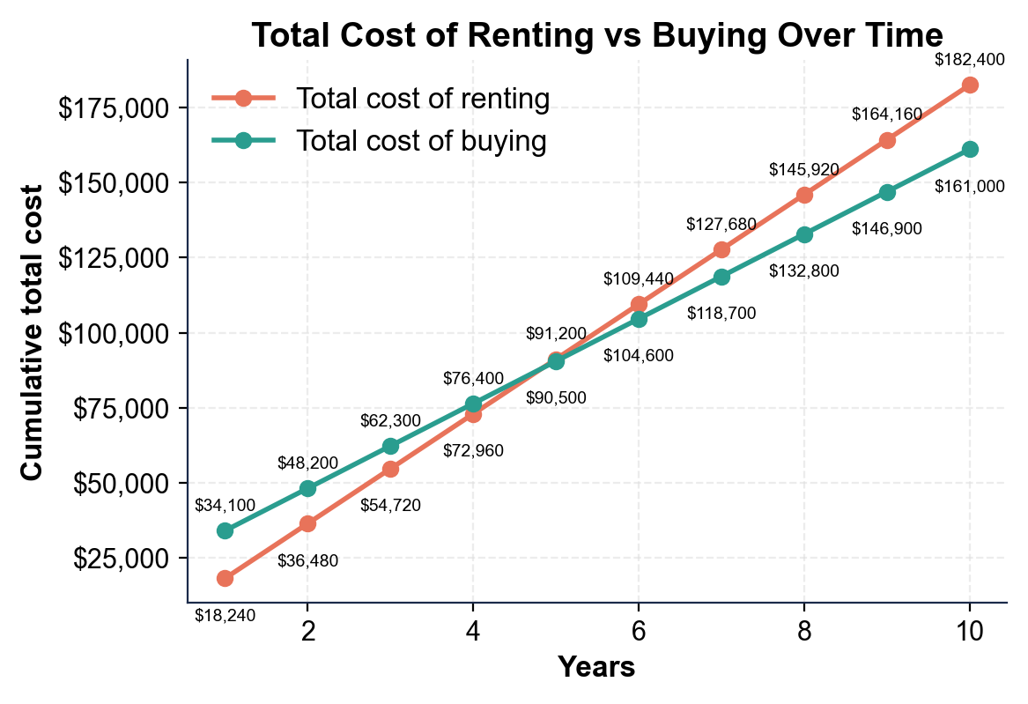
(a) Year 1: renting $18,240; buying $34,100. (b) Year 5: renting $91,200; buying $90,500. (c) Year 10: renting $182,400; buying $161,000. Accept these six values read directly off the two lines on the chart.

2. A4-Q2. As Renata Vega, find and use the crossover. (a) In what YEAR do the renting and buying lines cross (the first year buying's total cost is below renting's)? (b) At year 4, renting is $72,960 and buying is $76,400 - which is cheaper, and by how much? (c) At year 5, renting is $91,200 and buying is $90,500 - which is cheaper, and by how much? Show your subtraction for (b) and (c).
(1) The lines cross at YEAR 5 - the crossover year. (2) At year 4 renting is cheaper: $76,400 - $72,960 = $3,440 cheaper to rent. (3) At year 5 buying is cheaper: $91,200 - $90,500 = $700 cheaper to buy. Accept year 5 crossover, renting cheaper by $3,440 at year 4, and buying cheaper by $700 at year 5.

3. A4-Q3. As Renata Vega, use the chart to show the tradeoff over a longer stay. (a) At year 8, renting is $145,920 and buying is $132,800 - how much does buying SAVE by year 8? Show your subtraction. (b) In one sentence, describe what happens to the GAP between the two lines after the crossover year. (c) In one sentence, state the 5-year rule this chart illustrates.
(1) By year 8 buying saves $145,920 - $132,800 = $13,120. (2) After the crossover year the gap between the lines widens in buying's favor - the longer you stay past year 5, the more buying saves compared with renting. (3) The FIVE-YEAR RULE: buying usually pays off only if you stay long enough to pass the crossover (around five years) - stay past it and buying wins, move before it and renting was cheaper. Accept $13,120 saved, a gap-widens-in-buying's-favor description, and a stay-past-the-crossover 5-year-rule statement.

4. A4-Q4. As Renata Vega, connect the chart to Devon's real decision. (a) If Devon is confident he will stay in the condo for 8 years, does the chart say rent or buy - and why, using the numbers? (b) If Devon thinks he may move in about 3 years, does the chart say rent or buy - and why? (c) In one sentence, state the general rule the crossover gives you for making a rent-or-buy decision.
(1) If Devon stays 8 years the chart says BUY - by year 8 buying ($132,800) is $13,120 cheaper than renting ($145,920) and it also built him equity, so staying well past the year-5 crossover makes buying clearly better. (2) If Devon may move in about 3 years the chart says RENT - at year 3 he would be well before the year-5 crossover, so buying would cost more AND he would lose the flexibility to move easily. (3) The general rule: buy if you will confidently stay PAST the crossover year, and rent if you might move BEFORE it. Accept a buy-at-8-years-saves-$13,120 answer, a rent-at-3-years-before-crossover answer, and a buy-past/rent-before-the-crossover rule.

PART 5

Recommend Rent or Buy - Advise a New Client
1. As Renata Vega, take on a new client, Theo. Theo's TOTAL COST OF RENTING for 7 years works out to $123,480, and his TOTAL COST OF BUYING for 7 years works out to $112,300. Theo is confident he will stay in the same city for at least 8-10 years.
(a) Over his 7-year horizon, how much cheaper is buying than renting for Theo? Show your subtraction.
(b) State whether Theo is before or after his crossover at 7 years, and how you can tell.
(c) What is your first-glance recommendation for Theo - rent or buy?
(1) Buying is $123,480 - $112,300 = $11,180 cheaper than renting over Theo's 7-year horizon. (2) Theo is AFTER his crossover at 7 years - you can tell because buying already costs LESS than renting at year 7, which only happens once you have passed the crossover year. (3) First-glance recommendation: BUY - Theo will stay 8-10 years, well past his crossover, so buying is both cheaper and builds equity. Accept $11,180 cheaper, an after-the-crossover explanation, and a buy recommendation.
2. As Renata Vega, price Theo's equity. At year 7 Theo's condo is worth a HOME VALUE of $238,000 and he still owes a LOAN BALANCE of $177,500.
(a) Using EQUITY = HOME VALUE - LOAN BALANCE, what is Theo's equity at year 7?
(b) A renter over those same 7 years builds how much equity?
(c) In one sentence, explain to Theo what his equity really represents.
(1) EQUITY = HOME VALUE - LOAN BALANCE = $238,000 - $177,500 = $60,500. (2) A renter builds $0 in equity over the same 7 years - rent builds no equity. (3) Theo's $60,500 in equity is the part of the condo he actually owns; it is real wealth he would get back (on top of the lower total cost) if he sold, which renting would never have given him. Accept $60,500, $0 for the renter, and an equity-is-wealth-you-own-and-get-back explanation.
3. As Renata Vega, weigh Theo's flexibility against his commitment. Theo has a stable job he expects to keep, plans to stay in the city 8-10 years, and has enough saved for the down payment.
(a) In one sentence, explain why the FLEXIBILITY that renting protects matters less for Theo than it would for a short-timer.
(b) In one sentence, explain why buying's COMMITMENT is a reasonable fit for Theo's plans.
(1) Flexibility matters less for Theo because he plans to stay 8-10 years and has a stable job - he is unlikely to need to move soon, so the freedom to move easily is not worth giving up buying's lower long-term cost and equity. (2) Buying's commitment fits Theo because he intends to stay well past his crossover year and can afford the down payment, so being tied to one place (and having to sell to move) is a low risk for him and is outweighed by the equity and savings he gains. Accept a stays-long-so-flexibility-matters-less answer and a commitment-fits-his-long-stable-plans answer.
RECOMMEND RENT OR BUY - FINAL REPORT FOR THEO
4. RECOMMEND RENT OR BUY - FINAL REPORT FOR THEO. As Renata Vega, put your recommendation in writing for Theo. Write a 5-7 sentence recommendation (120-180 words) that: compares his 7-year total cost of renting ($123,480) and buying ($112,300) and states how much buying saves, states whether he is before or after his crossover, prices his equity using the labeled model (EQUITY = HOME VALUE - LOAN BALANCE = $238,000 - $177,500 = $60,500), makes a clear rent-or-buy recommendation, ties the recommendation to how long he plans to stay (8-10 years) using the crossover / 5-year rule, and addresses flexibility vs commitment for his situation. Check off each required element as you include it.
YOUR RESPONSE MUST:
☐ COMPARE THE TOTAL COSTS - state Theo's 7-year total cost of renting ($123,480) vs buying ($112,300) and that buying saves $11,180.
☐ PLACE HIM ON THE CROSSOVER - state that at 7 years Theo is AFTER his crossover, because buying already costs less than renting.
☐ PRICE THE EQUITY - show EQUITY = HOME VALUE - LOAN BALANCE = $238,000 - $177,500 = $60,500, and note a renter builds $0.
☐ MAKE THE RECOMMENDATION - clearly recommend BUY, tied to his plan to stay 8-10 years (well past the crossover / the 5-year rule).
☐ ADDRESS FLEXIBILITY VS COMMITMENT - note that buying's commitment is a reasonable fit because Theo is unlikely to need the flexibility to move soon.
GRADING RUBRIC
Grade the evidence and reasoning, not the conclusion — any defensible position is valid. Score against the 5 requirements above.
FULL CREDIT — clear position; meets all 5 requirements with accurate, specific numbers and evidence from the lesson.
PARTIAL — position stated, but misses 1-2 requirements or uses vague / incorrect numbers.
MINIMAL — no clear position, or missing most requirements and numbers.

MORE LESSONS LESS PLANNING
Thank You!
If you enjoyed this product, please do not forget to rate and review to assist other teachers.

Looking for future discounts? Earn TPT credits by reviewing purchased products.

Please contact me if you have any issues with this product. Just like our students, I am always looking for opportunities to grow.

