Recession Compared: 2008 vs 2020 vs 2024
STUDENT ACTIVITY
Name: | Date: | Period:
ESSENTIAL QUESTION
How do the three most recent U.S. downturns - the 2008 Great Recession, the 2020 COVID Recession, and the 2024 soft-landing scare - compare on cause, depth, and recovery, and why did the deeper 2020 recession recover so much faster than 2008?
THE SCENARIO
You are Devon Brooks, a Junior Economist in the office of the Council of Economic Advisers (CEA). The CEA Chair asks you to prepare a comparison brief on the three most recent U.S. downturns: the 2008 Great Recession, the 2020 COVID Recession, and the 2024 soft-landing scare.
BY THE END, YOU CAN:
✓ Compare the 2008, 2020, and 2024 economic downturns on causes, depth, and recovery
✓ Identify what each downturn taught policymakers about the next response
✓ Evaluate which downturn response worked best given the cause
HOW IT WORKS (do Parts 1–5 in order)
Part 1 — Recession-Comparison Reference Guide - Complete the Missing Terms
Part 2 — Apply the Terms - Devon Brooks Confirms the Recession-Comparison Vocabulary
Part 3 — Apply the Cause-Depth-Recovery Framework to All Three Downturns (Devon Brooks Analysis)
Part 4 — Read the Three Overlay Charts: Real GDP, Unemployment, and the S&P 500 (Devon Brooks Evidence Section)
Part 5 — Final Recommendation Memo to the CEA Chair on a Hypothetical 2027 Downturn (Devon Brooks Synthesis)
TIME about 45 minutes YOU’LL NEED the lesson slides and your Guided Notes.

PART 1

Recession-Comparison Reference Guide - Complete the Missing Terms
Fill in the missing term for each blank row — the definition is your clue. Your Guided Notes and the lesson slides have every term.

Term | Definition
___________ | The U.S. recession from December 2007 to June 2009, triggered by the housing market collapse and a global financial crisis; the deepest downturn since the Great Depression.
Subprime mortgages | High-risk home mortgages bundled into mortgage-backed securities; their collapse triggered the 2008 financial crisis.
___________ | The U.S. recession in 2020 triggered by pandemic lockdowns that closed businesses; the shortest recession on record at just two months.
Lehman Brothers | The investment bank whose September 2008 bankruptcy was the panic moment of the 2008 financial crisis.
___________ | The 2024 outcome: slow inflation without triggering a recession, even after the Fed raised rates sharply.
CARES Act | The March 2020 pandemic relief law (about 2.2T) that passed Congress faster than any prior emergency response.
___________ | A labor-market recession signal that fires when the 3-month average unemployment rate rises 0.5 points above its 12-month low.
Dodd-Frank Act | The 2010 reform that taught policymakers to stress-test the banks after the 2008 crisis.
___________ | In 2008 the Fed used large-scale bond buying to push down long rates.
TARP | Part of the 2008 fiscal response that totaled about 1.5T; about 700B to rescue the banks.

PART 2

Apply the Terms - Devon Brooks Confirms the Recession-Comparison Vocabulary
WORD BANK Soft landing · Great Recession · Sahm Rule · Quantitative easing · COVID Recession
1. The deepest U.S. downturn since the Great Depression - lasting from December 2007 to June 2009 and set off by a housing-market collapse and a global financial crisis - is the .

2. The shortest U.S. recession on record - just two months in 2020, caused by pandemic lockdowns that closed businesses overnight - is the .

3. Slowing inflation without tipping the economy into a recession - the rare 2024 outcome after the Fed raised rates sharply - is called a .

4. The labor-market recession signal that fires when the three-month average unemployment rate rises 0.5 points above its twelve-month low is the .

5. The Federal Reserve program of large-scale bond buying - first used at scale in 2008 to push down long-term interest rates - is .

PART 3

Apply the Cause-Depth-Recovery Framework to All Three Downturns (Devon Brooks Analysis)
1. APPLY THE FRAMEWORK TO 2008. As Devon Brooks, write a short paragraph that names the CAUSE of the 2008 Great Recession (mention housing AND financial), the DEPTH using two specific numbers from the lesson (one for real GDP and one for the unemployment peak), and the RECOVERY SHAPE, including how long it took for jobs to fully recover.

2. APPLY THE FRAMEWORK TO 2020. Write a short paragraph that names the CAUSE of the 2020 COVID Recession, the DEPTH using two specific numbers (real GDP drop AND unemployment peak), and the RECOVERY SHAPE, including how long the recession lasted according to the NBER.

3. APPLY THE FRAMEWORK TO 2024 AND FINAL COMPARISON. Write a short paragraph that names the CAUSE of the 2024 mini-shake, the DEPTH (note: there was no real depth - explain), and the RECOVERY (and what it is called). Then add ONE final sentence that combines all three cases: explain why the 2020 recovery was FASTER than the 2008 recovery even though 2020 was deeper.

PART 4

Read the Three Overlay Charts: Real GDP, Unemployment, and the S&P 500 (Devon Brooks Evidence Section)
1. As Devon Brooks, study the REAL GDP overlay chart inserted below (each line is real GDP indexed to 100 at its pre-recession peak). In ONE sentence, describe what the chart shows and which line dips the most.
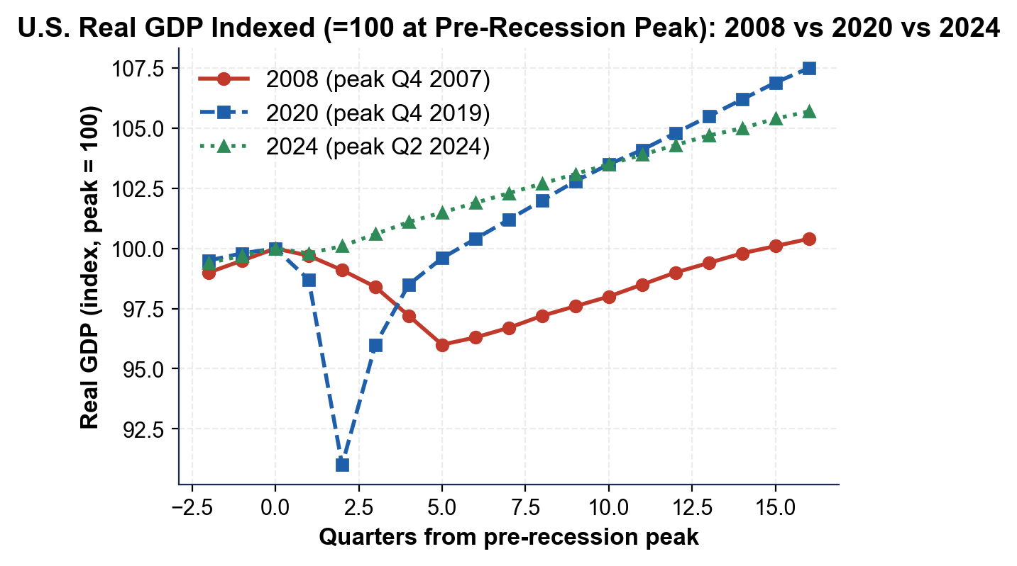

2. Using the real GDP chart above, read directly off the chart: what was the approximate trough value (lowest point) of each line - 2008, 2020, and 2024? Which downturn produced the DEEPEST drop from peak (100)? Express each as a percentage drop from peak.

3. Now study the UNEMPLOYMENT RATE overlay chart inserted below. In ONE sentence, describe what the chart shows and which downturn reached the highest peak.
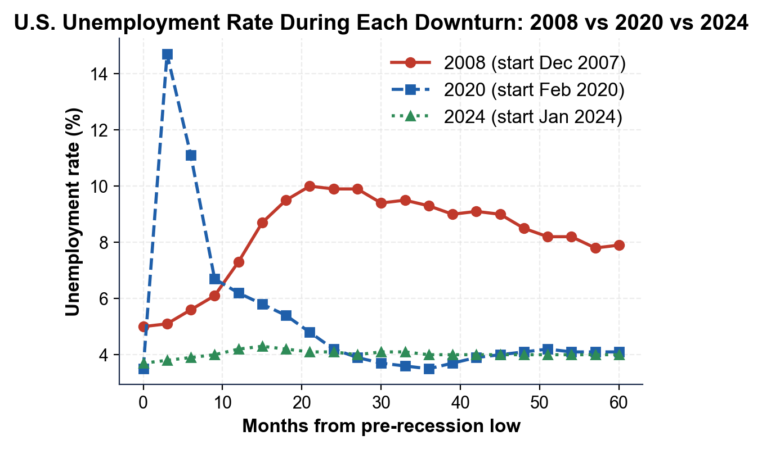

4. Using the unemployment chart above, read directly off the chart: what was the approximate PEAK unemployment rate in each downturn? Rank the three peaks from highest to lowest. Then explain in one sentence why the 2020 line - even though it peaked highest - fell back to normal faster than the 2008 line.

5. Now study the S&P 500 overlay chart inserted below (each line is the S&P 500 indexed to 100 at its pre-recession peak). In ONE sentence, describe what the chart shows and which line falls the deepest.
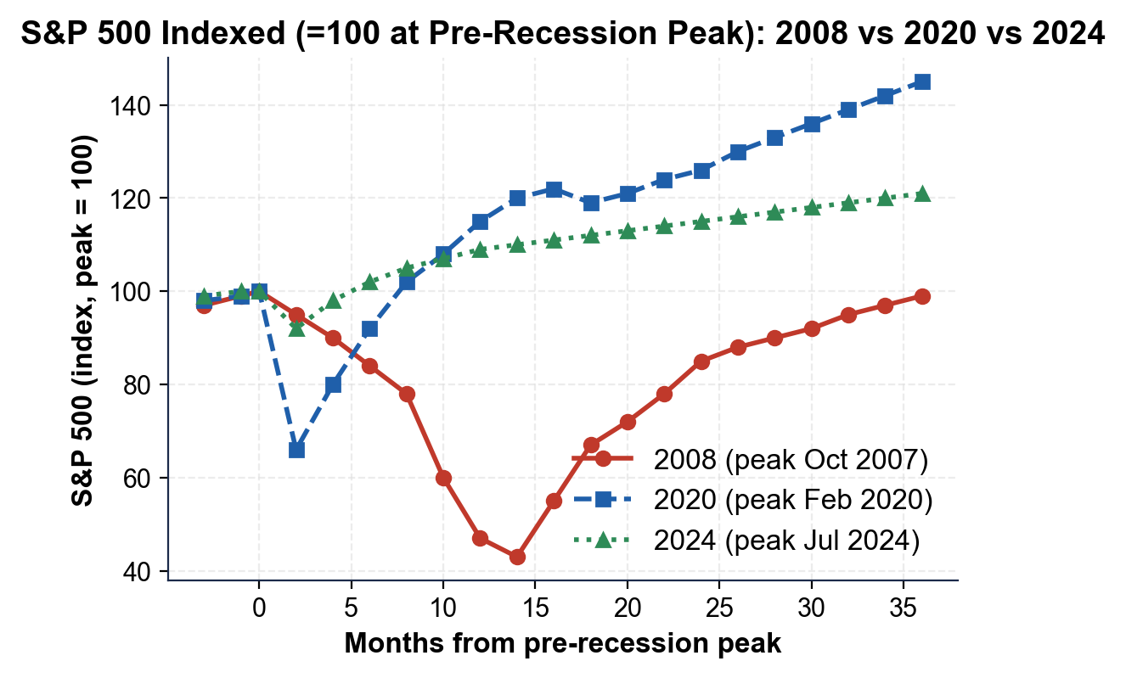

6. Using the S&P 500 chart above, read directly off the chart: what was the approximate TROUGH value of each line, and what percentage drop from peak does that represent? Rank the three stock-market drawdowns from deepest to shallowest.

7. Using the same S&P 500 chart, look at all three lines together: did the stock market start falling BEFORE or AFTER each recession was officially dated by the NBER, and did it recover BEFORE or AFTER the broader economy? Explain in 2-3 sentences why economists call stocks a LEADING INDICATOR, and cite at least ONE specific date.

PART 5

Final Recommendation Memo to the CEA Chair on a Hypothetical 2027 Downturn (Devon Brooks Synthesis)
FINAL RECOMMENDATION MEMO
1. FINAL RECOMMENDATION MEMO. It is 2027 and a new downturn is brewing. Real GDP fell 1.5% in Q2 2027 (one negative quarter). Several mid-sized regional banks have failed on commercial real estate losses. The unemployment rate has risen from 4.0% to 5.5% over six months. The S&P 500 is down about 25% from its peak and consumer confidence has collapsed. The CEA Chair asks which prior response - 2008-style, 2020-style, or 2024-style - the U.S. should model on. As Devon Brooks, write a 6-8 sentence memo using the header below, and check off each required element as you include it. (Sentence starters you can use: "The 2027 case most resembles..." and "I recommend...")
YOUR RESPONSE MUST:
☐ CLOSEST MATCH - identify which prior case (2008, 2020, or 2024) the 2027 situation most resembles, and cite the CAUSE that makes it the closest match.
☐ ONE SIMILAR + ONE DIFFERENT CASE - compare 2027 with another case it partly resembles AND contrast it with a clearly different case, using specific facts.
☐ CAUSE-DEPTH-RECOVERY - apply the framework to 2027: name the cause, describe the depth so far (cite at least one number from the prompt), and predict the likely recovery shape.
☐ A CLEAR RECOMMENDATION - recommend a specific response (a TARP-style bank rescue, an ARRA-style or CARES-style fiscal stimulus - ARRA was the $831B 2009 Recovery Act; CARES was the $2.2T 2020 relief law - a Fed-cut-alone approach, or a combination) and explain why it fits the cause.
MEMO
To: The Chair, Council of Economic Advisers
From: Devon Brooks, Junior Economist, CEA
Date:
Re: Which Recession Playbook Should the U.S. Use for the 2027 Downturn?

