ECONOMICS

RECESSION COMPARED: 2008 VS 2020 VS 2024
ANSWER KEY ACTIVITY

PART 1

Recession-Comparison Reference Guide - Complete the Missing Terms

Term | Definition
Great Recession | The U.S. recession from December 2007 to June 2009, triggered by the housing market collapse and a global financial crisis; the deepest downturn since the Great Depression.
Subprime mortgages | High-risk home mortgages bundled into mortgage-backed securities; their collapse triggered the 2008 financial crisis.
COVID Recession | The U.S. recession in 2020 triggered by pandemic lockdowns that closed businesses; the shortest recession on record at just two months.
Lehman Brothers | The investment bank whose September 2008 bankruptcy was the panic moment of the 2008 financial crisis.
Soft landing | The 2024 outcome: slow inflation without triggering a recession, even after the Fed raised rates sharply.
CARES Act | The March 2020 pandemic relief law (about 2.2T) that passed Congress faster than any prior emergency response.
Sahm Rule | A labor-market recession signal that fires when the 3-month average unemployment rate rises 0.5 points above its 12-month low.
Dodd-Frank Act | The 2010 reform that taught policymakers to stress-test the banks after the 2008 crisis.
Quantitative easing | In 2008 the Fed used large-scale bond buying to push down long rates.
TARP | Part of the 2008 fiscal response that totaled about 1.5T; about 700B to rescue the banks.

PART 2

Apply the Terms - Devon Brooks Confirms the Recession-Comparison Vocabulary
WORD BANK Soft landing · Great Recession · Sahm Rule · Quantitative easing · COVID Recession
1. The deepest U.S. downturn since the Great Depression - lasting from December 2007 to June 2009 and set off by a housing-market collapse and a global financial crisis - is the Great Recession.
Great Recession
2. The shortest U.S. recession on record - just two months in 2020, caused by pandemic lockdowns that closed businesses overnight - is the COVID Recession.
COVID Recession
3. Slowing inflation without tipping the economy into a recession - the rare 2024 outcome after the Fed raised rates sharply - is called a Soft landing.
Soft landing
4. The labor-market recession signal that fires when the three-month average unemployment rate rises 0.5 points above its twelve-month low is the Sahm Rule.
Sahm Rule
5. The Federal Reserve program of large-scale bond buying - first used at scale in 2008 to push down long-term interest rates - is Quantitative easing.
Quantitative easing

PART 3

Apply the Cause-Depth-Recovery Framework to All Three Downturns (Devon Brooks Analysis)
1. APPLY THE FRAMEWORK TO 2008. As Devon Brooks, write a short paragraph that names the CAUSE of the 2008 Great Recession (mention housing AND financial), the DEPTH using two specific numbers from the lesson (one for real GDP and one for the unemployment peak), and the RECOVERY SHAPE, including how long it took for jobs to fully recover.
CAUSE: The 2008 Great Recession was caused by the COLLAPSE OF THE HOUSING MARKET (home prices fell after the 2000-2006 bubble) combined with a GLOBAL FINANCIAL CRISIS triggered by the collapse of subprime mortgages bundled into mortgage-backed securities; the panic moment was the September 2008 Lehman Brothers bankruptcy. DEPTH: Real GDP fell about 4% from peak (December 2007) to trough (June 2009), and the unemployment rate peaked at 10.0% in October 2009. RECOVERY SHAPE: The recovery was L-SHAPED - a sharp fall, a long flat bottom, and a slow climb; it took until 2014 (about 6 years) for nonfarm payrolls to fully recover to pre-recession levels. Required: cause mentions housing AND financial; depth includes 4% GDP AND 10.0% unemployment; recovery names L-shape AND mentions 6 years (or 2014 jobs recovery).
2. APPLY THE FRAMEWORK TO 2020. Write a short paragraph that names the CAUSE of the 2020 COVID Recession, the DEPTH using two specific numbers (real GDP drop AND unemployment peak), and the RECOVERY SHAPE, including how long the recession lasted according to the NBER.
CAUSE: The 2020 COVID Recession was caused by deliberate government-ordered lockdowns and business closures in March 2020 to slow the spread of COVID-19 - a pandemic shock, not a financial or housing crisis. DEPTH: Real GDP fell about 9% from peak to trough (Q4 2019 to Q2 2020), and the unemployment rate peaked at 14.7% in April 2020 - the highest since the Great Depression. RECOVERY SHAPE: The recovery was V-SHAPED - a sharp fall and an equally sharp rebound; the NBER dated the recession from February 2020 to April 2020 - just TWO MONTHS, the shortest on record - and real GDP returned to its prior peak by Q2 2021. Required: cause names pandemic/lockdowns/COVID; depth includes 9% GDP AND 14.7% unemployment; recovery names V-shape AND 2 months (or Feb-April 2020 NBER dates).
3. APPLY THE FRAMEWORK TO 2024 AND FINAL COMPARISON. Write a short paragraph that names the CAUSE of the 2024 mini-shake, the DEPTH (note: there was no real depth - explain), and the RECOVERY (and what it is called). Then add ONE final sentence that combines all three cases: explain why the 2020 recovery was FASTER than the 2008 recovery even though 2020 was deeper.
CAUSE: The 2024 mini-shake was a SOFT-LANDING SCARE caused by the cooling labor market after the Fed had hiked rates from 0% to 5.25% in 2022-2023 to fight 9% inflation. DEPTH: There was no real recession depth - real GDP grew throughout 2024; unemployment ticked from 3.7% to a peak of just 4.3% in July 2024 (a tiny ripple). The Sahm Rule briefly triggered but the NBER did NOT call a recession. RECOVERY: There was no recovery needed - the economy never went into recession. The 2024 outcome is called a SOFT LANDING - the rare and difficult outcome the Fed had been aiming for. FINAL COMPARISON SENTENCE: The 2020 recovery was faster than the 2008 recovery because the FINANCIAL SYSTEM WAS NOT BROKEN in 2020 (banks could keep lending once the economy reopened) AND the FISCAL RESPONSE was bigger and faster ($4T in 2020 vs $1.5T in 2008). Required: 2024 cause mentions Fed tightening or soft-landing scare; identifies 4.3% unemployment peak or Sahm Rule; identifies SOFT LANDING; final sentence cites BOTH financial-system difference AND bigger faster fiscal response.

PART 4

Read the Three Overlay Charts: Real GDP, Unemployment, and the S&P 500 (Devon Brooks Evidence Section)
1. As Devon Brooks, study the REAL GDP overlay chart inserted below (each line is real GDP indexed to 100 at its pre-recession peak). In ONE sentence, describe what the chart shows and which line dips the most.
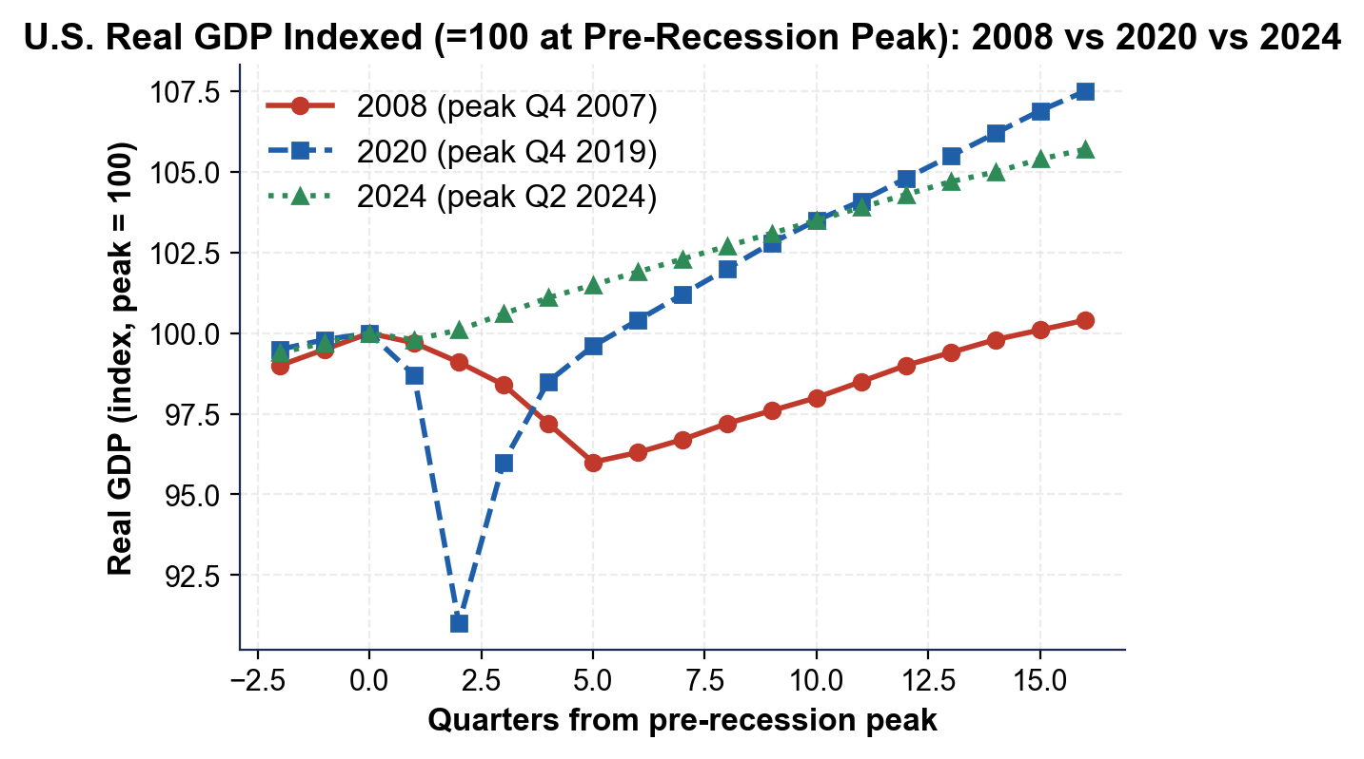
ONE-SENTENCE READ: the chart shows real GDP for the 2008, 2020, and 2024 downturns, each indexed to 100 at its pre-recession peak, and the 2020 line dips the most while 2024 barely moves.
2. Using the real GDP chart above, read directly off the chart: what was the approximate trough value (lowest point) of each line - 2008, 2020, and 2024? Which downturn produced the DEEPEST drop from peak (100)? Express each as a percentage drop from peak.
TROUGH VALUES: the 2008 line bottoms at about 96 (a 4% drop from peak), the 2020 line bottoms at about 91 (a 9% drop), and the 2024 line stays near 100 (essentially flat, about a 0% drop). DEEPEST: 2020, at about a 9% drop from peak. RANKING (by depth): 2020 (9%) > 2008 (4%) > 2024 (about 0%). NOTE: 2020 was the deepest but also climbs back to 100 the fastest, while 2008 recovers slowly. REQUIRED: identifies 2008 ~96 (4%), 2020 ~91 (9%), 2024 near 100; names 2020 as deepest.
3. Now study the UNEMPLOYMENT RATE overlay chart inserted below. In ONE sentence, describe what the chart shows and which downturn reached the highest peak.
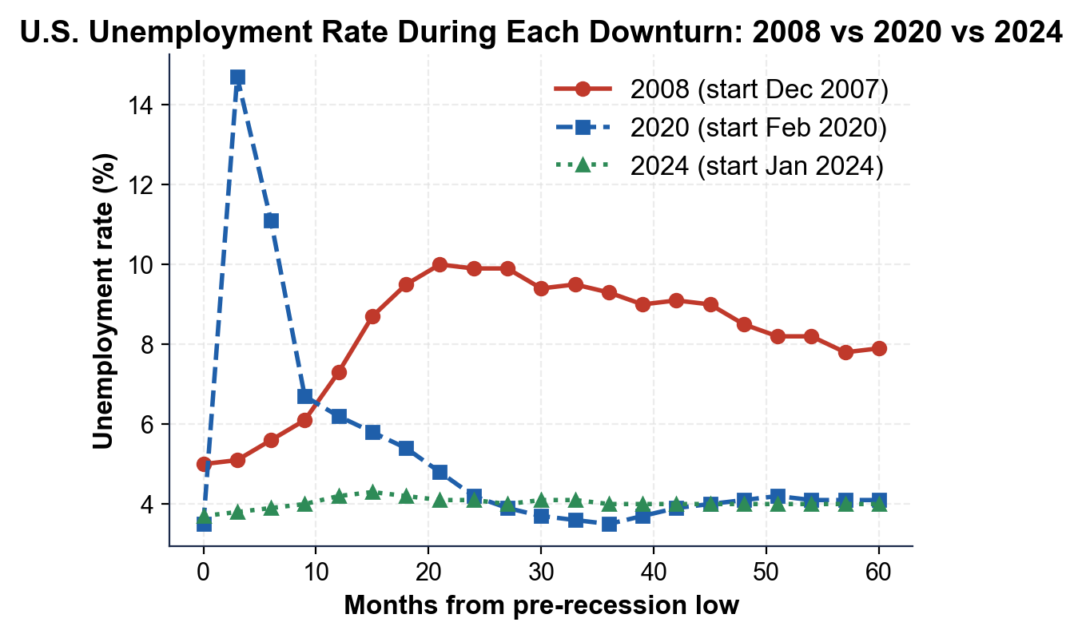
ONE-SENTENCE READ: the chart shows the unemployment rate during the 2008, 2020, and 2024 downturns, and the 2020 line spikes to the highest peak while 2024 barely rises.
4. Using the unemployment chart above, read directly off the chart: what was the approximate PEAK unemployment rate in each downturn? Rank the three peaks from highest to lowest. Then explain in one sentence why the 2020 line - even though it peaked highest - fell back to normal faster than the 2008 line.
PEAKS: 2008 about 10.0% (October 2009); 2020 about 14.7% (April 2020); 2024 briefly about 4.3% (July 2024). RANKING (highest to lowest): 2020 (14.7%) > 2008 (10.0%) > 2024 (4.3%). WHY 2020 FELL FASTER: even with the highest peak, the 2020 line dropped back fastest because the financial system stayed intact (banks kept lending), the fiscal response was massive (about $4T) and fast, and workers were rehired once lockdowns ended; in 2008 the broken banking system kept credit from flowing, so the recovery dragged on for years. REQUIRED: cites 10.0%, 14.7%, 4.3%; ranks 2020 > 2008 > 2024; explanation names intact financial system OR faster/bigger fiscal aid.
5. Now study the S&P 500 overlay chart inserted below (each line is the S&P 500 indexed to 100 at its pre-recession peak). In ONE sentence, describe what the chart shows and which line falls the deepest.
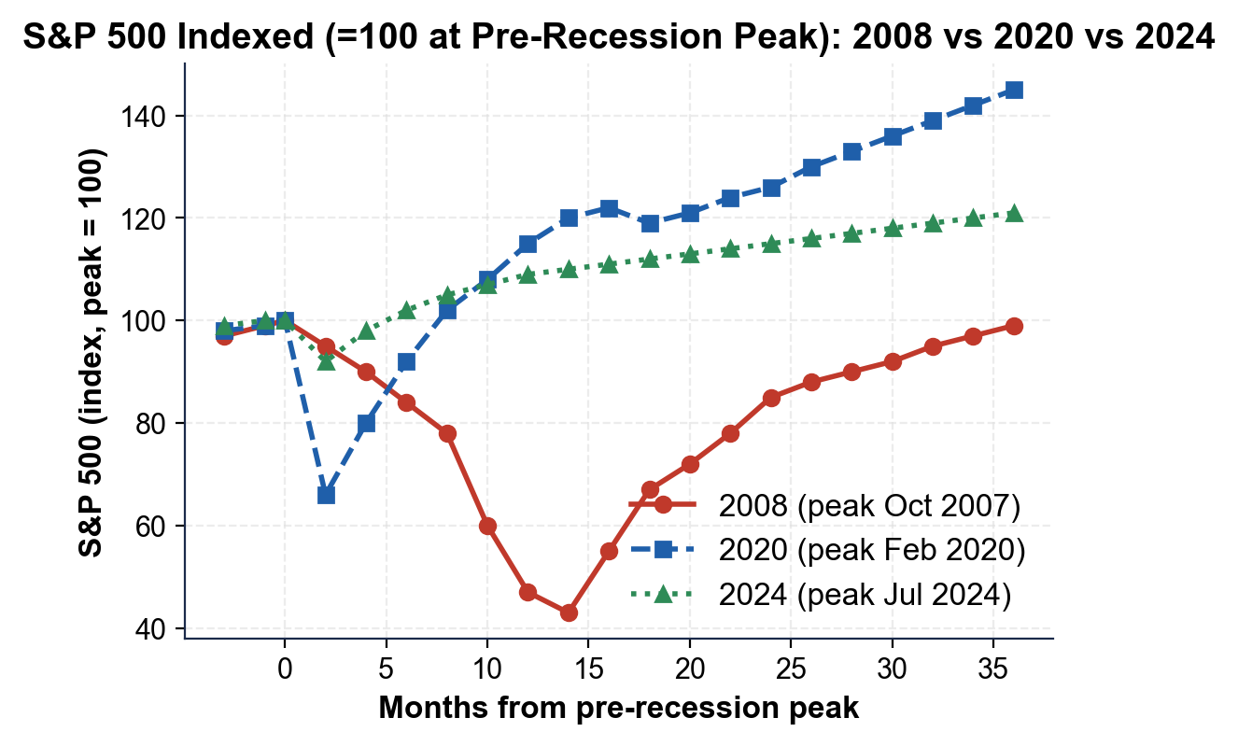
ONE-SENTENCE READ: the chart shows the S&P 500 for the 2008, 2020, and 2024 downturns, each indexed to 100 at its pre-recession peak, and the 2008 line falls the deepest while 2024 dips only slightly.
6. Using the S&P 500 chart above, read directly off the chart: what was the approximate TROUGH value of each line, and what percentage drop from peak does that represent? Rank the three stock-market drawdowns from deepest to shallowest.
TROUGHS AND DROPS: the 2008 line bottoms near 43 (about a 57% drop from peak - the deepest crash since the Great Depression); the 2020 line bottoms near 66 (about a 34% drop, in roughly one month); the 2024 line dips to about 92 (about an 8% drop in the August 2024 scare). RANKING (deepest to shallowest): 2008 (57%) > 2020 (34%) > 2024 (8%). NOTE: this ranking is OPPOSITE the GDP-depth ranking - stocks fell hardest in 2008 (a financial crisis), even though real GDP fell hardest in 2020. REQUIRED: cites ~57%, ~34%, ~8%; ranks 2008 > 2020 > 2024.
7. Using the same S&P 500 chart, look at all three lines together: did the stock market start falling BEFORE or AFTER each recession was officially dated by the NBER, and did it recover BEFORE or AFTER the broader economy? Explain in 2-3 sentences why economists call stocks a LEADING INDICATOR, and cite at least ONE specific date.
TIMING vs NBER DATES: in 2008 the S&P 500 peaked in October 2007, about two months BEFORE the NBER recession start of December 2007 - stocks fell first; in 2020 the S&P 500 peaked February 19, 2020, before the broad economy turned down. BOTTOMED FIRST: in 2008 stocks bottomed in March 2009, about three months BEFORE the NBER recession end of June 2009; in 2020 stocks bottomed March 23, 2020, weeks before the broad recovery. WHY LEADING INDICATOR: investors are forward-looking and price stocks on EXPECTED future earnings, so the market tends to fall before the decline shows up in GDP or jobs and to recover before the broad economy does. SPECIFIC FACT: the 2008 S&P 500 peaked October 9, 2007 - about two months before the NBER-dated start of the Great Recession. REQUIRED: stocks fell BEFORE the NBER start in at least one case; stocks recovered BEFORE the broad economy in at least one case; forward-looking mechanism; one specific date.

PART 5

Final Recommendation Memo to the CEA Chair on a Hypothetical 2027 Downturn (Devon Brooks Synthesis)
FINAL RECOMMENDATION MEMO
1. FINAL RECOMMENDATION MEMO. It is 2027 and a new downturn is brewing. Real GDP fell 1.5% in Q2 2027 (one negative quarter). Several mid-sized regional banks have failed on commercial real estate losses. The unemployment rate has risen from 4.0% to 5.5% over six months. The S&P 500 is down about 25% from its peak and consumer confidence has collapsed. The CEA Chair asks which prior response - 2008-style, 2020-style, or 2024-style - the U.S. should model on. As Devon Brooks, write a 6-8 sentence memo using the header below, and check off each required element as you include it. (Sentence starters you can use: "The 2027 case most resembles..." and "I recommend...")
YOUR RESPONSE MUST:
☐ CLOSEST MATCH - identify which prior case (2008, 2020, or 2024) the 2027 situation most resembles, and cite the CAUSE that makes it the closest match.
☐ ONE SIMILAR + ONE DIFFERENT CASE - compare 2027 with another case it partly resembles AND contrast it with a clearly different case, using specific facts.
☐ CAUSE-DEPTH-RECOVERY - apply the framework to 2027: name the cause, describe the depth so far (cite at least one number from the prompt), and predict the likely recovery shape.
☐ A CLEAR RECOMMENDATION - recommend a specific response (a TARP-style bank rescue, an ARRA-style or CARES-style fiscal stimulus - ARRA was the $831B 2009 Recovery Act; CARES was the $2.2T 2020 relief law - a Fed-cut-alone approach, or a combination) and explain why it fits the cause.
MEMO
To: The Chair, Council of Economic Advisers
From: Devon Brooks, Junior Economist, CEA
Date: [student completes]
Re: Which Recession Playbook Should the U.S. Use for the 2027 Downturn?
GRADING RUBRIC
Grade the evidence and reasoning, not the conclusion — any defensible position is valid. Score against the 4 requirements above.
FULL CREDIT — clear position; meets all 4 requirements with accurate, specific numbers and evidence from the lesson.
PARTIAL — position stated, but misses 1-2 requirements or uses vague / incorrect numbers.
MINIMAL — no clear position, or missing most requirements and numbers.
WHAT TO LOOK FOR IN THIS LESSON
Sample full-credit memo:
TO: The Chair, Council of Economic Advisers
FROM: Devon Brooks, Junior Economist, CEA
RE: Which Recession Playbook for the 2027 Downturn?
[1] CLOSEST MATCH: the 2027 case most resembles 2008. The trigger is financial-sector stress - mid-sized regional banks failing on commercial real estate losses - structurally the same kind of bank-balance-sheet crisis as the 2008 subprime/mortgage-backed-securities collapse, and the 25% stock-market drawdown echoes 2008 more than 2020 or 2024. [2] SIMILAR vs DIFFERENT: like 2008, the cause is a banking crisis; UNLIKE 2008, unemployment (5.5%) is still well below the 10.0% 2008 peak and the trigger is commercial real estate, not residential subprime. CONTRAST with 2020: 2020 was a pandemic shutdown with an INTACT financial system that a big demand boost could fix, while 2027 has a BROKEN financial system, so stimulus checks alone would not unfreeze bank lending. CONTRAST with 2024: 2024 was a soft-landing scare with no bank failures and no real recession, so the wait-and-see approach that worked then is not enough in 2027. [3] CAUSE-DEPTH-RECOVERY: CAUSE - regional bank failures (financial); DEPTH - one negative GDP quarter (-1.5%), unemployment up to 5.5%, stocks down 25%; RECOVERY - likely L-shaped and slow unless the banking system is repaired quickly. [4] RECOMMENDATION: model the response on 2008 - a TARP-style recapitalization to stabilize the failing regional banks PLUS an ARRA-style fiscal stimulus to support demand, combined with Fed rate cuts and emergency lending. This fits because the financial system must be repaired before ordinary stimulus can work.
REQUIRED-ELEMENT CHECKLIST (award credit per item):
[1] Names 2008 as the closest match AND cites the financial / bank-failure cause.
[2] Compares with one similar case AND contrasts with one different case using specifics.
[3] Applies cause-depth-recovery to 2027 with at least one number from the prompt.
[4] Clear recommendation tied to the cause.
Accept any sound analysis; the strongest memos identify the financial cause and recommend a bank-rescue + fiscal-stimulus combination rather than CARES-style checks alone.
MORE LESSONS LESS PLANNING
Thank You!
If you enjoyed this product, please do not forget to rate and review to assist other teachers.

Looking for future discounts? Earn TPT credits by reviewing purchased products.

Please contact me if you have any issues with this product. Just like our students, I am always looking for opportunities to grow.

