Real vs Nominal GDP: Why It Matters
STUDENT ACTIVITY
Name: | Date: | Period:
ESSENTIAL QUESTION
Why can headline GDP numbers be misleading, how does the GDP deflator convert nominal GDP into real GDP, and why must every comparison of GDP across years use real (inflation-adjusted) dollars?
THE SCENARIO
You are Dakota Hale, a Junior Analyst at the U.S. Bureau of Economic Analysis (BEA). The Chief Economist asks you to prepare a briefing on the difference between NOMINAL GDP and REAL GDP before the quarterly press release.
BY THE END, YOU CAN:
✓ Distinguish real GDP from nominal GDP
✓ Calculate real GDP using a price deflator
✓ Apply the distinction to compare GDP across years
HOW IT WORKS (do Parts 1–5 in order)
Part 1 — Real vs Nominal GDP Reference Guide - Complete the Missing Terms
Part 2 — Apply the Terms - Dakota Hale Builds the Real-vs-Nominal Vocabulary
Part 3 — Convert Nominal GDP to Real GDP - Three Real U.S. Years (Dakota Hale BEA Analysis)
Part 4 — Read the Real vs Nominal GDP Chart and the Deflator vs CPI Chart (Dakota Hale's BEA Evidence Section)
Part 5 — Final Policy Memo to the BEA Chief Economist (Dakota Hale Synthesis)
TIME about 45 minutes YOU’LL NEED the lesson slides and your Guided Notes.

PART 1

Real vs Nominal GDP Reference Guide - Complete the Missing Terms
Fill in the missing term for each blank row — the definition is your clue. Your Guided Notes and the lesson slides have every term.

Term | Definition
___________ | GDP measured in current-year prices; rises with both real output growth and inflation
Real GDP | GDP measured in constant base-year prices with inflation removed; the true measure of growth
___________ | A price index that compares current prices to a base year; used to convert nominal GDP to real GDP
CPI | The Consumer Price Index; a price index based on a fixed basket of consumer goods
___________ | The reference year whose prices compute real GDP; the deflator equals 100 in the base year
GDPC1 | The FRED series code for real U.S. GDP; chain-weighted in base-year dollars and used for long-run growth comparisons
___________ | A sustained rise in the overall price level; makes nominal GDP grow faster than real GDP
Nominal growth | The year-over-year change in nominal GDP; includes both real growth and inflation
___________ | Federal Reserve Economic Data; a free public database for GDP and inflation series
Constant dollars | Dollar values expressed in base-year prices; real GDP is measured in constant dollars

PART 2

Apply the Terms - Dakota Hale Builds the Real-vs-Nominal Vocabulary
WORD BANK FRED · GDP deflator · Inflation · Nominal GDP · Base year
1. GDP measured in current-year prices - the headline figure that rises with both real output growth AND rising prices - is .

2. The price index that compares current prices to a reference year - equal to 100 in that year and used to remove price changes from output figures - is the .

3. The reference year whose prices are used to compute real output - the year the price index equals 100 and real and nominal values match exactly - is the .

4. A sustained rise in the overall price level, which makes nominal figures grow faster than real figures, is .

5. The free public database from the Federal Reserve where you look up the GDP and GDPC1 series for nominal and real U.S. GDP is .

PART 3

Convert Nominal GDP to Real GDP - Three Real U.S. Years (Dakota Hale BEA Analysis)
1. As Dakota Hale, CONVERT NOMINAL TO REAL: 1990 U.S.
DATA. Given: 1990 nominal U.S. GDP = $6.0 trillion. 1990 GDP deflator = 55 (with 2017 = 100 as the base). Compute real GDP in 2017 base-year dollars using the formula REAL GDP = (NOMINAL GDP / DEFLATOR) x 100. Show your math step by step. Why is REAL 1990 GDP LARGER than NOMINAL 1990 GDP in this calculation?

2. CONVERT NOMINAL TO REAL: 2010 U.S. DATA. Given: 2010 nominal U.S. GDP = $15.0 trillion. 2010 GDP deflator = 85 (with 2017 = 100 as the base). Compute real GDP in 2017 base-year dollars. Show your math. Then compute the REAL GROWTH from 1990 to 2010 (using the 1990 real GDP you computed in Question 1) and express it as a percentage and as a growth factor.

3. CONVERT NOMINAL TO REAL: 2026 U.S. DATA AND THE BASE-YEAR CHECK. Given: 2026 nominal U.S. GDP = $28.0 trillion. 2026 GDP deflator = 130 (with 2017 = 100 as the base). Compute real 2026 GDP. Show your math. Then verify: in the BASE YEAR 2017, nominal GDP was $19.5T and the deflator was 100. Apply the formula to 2017 data and show why real GDP and nominal GDP MUST equal each other in the base year.

PART 4

Read the Real vs Nominal GDP Chart and the Deflator vs CPI Chart (Dakota Hale's BEA Evidence Section)
1. As Dakota Hale, study the U.S.
Real vs Nominal GDP 1990-2026 line chart inserted below (also shown in the slide deck). In ONE sentence, describe what the chart shows: which line is HIGHER in 2026, and what happens to the two lines somewhere in the middle of the chart?
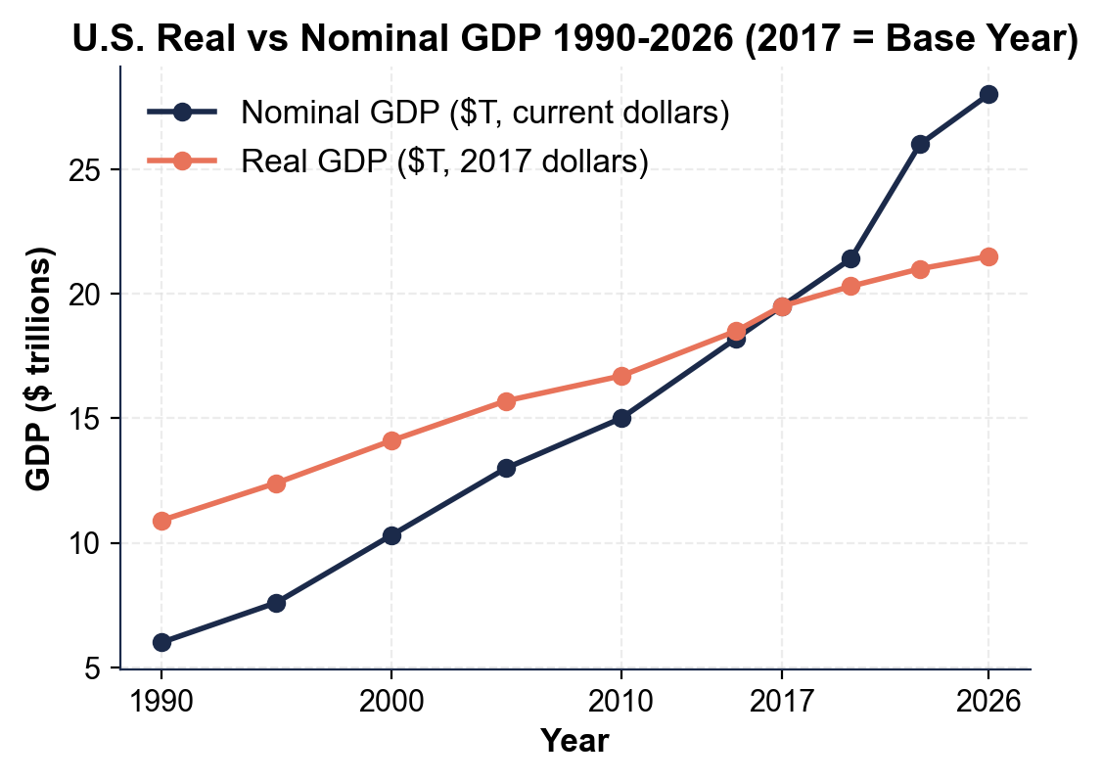

2. Using the chart above, read directly off the chart and compute.
(a) Approximately what was NOMINAL U.S. GDP in 1990?

(b) Approximately what was REAL U.S. GDP in 1990 (in base-year dollars)?

(c) In what year do the two lines CROSS?

(d) Read 2026 nominal and 2026 real, then compute BOTH the nominal growth factor (2026 nominal / 1990 nominal) and the real growth factor (2026 real / 1990 real).

(e) In 1-2 sentences, explain what the GAP between the two lines after the crossing year represents.

3. Now study the GDP Deflator vs CPI 1990-2026 line chart inserted below (also shown in the slide deck). In ONE sentence, describe what both indexes equal in the base year and which index is slightly higher by 2026.
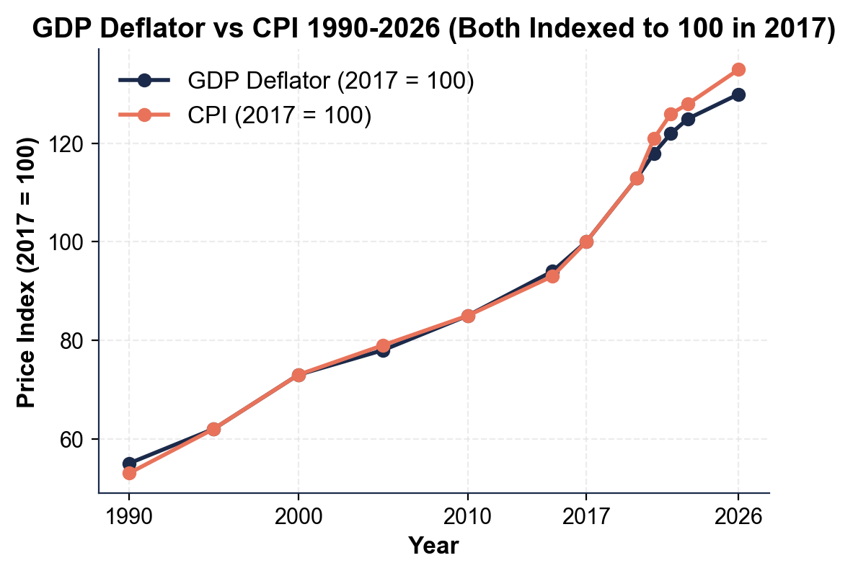

4. Using the deflator vs CPI chart above, read and explain.
(a) Approximately what was the GDP DEFLATOR in 1990?

(b) Approximately what was the GDP DEFLATOR in 2026?

(c) Approximately what was the CPI in 2026?

(d) In 1-2 sentences, explain why CPI is SLIGHTLY HIGHER than the deflator by 2026.

(e) Identify the acceleration period AFTER 2020 that is clearly visible on the chart as the steepest climb of both lines, then name ONE earlier inflation episode from the lesson (for example the 2008 oil-price spike) that is NOT as visible at this annual scale.

PART 5

Final Policy Memo to the BEA Chief Economist (Dakota Hale Synthesis)
POLICY RECOMMENDATION MEMO
1. POLICY RECOMMENDATION MEMO. As Dakota Hale, write a 6-8 sentence memo (about 200-300 words) to the BEA Chief Economist evaluating this press statement from a politician: "Since I took office five years ago, U.S. GDP has grown from $22 trillion to $28 trillion - a 27% increase. My policies are working!" Use the memo header below and check off each required element as you include it. (Sentence starters you can use: "This claim is misleading because..." and "To evaluate it properly I would need...")
YOUR RESPONSE MUST:
☐ WHY THE CLAIM IS MISLEADING - one to two sentences explaining that the 27% figure is NOMINAL growth, which mixes real output growth with inflation and therefore overstates the true increase in goods and services produced.
☐ TWO DATA NEEDS - name TWO specific data points you would need to evaluate the claim properly (for example the GDP deflator for each year, the CPI, or the FRED real-GDP series GDPC1) and say briefly what each one lets you do.
☐ ONE CHART NUMBER - cite ONE specific number you read off the U.S. Real vs Nominal GDP 1990-2026 chart in Part 4 (for example a nominal or real value, or one of the two growth factors) - use the value YOU read, do not copy it from here.
☐ ONE BEA RECOMMENDATION - name ONE specific change to how the BEA should publish its GDP press releases so this kind of misleading claim is harder to make (for example lead with real growth, publish real and nominal side by side, or add a one-line explainer).
☐ FIVE VOCABULARY TERMS - use at least FIVE lesson vocabulary terms from your Reference Guide (for example nominal GDP, real GDP, GDP deflator, base year, inflation, constant dollars, GDPC1).
MEMO
To: BEA Chief Economist
From: Dakota Hale, Junior Analyst, U.S. Bureau of Economic Analysis (BEA)
Date:
Re: Evaluating a Misleading GDP-Growth Claim (Real vs Nominal)

