ECONOMICS

REAL VS NOMINAL GDP: WHY IT MATTERS
ANSWER KEY ACTIVITY

PART 1

Real vs Nominal GDP Reference Guide - Complete the Missing Terms

Term | Definition
Nominal GDP | GDP measured in current-year prices; rises with both real output growth and inflation
Real GDP | GDP measured in constant base-year prices with inflation removed; the true measure of growth
GDP deflator | A price index that compares current prices to a base year; used to convert nominal GDP to real GDP
CPI | The Consumer Price Index; a price index based on a fixed basket of consumer goods
Base year | The reference year whose prices compute real GDP; the deflator equals 100 in the base year
GDPC1 | The FRED series code for real U.S. GDP; chain-weighted in base-year dollars and used for long-run growth comparisons
Inflation | A sustained rise in the overall price level; makes nominal GDP grow faster than real GDP
Nominal growth | The year-over-year change in nominal GDP; includes both real growth and inflation
FRED | Federal Reserve Economic Data; a free public database for GDP and inflation series
Constant dollars | Dollar values expressed in base-year prices; real GDP is measured in constant dollars

PART 2

Apply the Terms - Dakota Hale Builds the Real-vs-Nominal Vocabulary
WORD BANK FRED · GDP deflator · Inflation · Nominal GDP · Base year
1. GDP measured in current-year prices - the headline figure that rises with both real output growth AND rising prices - is Nominal GDP.
Nominal GDP
2. The price index that compares current prices to a reference year - equal to 100 in that year and used to remove price changes from output figures - is the GDP deflator.
GDP deflator
3. The reference year whose prices are used to compute real output - the year the price index equals 100 and real and nominal values match exactly - is the Base year.
Base year
4. A sustained rise in the overall price level, which makes nominal figures grow faster than real figures, is Inflation.
Inflation
5. The free public database from the Federal Reserve where you look up the GDP and GDPC1 series for nominal and real U.S. GDP is FRED.
FRED

PART 3

Convert Nominal GDP to Real GDP - Three Real U.S. Years (Dakota Hale BEA Analysis)
1. As Dakota Hale, CONVERT NOMINAL TO REAL: 1990 U.S.
DATA. Given: 1990 nominal U.S. GDP = $6.0 trillion. 1990 GDP deflator = 55 (with 2017 = 100 as the base). Compute real GDP in 2017 base-year dollars using the formula REAL GDP = (NOMINAL GDP / DEFLATOR) x 100. Show your math step by step. Why is REAL 1990 GDP LARGER than NOMINAL 1990 GDP in this calculation?
FORMULA: Real GDP = (Nominal GDP / Deflator) x 100 = (6.0 / 55) x 100. STEP-BY-STEP: 6.0 / 55 = 0.1091 (approximately); 0.1091 x 100 = 10.91, which rounds to approximately $10.9 trillion. RESULT: REAL 1990 GDP = $10.9 trillion in 2017 dollars. WHY REAL EXCEEDS NOMINAL: 1990 prices were LOWER than 2017 prices (deflator = 55 means 1990 prices were about 55% of 2017 prices, roughly 45% lower), so to express the 1990 quantity of goods and services in 2017 prices you scale UP. The same output that looks small in cheap 1990 dollars (nominal $6T) is bigger when priced in 2017 dollars (real $10.9T). REQUIRED: shows formula = (6.0 / 55) x 100; computes ~$10.9T; explains why real > nominal before the base year. Accept $10.9T or $10.91T.
2. CONVERT NOMINAL TO REAL: 2010 U.S. DATA. Given: 2010 nominal U.S. GDP = $15.0 trillion. 2010 GDP deflator = 85 (with 2017 = 100 as the base). Compute real GDP in 2017 base-year dollars. Show your math. Then compute the REAL GROWTH from 1990 to 2010 (using the 1990 real GDP you computed in Question 1) and express it as a percentage and as a growth factor.
FORMULA: Real GDP = (Nominal / Deflator) x 100 = (15.0 / 85) x 100. STEP-BY-STEP: 15.0 / 85 = 0.1765 (approximately); 0.1765 x 100 = 17.65, which rounds to approximately $17.6 trillion in 2017 dollars. RESULT: REAL 2010 GDP = approximately $17.6 trillion (accept $17.4T-$17.8T due to deflator rounding). REAL GROWTH 1990 TO 2010: Real 1990 = $10.9T; Real 2010 = $17.6T; growth factor = 17.6 / 10.9 = approximately 1.6x, or roughly 61% real growth over the 20 years. VERSUS NOMINAL: nominal growth in the same period was 15.0 / 6.0 = 2.5x or +150% - much bigger than real growth because prices rose. REQUIRED: shows formula = (15.0 / 85) x 100; computes ~$17.6T; computes the 1.6x growth factor or ~60% real growth.
3. CONVERT NOMINAL TO REAL: 2026 U.S. DATA AND THE BASE-YEAR CHECK. Given: 2026 nominal U.S. GDP = $28.0 trillion. 2026 GDP deflator = 130 (with 2017 = 100 as the base). Compute real 2026 GDP. Show your math. Then verify: in the BASE YEAR 2017, nominal GDP was $19.5T and the deflator was 100. Apply the formula to 2017 data and show why real GDP and nominal GDP MUST equal each other in the base year.
2026 CALCULATION: Real GDP = (28.0 / 130) x 100; 28.0 / 130 = 0.2154; 0.2154 x 100 = 21.54, which rounds to approximately $21.5 trillion in 2017 dollars (accept $21.4T-$21.6T). DIRECTION FLIPS: real ($21.5T) is now LESS than nominal ($28.0T) - the OPPOSITE of the 1990 result - because 2026 prices are HIGHER than 2017 prices (deflator = 130 means 2026 prices are 30% higher than the base year), so re-expressing 2026 output in 2017 prices scales DOWN. BASE-YEAR CHECK 2017: Real GDP = (19.5 / 100) x 100 = 19.5 x 1 = $19.5T, which equals nominal 2017 GDP exactly. WHY THEY MUST BE EQUAL: in the base year the deflator is 100 by definition, and (anything / 100) x 100 = anything, so real and nominal coincide - they are measured in the same prices. REQUIRED: 2026 real ~$21.5T; base-year check showing real 2017 = $19.5T = nominal 2017; explains why the base year is the crossover point.

PART 4

Read the Real vs Nominal GDP Chart and the Deflator vs CPI Chart (Dakota Hale's BEA Evidence Section)
1. As Dakota Hale, study the U.S.
Real vs Nominal GDP 1990-2026 line chart inserted below (also shown in the slide deck). In ONE sentence, describe what the chart shows: which line is HIGHER in 2026, and what happens to the two lines somewhere in the middle of the chart?
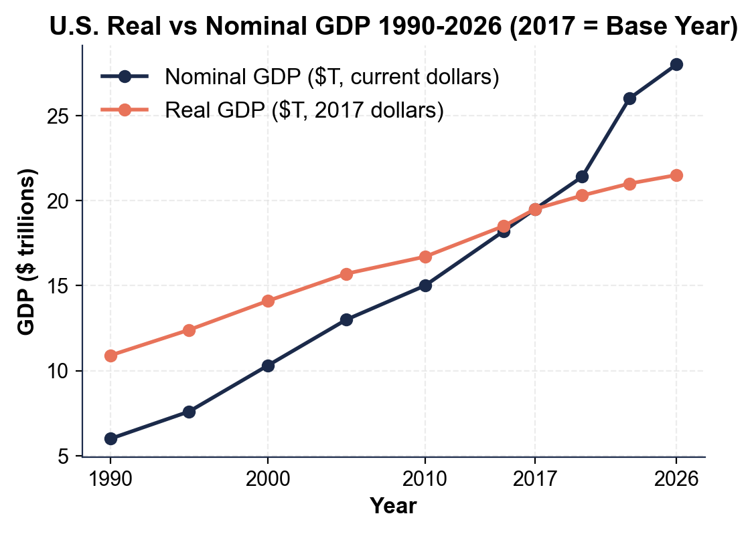
OVERALL PATTERN: both lines rise over time, but the NOMINAL line is higher in 2026 while the two lines CROSS once in the middle of the chart (at the base year) - before the crossing the real line is higher, after it the nominal line is higher. ACCEPT: any one sentence noting the nominal line is higher by 2026 and that the lines cross.
2. Using the chart above, read directly off the chart and compute.
(a) Approximately what was NOMINAL U.S. GDP in 1990?
NOMINAL 1990: approximately $6.0 trillion (accept $5.5-$6.5T).
(b) Approximately what was REAL U.S. GDP in 1990 (in base-year dollars)?
REAL 1990: approximately $10.9 trillion in base-year dollars (accept $10.5-$11.5T).
(c) In what year do the two lines CROSS?
CROSS YEAR: 2017 - the base year, where the deflator = 100 and both lines equal approximately $19.5T.
(d) Read 2026 nominal and 2026 real, then compute BOTH the nominal growth factor (2026 nominal / 1990 nominal) and the real growth factor (2026 real / 1990 real).
GROWTH FACTORS: 2026 nominal approximately $28T and 2026 real approximately $21.5T; nominal growth factor = 28 / 6 = approximately 4.7x; real growth factor = 21.5 / 10.9 = approximately 2.0x (accept 1.9x-2.1x).
(e) In 1-2 sentences, explain what the GAP between the two lines after the crossing year represents.
THE GAP: the gap between nominal and real after 2017 IS the inflation since the base year - the deflator rose from 100 to 130, so the nominal line grew about 30% just to keep up with rising prices; that extra growth is the widening gap above the real line, which shows only true output growth. REQUIRED: 1990 nominal ~$6T and real ~$10.9T; cross at 2017; growth factors ~4.7x and ~2.0x; gap = post-base-year inflation.
3. Now study the GDP Deflator vs CPI 1990-2026 line chart inserted below (also shown in the slide deck). In ONE sentence, describe what both indexes equal in the base year and which index is slightly higher by 2026.
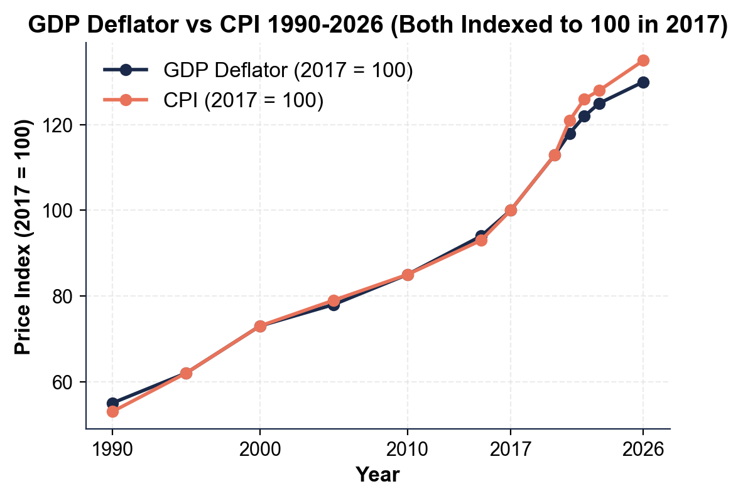
BASE-YEAR ANCHOR: both the GDP deflator and the CPI equal 100 in the base year (2017) and both rise over time, but the CPI ends slightly HIGHER than the deflator by 2026. ACCEPT: any one sentence noting both = 100 in the base year and that CPI is a bit higher by 2026.
4. Using the deflator vs CPI chart above, read and explain.
(a) Approximately what was the GDP DEFLATOR in 1990?
DEFLATOR 1990: approximately 55 (accept 50-60).
(b) Approximately what was the GDP DEFLATOR in 2026?
DEFLATOR 2026: approximately 130 (accept 125-135).
(c) Approximately what was the CPI in 2026?
CPI 2026: approximately 135 (accept 130-140); both indexes equal 100 in the base year by definition.
(d) In 1-2 sentences, explain why CPI is SLIGHTLY HIGHER than the deflator by 2026.
WHY CPI IS HIGHER: CPI measures only a FIXED BASKET of consumer goods and services (food, rent, healthcare, transportation), while the GDP deflator measures the price level of EVERYTHING in GDP - including business equipment, government purchases, and exports, some of which (notably tech equipment) fell in price even as consumer prices rose; CPI also updates its basket less often, so it can run a bit higher than the chain-weighted deflator.
(e) Identify the acceleration period AFTER 2020 that is clearly visible on the chart as the steepest climb of both lines, then name ONE earlier inflation episode from the lesson (for example the 2008 oil-price spike) that is NOT as visible at this annual scale.
VISIBLE ACCELERATION: the 2021-2022 post-COVID inflation surge - supply-chain disruptions and stimulus pushed both indexes up sharply (CPI rose about 8% in 2022, the fastest in 40 years), shown on the chart as the steep climb of both lines between 2020 and 2022 before they flatten toward 2026. EARLIER EPISODE FROM THE LESSON (less visible at this annual scale): the 2008 oil-price spike and financial crisis. REQUIRED: deflator 1990 ~55, deflator 2026 ~130, CPI 2026 ~135; explains CPI vs deflator difference (consumer-only basket); identifies the visible post-2020 surge and names the 2008 oil-price spike as the earlier lesson episode.

PART 5

Final Policy Memo to the BEA Chief Economist (Dakota Hale Synthesis)
POLICY RECOMMENDATION MEMO
1. POLICY RECOMMENDATION MEMO. As Dakota Hale, write a 6-8 sentence memo (about 200-300 words) to the BEA Chief Economist evaluating this press statement from a politician: "Since I took office five years ago, U.S. GDP has grown from $22 trillion to $28 trillion - a 27% increase. My policies are working!" Use the memo header below and check off each required element as you include it. (Sentence starters you can use: "This claim is misleading because..." and "To evaluate it properly I would need...")
YOUR RESPONSE MUST:
☐ WHY THE CLAIM IS MISLEADING - one to two sentences explaining that the 27% figure is NOMINAL growth, which mixes real output growth with inflation and therefore overstates the true increase in goods and services produced.
☐ TWO DATA NEEDS - name TWO specific data points you would need to evaluate the claim properly (for example the GDP deflator for each year, the CPI, or the FRED real-GDP series GDPC1) and say briefly what each one lets you do.
☐ ONE CHART NUMBER - cite ONE specific number you read off the U.S. Real vs Nominal GDP 1990-2026 chart in Part 4 (for example a nominal or real value, or one of the two growth factors) - use the value YOU read, do not copy it from here.
☐ ONE BEA RECOMMENDATION - name ONE specific change to how the BEA should publish its GDP press releases so this kind of misleading claim is harder to make (for example lead with real growth, publish real and nominal side by side, or add a one-line explainer).
☐ FIVE VOCABULARY TERMS - use at least FIVE lesson vocabulary terms from your Reference Guide (for example nominal GDP, real GDP, GDP deflator, base year, inflation, constant dollars, GDPC1).
MEMO
To: BEA Chief Economist
From: Dakota Hale, Junior Analyst, U.S. Bureau of Economic Analysis (BEA)
Date: [student completes]
Re: Evaluating a Misleading GDP-Growth Claim (Real vs Nominal)
GRADING RUBRIC
Grade the evidence and reasoning, not the conclusion — any defensible position is valid. Score against the 5 requirements above.
FULL CREDIT — clear position; meets all 5 requirements with accurate, specific numbers and evidence from the lesson.
PARTIAL — position stated, but misses 1-2 requirements or uses vague / incorrect numbers.
MINIMAL — no clear position, or missing most requirements and numbers.
WHAT TO LOOK FOR IN THIS LESSON
Sample full-credit memo:
TO: BEA Chief Economist
FROM: Dakota Hale, Junior Analyst, BEA
RE: Evaluating a Misleading GDP-Growth Claim (Real vs Nominal)
[1] WHY IT IS MISLEADING: the claim cites NOMINAL GDP growth, which mixes real output growth with INFLATION, so the 27% increase from $22T to $28T over five years almost certainly overstates how much the economy actually produced - much of it is just rising prices. [2] DATA NEEDS: to evaluate it properly I would need (a) the GDP DEFLATOR for the starting and ending year, so I can convert both nominal figures to real base-year dollars and recompute the growth rate, and (b) the FRED REAL GDP series GDPC1 for both years, the BEA-published chain-weighted real number that is authoritative for growth comparisons. [3] CHART NUMBER: on the U.S. Real vs Nominal GDP 1990-2026 chart, nominal GDP grew about 4.7x from 1990 to 2026 while real GDP only grew about 2.0x - more than half of the nominal growth was inflation, and the politician's 27% almost certainly contains a similar inflation component. [4] RECOMMENDATION: every BEA quarterly GDP press release should LEAD with the real GDP growth rate and put nominal GDP in a secondary table, with a one-line explainer that real GDP measures output while nominal GDP includes price changes. [5] VOCABULARY: this memo uses nominal GDP, real GDP, GDP deflator, base year, inflation, and GDPC1.
REQUIRED-ELEMENT CHECKLIST (award credit per item):
[1] Explains the claim is misleading because nominal includes inflation.
[2] Names TWO specific data needs (deflator, GDPC1, CPI, or similar).
[3] Cites one specific Part-4 chart number (the student's own reading).
[4] Names one defensible BEA-reporting recommendation.
[5] Uses at least FIVE Reference-Guide vocabulary terms.
Accept any sound analysis: the key is that the student distinguishes real from nominal, names concrete data needs, cites a real chart value, and proposes a defensible reporting change.
MORE LESSONS LESS PLANNING
Thank You!
If you enjoyed this product, please do not forget to rate and review to assist other teachers.

Looking for future discounts? Earn TPT credits by reviewing purchased products.

Please contact me if you have any issues with this product. Just like our students, I am always looking for opportunities to grow.

