Perfect Competition: The Theoretical Ideal
STUDENT ACTIVITY
Name: | Date: | Period:
ESSENTIAL QUESTION
If everyone sells the exact same thing, who gets to set the price?
THE SCENARIO
You are a 17-year-old senior. Your family runs a 2,000-acre wheat farm in central Kansas.
BY THE END, YOU CAN:
✓ List the FOUR conditions of perfect competition: many sellers, identical product, free entry and exit, and perfect information. Then check whether a real market meets each one.
✓ Tell apart two charts. The MARKET chart sets the equilibrium price. The INDIVIDUAL FIRM's horizontal demand curve shows what a price-taker actually faces.
✓ Explain why free entry and exit pushes long-run economic profit to zero. This is bad news for sellers. It is good news for consumers.
HOW IT WORKS (do Parts 1–5 in order)
Part 1 — Perfect Competition Reference Guide - Complete the Missing Terms
Part 2 — Apply the Terms - Perfect Competition Vocabulary in Context
Part 3 — You Read the Three Perfect-Competition Charts with Maya
Part 4 — Four Real-Market Scenarios - Apply the Model
Part 5 — Your Final Seasonal-Planting Memo to the Family
TIME about 45 minutes YOU’LL NEED the lesson slides and your Guided Notes.

PART 1

Perfect Competition Reference Guide - Complete the Missing Terms
Fill in the missing term for each blank row — the definition is your clue. Your Guided Notes and the lesson slides have every term.

Term | Definition
___________ | A theoretical market structure that meets four strict conditions - many sellers, identical product, free entry and exit, and perfect information; no real market meets all four perfectly
Price-taker | A seller that has no power to set the price and must accept whatever price the market gives; signature is a horizontal individual demand curve at the market price
___________ | A product so identical across all sellers that buyers do not care which seller they buy from; commodity grain, currency, and standardized stock shares are the cleanest examples
Free entry and exit | New firms can join the market with no significant legal, financial, or technological barriers; failing firms can leave with no significant exit cost
___________ | All buyers and sellers know all prices, product qualities, and production costs in the market - no one has an information advantage over anyone else
Horizontal demand curve | The demand curve that an INDIVIDUAL firm faces in perfect competition - perfectly elastic (flat) at the market price, because the firm is too small to influence price
___________ | Total revenue minus ALL costs including the opportunity cost of the owner's capital and labor - distinct from accounting profit; zero economic profit still pays the owner a normal market return
Long-run zero profit | The prediction that in a perfectly competitive market, free entry erodes positive economic profits and free exit relieves losses, so the long-run equilibrium has zero economic profit
___________ | A standardized, undifferentiated good (wheat, corn, copper, crude oil, gold) that trades on its market price alone; commodity markets are the closest real-world examples of perfect competition
Market structure | The classification of a market by the number of sellers, the degree of product differentiation, the height of entry barriers, and the amount of price-setting power firms have

PART 2

Apply the Terms - Perfect Competition Vocabulary in Context
WORD BANK perfect competition · commodity · economic profit · homogeneous product · perfect information
1. A market with many sellers, an identical product, free entry and exit, and perfect information is the theoretical benchmark economists call .

2. When wheat from one farm is interchangeable with wheat from every other farm, so buyers do not care which seller they buy from, economists call it a .

3. When every buyer and seller knows all prices, qualities, and costs, and no one holds an information advantage, the market has .

4. Total revenue minus ALL costs, including the opportunity cost of the time and money the owner could have used elsewhere, is called .

5. A standardized, undifferentiated good such as wheat, corn, copper, or gold that trades on its market price alone is a .

PART 3

You Read the Three Perfect-Competition Charts with Maya
1. Use Chart Reference 1 (chart_wheat_market_equilibrium) - the supply-and-demand graph shown below - to identify the equilibrium of the U.S. wheat market.
(a) Read the EQUILIBRIUM PRICE off the Y axis.

(b) Read the EQUILIBRIUM QUANTITY INDEX off the X axis.

(c) Explain why this MARKET-level equilibrium is what an individual farm must accept - using the term price-taker.

2. Use Chart Reference 2 (chart_firm_horizontal_demand) - the horizontal demand curve facing a single wheat farm shown below - to identify the firm-level demand curve.
(a) State the SHAPE of the demand curve (horizontal, downward-sloping, vertical, upward-sloping).

(b) State the price the farm RECEIVES whether it sells 10,000 bushels or 40,000 bushels.

(c) State the TECHNICAL NAME for this kind of demand curve (the elasticity word).

(d) In 1-2 sentences, explain what this shape says about the farm's pricing power.

3. Use Chart Reference 3 (chart_wheat_price_history) - the line chart of U.S. wheat prices 2010-2024 shown below - to extract specific data points and connect them to the price-taker concept.
(a) State the LOW year and its price.

(b) State the PEAK year and its price.

(c) Compute the LOW-TO-PEAK RATIO (round to 2 decimal places).

(d) Identify the specific real-world EVENT that caused the 2022 peak.

(e) Explain in 1-2 sentences what this chart tells you about the limits of an individual farmer's pricing power.

PART 4

Four Real-Market Scenarios - Apply the Model
1. RATE FOUR REAL MARKETS ON THE FOUR CONDITIONS. Maya gives you four real markets to diagnose:
(a) U.S. COMMODITY WHEAT

(b) U.S. SMARTPHONES (Apple, Samsung, Google, etc.)

(c) U.S. RESTAURANTS (sit-down and fast food)

(d) U.S. SEARCH ENGINES (Google, Bing, DuckDuckGo). For EACH market: rate it 0-10 on EACH of the four conditions. Give a 1-sentence justification for each rating. Then pick the market structure label that fits best (perfect competition / monopolistic competition / oligopoly / monopoly). This is a comparative diagnosis, not a memorization question. Use the model.

2. NEW FARM ENTERS THE MARKET. Suppose wheat prices have been high for two years ($8/bushel in 2021 and 2022). A neighboring farm grew corn last season. Because of the high price, it switches to wheat next season. Apply the perfect-competition model:
(a) Which CONDITION of perfect competition makes this switch possible at low cost?

(b) If thousands of farms make the same switch, what happens to the MARKET supply curve - shifts LEFT, shifts RIGHT, or stays the same?

(c) What happens to the equilibrium wheat PRICE as a result?

(d) Connect this to the long-run zero-economic-profit prediction.

3. AN ENTIRE MARKET FAILS A CONDITION. Suppose the U.S. government suddenly requires every wheat seller to buy a license. The license costs $500,000 per year. Apply the perfect-competition model:
(a) Which of the four CONDITIONS is now broken?

(b) What happens to the NUMBER of wheat sellers - increase, decrease, or no change?

(c) What happens to the equilibrium wheat PRICE?

(d) Identify which market structure (perfect competition / monopoly / oligopoly / monopolistic competition) the wheat market would now look more like.

4. LOSS YEAR FORCES EXIT. Suppose wheat prices drop to $3.50/bushel. This happens for two years in a row, like the 2016 trough. Apply the perfect-competition model to predict what happens next:
(a) Which CONDITION is doing the work in the long-run adjustment?

(b) What do you predict will happen to the NUMBER of wheat farms in the third year - increase, decrease, or no change?

(c) What do you predict will happen to the equilibrium wheat PRICE over the next 2-3 years?

(d) Explain in 1-2 sentences how this connects to the long-run zero-economic-profit prediction.

PART 5

Your Final Seasonal-Planting Memo to the Family
SEASONAL-PLANTING MEMO
1. Maya closes the meeting.
She asks you to write the one-page memo your family will read before deciding what to plant. The memo should be about 6-8 sentences. Use all four required terms at least once each: perfect competition, price-taker, horizontal demand curve, free entry. Knowing what you now know about perfect competition and price-taker farming: do you recommend the family plant WHEAT next season, or pivot to a different crop?
YOUR RESPONSE MUST:
☐ Names a SPECIFIC RECOMMENDATION - plant wheat, pivot to corn, pivot to a different crop, or diversify. Ties the recommendation to the PERFECT COMPETITION model.
☐ Uses the term PRICE-TAKER correctly. Shows that the family farm cannot set the wheat price. The farm must accept whatever the global market gives.
☐ Uses the phrase HORIZONTAL DEMAND CURVE correctly. Notes that the individual farm faces this shape, not the market's downward-sloping curve.
☐ Uses the term FREE ENTRY correctly. Notes that other farms can also switch in and out of wheat. This limits how long any price premium can last.
☐ Quotes at least ONE value from the wheat price history chart - for example, the 2016 low of $3.89, the 2022 peak of $8.83, or the 2024 close of $5.55. This grounds the recommendation in real data.
☐ Closes with a SPECIFIC NEXT STEP the family will take in the next 30 days - for example: lock in a futures price for the harvest, scout neighboring farms about planting plans, talk to the bank about financing, or sign up for crop insurance.
MEMO
To:
From:
Date:
Re: Seasonal planting recommendation - economic reasoning

CHART REFERENCE 1: THE WHEAT MARKET - SUPPLY, DEMAND, AND EQUILIBRIUM PRICE

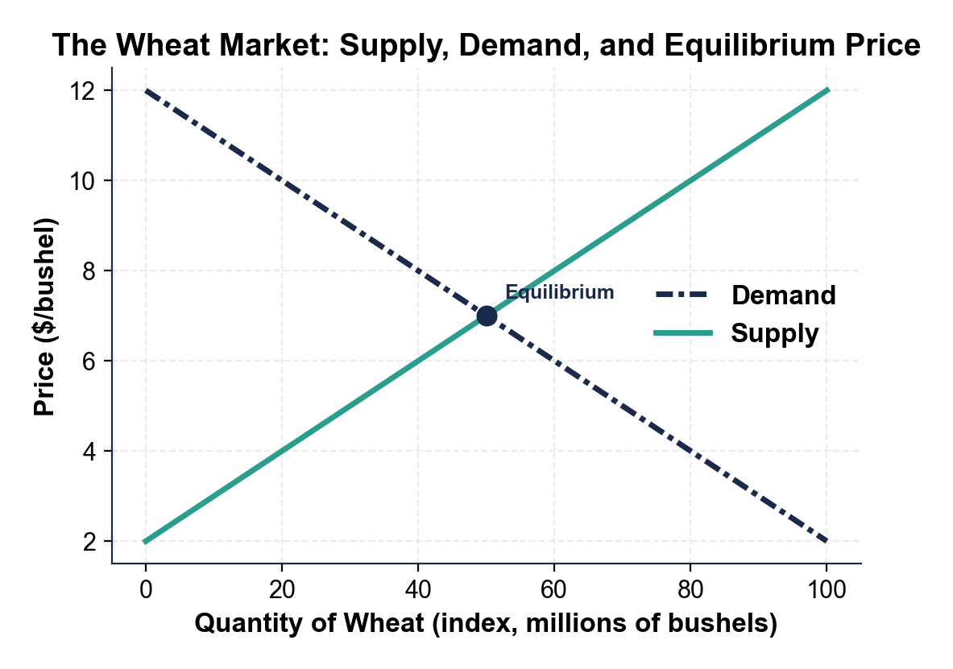

CHART REFERENCE 2: THE INDIVIDUAL WHEAT FARMER'S HORIZONTAL DEMAND CURVE

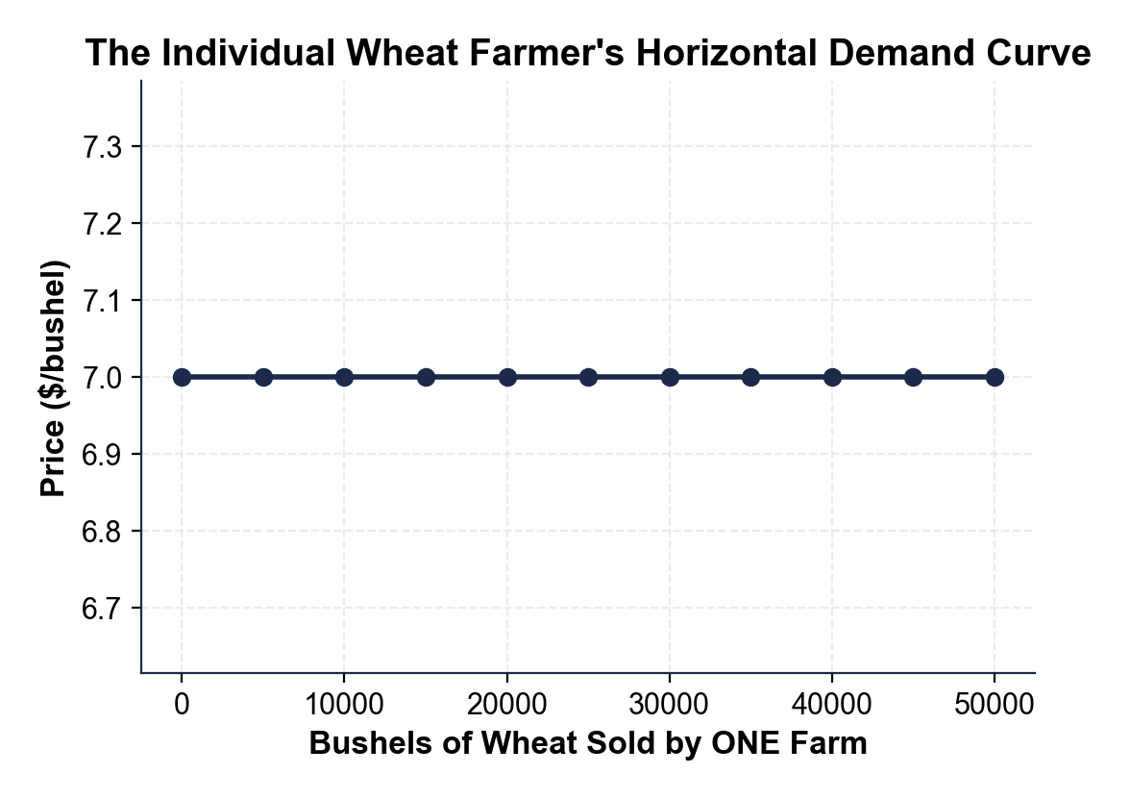

CHART REFERENCE 3: U.S. WHEAT PRICES 2010-2024

