ECONOMICS

PERFECT COMPETITION: THE THEORETICAL IDEAL
ANSWER KEY ACTIVITY

PART 1

Perfect Competition Reference Guide - Complete the Missing Terms

Term | Definition
Perfect competition | A theoretical market structure that meets four strict conditions - many sellers, identical product, free entry and exit, and perfect information; no real market meets all four perfectly
Price-taker | A seller that has no power to set the price and must accept whatever price the market gives; signature is a horizontal individual demand curve at the market price
Homogeneous product | A product so identical across all sellers that buyers do not care which seller they buy from; commodity grain, currency, and standardized stock shares are the cleanest examples
Free entry and exit | New firms can join the market with no significant legal, financial, or technological barriers; failing firms can leave with no significant exit cost
Perfect information | All buyers and sellers know all prices, product qualities, and production costs in the market - no one has an information advantage over anyone else
Horizontal demand curve | The demand curve that an INDIVIDUAL firm faces in perfect competition - perfectly elastic (flat) at the market price, because the firm is too small to influence price
Economic profit | Total revenue minus ALL costs including the opportunity cost of the owner's capital and labor - distinct from accounting profit; zero economic profit still pays the owner a normal market return
Long-run zero profit | The prediction that in a perfectly competitive market, free entry erodes positive economic profits and free exit relieves losses, so the long-run equilibrium has zero economic profit
Commodity | A standardized, undifferentiated good (wheat, corn, copper, crude oil, gold) that trades on its market price alone; commodity markets are the closest real-world examples of perfect competition
Market structure | The classification of a market by the number of sellers, the degree of product differentiation, the height of entry barriers, and the amount of price-setting power firms have

PART 2

Apply the Terms - Perfect Competition Vocabulary in Context
WORD BANK perfect competition · commodity · economic profit · homogeneous product · perfect information
1. A market with many sellers, an identical product, free entry and exit, and perfect information is the theoretical benchmark economists call perfect competition.
perfect competition
2. When wheat from one farm is interchangeable with wheat from every other farm, so buyers do not care which seller they buy from, economists call it a homogeneous product.
homogeneous product
3. When every buyer and seller knows all prices, qualities, and costs, and no one holds an information advantage, the market has perfect information.
perfect information
4. Total revenue minus ALL costs, including the opportunity cost of the time and money the owner could have used elsewhere, is called economic profit.
economic profit
5. A standardized, undifferentiated good such as wheat, corn, copper, or gold that trades on its market price alone is a commodity.
commodity. Wheat, corn, copper, and gold are standardized goods that trade on their market price alone, the cleanest real-world examples of perfect competition.

PART 3

You Read the Three Perfect-Competition Charts with Maya
1. Use Chart Reference 1 (chart_wheat_market_equilibrium) - the supply-and-demand graph shown below - to identify the equilibrium of the U.S. wheat market.
(a) Read the EQUILIBRIUM PRICE off the Y axis.
EQUILIBRIUM PRICE: $7/bushel - the Y-axis value at the labeled equilibrium dot.
(b) Read the EQUILIBRIUM QUANTITY INDEX off the X axis.
EQUILIBRIUM QUANTITY INDEX: 50 - the X-axis value at the same dot.
(c) Explain why this MARKET-level equilibrium is what an individual farm must accept - using the term price-taker.
The MARKET-level equilibrium is set by ALL wheat farms' supply meeting ALL wheat buyers' demand. An individual farm is too SMALL to influence either curve - it is one of tens of thousands of producers.
2. Use Chart Reference 2 (chart_firm_horizontal_demand) - the horizontal demand curve facing a single wheat farm shown below - to identify the firm-level demand curve.
(a) State the SHAPE of the demand curve (horizontal, downward-sloping, vertical, upward-sloping).
SHAPE: HORIZONTAL - a flat line at $7/bushel from quantity 0 to quantity 50,000.
(b) State the price the farm RECEIVES whether it sells 10,000 bushels or 40,000 bushels.
PRICE RECEIVED: $7/bushel at any quantity - whether the farm sells 10,000 bushels (revenue $70,000) or 40,000 bushels (revenue $280,000), the per-bushel price is the same $7.
(c) State the TECHNICAL NAME for this kind of demand curve (the elasticity word).
TECHNICAL NAME: PERFECTLY ELASTIC demand.
(d) In 1-2 sentences, explain what this shape says about the farm's pricing power.
The horizontal shape says the farm has ZERO pricing power. If the farm tried to charge $7.01, buyers would switch to any of the other 99,999 identical-product wheat farms at $7.

3. Use Chart Reference 3 (chart_wheat_price_history) - the line chart of U.S. wheat prices 2010-2024 shown below - to extract specific data points and connect them to the price-taker concept.
(a) State the LOW year and its price.
LOW YEAR: 2016 at $3.89/bushel.
(b) State the PEAK year and its price.
PEAK YEAR: 2022 at $8.83/bushel.
(c) Compute the LOW-TO-PEAK RATIO (round to 2 decimal places).
LOW-TO-PEAK RATIO: $8.83 / $3.89 = 2.27x (accept 2.2x - 2.3x).
(d) Identify the specific real-world EVENT that caused the 2022 peak.
EVENT: Russia's invasion of Ukraine in February 2022 cut off roughly 30% of global wheat exports overnight; the world price spiked in response. (Accept 'the Ukraine war' or 'Russia-Ukraine war' as the short answer.)
(e) Explain in 1-2 sentences what this chart tells you about the limits of an individual farmer's pricing power.
INDIVIDUAL FARMER PRICING POWER: zero. The 2016 low and the 2022 peak were both driven by GLOBAL forces (oversupply in 2016, war in 2022).

PART 4

Four Real-Market Scenarios - Apply the Model
1. RATE FOUR REAL MARKETS ON THE FOUR CONDITIONS. Maya gives you four real markets to diagnose:
(a) U.S. COMMODITY WHEAT
U.S. WHEAT: Many sellers 10/10 (100,000+ farms); Identical product 9/10 (federally graded); Free entry 8/10 (moderate capital, low legal barriers); Perfect info 9/10 (USDA NASS + futures markets). STRUCTURE: PERFECT COMPETITION (closest real-world fit).
(b) U.S. SMARTPHONES (Apple, Samsung, Google, etc.)
U.S. SMARTPHONES: Many sellers 2/10 (effectively Apple + Samsung duopoly with minor brands); Identical 1/10 (deliberately differentiated by brand/OS); Free entry 1/10 (enormous capital + patent thickets); Perfect info 5/10 (specs public, internals hidden). STRUCTURE: OLIGOPOLY (few large sellers, differentiated products, high entry barriers).
(c) U.S. RESTAURANTS (sit-down and fast food)
U.S. RESTAURANTS: Many sellers 8/10 (over 600,000 restaurants nationally); Identical 2/10 (each restaurant has its own menu/atmosphere); Free entry 6/10 (capital + licensing, moderate); Perfect info 5/10 (Yelp/menus public, quality variable). STRUCTURE: MONOPOLISTIC COMPETITION (many sellers, differentiated products, moderate entry).
(d) U.S. SEARCH ENGINES (Google, Bing, DuckDuckGo). For EACH market: rate it 0-10 on EACH of the four conditions. Give a 1-sentence justification for each rating. Then pick the market structure label that fits best (perfect competition / monopolistic competition / oligopoly / monopoly). This is a comparative diagnosis, not a memorization question. Use the model.
U.S. SEARCH ENGINES: Many sellers 1/10 (Google ~90% market share); Identical 3/10 (technically search results vary); Free entry 1/10 (enormous capital + data network effects); Perfect info 3/10 (algorithm is a trade secret). STRUCTURE: NEAR-MONOPOLY (one dominant seller, technically differentiated but near-monopoly market power).
2. NEW FARM ENTERS THE MARKET. Suppose wheat prices have been high for two years ($8/bushel in 2021 and 2022). A neighboring farm grew corn last season. Because of the high price, it switches to wheat next season. Apply the perfect-competition model:
(a) Which CONDITION of perfect competition makes this switch possible at low cost?
CONDITION 3 - FREE ENTRY AND EXIT. The neighboring corn farm can switch crops with no major legal or technology barriers. This is the free-entry mechanism that perfect competition predicts.
(b) If thousands of farms make the same switch, what happens to the MARKET supply curve - shifts LEFT, shifts RIGHT, or stays the same?
SUPPLY SHIFTS RIGHT. Thousands of new wheat-planting decisions add to total U.S. wheat supply. The market supply curve moves right at every price level.
(c) What happens to the equilibrium wheat PRICE as a result?
EQUILIBRIUM PRICE FALLS. Supply shifts right and demand stays the same, so the new equilibrium has a LOWER price and a higher quantity.
(d) Connect this to the long-run zero-economic-profit prediction.
This is the LONG-RUN ZERO-PROFIT MECHANISM in action. High prices attract new entry. New entry shifts supply right. The bigger supply pushes the price back down. Economic profit shrinks back toward zero. This is exactly what the model predicts should happen after two years of $8 wheat.

3. AN ENTIRE MARKET FAILS A CONDITION. Suppose the U.S. government suddenly requires every wheat seller to buy a license. The license costs $500,000 per year. Apply the perfect-competition model:
(a) Which of the four CONDITIONS is now broken?
CONDITION 3 - FREE ENTRY AND EXIT - is now broken. The $500,000/year licensing fee is a major legal and financial barrier to entry.
(b) What happens to the NUMBER of wheat sellers - increase, decrease, or no change?
NUMBER OF SELLERS DECREASES. Smaller farms cannot pay the fee, so they exit. New farms cannot afford to enter.
(c) What happens to the equilibrium wheat PRICE?
EQUILIBRIUM PRICE RISES. With fewer sellers, market supply shifts LEFT, and the equilibrium price rises. The market also loses the long-run zero-profit pressure, because new entry is blocked.
(d) Identify which market structure (perfect competition / monopoly / oligopoly / monopolistic competition) the wheat market would now look more like.
The wheat market now looks like an OLIGOPOLY - few large sellers, high entry barriers. If the fee leaves only one or two sellers, it looks like a MONOPOLY.
4. LOSS YEAR FORCES EXIT. Suppose wheat prices drop to $3.50/bushel. This happens for two years in a row, like the 2016 trough. Apply the perfect-competition model to predict what happens next:
(a) Which CONDITION is doing the work in the long-run adjustment?
CONDITION 3 - FREE ENTRY AND EXIT - is doing the work here, on the EXIT side. Farms losing money can shut down with no major exit cost.
(b) What do you predict will happen to the NUMBER of wheat farms in the third year - increase, decrease, or no change?
NUMBER OF FARMS DECREASES. At $3.50/bushel, marginal farms cannot cover their opportunity cost. Some shut down.
(c) What do you predict will happen to the equilibrium wheat PRICE over the next 2-3 years?
EQUILIBRIUM PRICE RISES over the next 2-3 years. As farms exit, market supply shifts LEFT.
(d) Explain in 1-2 sentences how this connects to the long-run zero-economic-profit prediction.
This is the LONG-RUN ZERO-PROFIT MECHANISM on the LOSS side. Free EXIT relieves losses by shrinking supply, until price rises back to a normal return. That normal return is zero economic profit in long-run equilibrium. The model predicts wheat farms cannot lose money forever, because the exit mechanism eventually restores break-even.

PART 5

Your Final Seasonal-Planting Memo to the Family
SEASONAL-PLANTING MEMO
1. Maya closes the meeting.
She asks you to write the one-page memo your family will read before deciding what to plant. The memo should be about 6-8 sentences. Use all four required terms at least once each: perfect competition, price-taker, horizontal demand curve, free entry. Knowing what you now know about perfect competition and price-taker farming: do you recommend the family plant WHEAT next season, or pivot to a different crop?
YOUR RESPONSE MUST:
☐ Names a SPECIFIC RECOMMENDATION - plant wheat, pivot to corn, pivot to a different crop, or diversify. Ties the recommendation to the PERFECT COMPETITION model.
☐ Uses the term PRICE-TAKER correctly. Shows that the family farm cannot set the wheat price. The farm must accept whatever the global market gives.
☐ Uses the phrase HORIZONTAL DEMAND CURVE correctly. Notes that the individual farm faces this shape, not the market's downward-sloping curve.
☐ Uses the term FREE ENTRY correctly. Notes that other farms can also switch in and out of wheat. This limits how long any price premium can last.
☐ Quotes at least ONE value from the wheat price history chart - for example, the 2016 low of $3.89, the 2022 peak of $8.83, or the 2024 close of $5.55. This grounds the recommendation in real data.
☐ Closes with a SPECIFIC NEXT STEP the family will take in the next 30 days - for example: lock in a futures price for the harvest, scout neighboring farms about planting plans, talk to the bank about financing, or sign up for crop insurance.
MEMO
To: [student completes]
From: [student completes]
Date: [student completes]
Re: Seasonal planting recommendation - economic reasoning
GRADING RUBRIC
Grade the evidence and reasoning, not the conclusion — any defensible position is valid. Score against the 6 requirements above.
FULL CREDIT — clear position; meets all 6 requirements with accurate, specific numbers and evidence from the lesson.
PARTIAL — position stated, but misses 1-2 requirements or uses vague / incorrect numbers.
MINIMAL — no clear position, or missing most requirements and numbers.
WHAT TO LOOK FOR IN THIS LESSON
Grade this memo using the rubric below. A full-credit memo does six things. First, it names a specific planting recommendation and ties it to the PERFECT COMPETITION model. Second, it uses PRICE-TAKER correctly - the farm cannot set its own wheat price. Third, it references the HORIZONTAL DEMAND CURVE the individual farm faces. Fourth, it uses FREE ENTRY correctly - other farms can switch in and out, which limits any price premium and pushes toward long-run zero economic profit. Fifth, it quotes at least one chart value, such as the 2016 low of $3.89, the 2022 peak of $8.83, or the 2024 close of $5.55. Sixth, it closes with a concrete next step in the next 30 days. The recommendation itself may vary - it could be all-wheat, a pivot, or diversification. Any of these is fine as long as the four terms are used correctly and all six elements are present.

CHART REFERENCE 1: THE WHEAT MARKET - SUPPLY, DEMAND, AND EQUILIBRIUM PRICE

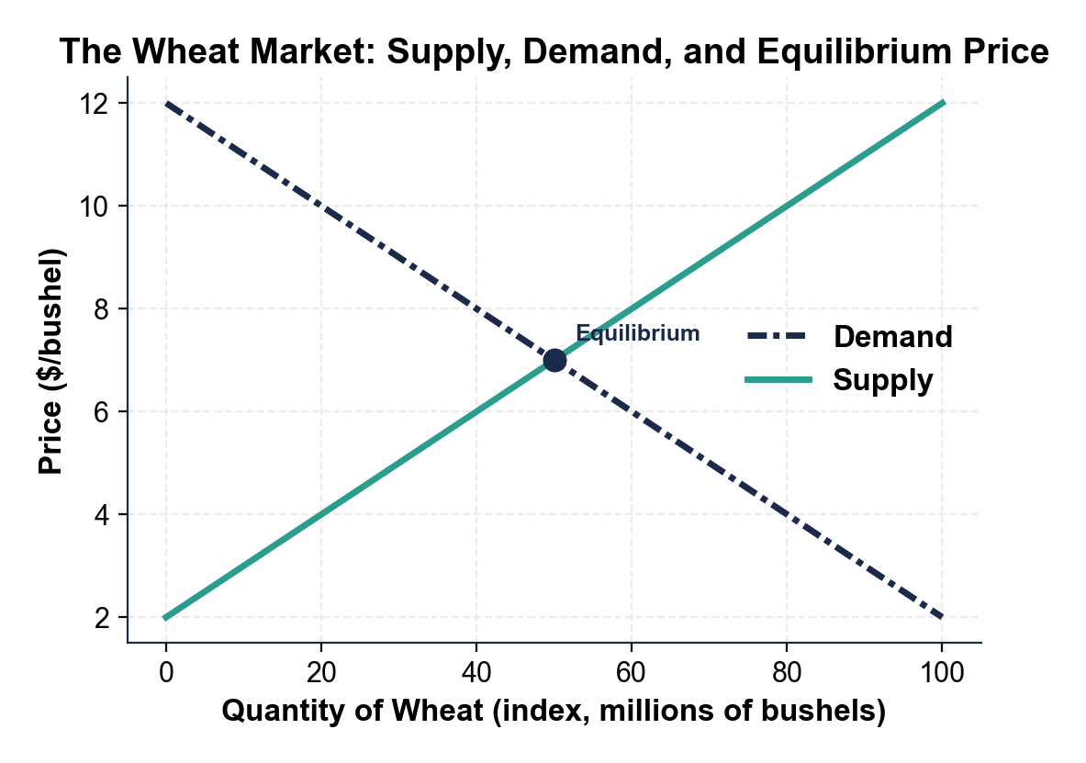

CHART REFERENCE 2: THE INDIVIDUAL WHEAT FARMER'S HORIZONTAL DEMAND CURVE

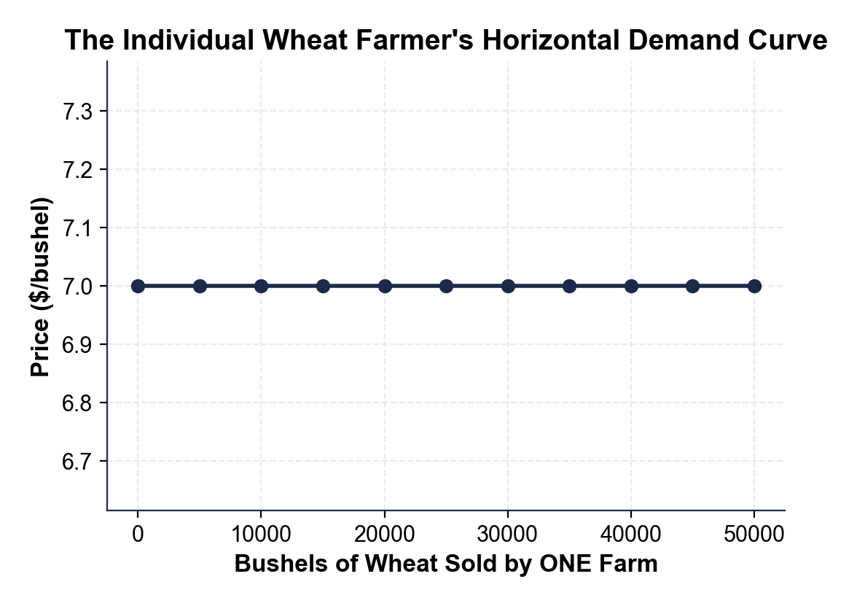

CHART REFERENCE 3: U.S. WHEAT PRICES 2010-2024

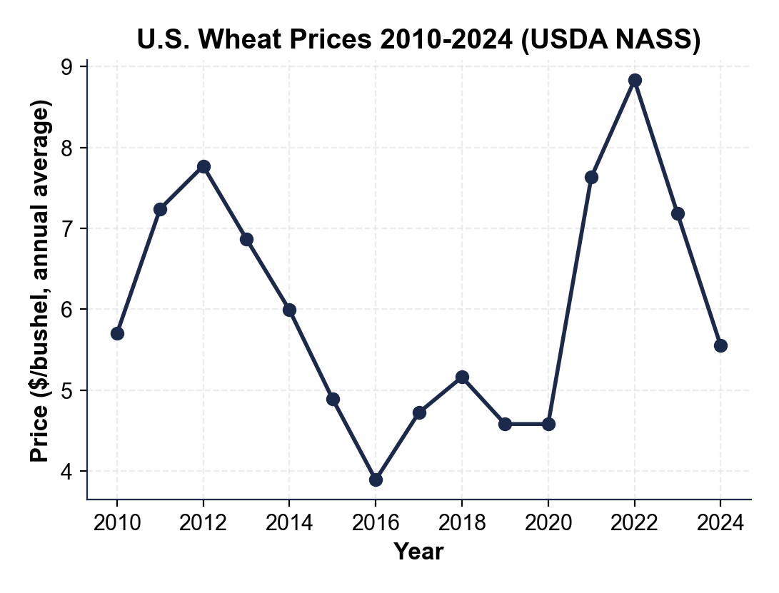
MORE LESSONS LESS PLANNING
Thank You!
If you enjoyed this product, please do not forget to rate and review to assist other teachers.

Looking for future discounts? Earn TPT credits by reviewing purchased products.

Please contact me if you have any issues with this product. Just like our students, I am always looking for opportunities to grow.

