Pandemic Economics: COVID's Lasting Impact
STUDENT ACTIVITY
Name: | Date: | Period:
ESSENTIAL QUESTION
Why was the COVID recession the shortest in NBER history despite the largest single-quarter GDP collapse - and which pandemic-era policies should become permanent vs sunset?
THE SCENARIO
YOUR ROLE: it is January 2025 and you are DR. ELENA VASQUEZ, Senior Economist at the White House Council of Economic Advisers (CEA). The President has asked the CEA for a 5-year COVID retrospective brief - a memo recommending which pandemic-era policies should become PERMANENT and which should SUNSET, drawing on cross-cycle lessons from 1929 (Great Depression - TK 99), 2008 (Housing Crash - TK 91), and 2020-2024 (COVID).
BY THE END, YOU CAN:
✓ Trace the COVID-19 economic impact from the March 2020 lockdown through the 2024 recovery: GDP collapse, stimulus, V-shape rebound, inflation surge, and rate-hike cycle
✓ Identify the lasting economic changes from the pandemic: remote/hybrid work as a permanent shift, supply-chain reshoring, and the 2021-2024 inflation surge
✓ Evaluate the policy response across the cycle (CARES Act, ARP, Fed zero-rate + QE, then 2022-2023 rate hikes) and compare it to the 1929 and 2008 playbooks
HOW IT WORKS (do Parts 1–5 in order)
Part 1 — Pandemic-Economics Reference Guide - Complete the Missing Terms
Part 2 — Apply the Terms - Pandemic-Economics Vocabulary in Context
Part 3 — Explain the Cross-Cycle Story
Part 4 — Read the Charts and Run the Numbers
Part 5 — Retrospective Memo to the President
TIME about 45 minutes YOU’LL NEED the lesson slides and your Guided Notes.

PART 1

Pandemic-Economics Reference Guide - Complete the Missing Terms
Fill in the missing term for each blank row — the definition is your clue. Your Guided Notes and the lesson slides have every term.

Term | Definition
___________ | Government-mandated stay-at-home orders that began in mid-March 2020; closed non-essential businesses, schools, and travel and triggered the sharpest quarterly GDP drop in modern records
COVID-19 recession | The two-quarter U.S. recession of Q1-Q2 2020; the sharpest single-quarter GDP contraction in modern records and the shortest NBER recession in history at just 2 months
___________ | Large-scale Federal Reserve purchases of Treasury and mortgage bonds; expanded the Fed balance sheet from $4.2 trillion to about $9 trillion between 2020 and 2022
CARES Act | The $2.2 trillion stimulus law signed in March 2020; included $1,200 checks, expanded unemployment, and Paycheck Protection Program (PPP) loans for small businesses
___________ | Performing job duties from home rather than the employer location; it surged during the 2020 lockdowns and settled into a permanent hybrid pattern that reshaped offices and commercial real estate by 2024
American Rescue Plan (ARP) | The $1.9 trillion stimulus law signed in March 2021; included $1,400 checks and the expanded Child Tax Credit and took total pandemic stimulus over $5 trillion
___________ | Year-over-year change in the Consumer Price Index; peaked at 9.1% in June 2022, the highest reading since 1981, and drove the Fed's rate-hike cycle
Federal funds rate | The interest rate banks charge each other for overnight lending; the Fed raised it from 0-0.25% to 5.25-5.50% between March 2022 and July 2023, the fastest hiking cycle in 40 years
___________ | The Federal Reserve's 2021 framing that the inflation surge would be temporary as supply chains normalized; the Fed dropped the term in November 2021 as prices kept rising
Inflation Reduction Act (IRA) | The $370 billion 2022 climate and clean-energy law; part of the post-pandemic reshoring push alongside the CHIPS Act, and also let Medicare negotiate drug prices

PART 2

Apply the Terms - Pandemic-Economics Vocabulary in Context
WORD BANK remote work · cpi inflation · quantitative easing · lockdown · transitory inflation
1. The government-mandated stay-at-home orders that began in mid-March 2020 and closed non-essential businesses, schools, and travel are a .

2. The Federal Reserve large-scale bond purchases that expanded the Fed balance sheet from $4.2 trillion to about $9 trillion between 2020 and 2022 are .

3. Performing job duties from home rather than the employer location, which became a permanent hybrid pattern after the 2020 lockdowns, is .

4. The year-over-year change in the Consumer Price Index, which peaked at 9.1% in June 2022 - the highest since 1981 - is .

5. The Fed's 2021 framing that the price surge would be temporary, a term it dropped in November 2021 as prices kept rising, is .

PART 3

Explain the Cross-Cycle Story
1. As Dr. Vasquez, explain in 5-7 sentences why the COVID recession was the SHORTEST in NBER history (just 2 months) despite the LARGEST single-quarter GDP collapse on record. Identify at least THREE specific policy moves that drove the fast recovery, and cite at least ONE specific number from this lesson to defend your reasoning.

2. As Dr. Vasquez, explain in 3-4 sentences which TWO Fed/Treasury moves you would tell the President SUCCEEDED and which TWO FAILED during the 2020-2024 cycle. Be specific about what was tried and what the result was.

3. As Dr. Vasquez, the President wants to know how the COVID stimulus compares to the two prior crisis responses. In 3-4 sentences, compare the 2020-2024 stimulus to the 1929 New Deal (TK 99) and the 2008 TARP (TK 91) as a SHARE OF GDP, and state which was largest and why that comparison matters.

PART 4

Read the Charts and Run the Numbers
1. Use the U.S. REAL GDP chart, inserted below and shown in the slide deck. Read the index value off the y-axis at Q4 2019, at Q2 2020 (the trough), and at Q1 2021, then calculate the percentage decline from Q4 2019 to Q2 2020. (Chart: chart_gdp_collapse_recovery)
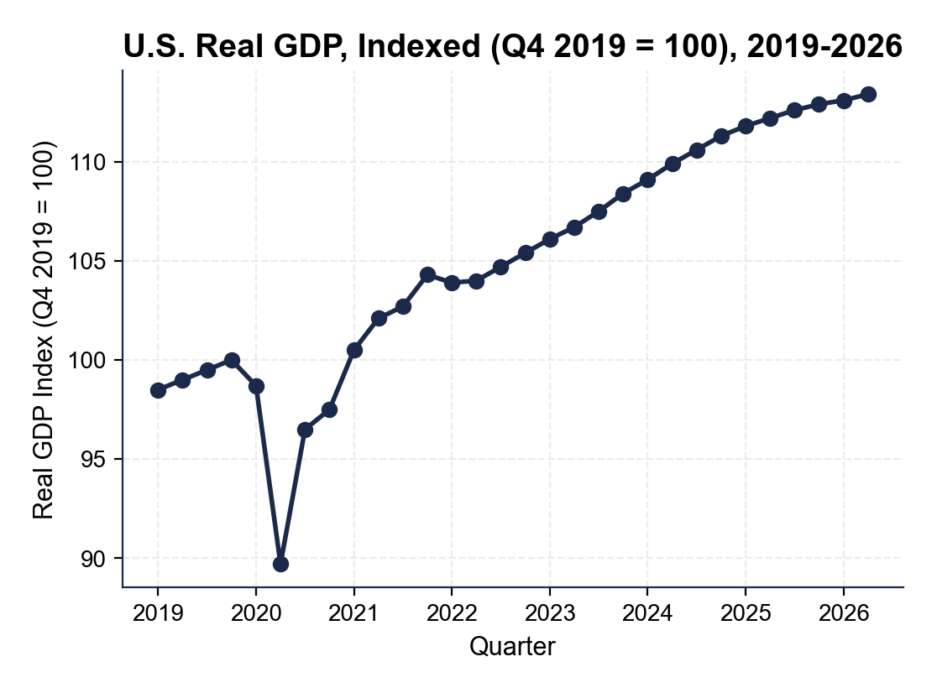

2. Use the same GDP chart.
About what is the index by 2026, and how does that compare to the pre-pandemic trend? In your CEA retrospective memo, why does this comparison matter for evaluating whether the stimulus was the right size?

3. Use the REMOTE WORK SHARE chart, inserted below and shown in the slide deck. Read the share off the y-axis at 2019, at 2020, and at 2024, then calculate the percentage-point step change from 2019 to 2024. (Chart: chart_remote_work_share)
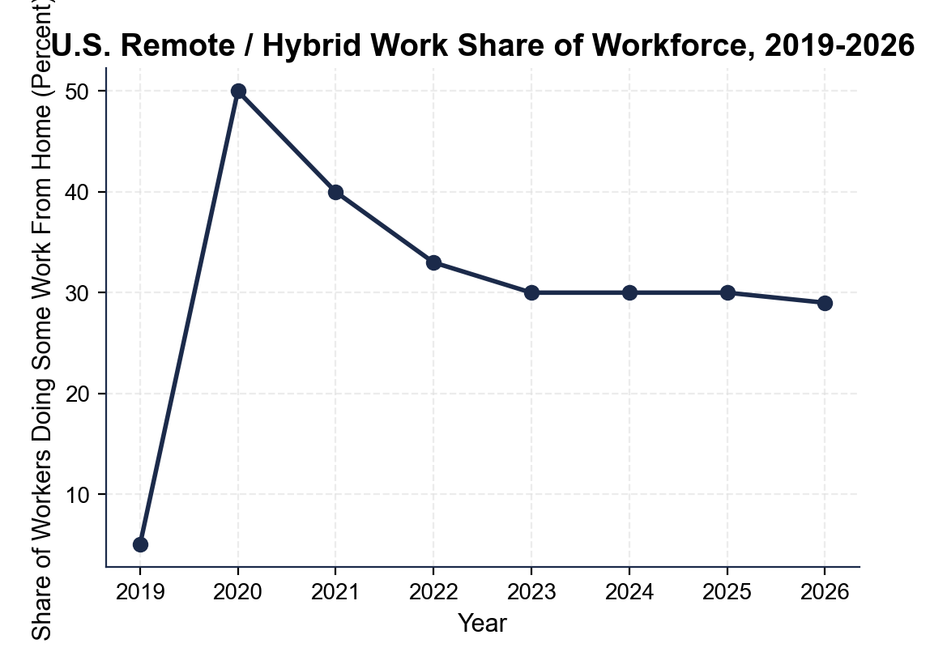

4. Using the same remote-work chart, calculate
(a) the PEAK-TO-SETTLED drop from the 2020 annual share to the 2024 settled share

(b) compare your 2019-to-2024 step-change result from the previous question (in about 5 years) to the 27 percentage-point rise in women's labor-force participation between 1948 and 2000 (52 years). What does this tell you about the speed of the COVID workforce shift?

5. Use the GLOBAL SUPPLY CHAIN PRESSURE INDEX (GSCPI) chart, inserted below and shown in the slide deck. Read the value off the y-axis at 2019, at the 2021 peak, and at 2023, then state in 2-3 sentences what the peak tells you about why CPI inflation hit 9.1% in June 2022. (Chart: chart_supply_chain_pressure)
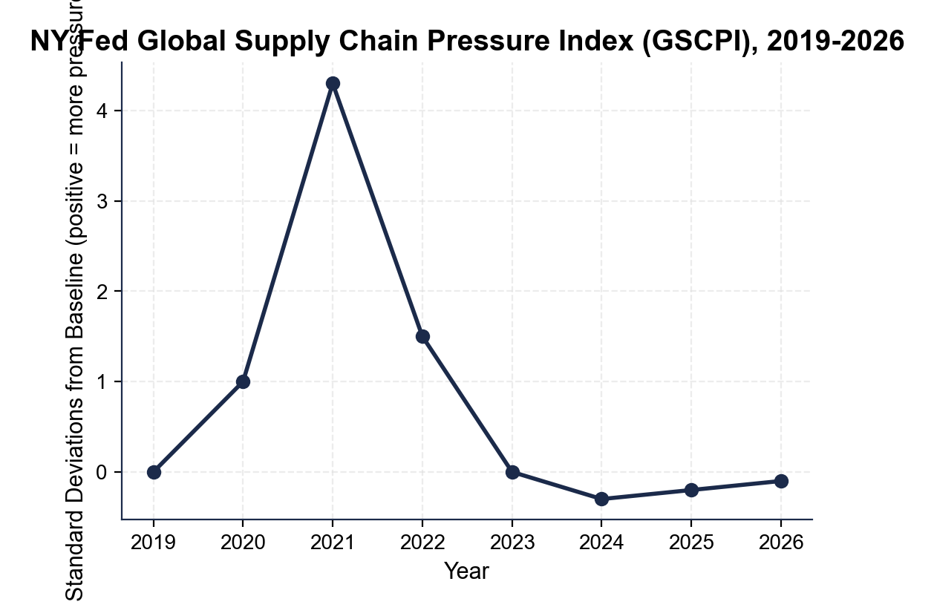

6. Now run the inflation and rate-hike math.
(a) Compute the PERCENTAGE-POINT INFLATION GAP between the June 2022 CPI peak (9.1%) and the Fed's 2% target.

(b) The Fed funds rate moved from 0-0.25% to 5.25-5.50% between March 2022 and July 2023 - calculate the percentage-point increase.

(c) Compare the two numbers in 1-2 sentences and state what they tell you about the Fed's response intensity.

PART 5

Retrospective Memo to the President
RETROSPECTIVE MEMO
1. RETROSPECTIVE MEMO. The President wants your written recommendation in two weeks. As Dr. Vasquez, write a 12-15 sentence memo (about 250-350 words) recommending EXACTLY TWO pandemic-era programs that should become PERMANENT and EXACTLY TWO that should SUNSET. Options for PERMANENT: expanded Child Tax Credit, CHIPS Act semiconductor subsidies, IRA climate provisions, Fed corporate-bond facility. Options for SUNSET: $1,400 stimulus checks, $600/week unemployment supplement, the fraud-prone PPP structure, the eviction moratorium. Use the memo header below and check off each required element as you include it.
YOUR RESPONSE MUST:
☐ TWO PERMANENT + TWO SUNSET - name EXACTLY two programs to keep permanent and EXACTLY two to sunset. Do not hedge.
☐ THREE LESSON NUMBERS - cite at least THREE specific facts or figures from the lesson or charts (for example: the about 9.1% Q2 2020 GDP collapse, the $5T+ total stimulus / about 25% of 2020 GDP, the 9.1% June 2022 CPI peak, the remote-work step change you found in Part 4, the supply-chain (GSCPI) peak you found in Part 4, the 525 basis points in 16 months, or the about 30% child-poverty cut from the expanded CTC).
☐ CROSS-CYCLE COMPARISON - make an EXPLICIT comparison to BOTH the 1929 New Deal (TK 99) AND the 2008 TARP (TK 91).
☐ ONE REALISTIC OBJECTION - acknowledge one credible objection an opponent would raise.
☐ ONE TRADE-OFF - state one trade-off you accept by choosing these four programs over the alternatives.
MEMO
To: The President of the United States
From: Dr. Elena Vasquez, Senior Economist, Council of Economic Advisers
Date:
Re: Which Pandemic-Era Policies to Keep Permanent vs Sunset

