ECONOMICS

PANDEMIC ECONOMICS: COVID'S LASTING IMPACT
ANSWER KEY ACTIVITY - ANSWER KEY

PART 1

Pandemic-Economics Reference Guide - Complete the Missing Terms

Term | Definition
Lockdown | Government-mandated stay-at-home orders that began in mid-March 2020; closed non-essential businesses, schools, and travel and triggered the sharpest quarterly GDP drop in modern records
COVID-19 recession | The two-quarter U.S. recession of Q1-Q2 2020; the sharpest single-quarter GDP contraction in modern records and the shortest NBER recession in history at just 2 months
Quantitative easing (QE) | Large-scale Federal Reserve purchases of Treasury and mortgage bonds; expanded the Fed balance sheet from $4.2 trillion to about $9 trillion between 2020 and 2022
CARES Act | The $2.2 trillion stimulus law signed in March 2020; included $1,200 checks, expanded unemployment, and Paycheck Protection Program (PPP) loans for small businesses
Remote work | Performing job duties from home rather than the employer location; it surged during the 2020 lockdowns and settled into a permanent hybrid pattern that reshaped offices and commercial real estate by 2024
American Rescue Plan (ARP) | The $1.9 trillion stimulus law signed in March 2021; included $1,400 checks and the expanded Child Tax Credit and took total pandemic stimulus over $5 trillion
CPI inflation | Year-over-year change in the Consumer Price Index; peaked at 9.1% in June 2022, the highest reading since 1981, and drove the Fed's rate-hike cycle
Federal funds rate | The interest rate banks charge each other for overnight lending; the Fed raised it from 0-0.25% to 5.25-5.50% between March 2022 and July 2023, the fastest hiking cycle in 40 years
Transitory inflation | The Federal Reserve's 2021 framing that the inflation surge would be temporary as supply chains normalized; the Fed dropped the term in November 2021 as prices kept rising
Inflation Reduction Act (IRA) | The $370 billion 2022 climate and clean-energy law; part of the post-pandemic reshoring push alongside the CHIPS Act, and also let Medicare negotiate drug prices

PART 2

Apply the Terms - Pandemic-Economics Vocabulary in Context
WORD BANK remote work · cpi inflation · quantitative easing · lockdown · transitory inflation
1. The government-mandated stay-at-home orders that began in mid-March 2020 and closed non-essential businesses, schools, and travel are a Lockdown.
Lockdown
2. The Federal Reserve large-scale bond purchases that expanded the Fed balance sheet from $4.2 trillion to about $9 trillion between 2020 and 2022 are Quantitative easing.
Quantitative easing
3. Performing job duties from home rather than the employer location, which became a permanent hybrid pattern after the 2020 lockdowns, is Remote work.
Remote work
4. The year-over-year change in the Consumer Price Index, which peaked at 9.1% in June 2022 - the highest since 1981 - is CPI inflation.
CPI inflation
5. The Fed's 2021 framing that the price surge would be temporary, a term it dropped in November 2021 as prices kept rising, is Transitory inflation.
Transitory inflation
PART 3

Explain the Cross-Cycle Story
1. As Dr. Vasquez, explain in 5-7 sentences why the COVID recession was the SHORTEST in NBER history (just 2 months) despite the LARGEST single-quarter GDP collapse on record. Identify at least THREE specific policy moves that drove the fast recovery, and cite at least ONE specific number from this lesson to defend your reasoning.
The COVID recession was unique - the depth was historic but the duration was the shortest in NBER history (2 months). Three policy moves drove the recovery: (1) FISCAL: total stimulus across the CARES Act ($2.2T, March 2020), the December 2020 deal ($900B), and the American Rescue Plan ($1.9T, March 2021) reached over $5 trillion - about 25% of one year of 2020 GDP. The 1929 (TK 99) New Deal was about 50% of one year of 1939 GDP spread over six years; the 2008 (TK 91) TARP was about 5% of 2008 GDP - so the COVID stimulus was the LARGEST as a share of GDP in U.S. history. (2) MONETARY: the Fed cut rates from 1.5% to 0-0.25% in two weeks (faster than 2008), launched unlimited QE that doubled the balance sheet from $4.2T to $9.0T, and bought corporate bonds for the first time ever - the 1929 lender-of-last-resort lesson (TK 76, TK 99) applied within weeks, not years. (3) VACCINE ROLLOUT: first doses December 2020, broad availability April 2021, which reopened the service economy and unleashed pent-up demand. Real GDP regained its pre-pandemic level by Q1 2021 (just 9 months from the trough) and unemployment fell from 14.7% (April 2020) to 3.9% by December 2021. Compare to 2008-2010: GDP took 4 years to recover. Acceptable answers identify any 3 of: $5T+ fiscal stimulus, Fed zero-rate + QE, vaccine rollout, the 2-week speed of the monetary response, and direct corporate-bond purchases.
2. As Dr. Vasquez, explain in 3-4 sentences which TWO Fed/Treasury moves you would tell the President SUCCEEDED and which TWO FAILED during the 2020-2024 cycle. Be specific about what was tried and what the result was.
TWO MOVES THAT SUCCEEDED: (1) The Fed's March 2020 zero-rate plus QE response combined with the Treasury's CARES Act produced the fastest recession-to-recovery cycle in U.S. history (GDP recovered in 9 months) - the 1929 lender-of-last-resort lesson (TK 76, TK 99) applied at unprecedented speed. (2) The Fed's 2022-2023 hiking cycle from 0-0.25% to 5.25-5.50% in 16 months brought CPI inflation down from 9.1% (June 2022) to about 2.5% by end-2024 WITHOUT triggering a recession - a SOFT LANDING that most economists predicted was impossible. TWO MOVES THAT FAILED: (1) The 'transitory inflation' framing in 2021 - the Fed insisted inflation would be temporary and dropped the term only in November 2021, when CPI was already above 6%, costing roughly 6 months of late hiking. (2) PPP fraud controls - of $800B in PPP loans, an estimated $200B+ was fraudulent or improper (DOJ 2024); the program kept workers on payroll but at a high efficiency cost. Accept reasonable variations identifying these or similar specific moves with concrete results.
3. As Dr. Vasquez, the President wants to know how the COVID stimulus compares to the two prior crisis responses. In 3-4 sentences, compare the 2020-2024 stimulus to the 1929 New Deal (TK 99) and the 2008 TARP (TK 91) as a SHARE OF GDP, and state which was largest and why that comparison matters.
AS A SHARE OF GDP PER YEAR, the COVID response was the LARGEST of the three. COVID: over $5 trillion in roughly 12-18 months = about 25% of one year of 2020 GDP. NEW DEAL (1929, TK 99): roughly 50% of one year of 1939 GDP but spread over six years - about 8% per year on average. TARP (2008, TK 91): about $700B authorized (about $427B disbursed) = roughly 5% of 2008 GDP. So per year, COVID (about 25%) was far larger than the New Deal (about 8%/year) or TARP (about 5%). WHY IT MATTERS: the unprecedented speed and scale are exactly why the NBER recession was only 2 months - the modern Fed and Treasury applied the 1929 and 2008 playbooks at the largest scale ever, but that same scale also fed the 2021-2022 inflation surge. Accept reasonable variations that correctly rank COVID largest per year and tie the scale to both the fast recovery and the inflation that followed.
PART 4

Read the Charts and Run the Numbers
1. Use the U.S. REAL GDP chart, inserted below and shown in the slide deck. Read the index value off the y-axis at Q4 2019, at Q2 2020 (the trough), and at Q1 2021, then calculate the percentage decline from Q4 2019 to Q2 2020. (Chart: chart_gdp_collapse_recovery)
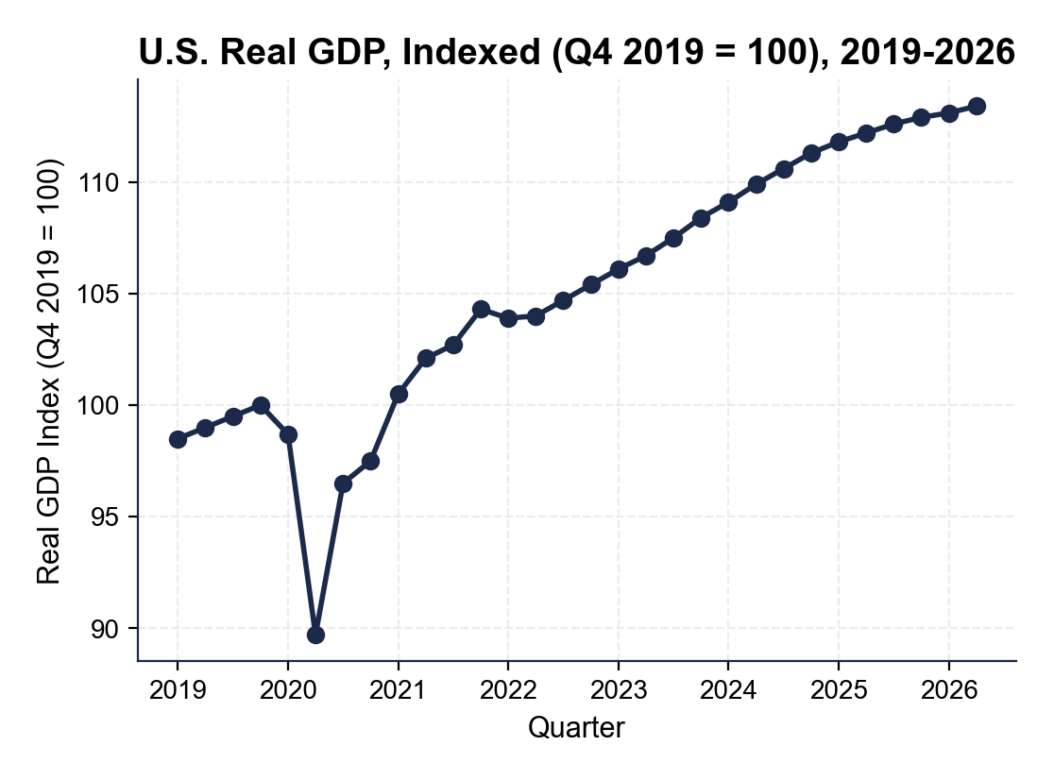
Q4 2019: index = 100.0 (the baseline). Q2 2020 TROUGH: index = about 89.7. Q1 2021 RECOVERY: index = about 100.5. PERCENTAGE DECLINE = (100.0 - 89.7) / 100.0 = 0.103 = about a 10.3% off-baseline drop (about 9.1% quarterly contraction by the standard Bureau of Economic Analysis statement). Accept readings of 89-91 for the Q2 2020 trough and 100-101 for the Q1 2021 recovery point. Both the trough and the full recovery happen within about 5 quarters - the fastest cycle in modern data.
2. Use the same GDP chart.
About what is the index by 2026, and how does that compare to the pre-pandemic trend? In your CEA retrospective memo, why does this comparison matter for evaluating whether the stimulus was the right size?
GDP index by 2026 = about 113. Compared to Q4 2019 = 100, U.S. real GDP is about 13% larger by 2026 than just before COVID. Pre-pandemic trend growth was about 2% per year, so a no-COVID counterfactual would project GDP near 113 by 2026 too (about 6 years x 2% = 12-13%). WHY THIS COMPARISON MATTERS: the economy in 2026 is at or slightly above the pre-pandemic trend line, meaning the $5T+ stimulus did NOT cause permanent above-trend growth, but it DID prevent a multi-year shortfall like 2008-2010 (where GDP stayed below trend for years). Accept readings of 112-114 for the 2026 index. The implication for the memo: the stimulus was roughly correctly sized - any smaller and the recovery would have been slower; any larger and inflation would have been even worse.
3. Use the REMOTE WORK SHARE chart, inserted below and shown in the slide deck. Read the share off the y-axis at 2019, at 2020, and at 2024, then calculate the percentage-point step change from 2019 to 2024. (Chart: chart_remote_work_share)
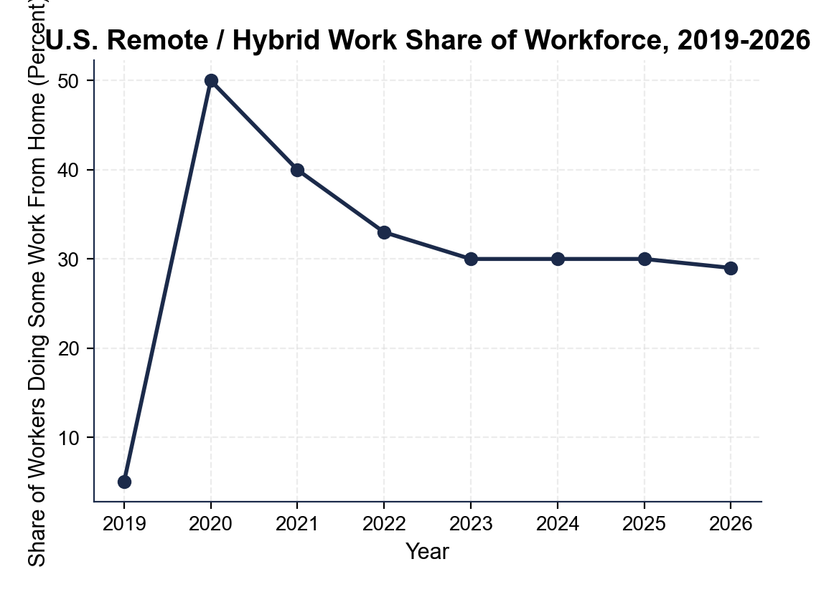
2019: about 5%. 2020: about 50% annual share (the quarterly peak was about 60% in April 2020). 2024: about 30% settled hybrid. STEP CHANGE = 30% - 5% = 25 PERCENTAGE POINTS. Accept readings of 4-6% for 2019, 45-55% for the 2020 annual share, and 28-32% for 2024. The 25 percentage-point step change is the largest workforce shift in any modern decade.
4. Using the same remote-work chart, calculate
(a) the PEAK-TO-SETTLED drop from the 2020 annual share to the 2024 settled share
PEAK-TO-SETTLED = 50% (2020 annual) - 30% (2024 settled) = 20 PERCENTAGE-POINT DROP as workers returned to offices.
(b) compare your 2019-to-2024 step-change result from the previous question (in about 5 years) to the 27 percentage-point rise in women's labor-force participation between 1948 and 2000 (52 years). What does this tell you about the speed of the COVID workforce shift?
The COVID step change = 25 percentage points in about 5 years = about 5 percentage points per year. Women's labor-force participation rose 27 percentage points (about 33% to 60%) over 52 years = about 0.5 percentage points per year. So the COVID remote-work shift was roughly 10x faster than the 20th-century gender shift. WHAT THIS TELLS US: the pandemic compressed a generation of workforce change into about 5 years. The implication for the memo: a structural shift this fast and this large will keep rippling through commercial real estate, urban tax bases, and labor markets - the policy response cannot assume the 2019 workforce will return.

5. Use the GLOBAL SUPPLY CHAIN PRESSURE INDEX (GSCPI) chart, inserted below and shown in the slide deck. Read the value off the y-axis at 2019, at the 2021 peak, and at 2023, then state in 2-3 sentences what the peak tells you about why CPI inflation hit 9.1% in June 2022. (Chart: chart_supply_chain_pressure)
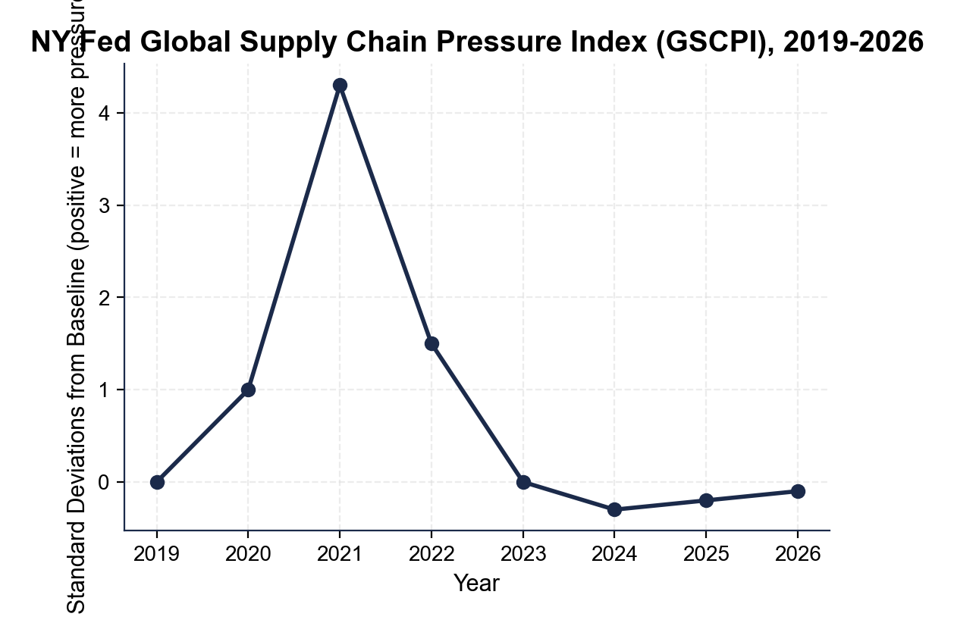
2019: about 0.0 (the index is standardized so the historical mean = 0). 2021 PEAK: about +4.3 standard deviations - the all-time high in the series. 2023: about 0.0 (back to baseline). Accept readings of -0.1 to +0.1 for 2019 and 2023 and 4.0-4.5 for the 2021 peak. WHAT THE PEAK TELLS US: the +4.3 peak is more than 4x any prior reading, so pandemic inflation was substantially SUPPLY-driven, not just demand-driven. When supply chains break this severely, prices rise even with normal demand - and demand was elevated by $5T+ in stimulus, so broken supply plus elevated demand produced the 9.1% CPI peak, the highest since 1981. (For comparison, 2008 supply chains stayed within about +/- 1 standard deviation.)
6. Now run the inflation and rate-hike math.
(a) Compute the PERCENTAGE-POINT INFLATION GAP between the June 2022 CPI peak (9.1%) and the Fed's 2% target.
INFLATION GAP = 9.1% - 2.0% = 7.1 PERCENTAGE POINTS above target at the peak.
(b) The Fed funds rate moved from 0-0.25% to 5.25-5.50% between March 2022 and July 2023 - calculate the percentage-point increase.
RATE INCREASE = 5.375% (midpoint of 5.25-5.50%) - 0.125% (midpoint of 0-0.25%) = 5.25 PERCENTAGE POINTS = 525 basis points in 16 months.
(c) Compare the two numbers in 1-2 sentences and state what they tell you about the Fed's response intensity.
The Fed raised the funds rate by 5.25 percentage points to attack a 7.1 percentage-point inflation overshoot - so rate hikes covered about 74% of the gap.
PART 5

Retrospective Memo to the President
RETROSPECTIVE MEMO
1. RETROSPECTIVE MEMO. The President wants your written recommendation in two weeks. As Dr. Vasquez, write a 12-15 sentence memo (about 250-350 words) recommending EXACTLY TWO pandemic-era programs that should become PERMANENT and EXACTLY TWO that should SUNSET. Options for PERMANENT: expanded Child Tax Credit, CHIPS Act semiconductor subsidies, IRA climate provisions, Fed corporate-bond facility. Options for SUNSET: $1,400 stimulus checks, $600/week unemployment supplement, the fraud-prone PPP structure, the eviction moratorium. Use the memo header below and check off each required element as you include it.
YOUR RESPONSE MUST:
☐ TWO PERMANENT + TWO SUNSET - name EXACTLY two programs to keep permanent and EXACTLY two to sunset. Do not hedge.
☐ THREE LESSON NUMBERS - cite at least THREE specific facts or figures from the lesson or charts (for example: the about 9.1% Q2 2020 GDP collapse, the $5T+ total stimulus / about 25% of 2020 GDP, the 9.1% June 2022 CPI peak, the remote-work step change you found in Part 4, the supply-chain (GSCPI) peak you found in Part 4, the 525 basis points in 16 months, or the about 30% child-poverty cut from the expanded CTC).
☐ CROSS-CYCLE COMPARISON - make an EXPLICIT comparison to BOTH the 1929 New Deal (TK 99) AND the 2008 TARP (TK 91).
☐ ONE REALISTIC OBJECTION - acknowledge one credible objection an opponent would raise.
☐ ONE TRADE-OFF - state one trade-off you accept by choosing these four programs over the alternatives.
MEMO
To: The President of the United States
From: Dr. Elena Vasquez, Senior Economist, Council of Economic Advisers
Date: [student completes]
Re: Which Pandemic-Era Policies to Keep Permanent vs Sunset
GRADING RUBRIC
Grade the evidence and reasoning, not the conclusion — any defensible position is valid. Score against the 5 requirements above.
FULL CREDIT — clear position; meets all 5 requirements with accurate, specific numbers and evidence from the lesson.
PARTIAL — position stated, but misses 1-2 requirements or uses vague / incorrect numbers.
MINIMAL — no clear position, or missing most requirements and numbers.

MORE LESSONS LESS PLANNING
Thank You!
If you enjoyed this product, please do not forget to rate and review to assist other teachers.

Looking for future discounts? Earn TPT credits by reviewing purchased products.

Please contact me if you have any issues with this product. Just like our students, I am always looking for opportunities to grow.

