Outsourcing: Jobs, Costs & Consequences
STUDENT ACTIVITY
Name: | Date: | Period:
ESSENTIAL QUESTION
Why has the U.S. outsourced work in four successive waves over four decades, what did each wave cost American workers, and how is the AI wave different from everything that came before?
THE SCENARIO
You are MARCUS BELL, a Labor Policy Analyst at the U.S. Department of Labor. A senator is preparing a major workforce-policy speech and has asked you for a fact-based briefing on the FOUR WAVES of U.S. outsourcing: Wave 1 (manufacturing offshored to Asia and Mexico, 1980s-2000s), Wave 2 (customer service offshored to India and the Philippines, 2000s), Wave 3 (software offshored to India and Eastern Europe, 2010s), and Wave 4 (AI-driven knowledge work, 2022-present).
BY THE END, YOU CAN:
✓ Define OUTSOURCING and trace its evolution through four waves - manufacturing, customer service, software, and AI-driven knowledge work
✓ Identify each wave's job impact on U.S. workers and explain the economic forces that drove jobs offshore
✓ Evaluate the AI-driven next wave of outsourcing and weigh consumer benefits against worker displacement
HOW IT WORKS (do Parts 1–5 in order)
Part 1 — Outsourcing Reference Guide - Complete the Missing Terms
Part 2 — Apply the Terms - Outsourcing Vocabulary in Context
Part 3 — Analyze the Four Waves - Manufacturing, Service, Software, AI
Part 4 — Read the Two Charts - Waves Over Time and Total Jobs by Wave
Part 5 — Marcus Bell's Policy Memo to the Senator
TIME about 45 minutes YOU’LL NEED the lesson slides and your Guided Notes.

PART 1

Outsourcing Reference Guide - Complete the Missing Terms
Fill in the missing term for each blank row — the definition is your clue. Your Guided Notes and the lesson slides have every term.

Term | Definition
___________ | When a company moves work it used to do in-house to outside workers or contractors, often in another country
Offshoring | A specific type of outsourcing where the work is moved to a different country such as China, India, or the Philippines
___________ | The economic driver of outsourcing: paying lower wages overseas for the same work
China shock | The economic disruption from 2001 to 2010 when U.S. manufacturing jobs accelerated their move to China after WTO accession
___________ | Business Process Outsourcing: the offshore industry that runs U.S. call centers and back-office work in India and the Philippines
Reshoring | Bringing previously offshored work back to the home country, also called onshoring
___________ | A task that follows clear rules and can be done step-by-step; routine tasks are easiest to outsource or automate
Non-routine task | A task requiring judgment, creativity, or in-person presence; non-routine work is hardest to outsource
___________ | When a worker loses their job because the work has been moved elsewhere or automated
Wage gap | The difference in pay between countries; a U.S. call-center worker earned about $35,000 a year while a Filipino worker earned about $5,000

PART 2

Apply the Terms - Outsourcing Vocabulary in Context
WORD BANK BPO · Labor arbitrage · Routine task · Outsourcing · Displacement
1. When a company moves work it used to do in-house out to outside workers or contractors - often in another country - that practice is called .

2. The single economic engine behind all four waves - paying lower wages overseas for the same work - is called .

3. The offshore industry that runs U.S. call centers and back-office work from India and the Philippines is known by the three-letter abbreviation .

4. A job that follows clear rules and can be done step-by-step - the kind easiest to send offshore or hand to AI - is a .

5. When a worker loses their job because the work has been moved elsewhere or automated, that worker has experienced .

PART 3

Analyze the Four Waves - Manufacturing, Service, Software, AI
1. As Marcus Bell, brief the senator on WAVE 1 (MANUFACTURING). In 3-4 sentences cover: roughly when it peaked, approximately how many TOTAL U.S. jobs the 2001-2010 China shock cost (manufacturing plus local-labor-market spillover), the 2001 policy event that accelerated it, and the U.S. region hit hardest. Use specific numbers and place names from the lesson.

2. As Marcus Bell, brief the senator on WAVE 2 (CUSTOMER SERVICE). In 3-4 sentences cover: roughly when it peaked, the two main destination countries, the U.S.-to-Philippines wage gap in ratio form, and the industry name for this offshored work. Name two specific U.S. companies that offshored customer service.

3. As Marcus Bell, brief the senator on WAVE 3 (SOFTWARE). In 3-4 sentences cover: roughly when it peaked, the Indian city that became the global center of U.S. software outsourcing, the U.S.-to-India software wage gap in ratio form, and the KEY DISTINCTION between what got offshored and what stayed in the U.S. Use specific dollar numbers.

4. As Marcus Bell, brief the senator on WAVE 4 (AI). In 4-5 sentences cover: the 2022 event that started it, the ONE feature that makes Wave 4 fundamentally different from Waves 1-3, the kinds of knowledge work AI is most likely to replace, and the Goldman Sachs (March 26, 2023) estimate of AI exposure (both the global number and the projected U.S. workforce percentage over 10 years).

PART 4

Read the Two Charts - Waves Over Time and Total Jobs by Wave
1. As Marcus Bell, use the FOUR-WAVES TIMELINE line chart (1980-2030), inserted below and shown in the slide deck, to read directly off the chart: approximately what YEAR did Wave 1 (manufacturing) peak, and approximately how many THOUSAND jobs per year were being displaced at that peak? Then name which wave is rising MOST STEEPLY from 2022 onward. (Chart: chart_outsourcing_waves_timeline)
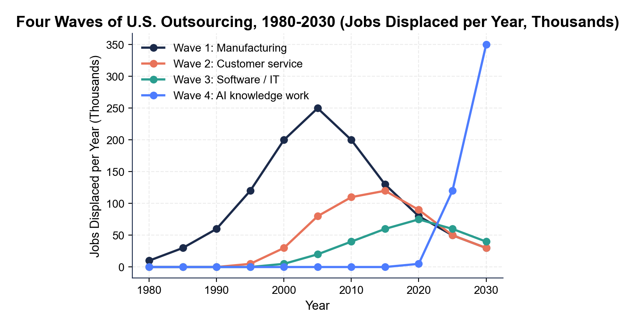

2. As Marcus Bell, use the same FOUR-WAVES TIMELINE chart to identify the approximate PEAK YEAR and the approximate PEAK per-year displacement for Wave 2 (customer service) and Wave 3 (software). Then in 2-3 sentences explain why the waves PEAK at different times instead of all hitting at once.

3. As Marcus Bell, use the JOBS-BY-WAVE BAR CHART, inserted below and shown in the slide deck, to read directly off the chart: how many MILLIONS of total U.S.
jobs were displaced by Wave 1, Wave 2, Wave 3, and Wave 4 (AI projected by 2030)? Then name the LARGEST historical wave and the LARGEST projected wave. (Chart: chart_jobs_outsourced_by_industry)
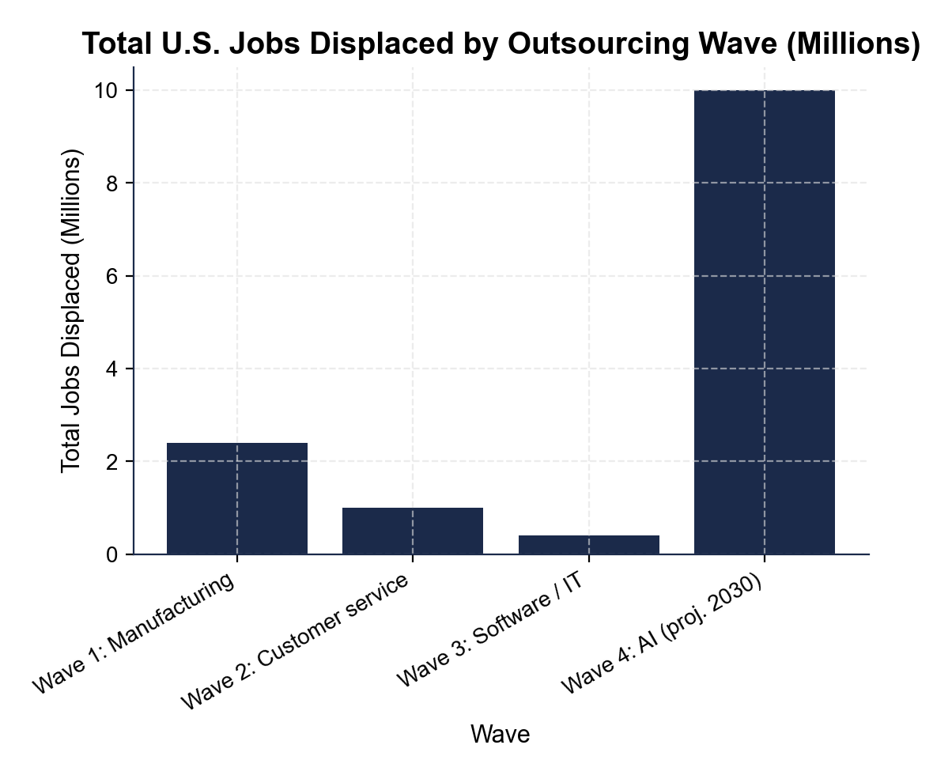

4. The senator's aide says: "AI is just the next wave of outsourcing - it will hit the same low-skill workers as Wave 1 did, and we can retrain them the way we tried to retrain manufacturing workers." As Marcus Bell, in 4-5 sentences explain why that claim is partly WRONG. Address:
(a) WHO Wave 4 actually hits

(b) whether U.S. retraining of displaced manufacturing workers actually succeeded

(c) what makes Wave 4 different from earlier waves in terms of the work itself.

PART 5

Marcus Bell's Policy Memo to the Senator
POLICY RECOMMENDATION MEMO
1. POLICY RECOMMENDATION MEMO. The senator is waiting for your written briefing. As Marcus Bell, write a 6-8 sentence memo (about 200-300 words) to the senator's office. Use the memo header below and check off each required element as you include it. (Sentence starters you can use: "Companies have offshored work for four decades because..." and "For the coming AI wave, I recommend...")
YOUR RESPONSE MUST:
☐ FRAME - one or two sentences explaining WHY companies have offshored work for four decades (the labor-arbitrage explanation).
☐ ONE WAGE-GAP PAIR - cite one specific pair of numbers showing a wage gap that drove offshoring (for example $35,000 vs $5,000 = 7-to-1 for Wave 2 Philippines, or $120,000 vs $15,000 = 8-to-1 for Wave 3 India).
☐ ONE CHART NUMBER - cite one specific number you recorded in Part 4: a jobs-per-year figure from the timeline chart, or a millions-of-jobs figure from the bar chart.
☐ THE TRADE-OFF - name WHO BENEFITS (consumers - roughly 330 million Americans - through cheaper goods and services) and WHO LOSES (displaced workers, often concentrated in specific regions or job categories).
☐ ONE CONCRETE POLICY RECOMMENDATION for displaced Wave 4 (AI) workers - something specific (AI-augmentation training subsidy, wage insurance, expanded unemployment insurance, an apprenticeship subsidy for non-routine trades), NOT a vague 'we should help workers.'
☐ FIVE VOCABULARY TERMS - use at least FIVE lesson terms (for example outsourcing, offshoring, labor arbitrage, BPO, China shock, displacement, routine vs non-routine task, reshoring, wage gap).
MEMO
To: Senator's Office
From: Marcus Bell, Labor Policy Analyst (U.S. Department of Labor)
Date:
Re: The Four Waves of U.S. Outsourcing and the Coming AI Wave

