ECONOMICS

OUTSOURCING: JOBS, COSTS & CONSEQUENCES
ANSWER KEY ACTIVITY

PART 1

Outsourcing Reference Guide - Complete the Missing Terms

Term | Definition
Outsourcing | When a company moves work it used to do in-house to outside workers or contractors, often in another country
Offshoring | A specific type of outsourcing where the work is moved to a different country such as China, India, or the Philippines
Labor arbitrage | The economic driver of outsourcing: paying lower wages overseas for the same work
China shock | The economic disruption from 2001 to 2010 when U.S. manufacturing jobs accelerated their move to China after WTO accession
BPO | Business Process Outsourcing: the offshore industry that runs U.S. call centers and back-office work in India and the Philippines
Reshoring | Bringing previously offshored work back to the home country, also called onshoring
Routine task | A task that follows clear rules and can be done step-by-step; routine tasks are easiest to outsource or automate
Non-routine task | A task requiring judgment, creativity, or in-person presence; non-routine work is hardest to outsource
Displacement | When a worker loses their job because the work has been moved elsewhere or automated
Wage gap | The difference in pay between countries; a U.S. call-center worker earned about $35,000 a year while a Filipino worker earned about $5,000

PART 2

Apply the Terms - Outsourcing Vocabulary in Context
WORD BANK BPO · Labor arbitrage · Routine task · Outsourcing · Displacement
1. When a company moves work it used to do in-house out to outside workers or contractors - often in another country - that practice is called Outsourcing.
Outsourcing
2. The single economic engine behind all four waves - paying lower wages overseas for the same work - is called Labor arbitrage.
Labor arbitrage
3. The offshore industry that runs U.S. call centers and back-office work from India and the Philippines is known by the three-letter abbreviation BPO.
BPO
4. A job that follows clear rules and can be done step-by-step - the kind easiest to send offshore or hand to AI - is a Routine task.
Routine task
5. When a worker loses their job because the work has been moved elsewhere or automated, that worker has experienced Displacement.
Displacement

PART 3

Analyze the Four Waves - Manufacturing, Service, Software, AI
1. As Marcus Bell, brief the senator on WAVE 1 (MANUFACTURING). In 3-4 sentences cover: roughly when it peaked, approximately how many TOTAL U.S. jobs the 2001-2010 China shock cost (manufacturing plus local-labor-market spillover), the 2001 policy event that accelerated it, and the U.S. region hit hardest. Use specific numbers and place names from the lesson.
PEAK: Wave 1 (manufacturing) peaked around 2005. TOTAL JOBS: the 2001-2010 CHINA SHOCK cost approximately 2.4 MILLION total U.S. jobs (manufacturing plus local-labor-market spillover, per Autor/Dorn/Hanson; manufacturing-only is closer to 1.0-1.5M). POLICY EVENT: China's 2001 accession to the WTO sharply lowered tariffs on Chinese goods and accelerated manufacturing offshoring. REGION: the RUST BELT - Cleveland, Detroit, Pittsburgh, Buffalo - was hit hardest, with wages falling 10-20% relative to the national average from 2000-2015. Many of those factory jobs never returned.
2. As Marcus Bell, brief the senator on WAVE 2 (CUSTOMER SERVICE). In 3-4 sentences cover: roughly when it peaked, the two main destination countries, the U.S.-to-Philippines wage gap in ratio form, and the industry name for this offshored work. Name two specific U.S. companies that offshored customer service.
PEAK: Wave 2 (customer service) peaked around 2015. DESTINATIONS: India and the Philippines. WAGE GAP: a U.S. call-center worker earned about $35,000/year while a Filipino worker earned about $5,000/year - a 7-TO-1 wage gap. INDUSTRY NAME: BPO (Business Process Outsourcing). COMPANIES: any two of Dell, AT&T, American Express, Citibank, or IBM. Estimated U.S. displacement from Wave 2 is 500,000-1.5 million (the lesson uses ~1.0 million as the midpoint).
3. As Marcus Bell, brief the senator on WAVE 3 (SOFTWARE). In 3-4 sentences cover: roughly when it peaked, the Indian city that became the global center of U.S. software outsourcing, the U.S.-to-India software wage gap in ratio form, and the KEY DISTINCTION between what got offshored and what stayed in the U.S. Use specific dollar numbers.
PEAK: Wave 3 (software) peaked around 2020. CITY: Bangalore (Bengaluru), now one of the world's largest tech hubs by headcount. WAGE GAP: a U.S. software engineer earned about $120,000/year versus about $15,000/year in India - an 8-TO-1 wage gap. KEY DISTINCTION: ROUTINE work moved offshore (boilerplate coding, QA testing, IT support, legacy maintenance) while NON-ROUTINE work stayed in the U.S. (senior architecture, product design, AI/ML research, on-site customer-facing work). That same routine-versus-non-routine split predicts what AI replaces in Wave 4. Estimated U.S. displacement from Wave 3 is 300,000-500,000.
4. As Marcus Bell, brief the senator on WAVE 4 (AI). In 4-5 sentences cover: the 2022 event that started it, the ONE feature that makes Wave 4 fundamentally different from Waves 1-3, the kinds of knowledge work AI is most likely to replace, and the Goldman Sachs (March 26, 2023) estimate of AI exposure (both the global number and the projected U.S. workforce percentage over 10 years).
START EVENT: the November 2022 launch of ChatGPT (followed by GitHub Copilot, Claude, and Midjourney). FUNDAMENTAL DIFFERENCE: Wave 4 is the FIRST wave that needs NO foreign country - AI eliminates the work entirely rather than moving it offshore, so there is nowhere for the job to come back from. MOST AT RISK: routine knowledge work - paralegal research, copywriting, customer-support chat, basic coding, marketing graphics, transcription, and basic translation. GOLDMAN SACHS ESTIMATE: the March 26, 2023 report projected about 300 MILLION jobs globally exposed to AI automation and up to 7% of the U.S. workforce displaced over 10 years (the lesson uses ~6-7% by 2030 as the derived figure). WHO IT HITS: unlike Waves 1-3, Wave 4 hits HIGH-skill knowledge workers as much as or more than low-skill workers.

PART 4

Read the Two Charts - Waves Over Time and Total Jobs by Wave
1. As Marcus Bell, use the FOUR-WAVES TIMELINE line chart (1980-2030), inserted below and shown in the slide deck, to read directly off the chart: approximately what YEAR did Wave 1 (manufacturing) peak, and approximately how many THOUSAND jobs per year were being displaced at that peak? Then name which wave is rising MOST STEEPLY from 2022 onward. (Chart: chart_outsourcing_waves_timeline)
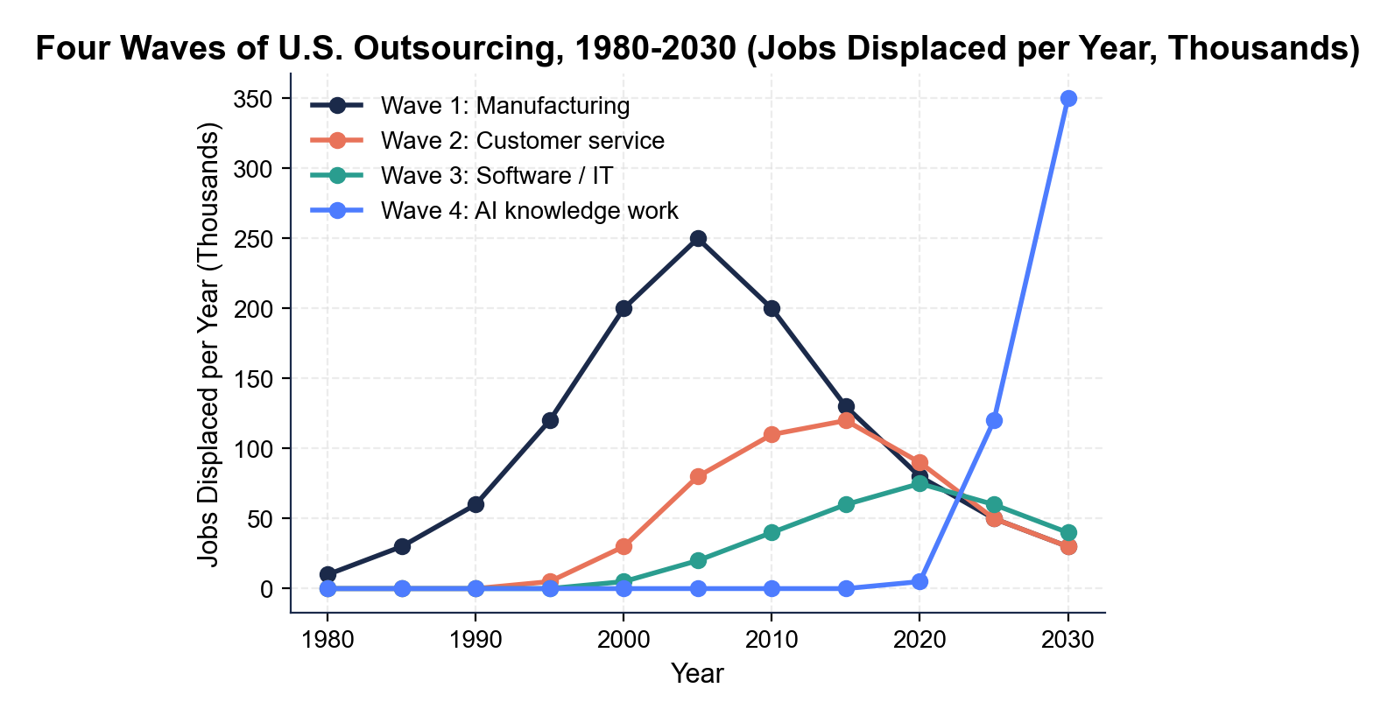
WAVE 1 PEAK: about 2005, at approximately 250 THOUSAND jobs per year (accept any year 2003-2007 and any value 200-275 thousand). STEEPEST FROM 2022: Wave 4 (AI) - the solid blue line rising sharply toward a projected ~350 thousand jobs per year by 2030, with no peak yet visible. TAKEAWAY: Wave 1 was the biggest historical per-year wave, but Wave 4 (AI) is on track to surpass it if the Goldman Sachs (March 26, 2023) projection holds.
2. As Marcus Bell, use the same FOUR-WAVES TIMELINE chart to identify the approximate PEAK YEAR and the approximate PEAK per-year displacement for Wave 2 (customer service) and Wave 3 (software). Then in 2-3 sentences explain why the waves PEAK at different times instead of all hitting at once.
WAVE 2 PEAK: about 2015 at ~120 thousand jobs per year (accept 2013-2017, 100-130 thousand). WAVE 3 PEAK: about 2020 at ~75-80 thousand jobs per year (accept 2020-2023, 70-90 thousand). WHY DIFFERENT TIMES: each wave depended on a different enabling technology maturing in a different decade - cheap shipping and containerization (Wave 1), reliable international voice and data lines (Wave 2), broadband and cloud collaboration tools (Wave 3), and large-scale generative AI after 2022 (Wave 4). Each new technology opened a new category of work to offshoring or automation, so the waves arrive about 10-15 years apart.
3. As Marcus Bell, use the JOBS-BY-WAVE BAR CHART, inserted below and shown in the slide deck, to read directly off the chart: how many MILLIONS of total U.S.
jobs were displaced by Wave 1, Wave 2, Wave 3, and Wave 4 (AI projected by 2030)? Then name the LARGEST historical wave and the LARGEST projected wave. (Chart: chart_jobs_outsourced_by_industry)
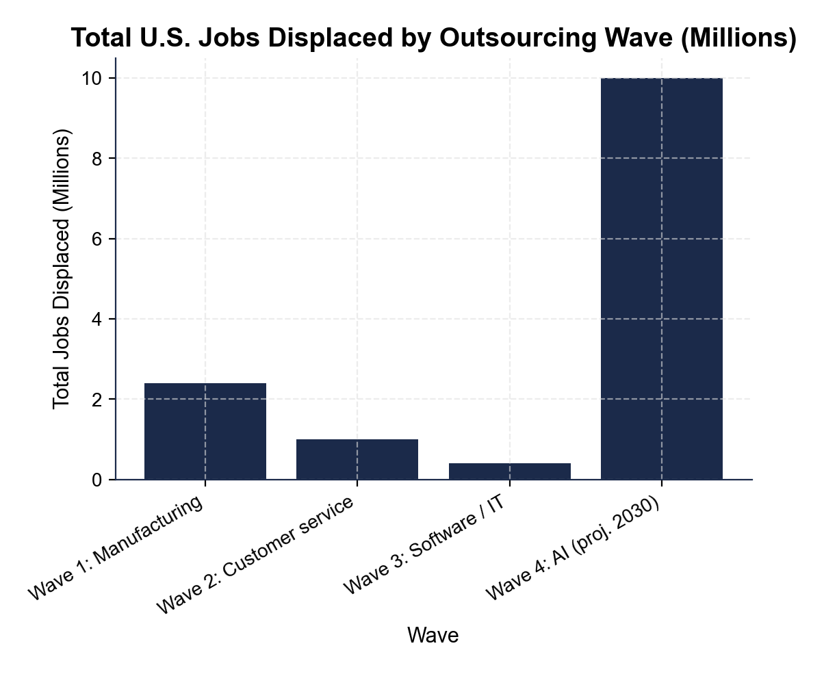
BAR READINGS: Wave 1 ~2.4 million total U.S. jobs (manufacturing plus local-labor-market spillover; Autor/Dorn/Hanson, 2001-2010); Wave 2 ~1.0 million; Wave 3 ~0.4 million; Wave 4 ~10 million projected by 2030 (a DERIVED projection from the Goldman Sachs March 26, 2023 report, NOT a direct Goldman quote). LARGEST HISTORICAL: Wave 1 (manufacturing) at ~2.4 million. LARGEST PROJECTED: Wave 4 (AI) at ~10 million. Accept readings within 10% of each bar value.
4. The senator's aide says: "AI is just the next wave of outsourcing - it will hit the same low-skill workers as Wave 1 did, and we can retrain them the way we tried to retrain manufacturing workers." As Marcus Bell, in 4-5 sentences explain why that claim is partly WRONG. Address:
(a) WHO Wave 4 actually hits
(b) whether U.S. retraining of displaced manufacturing workers actually succeeded
(c) what makes Wave 4 different from earlier waves in terms of the work itself.
WHO IT HITS: Wave 4 (AI) hits HIGH-skill knowledge workers as much as or more than low-skill workers - paralegals, copywriters, junior developers, marketing designers - the opposite of Wave 1's blue-collar manufacturing losses. RETRAINING RECORD: POOR, not successful - Autor's research found China-shock-displaced workers often never recovered comparable pay (many took lower-paid service jobs, went on disability, or left the workforce), Rust Belt wages fell 10-20% relative to the national average from 2000-2015, and Trade Adjustment Assistance reached only a fraction of them. WHAT'S DIFFERENT: in Wave 4 the work DISAPPEARS entirely - there is no foreign country it moved to and could later move back from - so 'retrain them for what?' is the unanswered question. A strong answer notes that retraining alone has historically underperformed and that Wave 4 may need additional tools such as wage insurance or AI-augmentation training.

PART 5

Marcus Bell's Policy Memo to the Senator
POLICY RECOMMENDATION MEMO
1. POLICY RECOMMENDATION MEMO. The senator is waiting for your written briefing. As Marcus Bell, write a 6-8 sentence memo (about 200-300 words) to the senator's office. Use the memo header below and check off each required element as you include it. (Sentence starters you can use: "Companies have offshored work for four decades because..." and "For the coming AI wave, I recommend...")
YOUR RESPONSE MUST:
☐ FRAME - one or two sentences explaining WHY companies have offshored work for four decades (the labor-arbitrage explanation).
☐ ONE WAGE-GAP PAIR - cite one specific pair of numbers showing a wage gap that drove offshoring (for example $35,000 vs $5,000 = 7-to-1 for Wave 2 Philippines, or $120,000 vs $15,000 = 8-to-1 for Wave 3 India).
☐ ONE CHART NUMBER - cite one specific number you recorded in Part 4: a jobs-per-year figure from the timeline chart, or a millions-of-jobs figure from the bar chart.
☐ THE TRADE-OFF - name WHO BENEFITS (consumers - roughly 330 million Americans - through cheaper goods and services) and WHO LOSES (displaced workers, often concentrated in specific regions or job categories).
☐ ONE CONCRETE POLICY RECOMMENDATION for displaced Wave 4 (AI) workers - something specific (AI-augmentation training subsidy, wage insurance, expanded unemployment insurance, an apprenticeship subsidy for non-routine trades), NOT a vague 'we should help workers.'
☐ FIVE VOCABULARY TERMS - use at least FIVE lesson terms (for example outsourcing, offshoring, labor arbitrage, BPO, China shock, displacement, routine vs non-routine task, reshoring, wage gap).
MEMO
To: Senator's Office
From: Marcus Bell, Labor Policy Analyst (U.S. Department of Labor)
Date: [student completes]
Re: The Four Waves of U.S. Outsourcing and the Coming AI Wave
GRADING RUBRIC
Grade the evidence and reasoning, not the conclusion — any defensible position is valid. Score against the 6 requirements above.
FULL CREDIT — clear position; meets all 6 requirements with accurate, specific numbers and evidence from the lesson.
PARTIAL — position stated, but misses 1-2 requirements or uses vague / incorrect numbers.
MINIMAL — no clear position, or missing most requirements and numbers.
WHAT TO LOOK FOR IN THIS LESSON
Sample full-credit memo:
To: Senator's Office
From: Marcus Bell, Labor Policy Analyst (U.S. Department of Labor)
Date: [today's date - leave bracketed]
Re: The Four Waves of U.S. Outsourcing and the Coming AI Wave
[1] FRAME: Companies have OFFSHORED work for four decades for one reason - LABOR ARBITRAGE, paying lower wages overseas for the same work. [2] WAGE-GAP PAIR: in Wave 2 the U.S.-to-Philippines call-center wage gap was about 7-to-1 - roughly $35,000/year for a U.S. worker versus $5,000/year offshore - so a firm moving 1,000 seats to Manila saved about $30 million a year. [3] CHART NUMBER: the jobs-by-wave bar chart shows the 2001-2010 CHINA SHOCK cost about 2.4 MILLION total U.S. jobs, while Wave 4 (AI) is projected at about 10 million by 2030. [4] TRADE-OFF: the gains are diffuse - roughly 330 million American consumers pay less (a flat-screen TV fell from $5,000 in 2000 to about $300 in 2024) - while the costs are concentrated on displaced workers, especially Rust Belt manufacturing communities. [5] POLICY RECOMMENDATION: for the AI wave I recommend an AI-AUGMENTATION TRAINING SUBSIDY paired with WAGE INSURANCE - workers who learn to use AI tools tend to out-earn workers who fight them, and wage insurance covers part of the pay drop for 2-3 years during the transition, which ordinary retraining (built for Wave 1) cannot do because the work itself disappears. [6] This is the unique challenge of Wave 4: unlike earlier waves there is no foreign country and no reshoring path, so DISPLACEMENT is permanent unless policy adapts.
REQUIRED-ELEMENT CHECKLIST (award credit per item):
[1] FRAME names labor arbitrage as the four-decade driver.
[2] ONE specific wage-gap pair ($35K vs $5K = 7-to-1, or $120K vs $15K = 8-to-1).
[3] ONE specific chart number (2.4M, 10M, ~250K/year peak ~2005, etc.).
[4] TRADE-OFF names consumers (benefit) and displaced workers (lose).
[5] ONE concrete policy recommendation (not 'help workers').
[6] at least FIVE lesson vocabulary terms used correctly.
Accept any defensible recommendation as long as it is specific and the wage-gap pair plus chart number are present.
MORE LESSONS LESS PLANNING
Thank You!
If you enjoyed this product, please do not forget to rate and review to assist other teachers.

Looking for future discounts? Earn TPT credits by reviewing purchased products.

Please contact me if you have any issues with this product. Just like our students, I am always looking for opportunities to grow.

