Oligopoly: When a Few Dominate
STUDENT ACTIVITY
Name: | Date: | Period:
ESSENTIAL QUESTION
When only three companies control the market, how do they keep prices high without ever picking up the phone?
THE SCENARIO
You are a high school senior selected for a 4-week summer internship at the Federal Trade Commission (FTC) Bureau of Competition. DR. MARCUS CHEN, a senior antitrust economist at the FTC, has been assigned to mentor you through how the agency evaluates whether the U.S. WIRELESS CARRIER market - dominated by Verizon, AT&T, and T-Mobile, which together serve roughly 96% of U.S. subscribers - is an oligopoly engaging in TACIT COLLUSION that warrants further investigation.
BY THE END, YOU CAN:
✓ Define OLIGOPOLY using its four defining features (few sellers, high barriers to entry, interdependent firms, differentiated or homogeneous products) and contrast it with both Perfect Competition (TK 21) and Monopoly (TK 22) using the four-firm concentration ratio
✓ Apply game theory to oligopoly pricing - read a prisoner's dilemma payoff matrix to find the Nash equilibrium, distinguish COLLUSION from TACIT COLLUSION, and explain why interdependent firms have a structural incentive to coordinate prices
✓ Read a KINKED DEMAND CURVE - explain why oligopoly prices are sticky (rivals do not match raises but DO match cuts), identify real-world examples (airlines, wireless, soft drinks), and evaluate when antitrust action is appropriate
HOW IT WORKS (do Parts 1–5 in order)
Part 1 — Oligopoly Reference Guide - Complete the Missing Terms
Part 2 — Apply the Terms - Oligopoly Vocabulary in Context
Part 3 — You Read the Three Oligopoly Charts with Dr. Marcus Chen
Part 4 — Four Real-Market Scenarios with Dr. Marcus Chen - Apply the Model
Part 5 — Your Final Policy Recommendation Memo to Dr. Chen
TIME about 45 minutes YOU’LL NEED the lesson slides and your Guided Notes.

PART 1

Oligopoly Reference Guide - Complete the Missing Terms
Fill in the missing term for each blank row — the definition is your clue. Your Guided Notes and the lesson slides have every term.

Term | Definition
___________ | A market structure dominated by a SMALL NUMBER of large firms (typically 4-10) where each firm's pricing and output decisions depend on what rivals will do; high barriers to entry; firms are interdependent
Interdependence | The defining feature of oligopoly: each firm's profit depends not just on its own choice but on what RIVAL firms choose; firms must constantly guess rival behavior, which is why game theory applies
___________ | The percent of total industry sales held by the FOUR LARGEST firms; CR4 > 40% suggests oligopoly tendencies, CR4 > 60% strongly suggests oligopoly, CR4 > 90% is near-monopoly
Collusion | When rival firms COORDINATE prices or output to act like a single monopoly; ILLEGAL when done explicitly under U.S. antitrust law (Sherman Act); the temptation is built into oligopoly's interdependence
___________ | When firms coordinate prices or output WITHOUT explicit communication - using price signals, public announcements, and price leadership; legally harder to prosecute than overt collusion but produces the same anticompetitive outcome
Cartel | A FORMAL agreement among rival firms to coordinate prices, output, or market shares - illegal in the U.S. (Sherman Act 1890) but legal in some international forums like OPEC's oil quotas
___________ | A model showing why oligopoly prices are STICKY: if a firm raises price, rivals do not follow and demand drops sharply; if a firm cuts price, rivals match and the price cut wins few new customers; the result is a kink at the current price and a strong incentive to leave price unchanged
Game theory | The branch of economics analyzing strategic decisions where one player's best move depends on what other players choose; the PRISONER'S DILEMMA payoff matrix is the standard tool for analyzing oligopoly pricing
___________ | A form of tacit collusion where ONE firm (the price leader) publicly announces a price change and rivals follow within days; common in airlines, wireless carriers, and steel; mimics cartel coordination without explicit communication
Nash equilibrium | An outcome in a strategic game where NO player can improve their payoff by changing their move unilaterally - given what the other players are doing; in the prisoner's dilemma, mutual defection (compete/compete) is the Nash equilibrium even though both firms prefer mutual cooperation

PART 2

Apply the Terms - Oligopoly Vocabulary in Context
WORD BANK cartel · game theory · tacit collusion · kinked demand · interdependence
1. Dr. Chen asks you to name the feature that separates oligopoly from every other market structure. Each oligopoly firm must constantly watch and guess what its rivals will do, because its own profit depends on their choices - this defining feature is called .

2. The carriers raise prices within days of each other but never sign a contract or send an email about it. Coordinating prices WITHOUT explicit communication, using price signals and price leadership, is called .

3. Dr. Chen sketches a demand line with a sharp bend at the current price: rivals match your price cuts but ignore your price raises, so moving price in either direction hurts. This model that explains sticky oligopoly prices is the curve.

4. To analyze whether the carriers should compete or coordinate, Dr. Chen uses a prisoner-dilemma payoff matrix. The branch of economics that studies strategic decisions where one player's best move depends on what other players choose is .

5. Unlike tacit coordination, a FORMAL agreement among rival firms to fix prices or output - illegal in the United States but legal for some international groups like OPEC - is called a .

PART 3

You Read the Three Oligopoly Charts with Dr. Marcus Chen
1. Use Chart Reference 1 (chart_cr4_industries) - the four-firm concentration ratio bar chart shown below - to map U.S. industries onto the oligopoly spectrum.
(a) For EACH of the six industries on the chart, state the CR4 value.

(b) Identify which industries CROSS the 60% oligopoly threshold.

(c) Rank the six industries from MOST concentrated to LEAST concentrated.

(d) In 1-2 sentences, explain why a HIGH CR4 makes tacit collusion easier than a low CR4.

2. Use Chart Reference 2 (chart_prisoners_dilemma) - the two-firm pricing payoff matrix shown below - to read the strategic logic of oligopoly.
(a) State the profit each carrier earns in BOTH COOPERATE.

(b) State the profit each carrier earns in BOTH COMPETE.

(c) State what happens when ONE CARRIER COMPETES ALONE (give both the winner's profit and the loser's profit).

(d) Identify the NASH EQUILIBRIUM - the outcome where neither firm can improve by changing strategy alone.

(e) In 1-2 sentences, explain why each firm INDIVIDUALLY wants to compete even though both would be BETTER OFF cooperating - and what this implies for tacit collusion in oligopolies.

3. Use Chart Reference 3 (chart_kinked_demand) - the kinked demand curve diagram shown below - to quantify why oligopoly prices stay sticky.
(a) Identify the KINK COORDINATES (the current price and quantity at the bend in the line).

(b) If the firm RAISES price from $50 to $54, state the new quantity demanded and the change in units (gain or loss).

(c) If the firm CUTS price from $50 to $35, state the new quantity demanded and the change in units (gain or loss).

(d) Identify which side of the kink is ELASTIC (rivals do NOT match) and which side is INELASTIC (rivals MATCH).

(e) In 1-2 sentences, explain why the asymmetric rival response makes oligopoly prices STICKY at the kink.

PART 4

Four Real-Market Scenarios with Dr. Marcus Chen - Apply the Model
1. RATE FOUR REAL OLIGOPOLIES ON THE FOUR FEATURES. For each industry below, rate it 0-10 on each feature, classify it as DIFFERENTIATED or HOMOGENEOUS, and justify your call. Ratings are judgment calls - any well-reasoned answer is valid; use the oligopoly model, not memorization.
Industry | Few Sellers | Barriers | Interdep. | Different. | Type
U.S. Wireless Carriers
Justification:
U.S. Commercial Airlines
Justification:
U.S. Soft Drink Market
Justification:
U.S. Athletic Footwear
Justification:

2. A NEW MERGER WOULD CREATE A TIGHTER OLIGOPOLY. Suppose T-MOBILE proposes acquiring DISH NETWORK (currently the 4th-largest wireless carrier with about 4% market share). Apply the oligopoly model:
(a) What would happen to the CR4 of the U.S. wireless market?

(b) Which oligopoly feature would STRENGTHEN as a result?

(c) Predict what would happen to oligopoly pricing power (consumer prices) - increase, decrease, or stay the same.

(d) In 1-2 sentences, recommend whether the DOJ Antitrust Division should APPROVE or BLOCK this merger - and explain why.

3. PRICE LEADERSHIP IN THE WIRELESS MARKET. Dr. Chen shows you a 2024 example: Verizon raised the price of its most popular unlimited plan from $80 to $90/month on March 15. AT&T raised its comparable plan from $80 to $90/month on March 28. T-Mobile raised its comparable plan from $75 to $85/month on April 5.
(a) Identify the PRICE LEADER.

(b) Identify the FOLLOWER firms.

(c) Is this pattern OVERT COLLUSION, TACIT COLLUSION, or just coincidence? Defend your answer with one specific piece of evidence.

(d) In 1-2 sentences, explain why this pattern is DIFFICULT to prosecute under antitrust law even if it produces the same consumer harm as an illegal cartel.

4. INVESTIGATE OR DECLINE? Two different FTC responses to suspected oligopoly behavior: (a) OPEN A FORMAL INVESTIGATION (Section 6(b) FTC Act market study; subpoenas; multi-year inquiry); (b) MONITOR but not investigate (passive observation; merger review only as deals come up). For EACH of these four scenarios, recommend which FTC response fits BEST AND give a one-sentence reason: (i) the U.S. wireless carrier market (price-leadership pattern from P4-Q3); (ii) the U.S. coffee shop market (CR4 around 25% - Starbucks dominant but many independents); (iii) the U.S. commercial airline market (CR4 around 80%, fare-test pattern documented); (iv) the U.S. residential broadband market (CR4 around 70%, often a regional duopoly per zip code).

PART 5

Your Final Policy Recommendation Memo to Dr. Chen
POLICY RECOMMENDATION MEMO
1. Dr. Chen closes out your internship and asks for your formal recommendation, written as a 6-8 sentence memo to her and using the four required terms (oligopoly, interdependence, tacit collusion, and kinked demand curve) at least once each. Based on everything you have learned, should the FTC Bureau of Competition OPEN A FORMAL INVESTIGATION of the U.S. wireless carrier market, MONITOR but not investigate, or DECLINE to investigate?
YOUR RESPONSE MUST:
☐ Names a SPECIFIC RECOMMENDATION (OPEN INVESTIGATION / MONITOR / DECLINE) AND ties it to the OLIGOPOLY model.
☐ Uses the term INTERDEPENDENCE correctly - acknowledges that wireless carriers must watch each other and their pricing decisions are not independent.
☐ Uses the phrase TACIT COLLUSION correctly - references the price-leadership pattern (Verizon leads, AT&T and T-Mobile follow within weeks) as evidence consistent with tacit collusion even without an explicit agreement.
☐ Uses the term KINKED DEMAND CURVE correctly - references that oligopoly prices are sticky and explains why this benefits firms at consumer expense.
☐ Quotes at least ONE specific value from the chart appendix (e.g., CR4 = 96% for wireless, $20B Both-Cooperate vs $10B Both-Compete Nash equilibrium, kink at Q=100/P=$50, 40-unit loss from $50 to $54 raise, 10-unit gain from $50 to $35 cut) to ground the recommendation in real data.
☐ Closes with a SPECIFIC NEXT STEP the FTC should take in the next 6 months (e.g., open a Section 6(b) market study; subpoena pricing communications from the three carriers; convene a public workshop on wireless market structure; coordinate with the DOJ on a joint review).
MEMO
To: Dr. Marcus Chen, Senior Antitrust Economist, FTC Bureau of Competition
From:
Date:
Re: Recommendation on U.S. wireless carrier market investigation

CHART REFERENCE 1: U.S. FOUR-FIRM CONCENTRATION RATIO ACROSS INDUSTRIES
Use Chart Reference 1 (chart_cr4_industries) - the four-firm concentration ratio bar chart shown below.
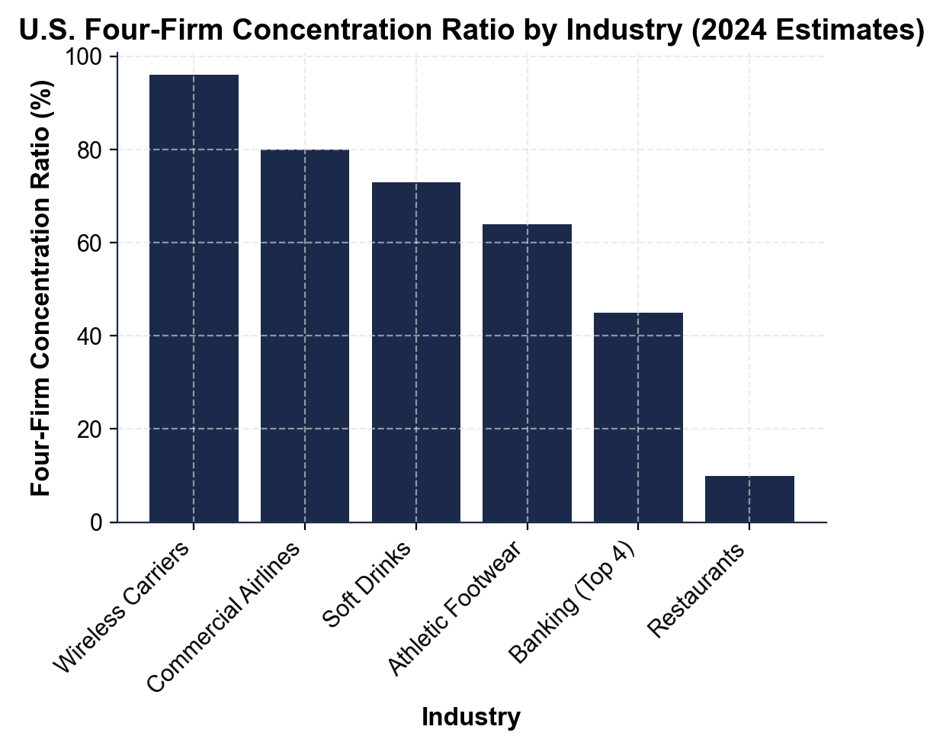
CHART REFERENCE 2: THE PRISONER'S DILEMMA - TWO-FIRM PRICING PAYOFF MATRIX
Use Chart Reference 2 (chart_prisoners_dilemma) - the two-firm pricing payoff matrix shown below.
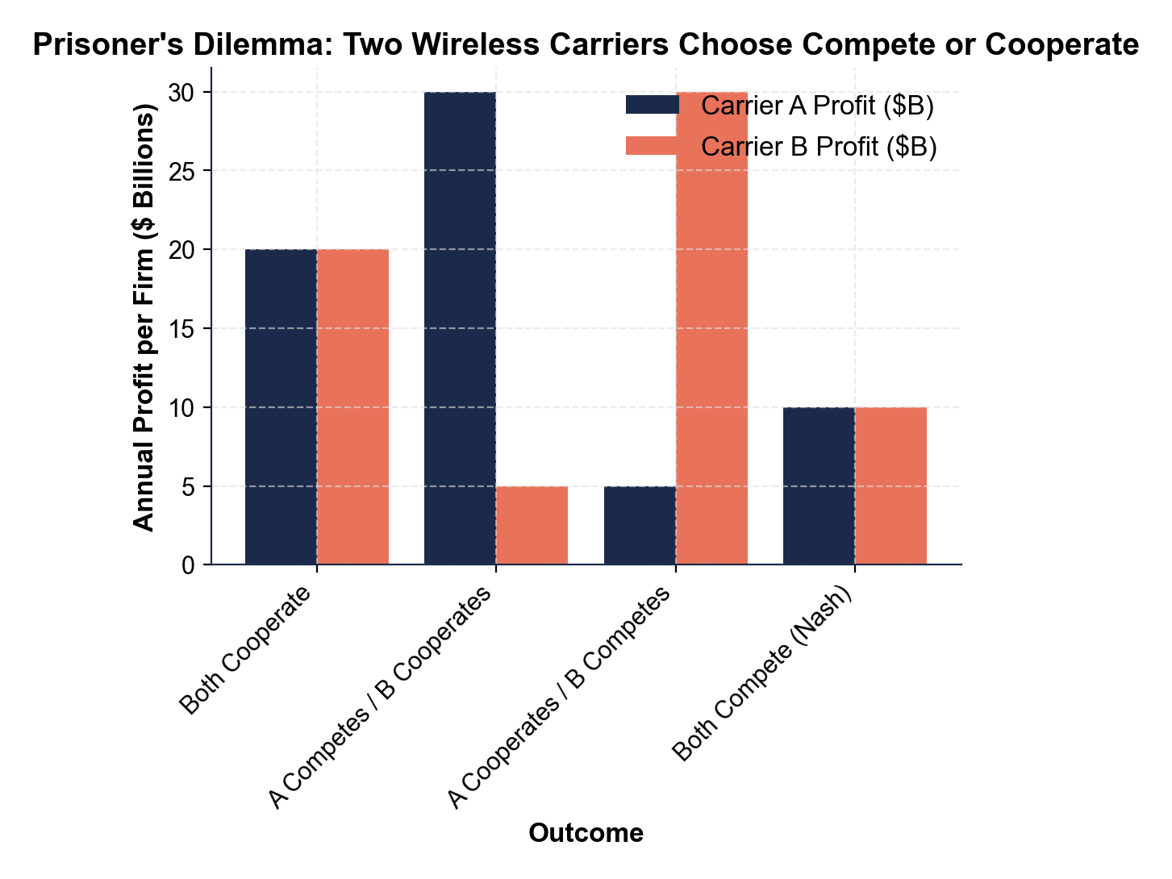
CHART REFERENCE 3: THE KINKED DEMAND CURVE - WHY OLIGOPOLY PRICES ARE STICKY
Use Chart Reference 3 (chart_kinked_demand) - the kinked demand curve diagram shown below.
