ECONOMICS

OLIGOPOLY: WHEN A FEW DOMINATE
ANSWER KEY ACTIVITY - ANSWER KEY

PART 1

Oligopoly Reference Guide - Complete the Missing Terms

Term | Definition
Oligopoly | A market structure dominated by a SMALL NUMBER of large firms (typically 4-10) where each firm's pricing and output decisions depend on what rivals will do; high barriers to entry; firms are interdependent
Interdependence | The defining feature of oligopoly: each firm's profit depends not just on its own choice but on what RIVAL firms choose; firms must constantly guess rival behavior, which is why game theory applies
Four-firm concentration ratio | The percent of total industry sales held by the FOUR LARGEST firms; CR4 > 40% suggests oligopoly tendencies, CR4 > 60% strongly suggests oligopoly, CR4 > 90% is near-monopoly
Collusion | When rival firms COORDINATE prices or output to act like a single monopoly; ILLEGAL when done explicitly under U.S. antitrust law (Sherman Act); the temptation is built into oligopoly's interdependence
Tacit collusion | When firms coordinate prices or output WITHOUT explicit communication - using price signals, public announcements, and price leadership; legally harder to prosecute than overt collusion but produces the same anticompetitive outcome
Cartel | A FORMAL agreement among rival firms to coordinate prices, output, or market shares - illegal in the U.S. (Sherman Act 1890) but legal in some international forums like OPEC's oil quotas
Kinked demand curve | A model showing why oligopoly prices are STICKY: if a firm raises price, rivals do not follow and demand drops sharply; if a firm cuts price, rivals match and the price cut wins few new customers; the result is a kink at the current price and a strong incentive to leave price unchanged
Game theory | The branch of economics analyzing strategic decisions where one player's best move depends on what other players choose; the PRISONER'S DILEMMA payoff matrix is the standard tool for analyzing oligopoly pricing
Price leadership | A form of tacit collusion where ONE firm (the price leader) publicly announces a price change and rivals follow within days; common in airlines, wireless carriers, and steel; mimics cartel coordination without explicit communication
Nash equilibrium | An outcome in a strategic game where NO player can improve their payoff by changing their move unilaterally - given what the other players are doing; in the prisoner's dilemma, mutual defection (compete/compete) is the Nash equilibrium even though both firms prefer mutual cooperation

PART 2

Apply the Terms - Oligopoly Vocabulary in Context
WORD BANK cartel · game theory · tacit collusion · kinked demand · interdependence
1. Dr. Chen asks you to name the feature that separates oligopoly from every other market structure. Each oligopoly firm must constantly watch and guess what its rivals will do, because its own profit depends on their choices - this defining feature is called interdependence.
interdependence. Each oligopoly firm depends on what rivals choose, which is why game theory applies to oligopoly and not to perfect competition or monopoly.
2. The carriers raise prices within days of each other but never sign a contract or send an email about it. Coordinating prices WITHOUT explicit communication, using price signals and price leadership, is called tacit collusion.
tacit collusion
3. Dr. Chen sketches a demand line with a sharp bend at the current price: rivals match your price cuts but ignore your price raises, so moving price in either direction hurts. This model that explains sticky oligopoly prices is the kinked demand curve.
kinked demand
4. To analyze whether the carriers should compete or coordinate, Dr. Chen uses a prisoner-dilemma payoff matrix. The branch of economics that studies strategic decisions where one player's best move depends on what other players choose is game theory.
game theory
5. Unlike tacit coordination, a FORMAL agreement among rival firms to fix prices or output - illegal in the United States but legal for some international groups like OPEC - is called a cartel.
cartel. A formal agreement among rivals to coordinate prices or output; illegal under the Sherman Act of 1890 but legal in some international forums.
PART 3

You Read the Three Oligopoly Charts with Dr. Marcus Chen
1. Use Chart Reference 1 (chart_cr4_industries) - the four-firm concentration ratio bar chart shown below - to map U.S. industries onto the oligopoly spectrum.
(a) For EACH of the six industries on the chart, state the CR4 value.
CR4 VALUES: Wireless Carriers 96%, Commercial Airlines 80%, Soft Drinks 73%, Athletic Footwear 64%, Banking 45%, Restaurants 10%.
(b) Identify which industries CROSS the 60% oligopoly threshold.
FOUR industries cross the 60% oligopoly threshold: wireless carriers (96%), airlines (80%), soft drinks (73%), and athletic footwear (64%). Banking sits just below at 45% (moderate concentration).
(c) Rank the six industries from MOST concentrated to LEAST concentrated.
RANK from most to least concentrated: Wireless (96) > Airlines (80) > Soft Drinks (73) > Athletic Footwear (64) > Banking (45) > Restaurants (10).
(d) In 1-2 sentences, explain why a HIGH CR4 makes tacit collusion easier than a low CR4.
A high CR4 means FEW firms control most of the market - so each firm only needs to watch 2-3 rivals to coordinate. With few rivals, parallel pricing emerges naturally and is hard to distinguish from coincidence; tacit collusion becomes the default equilibrium.
2. Use Chart Reference 2 (chart_prisoners_dilemma) - the two-firm pricing payoff matrix shown below - to read the strategic logic of oligopoly.
(a) State the profit each carrier earns in BOTH COOPERATE.
BOTH COOPERATE: each carrier earns $20B per year (leftmost pair of bars).
(b) State the profit each carrier earns in BOTH COMPETE.
BOTH COMPETE: each carrier earns $10B per year (rightmost pair of bars - the Nash equilibrium).
(c) State what happens when ONE CARRIER COMPETES ALONE (give both the winner's profit and the loser's profit).
ONE CARRIER COMPETES ALONE: the COMPETING carrier earns $30B (stealing market share); the COOPERATING carrier earns $5B (losing customers).
(d) Identify the NASH EQUILIBRIUM - the outcome where neither firm can improve by changing strategy alone.
The NASH EQUILIBRIUM is BOTH COMPETE at $10B each. Neither carrier can improve by switching unilaterally: if Carrier A switches from compete to cooperate while B keeps competing, A drops from $10B to $5B (worse).
(e) In 1-2 sentences, explain why each firm INDIVIDUALLY wants to compete even though both would be BETTER OFF cooperating - and what this implies for tacit collusion in oligopolies.
Each firm INDIVIDUALLY prefers to compete because compete is the DOMINANT STRATEGY: if the rival cooperates, competing yields $30B vs $20B (compete wins); if the rival competes, competing yields $10B vs $5B (compete still wins). So each firm individually chooses compete. But the combined outcome (both compete, $10B each) is WORSE for both than mutual cooperation ($20B each). This structural fact is exactly why oligopolies have a strong incentive to TACITLY COLLUDE - to escape the Nash equilibrium and reach the joint-better outcome without an illegal explicit agreement.

3. Use Chart Reference 3 (chart_kinked_demand) - the kinked demand curve diagram shown below - to quantify why oligopoly prices stay sticky.
(a) Identify the KINK COORDINATES (the current price and quantity at the bend in the line).
KINK COORDINATES: Q=100, P=$50. The bend in the demand line sits at quantity 100 and price $50.
(b) If the firm RAISES price from $50 to $54, state the new quantity demanded and the change in units (gain or loss).
RAISE PRICE TO $54: quantity drops from 100 to 60. The firm LOSES 40 units.
(c) If the firm CUTS price from $50 to $35, state the new quantity demanded and the change in units (gain or loss).
CUT PRICE TO $35: quantity rises from 100 to 110. The firm GAINS only 10 units.
(d) Identify which side of the kink is ELASTIC (rivals do NOT match) and which side is INELASTIC (rivals MATCH).
ABOVE the kink (price > $50) is ELASTIC - rivals do NOT match price raises. BELOW the kink (price < $50) is INELASTIC - rivals DO match price cuts.
(e) In 1-2 sentences, explain why the asymmetric rival response makes oligopoly prices STICKY at the kink.
Profit drops whether the firm moves price UP (lose many customers fast - elastic) or DOWN (gain few customers, lower per-unit revenue - inelastic). Since both directions hurt, the firm's BEST move is to LEAVE PRICE UNCHANGED at the kink - which is why oligopoly prices stay sticky for months at a time across…
PART 4

Four Real-Market Scenarios with Dr. Marcus Chen - Apply the Model
1. RATE FOUR REAL OLIGOPOLIES ON THE FOUR FEATURES. For each industry below, rate it 0-10 on each feature, classify it as DIFFERENTIATED or HOMOGENEOUS, and justify your call. Ratings are judgment calls - any well-reasoned answer is valid; use the oligopoly model, not memorization.
Industry | Few Sellers | Barriers | Interdep. | Different. | Type
U.S. Wireless Carriers | 10/10 | 10/10 | 10/10 | 7/10 | Differentiated*
Justification: *Differentiated at the brand layer; 5G is functionally near-homogeneous. CR4 ~96%; prices move within days.
U.S. Commercial Airlines | 9/10 | 9/10 | 9/10 | 5/10 | Homogeneous
Justification: CR4 ~80%; basic coach is largely identical; fare-test / fare-matching pattern.
U.S. Soft Drink Market | 8/10 | 10/10 | 7/10 | 9/10 | Differentiated
Justification: CR4 ~73%; strong brand + taste differentiation; Coke and Pepsi watch each other.
U.S. Athletic Footwear | 7/10 | 8/10 | 6/10 | 9/10 | Differentiated
Justification: CR4 ~64%; style + technology + endorsements differentiate; Nike and Adidas lead.

2. A NEW MERGER WOULD CREATE A TIGHTER OLIGOPOLY. Suppose T-MOBILE proposes acquiring DISH NETWORK (currently the 4th-largest wireless carrier with about 4% market share). Apply the oligopoly model:
(a) What would happen to the CR4 of the U.S. wireless market?
CR4 would barely change in arithmetic terms because the top 4 firms (Verizon, AT&T, T-Mobile, Dish) currently total around 96% - acquiring Dish does not raise the four-firm number much.
(b) Which oligopoly feature would STRENGTHEN as a result?
FEW SELLERS strengthens (from a token 4 to a real 3) AND INTERDEPENDENCE strengthens (3 firms can coordinate more easily than 4 - the 'rule of 3' in antitrust analysis).
(c) Predict what would happen to oligopoly pricing power (consumer prices) - increase, decrease, or stay the same.
PRICES would likely RISE. The original T-Mobile/Sprint merger (2020) was conditioned precisely on Dish growing into a 4th competitor - if Dish disappears, the 3-firm Nash equilibrium becomes more stable and prices drift toward the Both-Cooperate corner (good for firms, bad for consumers).
(d) In 1-2 sentences, recommend whether the DOJ Antitrust Division should APPROVE or BLOCK this merger - and explain why.
RECOMMEND BLOCKING. The DOJ would almost certainly challenge this merger because it removes the competitive constraint that justified approving T-Mobile/Sprint in 2020.
3. PRICE LEADERSHIP IN THE WIRELESS MARKET. Dr. Chen shows you a 2024 example: Verizon raised the price of its most popular unlimited plan from $80 to $90/month on March 15. AT&T raised its comparable plan from $80 to $90/month on March 28. T-Mobile raised its comparable plan from $75 to $85/month on April 5.
(a) Identify the PRICE LEADER.
PRICE LEADER: VERIZON - it raised first (March 15).
(b) Identify the FOLLOWER firms.
FOLLOWERS: AT&T (March 28, 13 days later) and T-Mobile (April 5, 21 days later).
(c) Is this pattern OVERT COLLUSION, TACIT COLLUSION, or just coincidence? Defend your answer with one specific piece of evidence.
Most likely TACIT COLLUSION - not coincidence and not overt collusion. EVIDENCE: the timing pattern (within 3 weeks, all three firms raising prices by the same $10 amount) is too consistent to be random; but there is no documented agreement, email, or meeting connecting the three decisions.
(d) In 1-2 sentences, explain why this pattern is DIFFICULT to prosecute under antitrust law even if it produces the same consumer harm as an illegal cartel.
Tacit collusion is hard to prosecute under Section 1 of the Sherman Act because that statute requires proving an AGREEMENT - which requires evidence of communication or a documented contract.
4. INVESTIGATE OR DECLINE? Two different FTC responses to suspected oligopoly behavior: (a) OPEN A FORMAL INVESTIGATION (Section 6(b) FTC Act market study; subpoenas; multi-year inquiry); (b) MONITOR but not investigate (passive observation; merger review only as deals come up). For EACH of these four scenarios, recommend which FTC response fits BEST AND give a one-sentence reason: (i) the U.S. wireless carrier market (price-leadership pattern from P4-Q3); (ii) the U.S. coffee shop market (CR4 around 25% - Starbucks dominant but many independents); (iii) the U.S. commercial airline market (CR4 around 80%, fare-test pattern documented); (iv) the U.S. residential broadband market (CR4 around 70%, often a regional duopoly per zip code).
(Accept any defensible policy match with sound reasoning.) (i) WIRELESS CARRIERS: OPEN A FORMAL INVESTIGATION. The CR4 is 96%, the price-leadership pattern is documented (P4-Q3 evidence), and the consumer impact is large (160M+ U.S. wireless subscribers). The 3-firm structure is exactly the case where tacit collusion is most likely. The investigation might reveal evidence sufficient for Section 5 enforcement or, at minimum, would inform future merger review. (ii) U.S. COFFEE SHOPS: MONITOR. CR4 is only ~25% (Starbucks plus a few chains, against thousands of independents). This is NOT an oligopoly. Formal investigation would waste FTC resources. (iii) COMMERCIAL AIRLINES: OPEN A FORMAL INVESTIGATION (or continue active scrutiny). CR4=80%, the fare-test pattern is documented, the basic coach product is largely homogeneous, and the consumer impact (450M+ U.S. air trips per year) is huge. The DOJ's 2024 challenge of JetBlue/Spirit shows that this market is already under active scrutiny. (iv) RESIDENTIAL BROADBAND: OPEN A FORMAL INVESTIGATION (with state-level coordination). CR4 = 70% nationally but most U.S. zip codes have only 1-2 broadband providers - effective DUOPOLY at the household level. Local price-fixing risk is high. FCC and state public service commissions historically share regulatory authority here.
PART 5

Your Final Policy Recommendation Memo to Dr. Chen
POLICY RECOMMENDATION MEMO
1. Dr. Chen closes out your internship and asks for your formal recommendation, written as a 6-8 sentence memo to her and using the four required terms (oligopoly, interdependence, tacit collusion, and kinked demand curve) at least once each. Based on everything you have learned, should the FTC Bureau of Competition OPEN A FORMAL INVESTIGATION of the U.S. wireless carrier market, MONITOR but not investigate, or DECLINE to investigate?
YOUR RESPONSE MUST:
☐ Names a SPECIFIC RECOMMENDATION (OPEN INVESTIGATION / MONITOR / DECLINE) AND ties it to the OLIGOPOLY model.
☐ Uses the term INTERDEPENDENCE correctly - acknowledges that wireless carriers must watch each other and their pricing decisions are not independent.
☐ Uses the phrase TACIT COLLUSION correctly - references the price-leadership pattern (Verizon leads, AT&T and T-Mobile follow within weeks) as evidence consistent with tacit collusion even without an explicit agreement.
☐ Uses the term KINKED DEMAND CURVE correctly - references that oligopoly prices are sticky and explains why this benefits firms at consumer expense.
☐ Quotes at least ONE specific value from the chart appendix (e.g., CR4 = 96% for wireless, $20B Both-Cooperate vs $10B Both-Compete Nash equilibrium, kink at Q=100/P=$50, 40-unit loss from $50 to $54 raise, 10-unit gain from $50 to $35 cut) to ground the recommendation in real data.
☐ Closes with a SPECIFIC NEXT STEP the FTC should take in the next 6 months (e.g., open a Section 6(b) market study; subpoena pricing communications from the three carriers; convene a public workshop on wireless market structure; coordinate with the DOJ on a joint review).
MEMO
To: Dr. Marcus Chen, Senior Antitrust Economist, FTC Bureau of Competition
From: [student completes]
Date: [student completes]
Re: Recommendation on U.S. wireless carrier market investigation
GRADING RUBRIC
Grade the evidence and reasoning, not the conclusion — any defensible position is valid. Score against the 6 requirements above.
FULL CREDIT — clear position; meets all 6 requirements with accurate, specific numbers and evidence from the lesson.
PARTIAL — position stated, but misses 1-2 requirements or uses vague / incorrect numbers.
MINIMAL — no clear position, or missing most requirements and numbers.
CHART REFERENCE 1: U.S. FOUR-FIRM CONCENTRATION RATIO ACROSS INDUSTRIES
Use Chart Reference 1 (chart_cr4_industries) - the four-firm concentration ratio bar chart shown below.
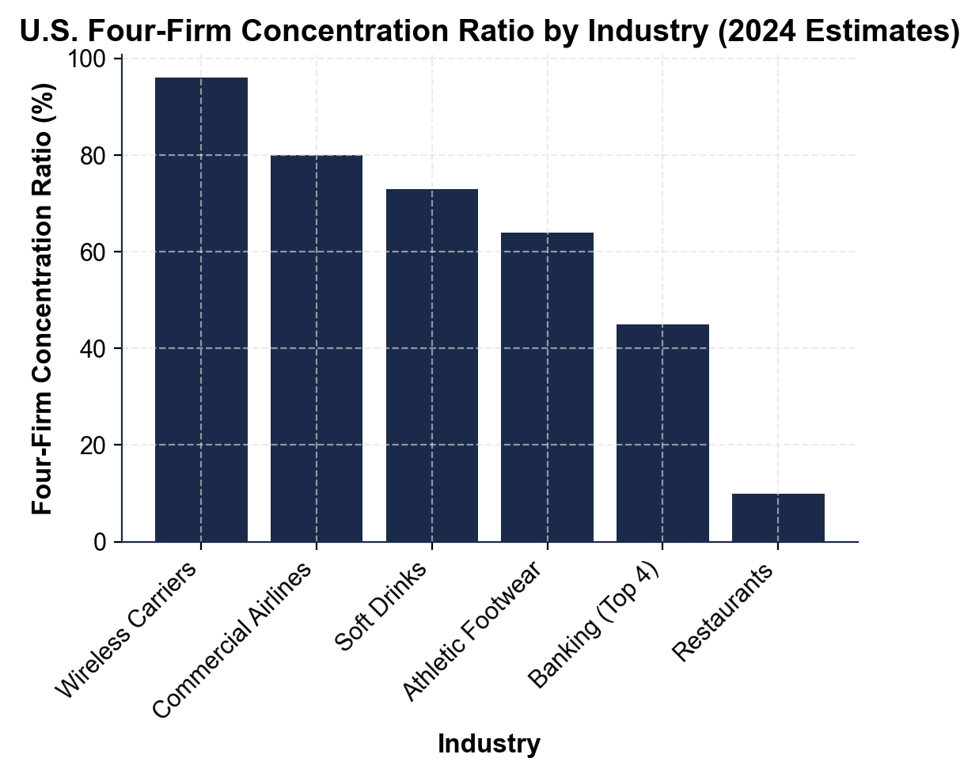
CHART REFERENCE 2: THE PRISONER'S DILEMMA - TWO-FIRM PRICING PAYOFF MATRIX
Use Chart Reference 2 (chart_prisoners_dilemma) - the two-firm pricing payoff matrix shown below.
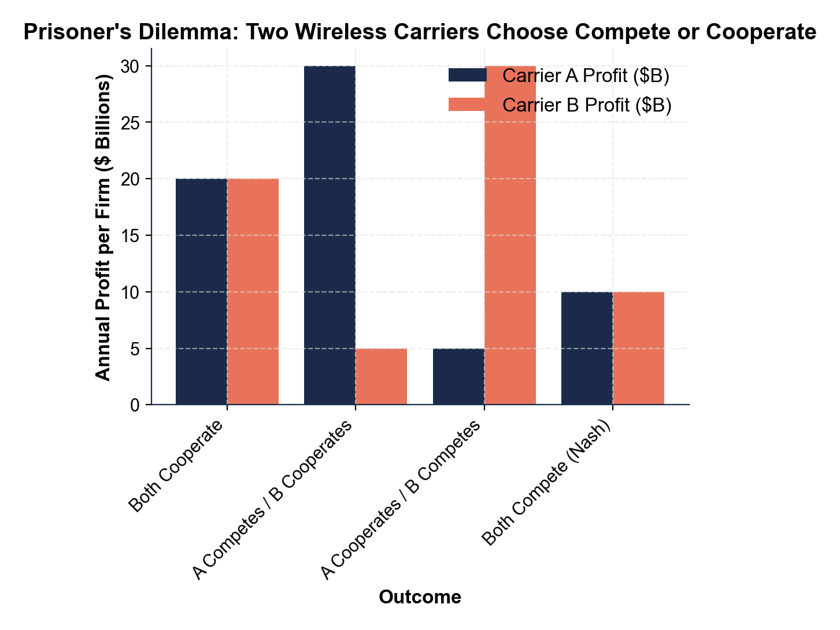
CHART REFERENCE 3: THE KINKED DEMAND CURVE - WHY OLIGOPOLY PRICES ARE STICKY
Use Chart Reference 3 (chart_kinked_demand) - the kinked demand curve diagram shown below.
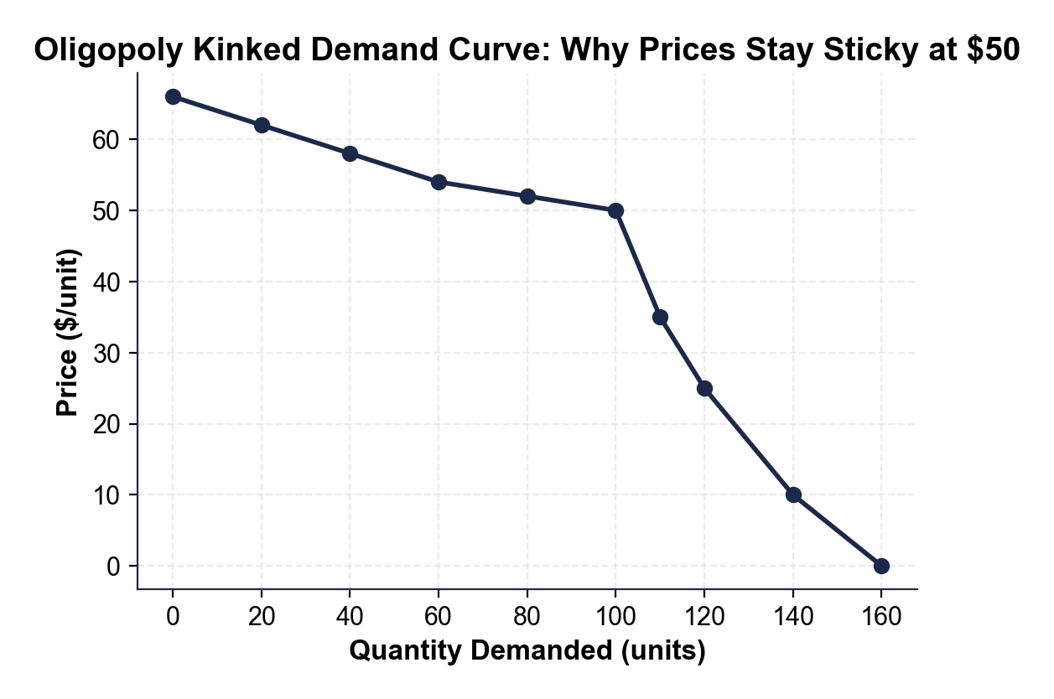

MORE LESSONS LESS PLANNING
Thank You!
If you enjoyed this product, please do not forget to rate and review to assist other teachers.

Looking for future discounts? Earn TPT credits by reviewing purchased products.

Please contact me if you have any issues with this product. Just like our students, I am always looking for opportunities to grow.

