Negotiating Big Purchases: Getting a Better Deal
STUDENT ACTIVITY
Name: | Date: | Period:
ESSENTIAL QUESTION
How do you get a better deal on a big purchase - why is the sticker price only a starting point, how do you use research and a walk-away price to negotiate, how do you calculate your savings and percent off with the labeled models, and how do you read a chart of average savings by category to know where negotiating pays off most?
THE SCENARIO
You are ROSA DELGADO, a negotiation coach who helps first-time buyers get a better deal on big purchases. TYLER BROOKS is buying his first used car.
BY THE END, YOU CAN:
✓ Explain why the sticker price is a starting point and what makes a big purchase negotiable
✓ Calculate the savings on a negotiated purchase using the labeled savings model
✓ Turn savings into a percent off using the labeled percent-off model
✓ Set a walk-away price and use research, timing, and a bar chart of average savings to judge a deal
HOW IT WORKS (do Parts 1–5 in order)
Part 1 — Negotiation Reference Guide - Complete the Missing Terms
Part 2 — Apply the Terms - Negotiation Vocabulary in Context
Part 3 — Calculate the Savings, Percent Off, and Walk-Away Decision - Use the Labeled Models
Part 4 — Read the Chart - Average Savings by Big-Purchase Category
Part 5 — Did the Client Get a Good Deal - Run and Score a New Negotiation
TIME about 45 minutes YOU’LL NEED the lesson slides and your Guided Notes.

PART 1

Negotiation Reference Guide - Complete the Missing Terms
Fill in the missing term for each blank row — the definition is your clue. Your Guided Notes and the lesson slides have every term.

Term | Definition
___________ | Working out a lower price by talking, offering, and countering with a seller
Sticker price | The seller's first asking price, before any negotiation
___________ | The final price you and the seller agree on after negotiating
Savings | How much you cut off the price: the sticker price minus the negotiated price
___________ | The highest price you are willing to pay before you walk away from the deal
Research | Finding out what a fair price is before you negotiate so you know your target
___________ | Your savings as a share of the sticker price: savings divided by the sticker price
Target price | The price you aim for going in, based on your research, a bit below fair market
___________ | Choosing when to buy (end of month, model-year clearance, holidays) to get a better deal
Counteroffer | A new price you offer back after the seller names a price

PART 2

Apply the Terms - Negotiation Vocabulary in Context
WORD BANK walk-away · negotiated price · timing · percent off · negotiation
1. Q1. Working out a lower price by talking, offering, and countering with a seller is called .

2. Q2. The final price you and the seller agree on after negotiating is called the .

3. Q3. The highest price you are willing to pay before you walk away from a deal is called your price (two words joined by a hyphen).

4. Q4. Your savings as a share of the sticker price, found by dividing savings by the sticker price, is called the .

5. Q5. Choosing when to buy - end of month, model-year clearance, or a holiday sale - to get a better deal is called .

PART 3

Calculate the Savings, Percent Off, and Walk-Away Decision - Use the Labeled Models
1. As Rosa Delgado, find Tyler's savings. Tyler talked the car from a $10,000 STICKER PRICE down to a $9,000 NEGOTIATED PRICE. Using SAVINGS = STICKER PRICE - NEGOTIATED PRICE,
(a) write the subtraction

(b) state Tyler's savings in dollars. Show your math.

2. As Rosa Delgado, turn Tyler's savings into a percent off. His savings are $1,000 and the sticker price is $10,000. Using PERCENT OFF = SAVINGS / STICKER PRICE,
(a) write the division

(b) give the decimal

(c) give the percent off. Show your math.

3. As Rosa Delgado, use Tyler's WALK-AWAY PRICE to judge the deal. Tyler set a walk-away price of $9,200 (the most he would pay) and negotiated the car to $9,000.
(a) Is the negotiated price at or below his walk-away price - should he buy or walk?

(b) What should Tyler do instead if the seller would not go below $9,400?

(c) In one sentence, explain why setting a walk-away price ahead of time protects a buyer.

PART 4

Read the Chart - Average Savings by Big-Purchase Category
As Rosa Delgado, study the bar chart titled "Average Savings by Big-Purchase Category" (it appears with A4-Q1). It shows the average dollars a buyer saves by negotiating in each of six categories. The same values are listed in the data table below. These are average per-category savings, not a running total, so you do NOT add them up. Use the chart and table to answer A4-Q1 to A4-Q3, then connect the chart to real planning in A4-Q4. Notice which bar is the TALLEST - that is where negotiation pays off the most.

Category of big purchase | Average amount saved by negotiating
Used car | $1,200
Furniture | $300
Mattress | $250
Jewelry | $350
Appliances | $150
Electronics | $75

Analysis

1. A4-Q1. As Rosa Delgado, study the bar chart on this page titled "Average Savings by Big-Purchase Category." It shows the average dollars a buyer saves by negotiating in each category. Read the chart and write the average dollar savings for each of the six bars: (a) Used car, (b) Furniture, (c) Mattress, (d) Jewelry, (e) Appliances, and (f) Electronics.
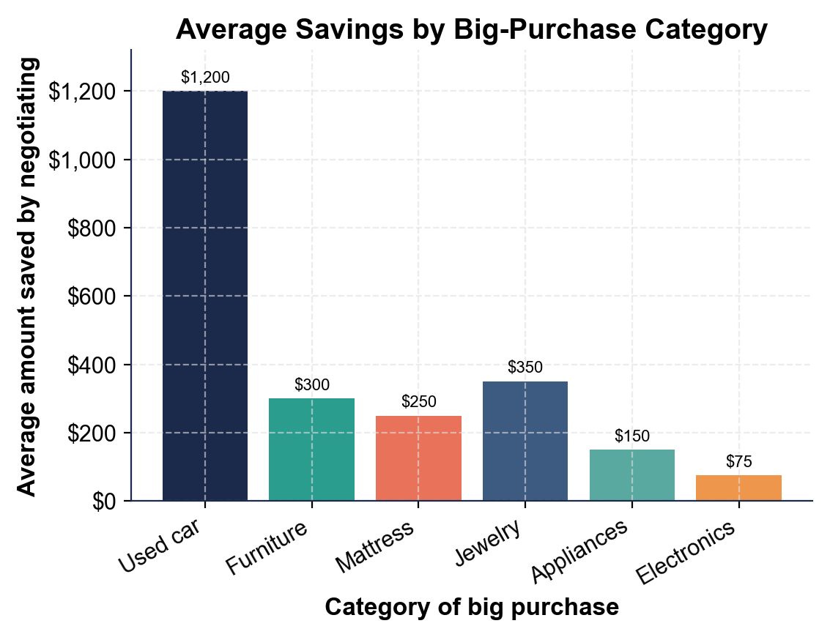

2. A4-Q2. As Rosa Delgado, use the chart to spot the biggest and smallest bars. (a) Which category saves the MOST when you negotiate, and how many dollars is it? (b) Which saves the LEAST, and how many dollars is it? (c) In one sentence, explain why a used car has more room to negotiate than electronics.

3. A4-Q3. As Rosa Delgado, compare the biggest and smallest bars. (a) Subtract the smallest bar from the biggest bar - what is the gap in average savings between a used car and electronics? (b) Tyler saved $1,000 negotiating his used car; how does that compare to the roughly $1,200 average for cars on the chart? Show your subtraction for (a).

4. A4-Q4. As Rosa Delgado, connect the chart to real planning. (a) Using the chart, which two or three categories are most worth negotiating hard, and why? (b) Which category is least worth the effort, and why? (c) In one sentence, explain why the chart is more useful for a buyer than just being told 'you can always negotiate.'

PART 5

Did the Client Get a Good Deal - Run and Score a New Negotiation
1. As Rosa Delgado, take on a new client, Jordan Price, buying a used SUV. Jordan researched, set a target price of $9,600 and a WALK-AWAY PRICE of $10,500, then negotiated the $12,000 STICKER PRICE down to a $10,200 NEGOTIATED PRICE.
(a) Using SAVINGS = STICKER PRICE - NEGOTIATED PRICE, find Jordan's savings.

(b) Using PERCENT OFF = SAVINGS / STICKER PRICE, find the percent off. Show your math for both.

2. As Rosa Delgado, use Jordan's WALK-AWAY PRICE to judge the deal. Jordan's walk-away price is $10,500.
(a) The negotiated price came in at $10,200 - should Jordan buy or walk, and why?

(b) In a different scenario, the seller will not go below $10,800 - should Jordan buy or walk, and why? Compare each price to the $10,500 walk-away.

3. As Rosa Delgado, weigh Jordan's negotiation beyond the numbers.
(a) Jordan saved $1,800, beating the roughly $1,200 average used-car savings on the chart by $600 - in one sentence, name one thing Jordan likely did well to beat the average.

(b) In one sentence, explain why you would NOT coach Jordan to open with an insultingly low offer far below his research target.

DID JORDAN GET A GOOD DEAL - FINAL REPORT
4. DID JORDAN GET A GOOD DEAL - FINAL REPORT. As Rosa Delgado, put your finding in writing for Jordan. Write a 5-7 sentence recommendation (120-180 words) that: states Jordan's savings using the labeled model ($12,000 - $10,200 = $1,800), states the percent off using the labeled model ($1,800 / $12,000 = 15%), compares the negotiated price to the $10,500 walk-away price and makes a clear buy-or-walk call, notes how Jordan's $1,800 savings compares to the roughly $1,200 average used-car savings on the chart, and names one negotiation move (research, timing, walk-away, or a good counteroffer) that helped him get the deal. Check off each required element as you include it.
YOUR RESPONSE MUST:
☐ STATE THE SAVINGS - show SAVINGS = $12,000 - $10,200 = $1,800 using the labeled model.
☐ STATE THE PERCENT OFF - show PERCENT OFF = $1,800 / $12,000 = 15% using the labeled model.
☐ MAKE THE WALK-AWAY CALL - compare the $10,200 negotiated price to the $10,500 walk-away price and clearly say buy or walk.
☐ COMPARE TO THE CHART - note that Jordan's $1,800 beat the roughly $1,200 average used-car savings by $600.
☐ NAME A MOVE THAT HELPED - name one negotiation move (research, timing, walk-away price, or a good counteroffer) that got him the deal.

