PERSONAL FINANCE

NEGOTIATING BIG PURCHASES: GETTING A BETTER DEAL
ANSWER KEY ACTIVITY - ANSWER KEY

PART 1

Negotiation Reference Guide - Complete the Missing Terms

Term | Definition
Negotiation | Working out a lower price by talking, offering, and countering with a seller
Sticker price | The seller's first asking price, before any negotiation
Negotiated price | The final price you and the seller agree on after negotiating
Savings | How much you cut off the price: the sticker price minus the negotiated price
Walk-away price | The highest price you are willing to pay before you walk away from the deal
Research | Finding out what a fair price is before you negotiate so you know your target
Percent off | Your savings as a share of the sticker price: savings divided by the sticker price
Target price | The price you aim for going in, based on your research, a bit below fair market
Timing | Choosing when to buy (end of month, model-year clearance, holidays) to get a better deal
Counteroffer | A new price you offer back after the seller names a price

PART 2

Apply the Terms - Negotiation Vocabulary in Context
WORD BANK walk-away · negotiated price · timing · percent off · negotiation
1. Q1. Working out a lower price by talking, offering, and countering with a seller is called negotiation.
negotiation
2. Q2. The final price you and the seller agree on after negotiating is called the negotiated price.
negotiated price
3. Q3. The highest price you are willing to pay before you walk away from a deal is called your walk-away price (two words joined by a hyphen).
walk-away
4. Q4. Your savings as a share of the sticker price, found by dividing savings by the sticker price, is called the percent off.
percent off
5. Q5. Choosing when to buy - end of month, model-year clearance, or a holiday sale - to get a better deal is called timing.
timing

PART 3

Calculate the Savings, Percent Off, and Walk-Away Decision - Use the Labeled Models
1. As Rosa Delgado, find Tyler's savings. Tyler talked the car from a $10,000 STICKER PRICE down to a $9,000 NEGOTIATED PRICE. Using SAVINGS = STICKER PRICE - NEGOTIATED PRICE,
(a) write the subtraction
(b) state Tyler's savings in dollars. Show your math.
(1) SAVINGS = STICKER PRICE - NEGOTIATED PRICE = $10,000 - $9,000 = $1,000. (2) Tyler's savings = $1,000. Accept a savings of $1,000.
2. As Rosa Delgado, turn Tyler's savings into a percent off. His savings are $1,000 and the sticker price is $10,000. Using PERCENT OFF = SAVINGS / STICKER PRICE,
(a) write the division
(b) give the decimal
(c) give the percent off. Show your math.
(1) PERCENT OFF = SAVINGS / STICKER PRICE = $1,000 / $10,000 = 0.10. (2) 0.10 as a percent = 10%. (3) Tyler got 10% off the sticker price. Accept 0.10 or 10% off.
3. As Rosa Delgado, use Tyler's WALK-AWAY PRICE to judge the deal. Tyler set a walk-away price of $9,200 (the most he would pay) and negotiated the car to $9,000.
(a) Is the negotiated price at or below his walk-away price - should he buy or walk?
(b) What should Tyler do instead if the seller would not go below $9,400?
(c) In one sentence, explain why setting a walk-away price ahead of time protects a buyer.
(1) The negotiated $9,000 is at or below Tyler's $9,200 walk-away price, so it is a good deal - BUY. (2) If the seller would not go below $9,400, that is above his $9,200 walk-away price, so Tyler should WALK away. (3) Setting a walk-away price ahead of time protects a buyer because it is decided from research before emotion takes over, so the buyer will not get talked into overpaying in the moment. Accept BUY at $9,000, WALK at $9,400, and a decide-in-advance / avoid-overpaying explanation.

PART 4

Read the Chart - Average Savings by Big-Purchase Category
As Rosa Delgado, study the bar chart titled "Average Savings by Big-Purchase Category" (it appears with A4-Q1). It shows the average dollars a buyer saves by negotiating in each of six categories. The same values are listed in the data table below. These are average per-category savings, not a running total, so you do NOT add them up. Use the chart and table to answer A4-Q1 to A4-Q3, then connect the chart to real planning in A4-Q4. Notice which bar is the TALLEST - that is where negotiation pays off the most.

Category of big purchase | Average amount saved by negotiating
Used car | $1,200
Furniture | $300
Mattress | $250
Jewelry | $350
Appliances | $150
Electronics | $75

Analysis

1. A4-Q1. As Rosa Delgado, study the bar chart on this page titled "Average Savings by Big-Purchase Category." It shows the average dollars a buyer saves by negotiating in each category. Read the chart and write the average dollar savings for each of the six bars: (a) Used car, (b) Furniture, (c) Mattress, (d) Jewelry, (e) Appliances, and (f) Electronics.
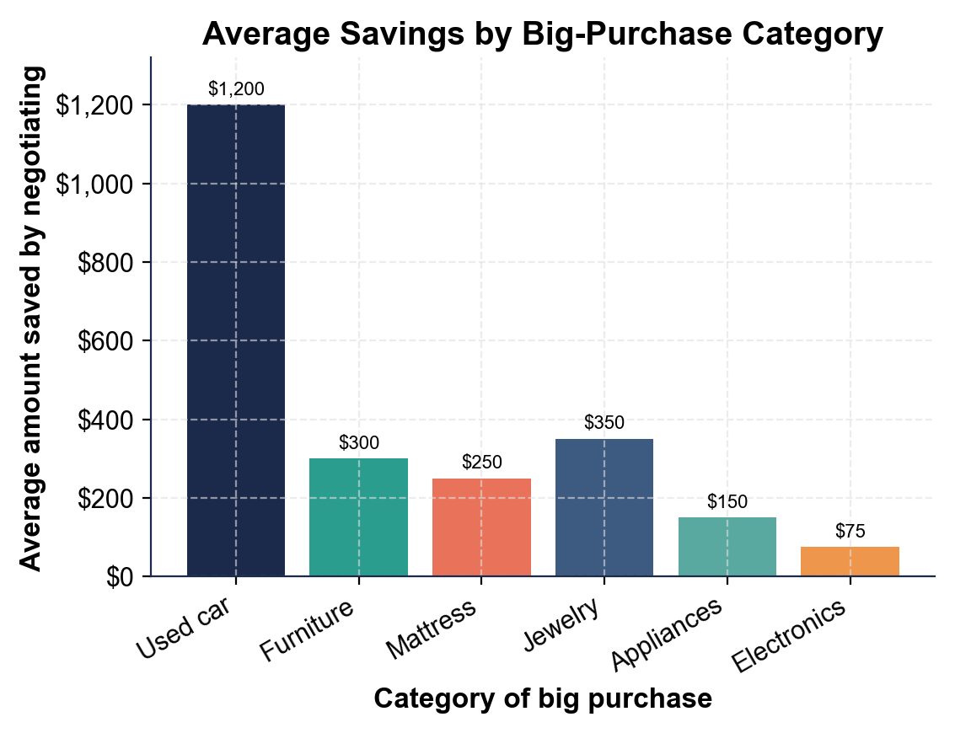
(a) Used car: $1,200. (b) Furniture: $300. (c) Mattress: $250. (d) Jewelry: $350. (e) Appliances: $150. (f) Electronics: $75. Accept these six values read directly off the six bars on the chart.

2. A4-Q2. As Rosa Delgado, use the chart to spot the biggest and smallest bars. (a) Which category saves the MOST when you negotiate, and how many dollars is it? (b) Which saves the LEAST, and how many dollars is it? (c) In one sentence, explain why a used car has more room to negotiate than electronics.
(1) The BIGGEST bar is USED CAR at $1,200. (2) The SMALLEST bar is ELECTRONICS at $75. (3) A used car has more room to negotiate than electronics because cars carry high markup and sellers are motivated to move a big-ticket item, while electronics have thin margins, so there is little room to come down. Accept used car ($1,200) biggest, electronics ($75) smallest, and a markup / thin-margin explanation.

3. A4-Q3. As Rosa Delgado, compare the biggest and smallest bars. (a) Subtract the smallest bar from the biggest bar - what is the gap in average savings between a used car and electronics? (b) Tyler saved $1,000 negotiating his used car; how does that compare to the roughly $1,200 average for cars on the chart? Show your subtraction for (a).
(1) GAP = $1,200 - $75 = $1,125 more average savings on a used car than on electronics. (2) Tyler's $1,000 savings is a bit below the roughly $1,200 average for used cars, so he did well but slightly under the typical car buyer - with more research or better timing he might have saved even more. Accept a $1,125 gap and a Tyler-is-a-little-below-the-$1,200-average comparison.

4. A4-Q4. As Rosa Delgado, connect the chart to real planning. (a) Using the chart, which two or three categories are most worth negotiating hard, and why? (b) Which category is least worth the effort, and why? (c) In one sentence, explain why the chart is more useful for a buyer than just being told 'you can always negotiate.'
(1) The most worth negotiating are the tallest bars - used car ($1,200), jewelry ($350), and furniture ($300) - because those categories have the most room and the biggest dollar payoff. (2) Electronics ($75) is least worth the effort because thin margins leave almost no room to come down. (3) The chart is more useful than 'you can always negotiate' because it shows WHERE negotiating actually pays off, so a buyer can spend their energy on the big-ticket items with room instead of haggling over a gadget. Accept used car/jewelry/furniture as the best targets, electronics as the worst, and a shows-where-effort-pays-off explanation.

PART 5

Did the Client Get a Good Deal - Run and Score a New Negotiation
1. As Rosa Delgado, take on a new client, Jordan Price, buying a used SUV. Jordan researched, set a target price of $9,600 and a WALK-AWAY PRICE of $10,500, then negotiated the $12,000 STICKER PRICE down to a $10,200 NEGOTIATED PRICE.
(a) Using SAVINGS = STICKER PRICE - NEGOTIATED PRICE, find Jordan's savings.
(b) Using PERCENT OFF = SAVINGS / STICKER PRICE, find the percent off. Show your math for both.
(1) SAVINGS = STICKER PRICE - NEGOTIATED PRICE = $12,000 - $10,200 = $1,800. (2) PERCENT OFF = SAVINGS / STICKER PRICE = $1,800 / $12,000 = 0.15 = 15% off. Accept a savings of $1,800 and 15% off.
2. As Rosa Delgado, use Jordan's WALK-AWAY PRICE to judge the deal. Jordan's walk-away price is $10,500.
(a) The negotiated price came in at $10,200 - should Jordan buy or walk, and why?
(b) In a different scenario, the seller will not go below $10,800 - should Jordan buy or walk, and why? Compare each price to the $10,500 walk-away.
(1) BUY: the negotiated $10,200 is at or below Jordan's $10,500 walk-away price, so it is a good deal. (2) WALK: $10,800 is above the $10,500 walk-away price, so Jordan should walk away even though he wants the SUV. Accept BUY at $10,200 (below walk-away) and WALK at $10,800 (above walk-away).
3. As Rosa Delgado, weigh Jordan's negotiation beyond the numbers.
(a) Jordan saved $1,800, beating the roughly $1,200 average used-car savings on the chart by $600 - in one sentence, name one thing Jordan likely did well to beat the average.
(b) In one sentence, explain why you would NOT coach Jordan to open with an insultingly low offer far below his research target.
(1) Jordan likely beat the average by doing solid research (so he knew a fair price and set a smart target and walk-away), by using good timing, and by being genuinely willing to walk away, which gave him leverage. (2) You would not coach an insultingly low opening offer because it can offend the seller and end the negotiation, or make the seller dig in - a first offer a bit below your target leaves room to move up toward a fair deal without blowing up the talk. Accept a research/timing/willing-to-walk answer and a lowball-ends-the-deal explanation.
DID JORDAN GET A GOOD DEAL - FINAL REPORT
4. DID JORDAN GET A GOOD DEAL - FINAL REPORT. As Rosa Delgado, put your finding in writing for Jordan. Write a 5-7 sentence recommendation (120-180 words) that: states Jordan's savings using the labeled model ($12,000 - $10,200 = $1,800), states the percent off using the labeled model ($1,800 / $12,000 = 15%), compares the negotiated price to the $10,500 walk-away price and makes a clear buy-or-walk call, notes how Jordan's $1,800 savings compares to the roughly $1,200 average used-car savings on the chart, and names one negotiation move (research, timing, walk-away, or a good counteroffer) that helped him get the deal. Check off each required element as you include it.
YOUR RESPONSE MUST:
☐ STATE THE SAVINGS - show SAVINGS = $12,000 - $10,200 = $1,800 using the labeled model.
☐ STATE THE PERCENT OFF - show PERCENT OFF = $1,800 / $12,000 = 15% using the labeled model.
☐ MAKE THE WALK-AWAY CALL - compare the $10,200 negotiated price to the $10,500 walk-away price and clearly say buy or walk.
☐ COMPARE TO THE CHART - note that Jordan's $1,800 beat the roughly $1,200 average used-car savings by $600.
☐ NAME A MOVE THAT HELPED - name one negotiation move (research, timing, walk-away price, or a good counteroffer) that got him the deal.
GRADING RUBRIC
Grade the evidence and reasoning, not the conclusion — any defensible position is valid. Score against the 5 requirements above.
FULL CREDIT — clear position; meets all 5 requirements with accurate, specific numbers and evidence from the lesson.
PARTIAL — position stated, but misses 1-2 requirements or uses vague / incorrect numbers.
MINIMAL — no clear position, or missing most requirements and numbers.

MORE LESSONS LESS PLANNING
Thank You!
If you enjoyed this product, please do not forget to rate and review to assist other teachers.

Looking for future discounts? Earn TPT credits by reviewing purchased products.

Please contact me if you have any issues with this product. Just like our students, I am always looking for opportunities to grow.

