Monopoly: One Seller, All the Power
STUDENT ACTIVITY
Name: | Date: | Period:
ESSENTIAL QUESTION
When one company is the only game in town, what stops it from charging whatever it wants?
THE SCENARIO
You are a high school senior selected for a 2-week policy internship at the State Public Utility Commission (PUC). DR. ELENA REYES, the senior energy economist at the Commission, has asked you to help her draft a recommendation on whether the regional electric utility - currently a regulated monopoly serving 2.4 million households - should remain regulated, be broken up by antitrust action, or be deregulated entirely.
BY THE END, YOU CAN:
✓ Define MONOPOLY using the four defining features (one seller, no close substitutes, high barriers to entry, price-maker firm) and contrast it with the four conditions of Perfect Competition from TK 21
✓ Read a monopoly pricing diagram - locate the QUANTITY where MR=MC, trace UP to the demand curve for the PRICE the monopoly charges, and compute the price/quantity gap vs the competitive equilibrium
✓ Explain DEADWEIGHT LOSS as the welfare triangle society loses to monopoly pricing, and distinguish REGULATED monopolies (utilities, patents) from UNREGULATED ones using real U.S. examples
HOW IT WORKS (do Parts 1–5 in order)
Part 1 — Monopoly Reference Guide - Complete the Missing Terms
Part 2 — Apply the Terms - Monopoly Vocabulary in Context
Part 3 — You Read the Three Monopoly Charts with Dr. Elena Reyes
Part 4 — Four Real-Market Scenarios with Dr. Elena Reyes - Apply the Model
Part 5 — Your Final Policy Recommendation Memo to Dr. Reyes
TIME about 45 minutes YOU’LL NEED the lesson slides and your Guided Notes.

PART 1

Monopoly Reference Guide - Complete the Missing Terms
Fill in the missing term for each blank row — the definition is your clue. Your Guided Notes and the lesson slides have every term.

Term | Definition
___________ | A market structure with ONE seller, no close substitutes for the product, and high barriers preventing new firms from entering; the single firm is a price-maker with significant market power
Price-maker | A firm with the power to SET its own price by choosing how much output to sell; opposite of price-taker; signature of a monopoly or strong oligopoly
___________ | A legal, financial, or technological obstacle that prevents new firms from joining a market - patents, government franchises, enormous fixed costs, and network effects are common examples
Natural monopoly | A market where one firm can serve the whole market at a lower total cost than two or more firms could - usually because of huge fixed infrastructure costs (electric grid, water pipes, rail tracks)
___________ | The total welfare lost to society when a monopoly produces less output than the competitive equilibrium - the consumer plus producer surplus that simply disappears, shown as a triangle on the monopoly diagram
Marginal revenue | The additional revenue a firm earns from selling ONE more unit of output; in monopoly, MR is always LOWER than the price because lowering price to sell one more unit drops the price on every unit
___________ | A monopoly whose prices, output, or service quality are controlled by a government agency (Public Utility Commission, FCC, etc.) to prevent the price-gouging an unregulated monopoly would otherwise impose
Patent | A legal grant from the government giving the patent holder a TIME-LIMITED monopoly (20 years for U.S. utility patents) on a specific invention; the trade-off is monopoly profit in exchange for disclosing the invention publicly
___________ | When a monopoly charges DIFFERENT prices to different buyers for the same product based on willingness to pay - common in pharma (different country prices), airlines (advance vs last-minute), and software (student vs business pricing)
Market power | A firm's ability to raise price above marginal cost without losing all its customers; in perfect competition market power is zero, in pure monopoly it is highest

PART 2

Apply the Terms - Monopoly Vocabulary in Context
WORD BANK maker · deadweight loss · discrimination · barrier to entry · natural monopoly
1. In perfect competition a firm is a price-taker that must accept the market price. A monopoly is the opposite: it SETS its own price by choosing how much output to produce, so economists call it a price- .

2. A patent, a government franchise, or an enormous fixed start-up cost can keep new firms OUT of a market and protect the single seller. Any such legal, financial, or technological obstacle is called a .

3. A monopoly restricts output below the competitive quantity, so some units that buyers value more than they cost to make never get produced. That destroyed welfare - the triangle on the monopoly diagram - is called .

4. The local electric utility is a because one wire grid can serve the entire service area at lower total cost than two or more competing networks could.

5. When a monopoly charges DIFFERENT buyers different prices for the same product based on their willingness to pay - country-by-country drug prices, advance vs last-minute airfare, student vs business software pricing - the practice is called price .

PART 3

You Read the Three Monopoly Charts with Dr. Elena Reyes
1. Use Chart Reference 1 (chart_monopoly_mr_mc) - the demand, marginal revenue, and marginal cost diagram shown below - to identify the monopoly equilibrium.
(a) Find the QUANTITY where the MR curve crosses the MC curve.

(b) Trace UP from that quantity to the DEMAND curve and read the monopoly PRICE.

(c) Identify where MC meets demand DIRECTLY (no MR involved) and read off the competitive QUANTITY and PRICE.

(d) In 1-2 sentences, explain why the monopoly produces at Q where MR=MC and not at the competitive quantity.

2. Use Chart Reference 2 (chart_deadweight_loss) - the deadweight loss diagram comparing monopoly equilibrium to competitive equilibrium shown below - to compute the welfare loss.
(a) Identify the COMPETITIVE equilibrium (Q and P) at the marked equilibrium dot.

(b) Identify the MONOPOLY equilibrium (Q=30, P=$14) shown by the caption + reference label.

(c) Compute the QUANTITY REDUCTION (units the monopoly does not produce) and the PRICE INCREASE (dollars per unit).

(d) Sketch the deadweight loss TRIANGLE - name its three corner points using (Q, P) coordinates.

(e) In 1-2 sentences, explain why this triangle is a LOSS to society, not a transfer.

3. Use Chart Reference 3 (chart_drug_price_comparison) - the bar chart comparing patented brand-name drug prices to their generic equivalents shown below - to put a dollar figure on patent-monopoly pricing power.
(a) For LIPITOR (atorvastatin), state the brand price and the generic price.

(b) For LEXAPRO (escitalopram), state the brand price and the generic price.

(c) Compute the brand-to-generic price RATIO for each of those two drugs (round to nearest whole number).

(d) Average the four brand-to-generic ratios across all four drugs (just estimate visually).

(e) In 1-2 sentences, explain how a PATENT functions as a barrier to entry and creates the price gap shown on the chart.

PART 4

Four Real-Market Scenarios with Dr. Elena Reyes - Apply the Model
1. RATE FOUR REAL MARKETS ON THE FOUR MONOPOLY FEATURES. Dr. Reyes gives you four real markets to diagnose: the local ELECTRIC UTILITY, PATENTED INSULIN under active patent, GOOGLE SEARCH, and the U.S. POSTAL SERVICE. For EACH market, rate it 0-10 on EACH of the four features, give a 1-sentence justification, then identify which market structure label (pure monopoly / near-monopoly / oligopoly / monopolistic competition) best fits. This is a comparative diagnosis, NOT a memorization question - use the model. Ratings are judgment calls; any well-reasoned answer is valid.
Market | One Seller | No Subs. | High Barriers | Price-Maker | Structure
Local Electric Utility
Justification:
Patented Insulin
Justification:
Google Search
Justification:
U.S. Postal Service
Justification:

2. A NEW MONOPOLY FORMS. Suppose a new prescription drug, NEUROCURE, just received a U.S. patent. NEUROCURE is the only drug shown to slow Alzheimer-type cognitive decline.
(a) Which feature(s) of monopoly does NEUROCURE have most strongly?

(b) Apply the two-step monopoly pricing rule: what does the manufacturer do?

(c) Will the price be ABOVE or BELOW marginal cost - by how much (qualitatively)?

(d) Predict what happens to the drug price when the patent expires in 2046.

3. A NEW SUBSTITUTE BREAKS A MONOPOLY. Suppose a startup invents a HOME SOLAR + BATTERY SYSTEM that costs 30% less than grid electricity over a 25-year period and works during grid outages. Apply the monopoly model to the local electric utility:
(a) Which feature of monopoly is now WEAKENED?

(b) What happens to the utility's pricing power - increases, decreases, or stays the same?

(c) What happens to the deadweight loss the utility was causing - shrinks, grows, or stays the same?

(d) In 1-2 sentences, explain what this case shows about how monopolies eventually get competed away (or not) over time.

4. REGULATE OR BREAK UP? Two different U.S. policy responses to monopoly: REGULATE the monopoly (Public Utility Commission caps prices, as with electric utilities) and BREAK UP the monopoly (antitrust action, as with Standard Oil 1911 and AT&T 1984). For EACH of the four monopolies below, identify which response - regulate, break up, leave alone, or let-substitutes-handle-it - best fits AND give a one-sentence reason. Accept any defensible policy match with sound reasoning.
Monopoly | Best Response | One-Sentence Reason
Local electric utility
Patented insulin (active patent)
Google search
Local cable TV (streaming available)

PART 5

Your Final Policy Recommendation Memo to Dr. Reyes
POLICY RECOMMENDATION MEMO
1. Dr. Reyes closes the internship by asking for your call. The regional electric utility serves 2.4 million households as a regulated monopoly, and the Commission must decide its future. Use everything you learned about monopoly economics and deadweight loss, and use all four required terms - MONOPOLY, PRICE-MAKER, DEADWEIGHT LOSS, and BARRIER TO ENTRY - at least once each. In a 6-8 sentence memo to Dr. Reyes, do you recommend that the State PUC KEEP regulating the regional electric utility, BREAK IT UP via antitrust, or DEREGULATE it entirely - and why?
YOUR RESPONSE MUST:
☐ Names a SPECIFIC RECOMMENDATION (KEEP regulating / BREAK UP / DEREGULATE entirely) AND ties it to the MONOPOLY model.
☐ Uses the term PRICE-MAKER correctly - acknowledges that without the PUC the utility would have significant price-setting power because of its monopoly structure.
☐ Uses the phrase DEADWEIGHT LOSS correctly - references that an unregulated electric utility would impose a deadweight loss on the 2.4 million households served, and quantifies it (Dr. Reyes's $50-$80/household/year finding from the persona, or a chart-derived estimate).
☐ Uses the term BARRIER TO ENTRY correctly - identifies which barrier(s) the utility has (typically: technological natural-monopoly barrier + legal franchise barrier).
☐ Quotes at least ONE specific value from the chart appendix (e.g., monopoly Q=30 and P=$14, competitive Q=50 and P=$10, $4 price increase per unit, 20x brand-to-generic drug ratio as a real-world calibration of monopoly pricing power) to ground the recommendation in real data.
☐ Closes with a SPECIFIC NEXT STEP the Commission should take in the next 6 months (e.g., review the proposed 2027 rate increase; commission an audit of substitute solar penetration; subpoena cost data; convene a public hearing).
MEMO
To: Dr. Elena Reyes, Senior Energy Economist
From:
Date:
Re: Recommendation on regional electric utility regulation

CHART REFERENCE 1: THE MONOPOLY PRICING DIAGRAM (DEMAND, MARGINAL REVENUE, MARGINAL COST)
Use Chart Reference 1 (chart_monopoly_mr_mc) - the demand, marginal revenue, and marginal cost diagram shown below.
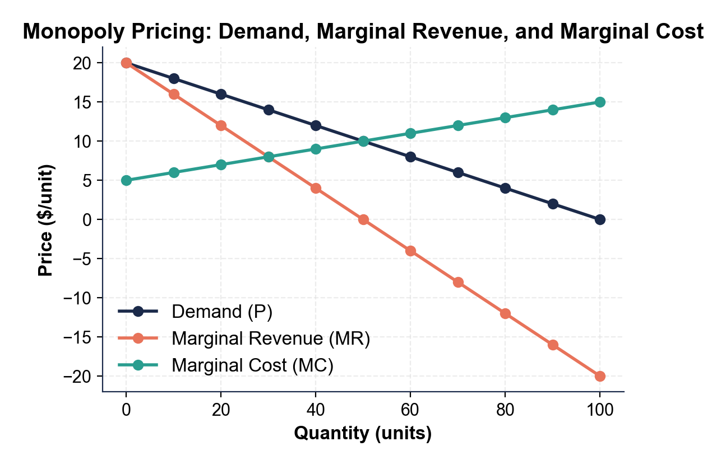
CHART REFERENCE 2: DEADWEIGHT LOSS - MONOPOLY VS COMPETITIVE EQUILIBRIUM
Use Chart Reference 2 (chart_deadweight_loss) - the deadweight loss diagram comparing monopoly equilibrium to competitive equilibrium shown below.
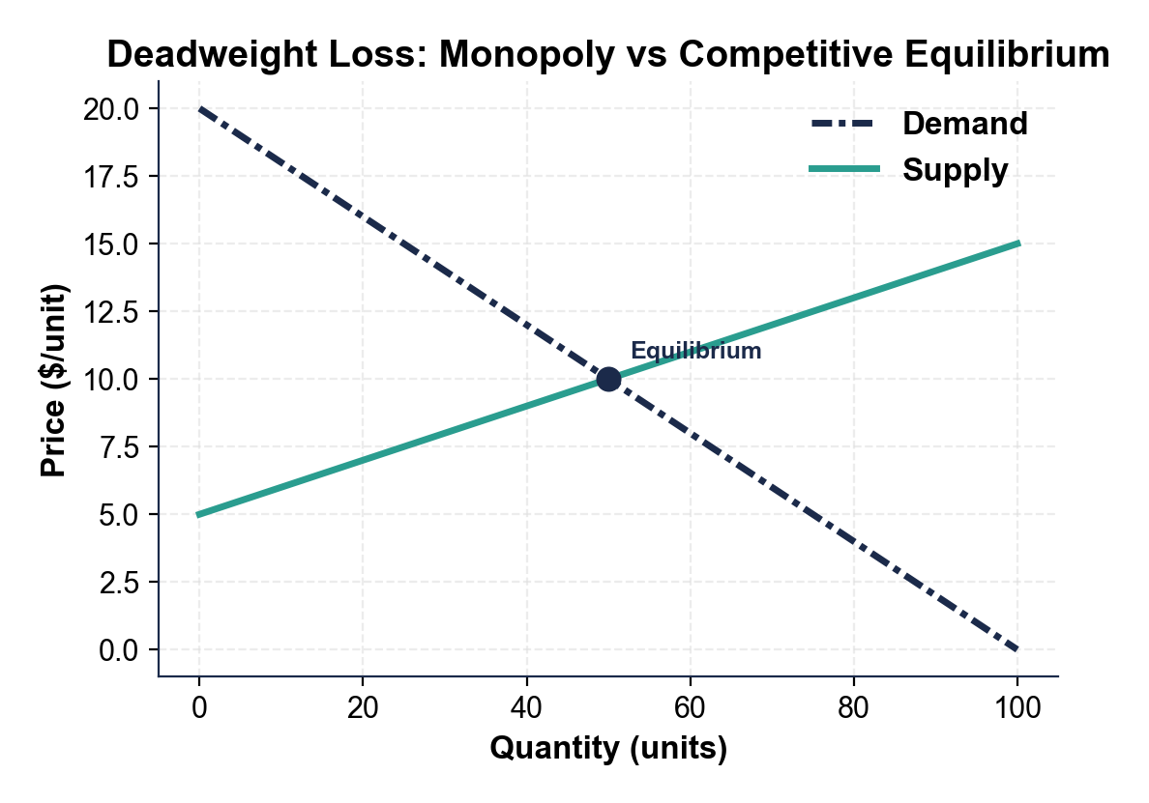
CHART REFERENCE 3: U.S. BRAND-NAME VS GENERIC DRUG PRICES
Use Chart Reference 3 (chart_drug_price_comparison) - the bar chart comparing patented brand-name drug prices to their generic equivalents shown below.
