ECONOMICS

MONOPOLY: ONE SELLER, ALL THE POWER
ANSWER KEY ACTIVITY - ANSWER KEY

PART 1

Monopoly Reference Guide - Complete the Missing Terms

Term | Definition
Monopoly | A market structure with ONE seller, no close substitutes for the product, and high barriers preventing new firms from entering; the single firm is a price-maker with significant market power
Price-maker | A firm with the power to SET its own price by choosing how much output to sell; opposite of price-taker; signature of a monopoly or strong oligopoly
Barrier to entry | A legal, financial, or technological obstacle that prevents new firms from joining a market - patents, government franchises, enormous fixed costs, and network effects are common examples
Natural monopoly | A market where one firm can serve the whole market at a lower total cost than two or more firms could - usually because of huge fixed infrastructure costs (electric grid, water pipes, rail tracks)
Deadweight loss | The total welfare lost to society when a monopoly produces less output than the competitive equilibrium - the consumer plus producer surplus that simply disappears, shown as a triangle on the monopoly diagram
Marginal revenue | The additional revenue a firm earns from selling ONE more unit of output; in monopoly, MR is always LOWER than the price because lowering price to sell one more unit drops the price on every unit
Regulated monopoly | A monopoly whose prices, output, or service quality are controlled by a government agency (Public Utility Commission, FCC, etc.) to prevent the price-gouging an unregulated monopoly would otherwise impose
Patent | A legal grant from the government giving the patent holder a TIME-LIMITED monopoly (20 years for U.S. utility patents) on a specific invention; the trade-off is monopoly profit in exchange for disclosing the invention publicly
Price discrimination | When a monopoly charges DIFFERENT prices to different buyers for the same product based on willingness to pay - common in pharma (different country prices), airlines (advance vs last-minute), and software (student vs business pricing)
Market power | A firm's ability to raise price above marginal cost without losing all its customers; in perfect competition market power is zero, in pure monopoly it is highest

PART 2

Apply the Terms - Monopoly Vocabulary in Context
WORD BANK maker · deadweight loss · discrimination · barrier to entry · natural monopoly
1. In perfect competition a firm is a price-taker that must accept the market price. A monopoly is the opposite: it SETS its own price by choosing how much output to produce, so economists call it a price-maker.
maker. A monopoly faces the whole downward-sloping market demand curve, so it picks the quantity it sells and the demand curve sets the highest price buyers will pay.
2. A patent, a government franchise, or an enormous fixed start-up cost can keep new firms OUT of a market and protect the single seller. Any such legal, financial, or technological obstacle is called a barrier to entry.
barrier to entry
3. A monopoly restricts output below the competitive quantity, so some units that buyers value more than they cost to make never get produced. That destroyed welfare - the triangle on the monopoly diagram - is called deadweight loss.
deadweight loss
4. The local electric utility is a natural monopoly because one wire grid can serve the entire service area at lower total cost than two or more competing networks could.
natural monopoly
5. When a monopoly charges DIFFERENT buyers different prices for the same product based on their willingness to pay - country-by-country drug prices, advance vs last-minute airfare, student vs business software pricing - the practice is called price discrimination.
discrimination. The monopoly captures extra revenue by sorting buyers into groups and charging each group the most it will pay.
PART 3

You Read the Three Monopoly Charts with Dr. Elena Reyes
1. Use Chart Reference 1 (chart_monopoly_mr_mc) - the demand, marginal revenue, and marginal cost diagram shown below - to identify the monopoly equilibrium.
(a) Find the QUANTITY where the MR curve crosses the MC curve.
MONOPOLY QUANTITY: Q=30 - where the coral MR line crosses the teal MC line (MR=$8 and MC=$8 at that quantity).
(b) Trace UP from that quantity to the DEMAND curve and read the monopoly PRICE.
MONOPOLY PRICE: $14/unit - tracing UP from Q=30 to the navy demand curve.
(c) Identify where MC meets demand DIRECTLY (no MR involved) and read off the competitive QUANTITY and PRICE.
COMPETITIVE EQUILIBRIUM: Q=50 and P=$10 - where the MC curve meets the demand curve directly.
(d) In 1-2 sentences, explain why the monopoly produces at Q where MR=MC and not at the competitive quantity.
The monopoly produces at Q=30 (not Q=50) because at every quantity past 30, the EXTRA revenue (MR) from selling one more unit is LESS than the EXTRA cost (MC) of producing it. Producing past Q=30 destroys profit. The monopoly profit-maximizes by stopping at Q=30 and charging the highest price the demand curve will bear at that quantity ($14).
2. Use Chart Reference 2 (chart_deadweight_loss) - the deadweight loss diagram comparing monopoly equilibrium to competitive equilibrium shown below - to compute the welfare loss.
(a) Identify the COMPETITIVE equilibrium (Q and P) at the marked equilibrium dot.
COMPETITIVE EQUILIBRIUM: Q=50 and P=$10 - the marked dot where supply (MC) meets demand.
(b) Identify the MONOPOLY equilibrium (Q=30, P=$14) shown by the caption + reference label.
MONOPOLY EQUILIBRIUM: Q=30 and P=$14 - up and to the left of the competitive point.
(c) Compute the QUANTITY REDUCTION (units the monopoly does not produce) and the PRICE INCREASE (dollars per unit).
QUANTITY REDUCTION: 50 - 30 = 20 units (the monopoly produces 20 fewer units than the competitive market). PRICE INCREASE: $14 - $10 = $4 per unit (the monopoly charges $4 more per unit).
(d) Sketch the deadweight loss TRIANGLE - name its three corner points using (Q, P) coordinates.
DEADWEIGHT LOSS TRIANGLE corners: (Q=30, P=$14) at the top - on the demand line above the monopoly quantity. (Q=30, P=$8) at the bottom - on the supply (MC) line above the monopoly quantity. (Q=50, P=$10) at the right - the competitive equilibrium point. The triangle is bounded above by the demand line, below by the supply line, and on the left by the vertical Q=30 segment from $8 to $14.
(e) In 1-2 sentences, explain why this triangle is a LOSS to society, not a transfer.
This triangle is a LOSS, not a transfer, because the 20 units between Q=30 and Q=50 would have been worth MORE to buyers than they cost to produce (demand > supply between Q=30 and Q=50). In competition those units WOULD have been made and consumed - both buyer and seller would have gained. The monopoly's choice to restrict output destroys that welfare entirely - no one gets it.

3. Use Chart Reference 3 (chart_drug_price_comparison) - the bar chart comparing patented brand-name drug prices to their generic equivalents shown below - to put a dollar figure on patent-monopoly pricing power.
(a) For LIPITOR (atorvastatin), state the brand price and the generic price.
LIPITOR: brand $180, generic $9.
(b) For LEXAPRO (escitalopram), state the brand price and the generic price.
LEXAPRO: brand $300, generic $15.
(c) Compute the brand-to-generic price RATIO for each of those two drugs (round to nearest whole number).
LIPITOR ratio: $180 / $9 = 20x. LEXAPRO ratio: $300 / $15 = 20x.
(d) Average the four brand-to-generic ratios across all four drugs (just estimate visually).
AVERAGE across all four drugs (Lipitor 20x, Prozac 21x, Lexapro 20x, Singulair 20x): roughly 20x.
(e) In 1-2 sentences, explain how a PATENT functions as a barrier to entry and creates the price gap shown on the chart.
A patent is a LEGAL barrier to entry - the U.S. Patent Office grants the patent holder a 20-year LEGAL MONOPOLY on the molecule. During those 20 years, no other firm can legally make and sell that drug. The patent-holding firm is therefore the SINGLE SELLER with NO CLOSE SUBSTITUTES (other patented drugs are differentiated; generic versions are forbidden by law). The firm can act as a price-maker and charge close to the highest price the demand curve will bear. When the patent expires, generic competition is allowed, supply shifts right dramatically, and the price collapses to roughly 5% of the brand price (the 20x ratio shown on the chart).
PART 4

Four Real-Market Scenarios with Dr. Elena Reyes - Apply the Model
1. RATE FOUR REAL MARKETS ON THE FOUR MONOPOLY FEATURES. Dr. Reyes gives you four real markets to diagnose: the local ELECTRIC UTILITY, PATENTED INSULIN under active patent, GOOGLE SEARCH, and the U.S. POSTAL SERVICE. For EACH market, rate it 0-10 on EACH of the four features, give a 1-sentence justification, then identify which market structure label (pure monopoly / near-monopoly / oligopoly / monopolistic competition) best fits. This is a comparative diagnosis, NOT a memorization question - use the model. Ratings are judgment calls; any well-reasoned answer is valid.
Market | One Seller | No Subs. | High Barriers | Price-Maker | Structure
Local Electric Utility | 10/10 | 9/10 | 10/10 | 7/10 | Pure monopoly (regulated)
Justification: One wire grid; refrigeration/AC have no real substitute; technological + legal franchise barriers stacked; PUC caps hold the price-maker rating to 7/10.
Patented Insulin | 9/10 | 10/10 | 10/10 | 9/10 | Pure monopoly (unregulated price)
Justification: Patent holder for the specific formulation; life-or-death need with no substitute; patent + FDA + manufacturing barriers; historical ~1000% price increases over 20 years.
Google Search | 8/10 | 4/10 | 10/10 | 7/10 | Near-monopoly (under antitrust scrutiny)
Justification: 90%+ U.S. search share; Bing/DuckDuckGo exist but few switch; network effects + data scale + ad inventory barriers; consumers pay $0 but advertisers pay monopoly-level ad prices.
U.S. Postal Service | 6/10 | 3/10 | 5/10 | 4/10 | Partial monopoly in collapse
Justification: Legal monopoly on first-class mail only - UPS/FedEx compete for packages and email is the dominant substitute; Congress sets rates and substitutes have eroded the whole market.

2. A NEW MONOPOLY FORMS. Suppose a new prescription drug, NEUROCURE, just received a U.S. patent. NEUROCURE is the only drug shown to slow Alzheimer-type cognitive decline.
(a) Which feature(s) of monopoly does NEUROCURE have most strongly?
NEUROCURE has all four features strongly: (1) ONE SELLER (the patent holder); (2) NO CLOSE SUBSTITUTES (no other Alzheimer treatment exists); (3) HIGH BARRIERS (patent + FDA approval + manufacturing); (4) PRICE-MAKER (will set its own price).
(b) Apply the two-step monopoly pricing rule: what does the manufacturer do?
The manufacturer applies the two-step rule: find the QUANTITY where MR=MC (its profit-maximizing output), then trace UP to the demand curve to read the PRICE the desperate market will bear.
(c) Will the price be ABOVE or BELOW marginal cost - by how much (qualitatively)?
PRICE WILL BE FAR ABOVE MC - likely 10-50x marginal cost of manufacturing. The actual molecule might cost $5 to produce; the patented price could be $100-$500 per dose.
(d) Predict what happens to the drug price when the patent expires in 2046.
When the patent expires in 2046, generic manufacturers will enter (the legal barrier is removed). Supply will shift dramatically right.
3. A NEW SUBSTITUTE BREAKS A MONOPOLY. Suppose a startup invents a HOME SOLAR + BATTERY SYSTEM that costs 30% less than grid electricity over a 25-year period and works during grid outages. Apply the monopoly model to the local electric utility:
(a) Which feature of monopoly is now WEAKENED?
Feature 2 - NO CLOSE SUBSTITUTES - is now weakened. Home solar + battery is a close substitute for grid electricity.
(b) What happens to the utility's pricing power - increases, decreases, or stays the same?
The utility's pricing power DECREASES. As more households install solar + battery, fewer households are forced to buy from the utility.
(c) What happens to the deadweight loss the utility was causing - shrinks, grows, or stays the same?
The deadweight loss SHRINKS. The original monopoly cost society the welfare triangle between the monopoly and competitive equilibria.
(d) In 1-2 sentences, explain what this case shows about how monopolies eventually get competed away (or not) over time.
Monopolies are usually broken not by antitrust action but by TECHNOLOGICAL SUBSTITUTION. Cable TV was broken by streaming, taxis by ride-share, postal mail by email, brick-and-mortar by Amazon.
4. REGULATE OR BREAK UP? Two different U.S. policy responses to monopoly: REGULATE the monopoly (Public Utility Commission caps prices, as with electric utilities) and BREAK UP the monopoly (antitrust action, as with Standard Oil 1911 and AT&T 1984). For EACH of the four monopolies below, identify which response - regulate, break up, leave alone, or let-substitutes-handle-it - best fits AND give a one-sentence reason. Accept any defensible policy match with sound reasoning.
Monopoly | Best Response | One-Sentence Reason
Local electric utility | Regulate | It is a natural monopoly (one wire grid is cheapest), so a breakup would only create higher-cost duplication; continuous PUC rate review is the standard answer.
Patented insulin (active patent) | Regulate now / let substitutes handle it later | The patent is a time-limited monopoly designed to expire, so let generics take over post-expiration; during the patent period some countries (UK, France) regulate pharma prices directly.
Google search | Break up (defensible: leave alone) | Antitrust fits dominant share plus high barriers without the natural-monopoly justification - the 2024 DOJ v. Google argument; the leave-alone counter is that consumers pay $0 for search.
Local cable TV (streaming available) | Let substitutes handle it | The cable monopoly is already being competed away by streaming, so heavy regulation or a breakup is unnecessary - technological substitution is doing the work.

PART 5

Your Final Policy Recommendation Memo to Dr. Reyes
POLICY RECOMMENDATION MEMO
1. Dr. Reyes closes the internship by asking for your call. The regional electric utility serves 2.4 million households as a regulated monopoly, and the Commission must decide its future. Use everything you learned about monopoly economics and deadweight loss, and use all four required terms - MONOPOLY, PRICE-MAKER, DEADWEIGHT LOSS, and BARRIER TO ENTRY - at least once each. In a 6-8 sentence memo to Dr. Reyes, do you recommend that the State PUC KEEP regulating the regional electric utility, BREAK IT UP via antitrust, or DEREGULATE it entirely - and why?
YOUR RESPONSE MUST:
☐ Names a SPECIFIC RECOMMENDATION (KEEP regulating / BREAK UP / DEREGULATE entirely) AND ties it to the MONOPOLY model.
☐ Uses the term PRICE-MAKER correctly - acknowledges that without the PUC the utility would have significant price-setting power because of its monopoly structure.
☐ Uses the phrase DEADWEIGHT LOSS correctly - references that an unregulated electric utility would impose a deadweight loss on the 2.4 million households served, and quantifies it (Dr. Reyes's $50-$80/household/year finding from the persona, or a chart-derived estimate).
☐ Uses the term BARRIER TO ENTRY correctly - identifies which barrier(s) the utility has (typically: technological natural-monopoly barrier + legal franchise barrier).
☐ Quotes at least ONE specific value from the chart appendix (e.g., monopoly Q=30 and P=$14, competitive Q=50 and P=$10, $4 price increase per unit, 20x brand-to-generic drug ratio as a real-world calibration of monopoly pricing power) to ground the recommendation in real data.
☐ Closes with a SPECIFIC NEXT STEP the Commission should take in the next 6 months (e.g., review the proposed 2027 rate increase; commission an audit of substitute solar penetration; subpoena cost data; convene a public hearing).
MEMO
To: Dr. Elena Reyes, Senior Energy Economist
From: [student completes]
Date: [student completes]
Re: Recommendation on regional electric utility regulation
GRADING RUBRIC
Grade the evidence and reasoning, not the conclusion — any defensible position is valid. Score against the 6 requirements above.
FULL CREDIT — clear position; meets all 6 requirements with accurate, specific numbers and evidence from the lesson.
PARTIAL — position stated, but misses 1-2 requirements or uses vague / incorrect numbers.
MINIMAL — no clear position, or missing most requirements and numbers.
CHART REFERENCE 1: THE MONOPOLY PRICING DIAGRAM (DEMAND, MARGINAL REVENUE, MARGINAL COST)
Use Chart Reference 1 (chart_monopoly_mr_mc) - the demand, marginal revenue, and marginal cost diagram shown below.
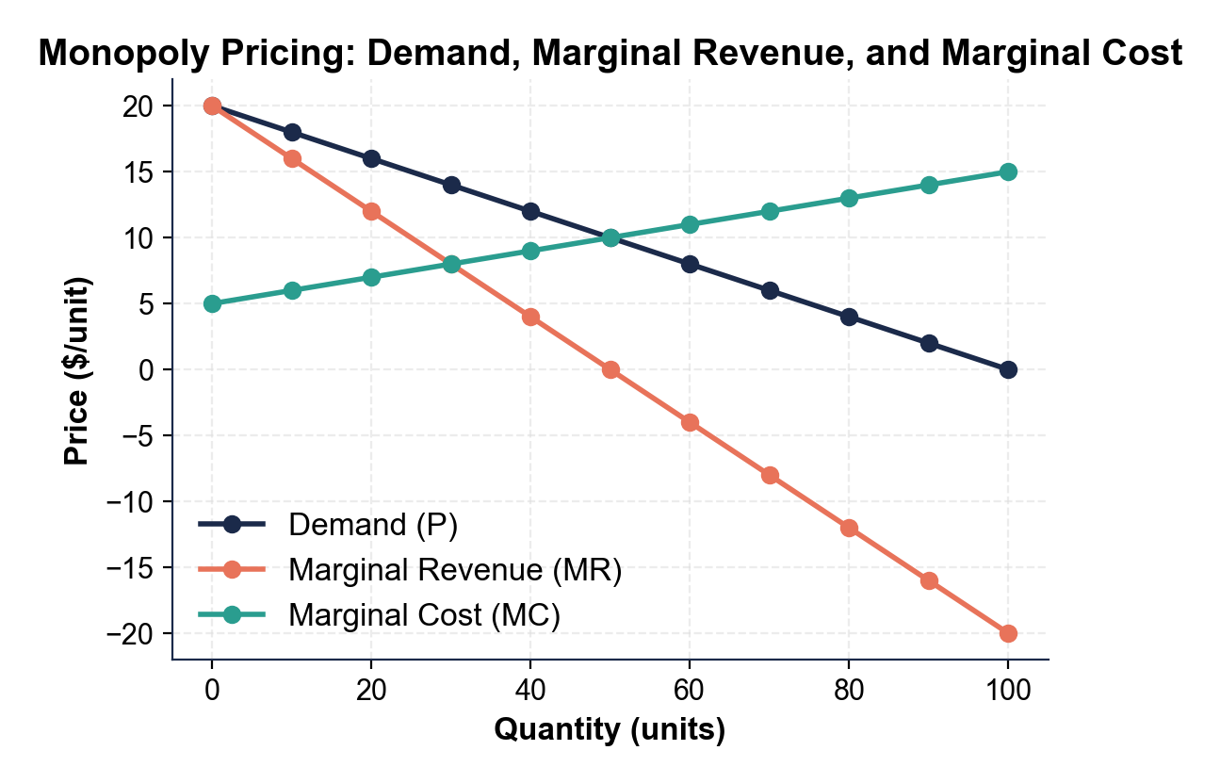
CHART REFERENCE 2: DEADWEIGHT LOSS - MONOPOLY VS COMPETITIVE EQUILIBRIUM
Use Chart Reference 2 (chart_deadweight_loss) - the deadweight loss diagram comparing monopoly equilibrium to competitive equilibrium shown below.
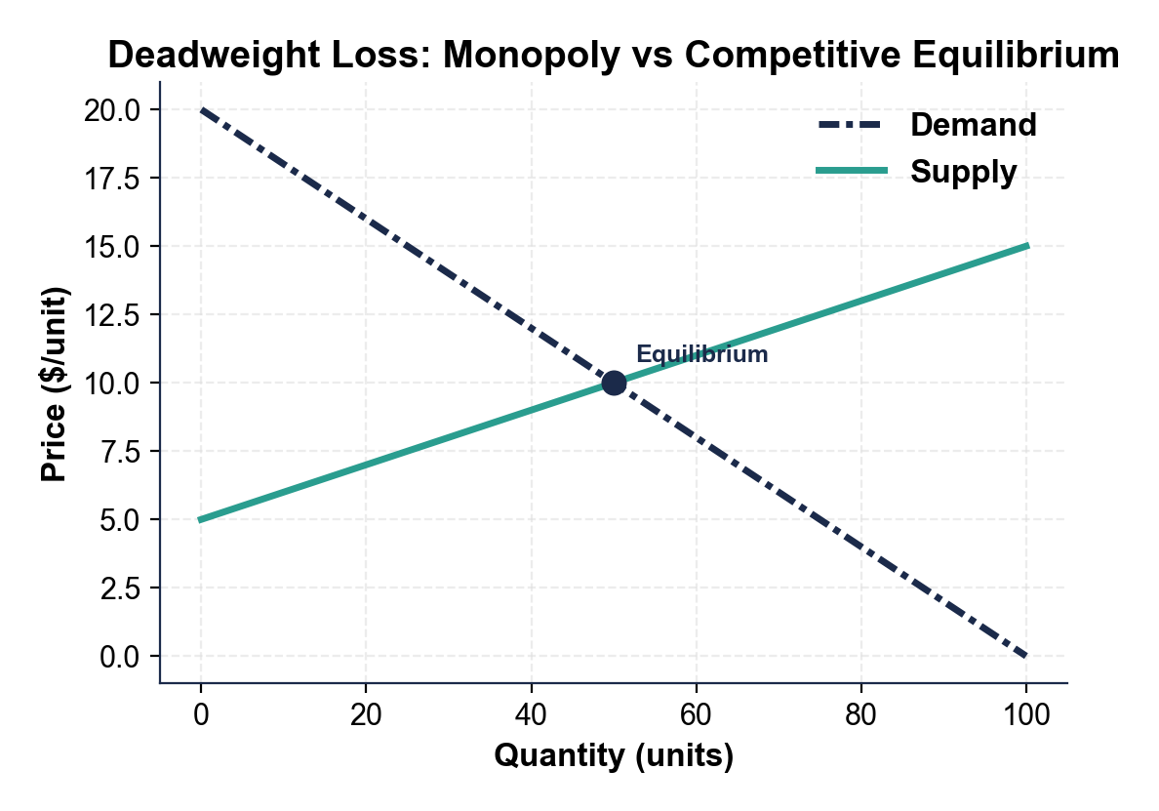
CHART REFERENCE 3: U.S. BRAND-NAME VS GENERIC DRUG PRICES
Use Chart Reference 3 (chart_drug_price_comparison) - the bar chart comparing patented brand-name drug prices to their generic equivalents shown below.
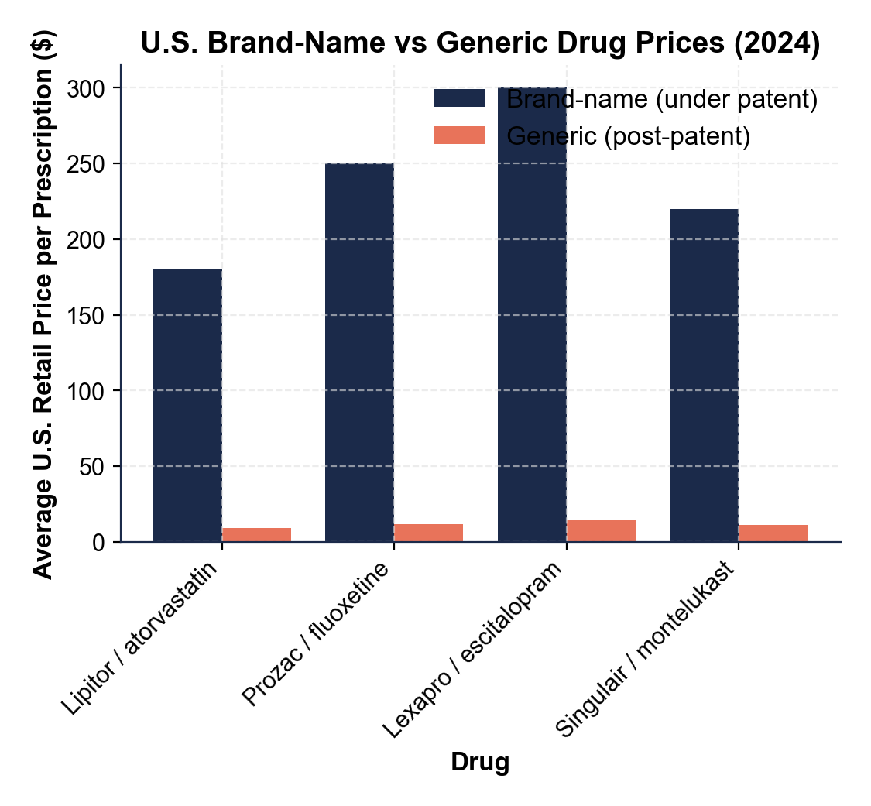

MORE LESSONS LESS PLANNING
Thank You!
If you enjoyed this product, please do not forget to rate and review to assist other teachers.

Looking for future discounts? Earn TPT credits by reviewing purchased products.

Please contact me if you have any issues with this product. Just like our students, I am always looking for opportunities to grow.

