Monopolistic Competition: Brand Wars
STUDENT ACTIVITY
Name: | Date: | Period:
ESSENTIAL QUESTION
Why do you pay $5.50 for a Starbucks latte when the coffee next door is basically the same?
THE SCENARIO
You are a high school senior selected for a 4-week summer internship at a Chicago brand-consulting firm. MARCUS VELEZ, a marketing analyst at the firm, has been assigned to mentor you through how brand consultants advise monopolistically competitive U.S. firms (restaurants, athletic apparel brands, coffee shops, hair salon chains) on PRODUCT DIFFERENTIATION strategy - especially how to build the brand image and non-price competition tools that justify a price premium in a market with hundreds of thousands of close substitutes.
BY THE END, YOU CAN:
✓ Define MONOPOLISTIC COMPETITION using its four defining features (many sellers, differentiated products, free entry and exit, some price-setting power) and place it on the Unit 3 spectrum between Perfect Competition (TK 21) and Oligopoly (TK 23)
✓ Explain PRODUCT DIFFERENTIATION as the engine of monopolistic competition - identify the four types (physical, service, location, brand image) and use real industry examples (restaurants, clothing, coffee shops, hair salons) to show how differentiation creates SOME pricing power without crossing into oligopoly territory
✓ Analyze ADVERTISING and BRAND WARS - explain why monopolistically competitive firms spend heavily on advertising, evaluate the difference between informative and persuasive ads, and identify why this structure produces ZERO LONG-RUN ECONOMIC PROFIT despite short-run pricing power
HOW IT WORKS (do Parts 1–5 in order)
Part 1 — Monopolistic Competition Reference Guide - Complete the Missing Terms
Part 2 — Apply the Terms - Monopolistic Competition Vocabulary in Context
Part 3 — You Read the Three MC Charts with Marcus Velez
Part 4 — Four Real-Market Scenarios with Marcus Velez - Apply the Model
Part 5 — Your Final Brand Strategy Memo to Marcus
TIME about 45 minutes YOU’LL NEED the lesson slides and your Guided Notes.

PART 1

Monopolistic Competition Reference Guide - Complete the Missing Terms
Fill in the missing term for each blank row — the definition is your clue. Your Guided Notes and the lesson slides have every term.

Term | Definition
___________ | A market structure with MANY SELLERS who each offer DIFFERENTIATED (not identical) products; free entry and exit; each firm has SOME limited pricing power because its product is unique but faces many close substitutes; the most common real-world market structure
Product differentiation | The strategy of making a product DISTINCT from competitors' products through real differences (ingredients, materials, design) or perceived differences (brand image, advertising, packaging); the defining feature of monopolistic competition that gives each firm a sloped demand curve
___________ | The CONSUMER PERCEPTION of a product built through advertising, packaging, celebrity endorsement, and store experience; lets monopolistically competitive firms charge a price premium even when the underlying product is similar to rivals (e.g., Starbucks vs Dunkin coffee)
Non-price competition | Competition through means OTHER THAN price - advertising, location, customer service, product features, store design, loyalty programs; dominates monopolistic competition because price cuts are easy for rivals to match
___________ | The condition that new firms can enter the market with low startup costs and existing firms can leave without major losses; drives long-run economic profits to ZERO in monopolistic competition (new entrants compete away any excess profit)
Zero economic profit (long run) | The condition where firms earn only normal profit (just enough to cover opportunity costs); occurs in monopolistic competition's long run because free entry attracts new firms whenever profits are positive, shifting each firm's demand curve until profit equals zero
___________ | Firms operate BELOW efficient scale - empty tables, empty chairs; the MC inefficiency where each firm cannot fill capacity because too many differentiated firms split the customer base
Informative advertising | Advertising that conveys FACTUAL product information - price, features, availability, store hours
___________ | Advertising designed to build brand image and emotional attachment without factual product information
Variety vs efficiency tradeoff | The economic tradeoff in monopolistic competition: consumers get more PRODUCT VARIETY (many restaurants, many coffee brands, many clothing styles) but pay slightly higher prices and the market produces below efficient scale; most economists view the variety benefit as worth the small inefficiency

PART 2

Apply the Terms - Monopolistic Competition Vocabulary in Context
WORD BANK differentiation · monopolistic competition · entry exit · brand image · excess capacity
1. Marcus starts with the big label. A market with MANY sellers, DIFFERENTIATED products, free entry and exit, and some limited pricing power - the most common real market structure - is called .

2. Marcus says the engine of this structure has a name. Making your product DISTINCT from rivals through real differences (ingredients, design) or perceived differences (advertising, packaging) is called product .

3. Marcus explains why Starbucks can charge more than the shop next door. The consumer PERCEPTION built through advertising, packaging, and store experience that lets a firm charge a price premium is its .

4. Marcus points to the reason long-run profit disappears. The condition that lets new firms enter cheaply and existing firms leave easily - which competes long-run economic profit down to zero - is free and .

5. Marcus names the structural inefficiency of this market. When firms operate BELOW efficient scale - empty tables, empty salon chairs - because too many differentiated firms split the customers, economists call it .

PART 3

You Read the Three MC Charts with Marcus Velez
1. Use Chart Reference 1 (chart_mc_industry_size) - the U.S. monopolistic-competition firm-count bar chart shown below - to read the scale of MC industries.
(a) For EACH of the five industries on the chart, state the firm count in thousands.

(b) Rank the five industries from MOST firms to LEAST firms.

(c) Compute the ratio between restaurants and the smallest industry on the chart.

(d) In 1-2 sentences, explain why having hundreds of thousands of firms makes price coordination structurally impossible (contrast with oligopoly).

2. Use Chart Reference 2 (chart_advertising_intensity) - the advertising-intensity bar chart shown below - to read the SIGNATURE behavior of MC firms.
(a) For each of the five industries on the chart, state the ad-spend percentage of revenue.

(b) Identify the highest-spending industry.

(c) State the typical industry average (the chart shows this in the alt text or compare to general knowledge - 1-2% is the standard baseline).

(d) For EACH of the five industries, compute the ratio of its ad-intensity to the 1.5% midpoint of the typical average.

(e) In 1-2 sentences, explain WHY MC industries spend so much more on advertising than the typical industry average.

3. Use Chart Reference 3 (chart_long_run_zero_profit) - the short-run vs long-run MC demand curve shown below - to read the long-run adjustment that drives MC profits to zero.
(a) From the SHORT-RUN demand curve, state the price and quantity at the firm's operating point.

(b) From the LONG-RUN demand curve, state the price and quantity at the new long-run operating point.

(c) State the direction the demand curve SHIFTS over time (left or right) and the mechanism that causes the shift.

(d) Compute the short-run profit per unit and the long-run profit per unit.

(e) In 1-2 sentences, explain what this means for big MC brands like Starbucks and Nike - do they earn permanent monopoly-like profits?

PART 4

Four Real-Market Scenarios with Marcus Velez - Apply the Model
1. DIAGNOSE FOUR REAL MC MARKETS. Marcus gives you four monopolistically competitive industries to diagnose:
(a) U.S. RESTAURANTS

(b) STARBUCKS VS DUNKIN coffee market

(c) NIKE VS ADIDAS athletic apparel market

(d) U.S. HAIR SALONS. For EACH industry, rate it 0-10 on EACH of the four features, give a 1-sentence justification, then identify which of the four differentiation types (physical, service, location, brand image) it uses MOST HEAVILY.

2. IDENTIFY THREE BRAND PREMIUMS IN YOUR OWN LIFE. Marcus asks you to think about brands YOU personally pay a premium for over a generic alternative. Pick THREE real brands you actually use (or have purchased) in the past year - one from each of three different MC industries (restaurants, clothing/apparel, coffee shops, food/snacks, athletic apparel, electronics accessories, beauty/personal care, etc.). For EACH brand:
(a) Name the brand AND a cheaper generic alternative for the same product type.

(b) Estimate the price premium as a percent (e.g., "$5.50 vs $3.50 = 60% premium").

(c) Identify which of the four differentiation types (physical, service, location, brand image) drives the premium most.

3. DIAGNOSE A SHORT-RUN VS LONG-RUN STORY. Marcus shows you a 2024 case: SMASH-BURGER SHOPS (small-batch hand-pressed burger restaurants - Smashburger, MrBeast Burger, smaller local chains). The category exploded from 2019 to 2023 - 150+ new chains opened in U.S. cities. By 2024-2025, dozens of chains were closing. Apply the MC model:
(a) What was the SHORT-RUN economic profit pattern in 2019-2022?

(b) What does the long-run zero-profit model predict happened next?

(c) Which of the four differentiation types did smash-burger chains use most heavily, and why was it not enough to sustain profits long-term?

(d) In 1-2 sentences, recommend what a smash-burger chain should do NOW to survive the shake-out.

4. EVALUATE A POLICY DEBATE ABOUT MC ADVERTISING. Some economists argue that PERSUASIVE advertising in MC is socially WASTEFUL (consumers pay for ads through higher prices but get no real product information). Others argue that persuasive advertising is socially VALUABLE (it lets firms differentiate and gives consumers more product variety to choose from). Marcus asks you to evaluate:
(a) State the WASTEFUL case in 1-2 sentences - cite a specific industry from the advertising-intensity chart.

(b) State the VALUABLE case in 1-2 sentences - cite a specific industry from the chart.

(c) Take a position - is persuasive advertising in MC mostly wasteful or mostly valuable? Defend with one substantive reason.

(d) Identify ONE policy intervention that could limit wasteful advertising without destroying valuable differentiation.

PART 5

Your Final Brand Strategy Memo to Marcus
BRAND STRATEGY MEMO
1. Marcus closes the internship with a real client problem.
MEDITERRANEAN MARK - a fast-casual chain serving Mediterranean bowls, hummus, falafel, and kabobs - is launching 25 locations across five major U.S. cities (Chicago, Atlanta, Phoenix, Boston, Seattle) over the next 18 months with $50M in startup capital, entering a market already crowded with Chipotle, Cava, and Sweetgreen. Using everything you learned about monopolistic competition in Parts 1-4, and using all four required terms (monopolistic competition, product differentiation, non-price competition, zero economic profit) at least once each, what 6-8 sentence brand strategy do you recommend for Mediterranean Mark, and which of the four differentiation types (physical, service, location, brand image) should they prioritize most heavily?
YOUR RESPONSE MUST:
☐ Names the MARKET STRUCTURE (MONOPOLISTIC COMPETITION) and cites at least one specific fact about U.S. restaurants from the lesson (750,000 firms, CR4 around 10%, 60% year-1 failure, $50-200K startup cost).
☐ Recommends a PRIMARY differentiation type out of the four (physical, service, location, brand image) AND a secondary type - with one sentence of reasoning for each choice.
☐ Uses the term PRODUCT DIFFERENTIATION correctly - explains how Mediterranean Mark will distinguish itself from existing fast-casual restaurants (Chipotle, Cava, Sweetgreen).
☐ Uses the phrase NON-PRICE COMPETITION correctly - explains why Mediterranean Mark should NOT compete on price (price cuts get matched; differentiation is the better weapon).
☐ Uses the term ZERO ECONOMIC PROFIT correctly - acknowledges that even successful differentiation will eventually face the long-run zero-profit adjustment, and explains how Mediterranean Mark should plan for it (continuous innovation, loyalty programs, switching costs).
☐ Quotes at least ONE specific value from the chart appendix (e.g., 750K U.S. restaurants, 4.5% QSR ad spend, $20 short-run vs $0 long-run profit per unit) to ground the strategy in real data.
☐ Closes with a SPECIFIC FIRST-YEAR ACTION the client should take (e.g., launch with a signature physical-differentiation item like a proprietary garlic-tahini sauce; open all 25 stores in premium-walkability locations; partner with three local Mediterranean cooking influencers per city for persuasive advertising).
MEMO
To: Marcus Velez, Brand Consultant
From:
Date:
Re: Brand Strategy Recommendation - Mediterranean Mark Launch

CHART REFERENCE 1: NUMBER OF FIRMS IN U.S. MONOPOLISTIC COMPETITION INDUSTRIES
Use Chart Reference 1 (chart_mc_industry_size) - the U.S. monopolistic-competition firm-count bar chart shown below.
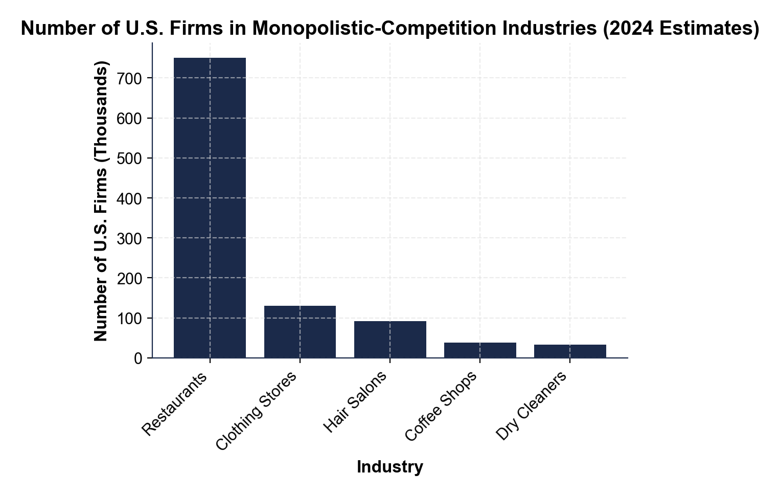
CHART REFERENCE 2: ADVERTISING SPEND AS % OF REVENUE (MC INDUSTRIES)
Use Chart Reference 2 (chart_advertising_intensity) - the advertising-intensity bar chart shown below.
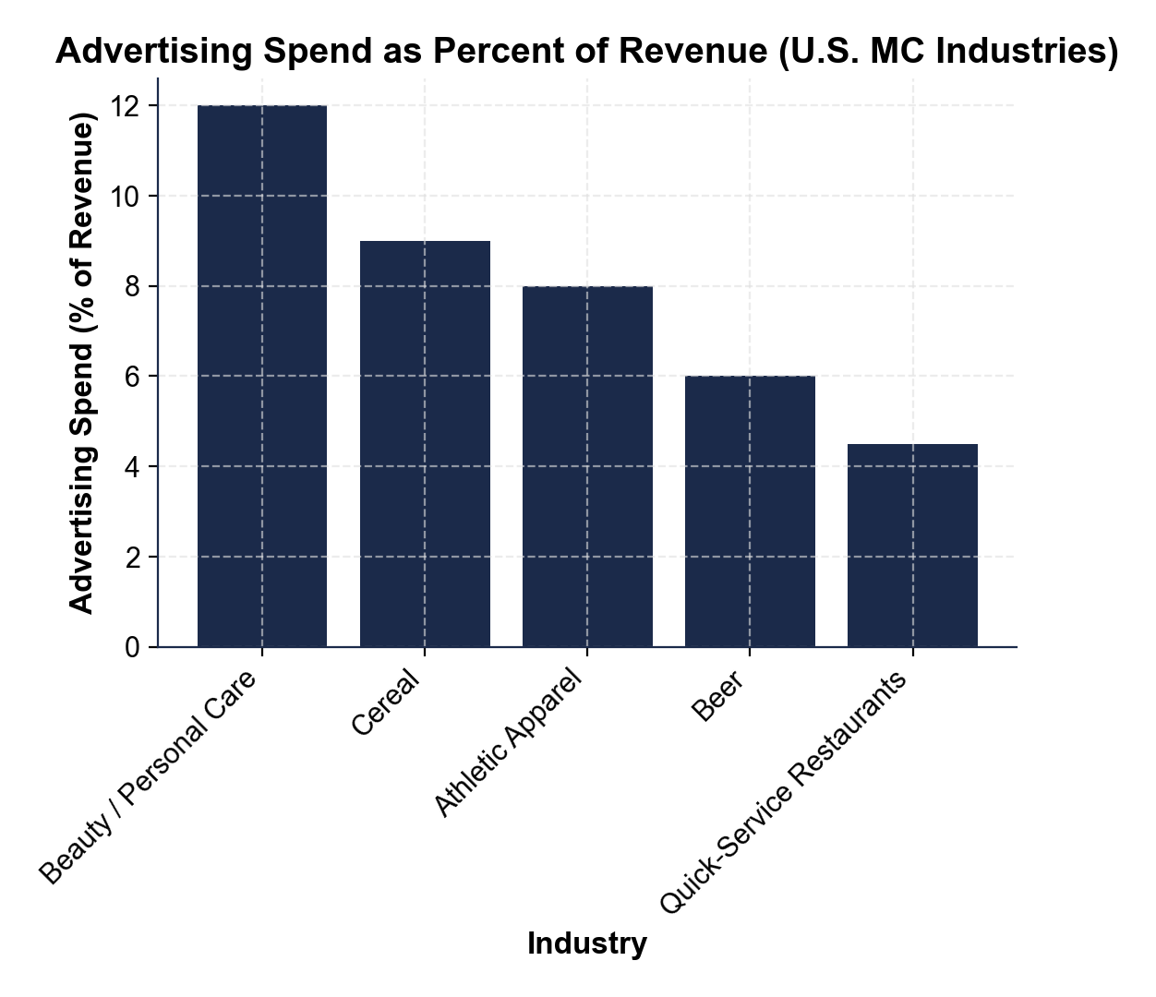
CHART REFERENCE 3: SHORT-RUN VS LONG-RUN MC DEMAND CURVE - FREE ENTRY DRIVES PROFIT TO ZERO
Use Chart Reference 3 (chart_long_run_zero_profit) - the short-run vs long-run MC demand curve diagram shown below.
