ECONOMICS

MONOPOLISTIC COMPETITION: BRAND WARS
ANSWER KEY ACTIVITY - ANSWER KEY

PART 1

Monopolistic Competition Reference Guide - Complete the Missing Terms

Term | Definition
Monopolistic competition | A market structure with MANY SELLERS who each offer DIFFERENTIATED (not identical) products; free entry and exit; each firm has SOME limited pricing power because its product is unique but faces many close substitutes; the most common real-world market structure
Product differentiation | The strategy of making a product DISTINCT from competitors' products through real differences (ingredients, materials, design) or perceived differences (brand image, advertising, packaging); the defining feature of monopolistic competition that gives each firm a sloped demand curve
Brand image | The CONSUMER PERCEPTION of a product built through advertising, packaging, celebrity endorsement, and store experience; lets monopolistically competitive firms charge a price premium even when the underlying product is similar to rivals (e.g., Starbucks vs Dunkin coffee)
Non-price competition | Competition through means OTHER THAN price - advertising, location, customer service, product features, store design, loyalty programs; dominates monopolistic competition because price cuts are easy for rivals to match
Free entry and exit | The condition that new firms can enter the market with low startup costs and existing firms can leave without major losses; drives long-run economic profits to ZERO in monopolistic competition (new entrants compete away any excess profit)
Zero economic profit (long run) | The condition where firms earn only normal profit (just enough to cover opportunity costs); occurs in monopolistic competition's long run because free entry attracts new firms whenever profits are positive, shifting each firm's demand curve until profit equals zero
Excess capacity | Firms operate BELOW efficient scale - empty tables, empty chairs; the MC inefficiency where each firm cannot fill capacity because too many differentiated firms split the customer base
Informative advertising | Advertising that conveys FACTUAL product information - price, features, availability, store hours
Persuasive advertising | Advertising designed to build brand image and emotional attachment without factual product information
Variety vs efficiency tradeoff | The economic tradeoff in monopolistic competition: consumers get more PRODUCT VARIETY (many restaurants, many coffee brands, many clothing styles) but pay slightly higher prices and the market produces below efficient scale; most economists view the variety benefit as worth the small inefficiency

PART 2

Apply the Terms - Monopolistic Competition Vocabulary in Context
WORD BANK differentiation · monopolistic competition · entry exit · brand image · excess capacity
1. Marcus starts with the big label. A market with MANY sellers, DIFFERENTIATED products, free entry and exit, and some limited pricing power - the most common real market structure - is called monopolistic competition.
monopolistic competition
2. Marcus says the engine of this structure has a name. Making your product DISTINCT from rivals through real differences (ingredients, design) or perceived differences (advertising, packaging) is called product differentiation.
differentiation. Product differentiation is the engine of monopolistic competition; it gives each firm a downward-sloping demand curve and some pricing power even though close substitutes exist.
3. Marcus explains why Starbucks can charge more than the shop next door. The consumer PERCEPTION built through advertising, packaging, and store experience that lets a firm charge a price premium is its brand image.
brand image
4. Marcus points to the reason long-run profit disappears. The condition that lets new firms enter cheaply and existing firms leave easily - which competes long-run economic profit down to zero - is free entry and exit.
entry exit
5. Marcus names the structural inefficiency of this market. When firms operate BELOW efficient scale - empty tables, empty salon chairs - because too many differentiated firms split the customers, economists call it excess capacity.
excess capacity
PART 3

You Read the Three MC Charts with Marcus Velez
1. Use Chart Reference 1 (chart_mc_industry_size) - the U.S. monopolistic-competition firm-count bar chart shown below - to read the scale of MC industries.
(a) For EACH of the five industries on the chart, state the firm count in thousands.
FIRM COUNTS: Restaurants 750,000. Clothing stores 130,000.
(b) Rank the five industries from MOST firms to LEAST firms.
RANK from most to least: Restaurants (750K) > Clothing Stores (130K) > Hair Salons (92K) > Coffee Shops (38K) > Dry Cleaners (33K).
(c) Compute the ratio between restaurants and the smallest industry on the chart.
RATIO: 750/33 = roughly 23x. Restaurants have about 23 times more firms than dry cleaners.
(d) In 1-2 sentences, explain why having hundreds of thousands of firms makes price coordination structurally impossible (contrast with oligopoly).
With 750,000 firms in restaurants, NO single firm can affect the market price. Each firm acts independently.
2. Use Chart Reference 2 (chart_advertising_intensity) - the advertising-intensity bar chart shown below - to read the SIGNATURE behavior of MC firms.
(a) For each of the five industries on the chart, state the ad-spend percentage of revenue.
AD-SPEND %: Beauty / personal care 12%. Cereal 9%.
(b) Identify the highest-spending industry.
HIGHEST: Beauty and personal care at 12% of revenue.
(c) State the typical industry average (the chart shows this in the alt text or compare to general knowledge - 1-2% is the standard baseline).
TYPICAL INDUSTRY AVERAGE: about 1-2% (use 1.5% as the midpoint baseline).
(d) For EACH of the five industries, compute the ratio of its ad-intensity to the 1.5% midpoint of the typical average.
RATIOS to 1.5%: Beauty 12/1.5 = 8x. Cereal 9/1.5 = 6x. Athletic apparel 8/1.5 = 5.3x. Beer 6/1.5 = 4x. QSR 4.5/1.5 = 3x. EVERY MC industry on the chart spends 3-8 times more than the typical baseline.
(e) In 1-2 sentences, explain WHY MC industries spend so much more on advertising than the typical industry average.
MC firms spend heavily on advertising because PRODUCT DIFFERENTIATION (especially brand-image differentiation) is the primary competitive weapon in MC. Price cuts are instantly matched by rivals so they accomplish nothing. Advertising, by contrast, BUILDS BRAND IMAGE that justifies a price premium - which is why beauty/personal care (where products are physically very similar) leads the chart at 12%.
3. Use Chart Reference 3 (chart_long_run_zero_profit) - the short-run vs long-run MC demand curve shown below - to read the long-run adjustment that drives MC profits to zero.
(a) From the SHORT-RUN demand curve, state the price and quantity at the firm's operating point.
SHORT-RUN: price = $30, quantity = 80 units. The firm sells 80 units at $30 each.
(b) From the LONG-RUN demand curve, state the price and quantity at the new long-run operating point.
LONG-RUN: price = $15, quantity = 40 units. The firm sells only 40 units at $15 each after the market adjusts.
(c) State the direction the demand curve SHIFTS over time (left or right) and the mechanism that causes the shift.
The demand curve shifts LEFT over time. MECHANISM: positive short-run economic profit attracts new firms; each new firm steals some customers from the existing firm; demand for each firm shifts left until price equals average cost.
(d) Compute the short-run profit per unit and the long-run profit per unit.
SHORT-RUN profit per unit = $30 - $10 (average cost) = $20 per unit. LONG-RUN profit per unit = $15 - $15 (average cost) = $0 per unit (zero economic profit; normal profit only).
(e) In 1-2 sentences, explain what this means for big MC brands like Starbucks and Nike - do they earn permanent monopoly-like profits?
Even big MC brands like Starbucks and Nike earn ZERO long-run economic profit because free entry keeps competing their differentiation away. Their high accounting profit is mostly NORMAL profit (the opportunity cost of capital, what they could earn investing elsewhere) - not excess monopoly-like profit.
PART 4

Four Real-Market Scenarios with Marcus Velez - Apply the Model
1. DIAGNOSE FOUR REAL MC MARKETS. Marcus gives you four monopolistically competitive industries to diagnose:
(a) U.S. RESTAURANTS
U.S. RESTAURANTS: Many sellers 10/10 (750K firms). Differentiated 10/10 (every menu unique). Free entry 10/10 ($50-200K startup; 60% year-1 failure). Some pricing power 7-8/10 ($18 burger costs $7). DOMINANT DIFFERENTIATION TYPE: a mix of PHYSICAL (menu) and BRAND IMAGE (restaurant vibe/concept) - varies by restaurant.
(b) STARBUCKS VS DUNKIN coffee market
STARBUCKS VS DUNKIN COFFEE: Many sellers 9/10 (38K U.S. shops). Differentiated 10/10 (premium vs value positioning). Free entry 9/10 ($30-300K startup). Some pricing power 8/10 (Starbucks 60% premium over Dunkin). DOMINANT DIFFERENTIATION: BRAND IMAGE (Starbucks third-place vibe; Dunkin working-class identity) reinforced by SERVICE (Starbucks barista experience; Dunkin speed).
(c) NIKE VS ADIDAS athletic apparel market
NIKE VS ADIDAS ATHLETIC APPAREL: Many sellers 7/10 (thousands of brands but Nike + Adidas dominate). Differentiated 10/10 (huge brand differentiation). Free entry 7/10 (D2C is low cost; big retail is hard). Some pricing power 9/10 (Lululemon $98 vs Champion $25 - 3.9x premium). DOMINANT DIFFERENTIATION: BRAND IMAGE - athlete endorsements (Nike's Jordan, LeBron) and lifestyle positioning (Lululemon yoga, Adidas retro).
(d) U.S. HAIR SALONS. For EACH industry, rate it 0-10 on EACH of the four features, give a 1-sentence justification, then identify which of the four differentiation types (physical, service, location, brand image) it uses MOST HEAVILY.
U.S. HAIR SALONS: Many sellers 10/10 (92K firms). Differentiated 9/10 (each salon has its own stylists, vibe). Free entry 9/10 ($25-100K startup). Some pricing power 7/10 ($80 haircut vs $20 cuts). DOMINANT DIFFERENTIATION: a mix of SERVICE (stylist expertise/relationship) and LOCATION (neighborhood proximity).
2. IDENTIFY THREE BRAND PREMIUMS IN YOUR OWN LIFE. Marcus asks you to think about brands YOU personally pay a premium for over a generic alternative. Pick THREE real brands you actually use (or have purchased) in the past year - one from each of three different MC industries (restaurants, clothing/apparel, coffee shops, food/snacks, athletic apparel, electronics accessories, beauty/personal care, etc.). For EACH brand:
(a) Name the brand AND a cheaper generic alternative for the same product type.
(b) Estimate the price premium as a percent (e.g., "$5.50 vs $3.50 = 60% premium").
(c) Identify which of the four differentiation types (physical, service, location, brand image) drives the premium most.
(Accept any defensible brand choices with reasonable premium estimates.) Sample answer 1 - COFFEE: (a) Starbucks vs grocery store coffee. (b) Starbucks latte $5.50 vs $2 home-brewed coffee with milk = 175% premium. (c) BRAND IMAGE differentiation (Starbucks third-place vibe) + SERVICE (barista experience) drive the premium. Sample answer 2 - ATHLETIC APPAREL: (a) Nike Dri-FIT shirt vs Hanes athletic shirt. (b) Nike $35 vs Hanes $12 = 192% premium. (c) BRAND IMAGE differentiation (Nike's athletic identity, athlete endorsements) drives the premium. The shirts are functionally similar - cotton/poly blend. Sample answer 3 - SNACK FOOD: (a) Cheetos vs store-brand cheese puffs. (b) Cheetos $4.50 vs Great Value cheese puffs $2.50 = 80% premium. (c) PHYSICAL differentiation (Cheetos recipe is genuinely different) + BRAND IMAGE differentiation (the Chester Cheetah brand) jointly drive the premium. Sample answer 4 - SNEAKERS: (a) Air Jordan retro vs generic basketball shoe at Walmart. (b) Air Jordan $180 vs Walmart sneaker $35 = 414% premium. (c) BRAND IMAGE differentiation (Jordan brand, MJ endorsement, cultural status) dominates. Some physical differentiation in cushioning but most of the premium is brand image. Sample answer 5 - PHONES: (a) Apple iPhone vs comparable Android (Samsung Galaxy or Google Pixel). (b) iPhone $800-1200 vs Android $300-600 = 100-200% premium. (c) BRAND IMAGE differentiation (Apple ecosystem, premium tech identity) plus SERVICE (Apple Store support).

3. DIAGNOSE A SHORT-RUN VS LONG-RUN STORY. Marcus shows you a 2024 case: SMASH-BURGER SHOPS (small-batch hand-pressed burger restaurants - Smashburger, MrBeast Burger, smaller local chains). The category exploded from 2019 to 2023 - 150+ new chains opened in U.S. cities. By 2024-2025, dozens of chains were closing. Apply the MC model:
(a) What was the SHORT-RUN economic profit pattern in 2019-2022?
In 2019-2022, smash-burger chains were earning HIGH POSITIVE short-run economic profit. The category was novel; consumers were willing to pay $14-18 for a smash burger that cost $5-7 to make.
(b) What does the long-run zero-profit model predict happened next?
The long-run zero-profit model predicts what happened: free entry kept attracting new chains until the market saturated. Demand for each existing chain shifted LEFT (customers split across many similar concepts).
(c) Which of the four differentiation types did smash-burger chains use most heavily, and why was it not enough to sustain profits long-term?
Most smash-burger chains relied heavily on BRAND IMAGE differentiation (trendy hand-pressed concept, influencer marketing, Instagram aesthetic). PHYSICAL differentiation was modest - smash burgers are technically similar across chains.
(d) In 1-2 sentences, recommend what a smash-burger chain should do NOW to survive the shake-out.
RECOMMENDATION: lean harder on the OTHER differentiation types. Add SERVICE differentiation (loyalty programs, faster service, app-only deals).
4. EVALUATE A POLICY DEBATE ABOUT MC ADVERTISING. Some economists argue that PERSUASIVE advertising in MC is socially WASTEFUL (consumers pay for ads through higher prices but get no real product information). Others argue that persuasive advertising is socially VALUABLE (it lets firms differentiate and gives consumers more product variety to choose from). Marcus asks you to evaluate:
(a) State the WASTEFUL case in 1-2 sentences - cite a specific industry from the advertising-intensity chart.
WASTEFUL CASE: in the BEAUTY/PERSONAL CARE industry (12% of revenue on ads, the highest on the chart), the underlying products are physically very similar across brands. The 12% ad-spend is purely persuasive brand-building. Consumers pay roughly 12% more than they would in a market with no advertising - and they receive no factual product information in exchange. Roughly $30B per year in U.S. beauty/personal care advertising is essentially transferred from consumer surplus to ad agencies and brand marketing without adding real value.
(b) State the VALUABLE case in 1-2 sentences - cite a specific industry from the chart.
VALUABLE CASE: in the QUICK-SERVICE RESTAURANTS industry (4.5% on ads), persuasive advertising builds the brand-image differentiation that gives consumers the VARIETY they value. The reason 750,000 U.S. restaurants can coexist (rather than collapsing to a few efficient cafeterias) is precisely because brand-image differentiation gives each restaurant a distinct identity. Consumers WANT this variety - they pick Chick-fil-A vs Wendy's vs Chipotle based on brand identity as much as price. Without persuasive advertising, the variety collapses.
(c) Take a position - is persuasive advertising in MC mostly wasteful or mostly valuable? Defend with one substantive reason.
TAKE A POSITION: (Accept any defensible position.) Sample - persuasive advertising is MOSTLY VALUABLE because it underwrites the differentiation that lets MC produce VARIETY (the consumer's preferred tradeoff over pure efficiency).
(d) Identify ONE policy intervention that could limit wasteful advertising without destroying valuable differentiation.
POLICY INTERVENTIONS: (1) Restrict persuasive advertising to children below age 13 (already partially regulated; could be extended). (2) Mandate disclosure of physical-vs-perceived differentiation on packaging for high-ad-intensity categories. (3) Tax persuasive advertising at a higher rate than informative advertising (technically difficult to enforce but would internalize the externality). (4) Require informative content (price, ingredients) in any ad over $1M annual spend.
PART 5

Your Final Brand Strategy Memo to Marcus
BRAND STRATEGY MEMO
1. Marcus closes the internship with a real client problem.
MEDITERRANEAN MARK - a fast-casual chain serving Mediterranean bowls, hummus, falafel, and kabobs - is launching 25 locations across five major U.S. cities (Chicago, Atlanta, Phoenix, Boston, Seattle) over the next 18 months with $50M in startup capital, entering a market already crowded with Chipotle, Cava, and Sweetgreen. Using everything you learned about monopolistic competition in Parts 1-4, and using all four required terms (monopolistic competition, product differentiation, non-price competition, zero economic profit) at least once each, what 6-8 sentence brand strategy do you recommend for Mediterranean Mark, and which of the four differentiation types (physical, service, location, brand image) should they prioritize most heavily?
YOUR RESPONSE MUST:
☐ Names the MARKET STRUCTURE (MONOPOLISTIC COMPETITION) and cites at least one specific fact about U.S. restaurants from the lesson (750,000 firms, CR4 around 10%, 60% year-1 failure, $50-200K startup cost).
☐ Recommends a PRIMARY differentiation type out of the four (physical, service, location, brand image) AND a secondary type - with one sentence of reasoning for each choice.
☐ Uses the term PRODUCT DIFFERENTIATION correctly - explains how Mediterranean Mark will distinguish itself from existing fast-casual restaurants (Chipotle, Cava, Sweetgreen).
☐ Uses the phrase NON-PRICE COMPETITION correctly - explains why Mediterranean Mark should NOT compete on price (price cuts get matched; differentiation is the better weapon).
☐ Uses the term ZERO ECONOMIC PROFIT correctly - acknowledges that even successful differentiation will eventually face the long-run zero-profit adjustment, and explains how Mediterranean Mark should plan for it (continuous innovation, loyalty programs, switching costs).
☐ Quotes at least ONE specific value from the chart appendix (e.g., 750K U.S. restaurants, 4.5% QSR ad spend, $20 short-run vs $0 long-run profit per unit) to ground the strategy in real data.
☐ Closes with a SPECIFIC FIRST-YEAR ACTION the client should take (e.g., launch with a signature physical-differentiation item like a proprietary garlic-tahini sauce; open all 25 stores in premium-walkability locations; partner with three local Mediterranean cooking influencers per city for persuasive advertising).
MEMO
To: Marcus Velez, Brand Consultant
From: [student completes]
Date: [student completes]
Re: Brand Strategy Recommendation - Mediterranean Mark Launch
GRADING RUBRIC
Grade the evidence and reasoning, not the conclusion — any defensible position is valid. Score against the 7 requirements above.
FULL CREDIT — clear position; meets all 7 requirements with accurate, specific numbers and evidence from the lesson.
PARTIAL — position stated, but misses 1-2 requirements or uses vague / incorrect numbers.
MINIMAL — no clear position, or missing most requirements and numbers.
CHART REFERENCE 1: NUMBER OF FIRMS IN U.S. MONOPOLISTIC COMPETITION INDUSTRIES
Use Chart Reference 1 (chart_mc_industry_size) - the U.S. monopolistic-competition firm-count bar chart shown below.
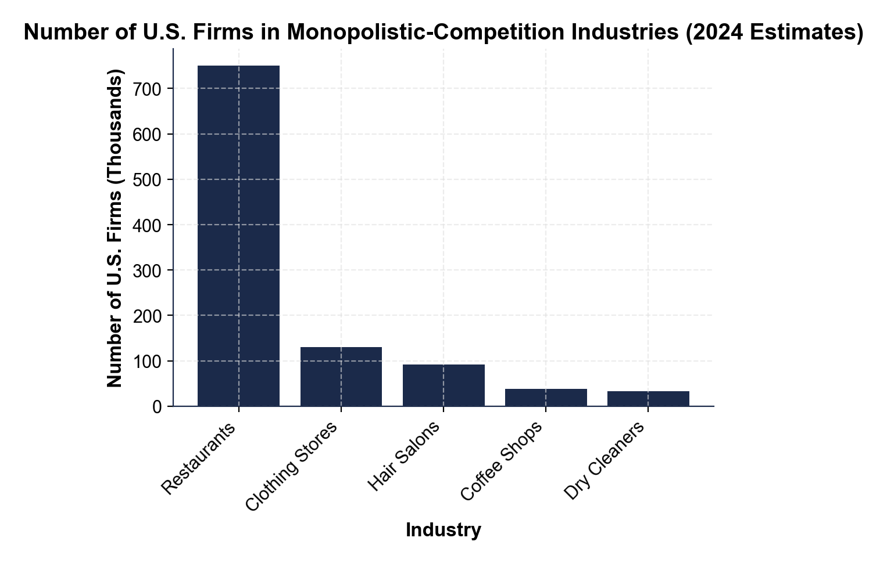
CHART REFERENCE 2: ADVERTISING SPEND AS % OF REVENUE (MC INDUSTRIES)
Use Chart Reference 2 (chart_advertising_intensity) - the advertising-intensity bar chart shown below.
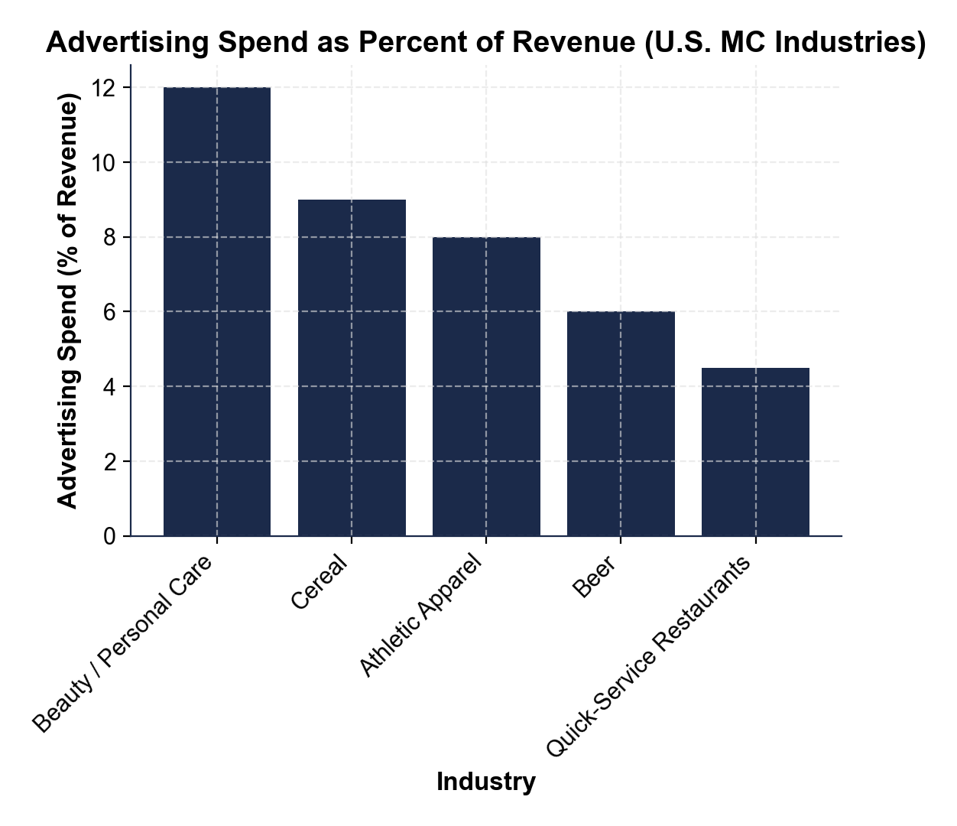
CHART REFERENCE 3: SHORT-RUN VS LONG-RUN MC DEMAND CURVE - FREE ENTRY DRIVES PROFIT TO ZERO
Use Chart Reference 3 (chart_long_run_zero_profit) - the short-run vs long-run MC demand curve diagram shown below.
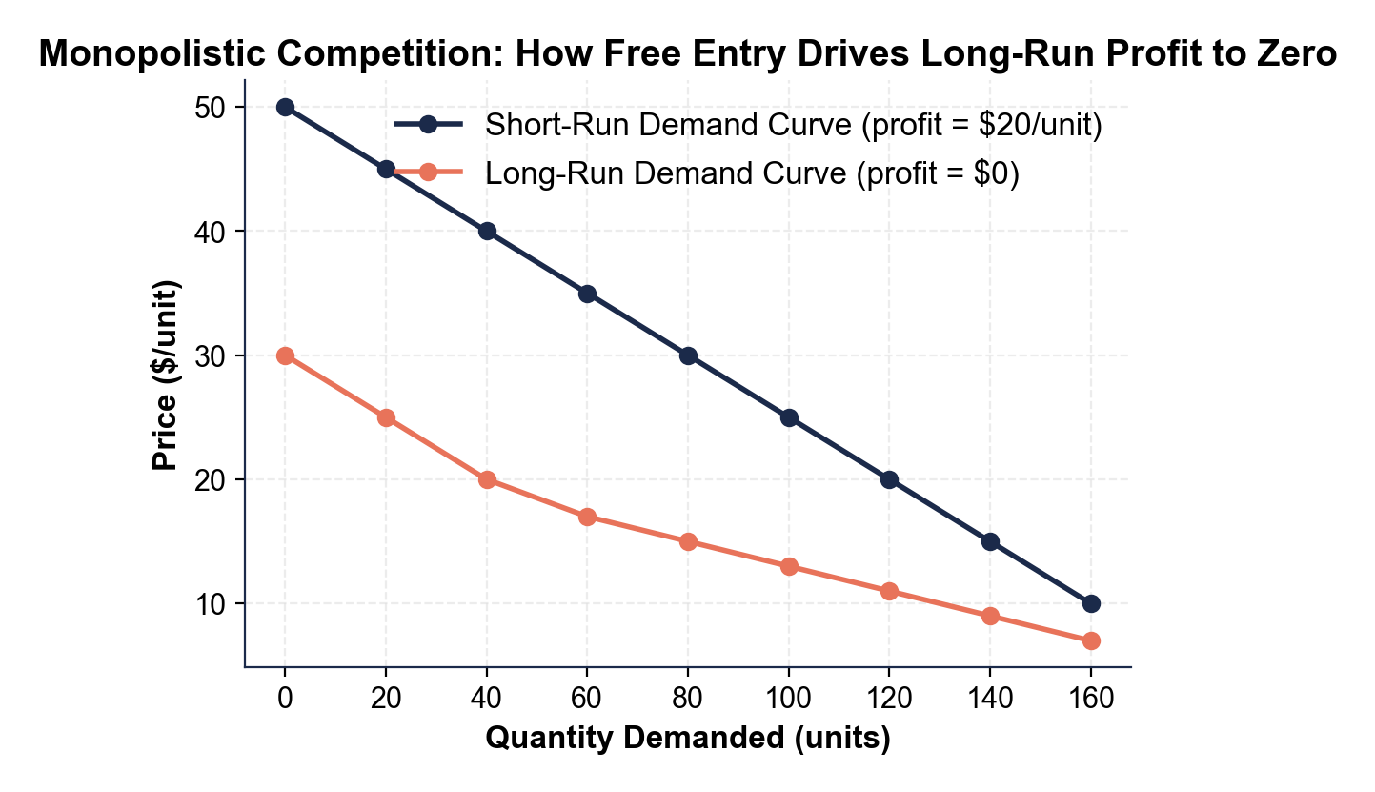

MORE LESSONS LESS PLANNING
Thank You!
If you enjoyed this product, please do not forget to rate and review to assist other teachers.

Looking for future discounts? Earn TPT credits by reviewing purchased products.

Please contact me if you have any issues with this product. Just like our students, I am always looking for opportunities to grow.

