Market Equilibrium: Where Supply Meets Demand
STUDENT ACTIVITY
Name: | Date: | Period:
ESSENTIAL QUESTION
What invisible force pulls every price back to where buyers and sellers agree?
THE SCENARIO
You are a high school senior doing a 1-week job-shadow at BELLA'S PIZZA KITCHEN, a busy pizzeria. JORDAN AVERY, the restaurant's market analyst, is teaching you how to combine the DEMAND schedule (what buyers want, from the demand lesson) and the SUPPLY schedule (what the kitchen makes, from the supply lesson) onto ONE chart to find the MARKET EQUILIBRIUM - the single price and quantity where quantity demanded exactly equals quantity supplied.
BY THE END, YOU CAN:
✓ Define MARKET EQUILIBRIUM and find the EQUILIBRIUM PRICE and EQUILIBRIUM QUANTITY where the demand and supply curves cross
✓ Identify a SURPLUS (price above equilibrium) and a SHORTAGE (price below equilibrium), and read each one off a supply-and-demand chart
✓ Explain HOW a market self-corrects - a surplus pushes the price DOWN and a shortage pushes the price UP, back toward equilibrium
HOW IT WORKS (do Parts 1–5 in order)
Part 1 — Market Equilibrium Reference Guide - Complete the Missing Terms
Part 2 — Apply the Terms - Market Equilibrium Vocabulary in Context
Part 3 — You Read All Three Charts with Jordan Avery
Part 4 — Four Real-Market Scenarios with Jordan Avery - Surplus, Shortage, or Clears?
Part 5 — Your Final Pricing Recommendation Memo to Jordan Avery
TIME about 45 minutes YOU’LL NEED the lesson slides and your Guided Notes.

PART 1

Market Equilibrium Reference Guide - Complete the Missing Terms
Fill in the missing term for each blank row — the definition is your clue. Your Guided Notes and the lesson slides have every term.

Term | Definition
___________ | The single price and quantity at which the quantity demanded exactly equals the quantity supplied; the point where the demand curve and the supply curve cross
Equilibrium price | The one price at which quantity demanded equals quantity supplied, so there is no surplus and no shortage; also called the market-clearing price
___________ | The quantity bought and sold at the equilibrium price, where the demand curve and the supply curve intersect
Surplus | When the price is set ABOVE equilibrium, the quantity supplied is greater than the quantity demanded, so unsold goods pile up; also called excess supply
___________ | When the price is set BELOW equilibrium, the quantity demanded is greater than the quantity supplied, so the good sells out; also called excess demand
Quantity demanded | The amount buyers are willing and able to buy at one specific price; read off the demand curve
___________ | The amount producers are willing and able to offer for sale at one specific price; read off the supply curve
Market-clearing price | Another name for the equilibrium price - the price that 'clears' the market by leaving no surplus and no shortage
___________ | Another name for a surplus - the amount by which quantity supplied exceeds quantity demanded when the price is above equilibrium
Excess demand | Another name for a shortage - the amount by which quantity demanded exceeds quantity supplied when the price is below equilibrium

PART 2

Apply the Terms - Market Equilibrium Vocabulary in Context
WORD BANK market equilibrium · surplus · quantity supplied · excess supply · shortage
1. Jordan starts you with a definition. The single price and quantity at which quantity demanded exactly equals quantity supplied - the one point where the demand curve and the supply curve cross - is called the .

2. The owner sets a price ABOVE the equilibrium, so the kitchen makes more pizzas than customers want and the extra ones go unsold. This excess supply is called a .

3. The owner sets a price BELOW the equilibrium, so customers want far more pizzas than the kitchen offers and it sells out by noon. This excess demand is called a .

4. Jordan points to the supply curve. The amount producers are willing and able to offer for sale at one specific price, read off the supply curve, is the .

5. Jordan asks for the other name for a surplus. The amount by which quantity supplied beats quantity demanded when the price is above equilibrium is called .

PART 3

You Read All Three Charts with Jordan Avery
1. Use Chart Reference 1 (chart_market_equilibrium) - the pizza market chart shown below - to find the equilibrium.
(a) Find the single point where the navy DEMAND curve and the teal SUPPLY curve cross.

(b) Read the EQUILIBRIUM PRICE up the vertical (price) axis.

(c) Read the EQUILIBRIUM QUANTITY across the horizontal (quantity) axis.

(d) At that equilibrium price, what is true about quantity demanded compared to quantity supplied?

2. Use Chart Reference 2 (chart_surplus_above_eq) - the surplus chart shown below - to measure a surplus. The coral dashed line marks a price of $12, which is ABOVE the $8 equilibrium.
(a) Trace the $12 price line across to the teal SUPPLY curve and read the quantity supplied.

(b) Trace the $12 price line across to the navy DEMAND curve and read the quantity demanded.

(c) Compute the SURPLUS (quantity supplied minus quantity demanded).

(d) In 1-2 sentences, explain what will happen to the price because of this surplus.

3. Use Chart Reference 3 (chart_shortage_below_eq) - the shortage chart shown below - to measure a shortage. The coral dashed line marks a price of $4, which is BELOW the $8 equilibrium.
(a) Trace the $4 price line across to the navy DEMAND curve and read the quantity demanded.

(b) Trace the $4 price line across to the teal SUPPLY curve and read the quantity supplied.

(c) Compute the SHORTAGE (quantity demanded minus quantity supplied).

(d) In 1-2 sentences, explain what will happen to the price because of this shortage.

4. CONNECT THE THREE CHARTS. Jordan points out that all three charts use the SAME pizza demand and supply curves.
(a) On the equilibrium chart (Chart 1), what price and quantity clear the market?

(b) On the surplus chart (Chart 2), is the $12 price line ABOVE or BELOW the equilibrium - and is the gap a surplus or a shortage?

(c) On the shortage chart (Chart 3), is the $4 price line ABOVE or BELOW the equilibrium - and is the gap a surplus or a shortage?

(d) In one sentence, state the rule connecting price position (above vs below equilibrium) to surplus vs shortage.

PART 4

Four Real-Market Scenarios with Jordan Avery - Surplus, Shortage, or Clears?
1. SURPLUS, SHORTAGE, or CLEARS? Jordan gives you four real situations. For EACH, decide whether the price creates a SURPLUS, a SHORTAGE, or CLEARS the market (equilibrium), and give a one-sentence reason.
Situation | Surplus / Shortage / Clears | Why?
A toy store prices the season's hottest toy WAY below what buyers would pay; it sells out in an hour and a line forms.
A bakery prices day-old bread so high that almost no one buys it and loaves pile up unsold.
A pizzeria sets its price at exactly the point where the demand and supply curves cross, and sells every pizza it makes with no line and no leftovers.
A clothing store marks winter coats far above equilibrium in March, and the racks stay full.

2. WHICH WAY DOES THE PRICE MOVE? For EACH situation below, decide whether the market price will RISE or FALL, and explain in a few words why.
Situation | Rise / Fall | Why?
A store has a big surplus of unsold goods.
A product has a shortage and is sold out everywhere with buyers competing for it.
A concert is priced below equilibrium and tickets vanish in seconds.
A warehouse is overflowing with unsold inventory the company priced too high.

3. SELF-CORRECTION CHECK. Jordan reminds you that an unregulated market is SELF-CORRECTING - it fixes a wrong price on its own.
(a) In plain English, what does it mean that a market is self-correcting?

(b) Walk the surplus case: a pizzeria starts at $12 (above the $8 equilibrium). In 1-2 sentences, describe the steps the price takes to fix the surplus and where it ends up.

(c) Walk the shortage case: a pizzeria starts at $4 (below the $8 equilibrium). In 1-2 sentences, describe the steps the price takes to fix the shortage and where it ends up.

4. PREDICT FROM THE TABLE. Using ONLY the combined pizza table (at $12: Qd 200, Qs 600; at $8: Qd 400, Qs 400; at $4: Qd 600, Qs 200), answer Jordan's prediction questions.
(a) At which price does quantity demanded EQUAL quantity supplied, and what is that price called?

(b) At $12, is there a surplus or a shortage, and how big is it?

(c) At $4, is there a surplus or a shortage, and how big is it?

(d) If Bella's is currently charging $12 and wants the market to clear, should it RAISE or LOWER the price, and to what?

PART 5

Your Final Pricing Recommendation Memo to Jordan Avery
PRICING RECOMMENDATION MEMO
1. Jordan closes out the job-shadow with one last task.
The owner of Bella's wants a single recommended price for next month, and Jordan needs you to back it up with the combined demand and supply data you have been working with. Using market equilibrium and the chart values, what price should Bella's charge so the market clears, and what would go wrong if the price were set too high or too low?
YOUR RESPONSE MUST:
☐ States what MARKET EQUILIBRIUM is - the price and quantity where quantity demanded equals quantity supplied (where the curves cross).
☐ Recommends the EQUILIBRIUM PRICE ($8) AND states the equilibrium quantity (400 pizzas) the market will clear at.
☐ Explains the SURPLUS that happens if the price is set too high (e.g., at $12: quantity supplied 600 beats quantity demanded 200, so 400 pizzas go unsold) and that the price would have to fall.
☐ Explains the SHORTAGE that happens if the price is set too low (e.g., at $4: quantity demanded 600 beats quantity supplied 200, so the kitchen sells out) and that the price would have to rise.
☐ Quotes at least ONE specific number from the charts or table (e.g., equilibrium at $8 and 400 pizzas, or the surplus/shortage of 400) to ground the recommendation in the data.
☐ Closes with a clear one-sentence reason WHY the equilibrium price is the right choice - it clears the market with no surplus and no shortage.
☐ Uses all four required terms at least once each: market equilibrium, equilibrium price, surplus, shortage.
MEMO
To: Jordan Avery, Market Analyst at Bella Pizza Kitchen
From:
Date:
Re: Pricing recommendation for next month

CHART REFERENCE 1: THE PIZZA MARKET - WHERE SUPPLY MEETS DEMAND
Use Chart Reference 1 (chart_market_equilibrium) - the pizza market chart shown below.
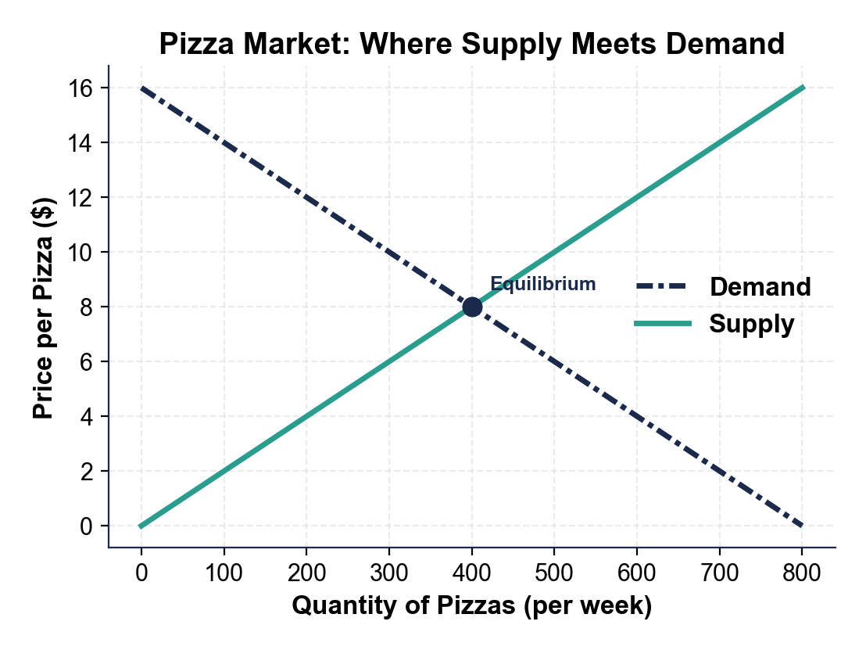
CHART REFERENCE 2: A SURPLUS - PRICE SET ABOVE EQUILIBRIUM
Use Chart Reference 2 (chart_surplus_above_eq) - the surplus chart shown below.
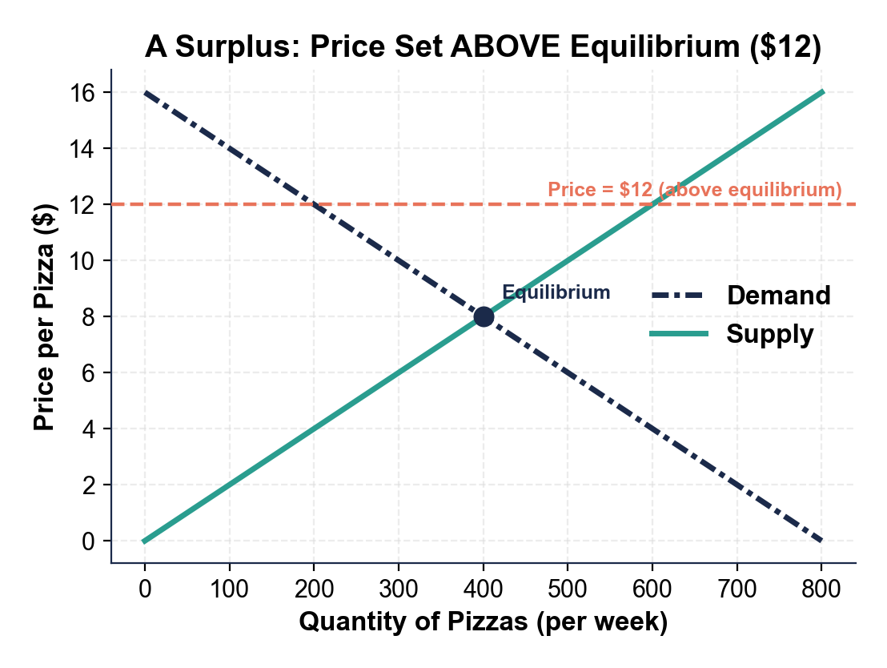
CHART REFERENCE 3: A SHORTAGE - PRICE SET BELOW EQUILIBRIUM
Use Chart Reference 3 (chart_shortage_below_eq) - the shortage chart shown below.
