ECONOMICS

MARKET EQUILIBRIUM: WHERE SUPPLY MEETS DEMAND
ANSWER KEY ACTIVITY - ANSWER KEY

PART 1

Market Equilibrium Reference Guide - Complete the Missing Terms

Term | Definition
Market equilibrium | The single price and quantity at which the quantity demanded exactly equals the quantity supplied; the point where the demand curve and the supply curve cross
Equilibrium price | The one price at which quantity demanded equals quantity supplied, so there is no surplus and no shortage; also called the market-clearing price
Equilibrium quantity | The quantity bought and sold at the equilibrium price, where the demand curve and the supply curve intersect
Surplus | When the price is set ABOVE equilibrium, the quantity supplied is greater than the quantity demanded, so unsold goods pile up; also called excess supply
Shortage | When the price is set BELOW equilibrium, the quantity demanded is greater than the quantity supplied, so the good sells out; also called excess demand
Quantity demanded | The amount buyers are willing and able to buy at one specific price; read off the demand curve
Quantity supplied | The amount producers are willing and able to offer for sale at one specific price; read off the supply curve
Market-clearing price | Another name for the equilibrium price - the price that 'clears' the market by leaving no surplus and no shortage
Excess supply | Another name for a surplus - the amount by which quantity supplied exceeds quantity demanded when the price is above equilibrium
Excess demand | Another name for a shortage - the amount by which quantity demanded exceeds quantity supplied when the price is below equilibrium

PART 2

Apply the Terms - Market Equilibrium Vocabulary in Context
WORD BANK market equilibrium · surplus · quantity supplied · excess supply · shortage
1. Jordan starts you with a definition. The single price and quantity at which quantity demanded exactly equals quantity supplied - the one point where the demand curve and the supply curve cross - is called the market equilibrium.
market equilibrium
2. The owner sets a price ABOVE the equilibrium, so the kitchen makes more pizzas than customers want and the extra ones go unsold. This excess supply is called a surplus.
surplus. A surplus happens when the price is above equilibrium and quantity supplied is greater than quantity demanded, so unsold goods pile up.
3. The owner sets a price BELOW the equilibrium, so customers want far more pizzas than the kitchen offers and it sells out by noon. This excess demand is called a shortage.
shortage. A shortage happens when the price is below equilibrium and quantity demanded is greater than quantity supplied, so the good sells out.
4. Jordan points to the supply curve. The amount producers are willing and able to offer for sale at one specific price, read off the supply curve, is the quantity supplied.
quantity supplied
5. Jordan asks for the other name for a surplus. The amount by which quantity supplied beats quantity demanded when the price is above equilibrium is called excess supply.
excess supply
PART 3

You Read All Three Charts with Jordan Avery
1. Use Chart Reference 1 (chart_market_equilibrium) - the pizza market chart shown below - to find the equilibrium.
(a) Find the single point where the navy DEMAND curve and the teal SUPPLY curve cross.
The two curves cross at one point - the navy demand curve (sloping down) meets the teal supply curve (sloping up) at the dot labeled "Equilibrium."
(b) Read the EQUILIBRIUM PRICE up the vertical (price) axis.
The EQUILIBRIUM PRICE is $8 (read up the vertical axis from the crossing point).
(c) Read the EQUILIBRIUM QUANTITY across the horizontal (quantity) axis.
The EQUILIBRIUM QUANTITY is 400 pizzas per week (read across the horizontal axis from the crossing point).
(d) At that equilibrium price, what is true about quantity demanded compared to quantity supplied?
At the $8 equilibrium price, quantity demanded EQUALS quantity supplied (both are 400 pizzas). That is why it is the equilibrium - there is no surplus and no shortage; the market clears.
2. Use Chart Reference 2 (chart_surplus_above_eq) - the surplus chart shown below - to measure a surplus. The coral dashed line marks a price of $12, which is ABOVE the $8 equilibrium.
(a) Trace the $12 price line across to the teal SUPPLY curve and read the quantity supplied.
At $12, the SUPPLY curve reads 600 pizzas (quantity supplied).
(b) Trace the $12 price line across to the navy DEMAND curve and read the quantity demanded.
At $12, the DEMAND curve reads 200 pizzas (quantity demanded).
(c) Compute the SURPLUS (quantity supplied minus quantity demanded).
SURPLUS = quantity supplied - quantity demanded = 600 - 200 = 400 unsold pizzas.
(d) In 1-2 sentences, explain what will happen to the price because of this surplus.
Because there is a surplus (the price is too high), the price will be pushed DOWN toward the $8 equilibrium. As the price falls, quantity demanded rises and quantity supplied falls until the surplus disappears and the market clears.

3. Use Chart Reference 3 (chart_shortage_below_eq) - the shortage chart shown below - to measure a shortage. The coral dashed line marks a price of $4, which is BELOW the $8 equilibrium.
(a) Trace the $4 price line across to the navy DEMAND curve and read the quantity demanded.
At $4, the DEMAND curve reads 600 pizzas (quantity demanded).
(b) Trace the $4 price line across to the teal SUPPLY curve and read the quantity supplied.
At $4, the SUPPLY curve reads 200 pizzas (quantity supplied).
(c) Compute the SHORTAGE (quantity demanded minus quantity supplied).
SHORTAGE = quantity demanded - quantity supplied = 600 - 200 = 400 pizzas.
(d) In 1-2 sentences, explain what will happen to the price because of this shortage.
Because there is a shortage (the price is too low), the price will be pushed UP toward the $8 equilibrium. As the price rises, quantity demanded falls and quantity supplied rises until the shortage disappears and the market clears.
4. CONNECT THE THREE CHARTS. Jordan points out that all three charts use the SAME pizza demand and supply curves.
(a) On the equilibrium chart (Chart 1), what price and quantity clear the market?
On Chart 1 the market clears at the equilibrium: PRICE $8 and QUANTITY 400 pizzas, where the curves cross.
(b) On the surplus chart (Chart 2), is the $12 price line ABOVE or BELOW the equilibrium - and is the gap a surplus or a shortage?
On Chart 2 the $12 line is ABOVE the $8 equilibrium, and the gap is a SURPLUS (quantity supplied 600 beats quantity demanded 200).
(c) On the shortage chart (Chart 3), is the $4 price line ABOVE or BELOW the equilibrium - and is the gap a surplus or a shortage?
On Chart 3 the $4 line is BELOW the $8 equilibrium, and the gap is a SHORTAGE (quantity demanded 600 beats quantity supplied 200).
(d) In one sentence, state the rule connecting price position (above vs below equilibrium) to surplus vs shortage.
THE RULE: a price ABOVE equilibrium creates a SURPLUS (too much supplied); a price BELOW equilibrium creates a SHORTAGE (too much demanded); only the equilibrium price clears the market.
PART 4

Four Real-Market Scenarios with Jordan Avery - Surplus, Shortage, or Clears?
1. SURPLUS, SHORTAGE, or CLEARS? Jordan gives you four real situations. For EACH, decide whether the price creates a SURPLUS, a SHORTAGE, or CLEARS the market (equilibrium), and give a one-sentence reason.
Situation | Surplus / Shortage / Clears | Why?
A toy store prices the season's hottest toy WAY below what buyers would pay; it sells out in an hour and a line forms. | Shortage | Price set BELOW equilibrium, so quantity demanded far exceeds quantity supplied; the toy sells out and buyers line up (excess demand).
A bakery prices day-old bread so high that almost no one buys it and loaves pile up unsold. | Surplus | Price set ABOVE equilibrium, so quantity supplied exceeds quantity demanded; the bread goes unsold (excess supply).
A pizzeria sets its price at exactly the point where the demand and supply curves cross, and sells every pizza it makes with no line and no leftovers. | Clears (equilibrium) | Price is exactly where the curves cross, so quantity demanded equals quantity supplied; no leftovers and no line.
A clothing store marks winter coats far above equilibrium in March, and the racks stay full. | Surplus | Coats are priced above equilibrium, so quantity supplied exceeds quantity demanded; the racks stay full of unsold coats.

2. WHICH WAY DOES THE PRICE MOVE? For EACH situation below, decide whether the market price will RISE or FALL, and explain in a few words why.
Situation | Rise / Fall | Why?
A store has a big surplus of unsold goods. | Fall | A surplus means sellers cannot move their goods, so they cut the price to clear the extra inventory; price falls toward equilibrium.
A product has a shortage and is sold out everywhere with buyers competing for it. | Rise | A shortage means buyers compete for too few goods, so sellers can raise the price; price rises toward equilibrium.
A concert is priced below equilibrium and tickets vanish in seconds. | Rise | Tickets priced below equilibrium create a shortage (they sell out instantly), which pushes the price UP toward equilibrium.
A warehouse is overflowing with unsold inventory the company priced too high. | Fall | Overflowing unsold inventory is a surplus from a price set too high, which pushes the price DOWN toward equilibrium.

3. SELF-CORRECTION CHECK. Jordan reminds you that an unregulated market is SELF-CORRECTING - it fixes a wrong price on its own.
(a) In plain English, what does it mean that a market is self-correcting?
A SELF-CORRECTING market means the price moves on its own toward equilibrium without anyone planning it: surpluses and shortages create pressure that pushes the price back to where quantity demanded equals quantity supplied.
(b) Walk the surplus case: a pizzeria starts at $12 (above the $8 equilibrium). In 1-2 sentences, describe the steps the price takes to fix the surplus and where it ends up.
SURPLUS CASE: at $12 the kitchen makes 600 but sells only 200, so 400 pizzas go unsold; to move them, the price is cut, which raises quantity demanded and lowers quantity supplied; the price keeps falling until it reaches the $8 equilibrium, where the surplus is gone.
(c) Walk the shortage case: a pizzeria starts at $4 (below the $8 equilibrium). In 1-2 sentences, describe the steps the price takes to fix the shortage and where it ends up.
SHORTAGE CASE: at $4 buyers want 600 but the kitchen makes only 200, so it sells out; with buyers competing, the price is raised, which lowers quantity demanded and raises quantity supplied; the price keeps rising until it reaches the $8 equilibrium, where the shortage is gone.
4. PREDICT FROM THE TABLE. Using ONLY the combined pizza table (at $12: Qd 200, Qs 600; at $8: Qd 400, Qs 400; at $4: Qd 600, Qs 200), answer Jordan's prediction questions.
(a) At which price does quantity demanded EQUAL quantity supplied, and what is that price called?
At $8 quantity demanded (400) equals quantity supplied (400); that price is the EQUILIBRIUM PRICE (the market-clearing price).
(b) At $12, is there a surplus or a shortage, and how big is it?
At $12 there is a SURPLUS, because quantity supplied (600) is greater than quantity demanded (200); the surplus is 600 - 200 = 400 pizzas.
(c) At $4, is there a surplus or a shortage, and how big is it?
At $4 there is a SHORTAGE, because quantity demanded (600) is greater than quantity supplied (200); the shortage is 600 - 200 = 400 pizzas.
(d) If Bella's is currently charging $12 and wants the market to clear, should it RAISE or LOWER the price, and to what?
Bella's should LOWER the price from $12 down to the $8 equilibrium, where quantity demanded equals quantity supplied and the market clears (no surplus, no shortage).
PART 5

Your Final Pricing Recommendation Memo to Jordan Avery
PRICING RECOMMENDATION MEMO
1. Jordan closes out the job-shadow with one last task.
The owner of Bella's wants a single recommended price for next month, and Jordan needs you to back it up with the combined demand and supply data you have been working with. Using market equilibrium and the chart values, what price should Bella's charge so the market clears, and what would go wrong if the price were set too high or too low?
YOUR RESPONSE MUST:
☐ States what MARKET EQUILIBRIUM is - the price and quantity where quantity demanded equals quantity supplied (where the curves cross).
☐ Recommends the EQUILIBRIUM PRICE ($8) AND states the equilibrium quantity (400 pizzas) the market will clear at.
☐ Explains the SURPLUS that happens if the price is set too high (e.g., at $12: quantity supplied 600 beats quantity demanded 200, so 400 pizzas go unsold) and that the price would have to fall.
☐ Explains the SHORTAGE that happens if the price is set too low (e.g., at $4: quantity demanded 600 beats quantity supplied 200, so the kitchen sells out) and that the price would have to rise.
☐ Quotes at least ONE specific number from the charts or table (e.g., equilibrium at $8 and 400 pizzas, or the surplus/shortage of 400) to ground the recommendation in the data.
☐ Closes with a clear one-sentence reason WHY the equilibrium price is the right choice - it clears the market with no surplus and no shortage.
☐ Uses all four required terms at least once each: market equilibrium, equilibrium price, surplus, shortage.
MEMO
To: Jordan Avery, Market Analyst at Bella Pizza Kitchen
From: [student completes]
Date: [student completes]
Re: Pricing recommendation for next month
GRADING RUBRIC
Grade the evidence and reasoning, not the conclusion — any defensible position is valid. Score against the 7 requirements above.
FULL CREDIT — clear position; meets all 7 requirements with accurate, specific numbers and evidence from the lesson.
PARTIAL — position stated, but misses 1-2 requirements or uses vague / incorrect numbers.
MINIMAL — no clear position, or missing most requirements and numbers.
CHART REFERENCE 1: THE PIZZA MARKET - WHERE SUPPLY MEETS DEMAND
Use Chart Reference 1 (chart_market_equilibrium) - the pizza market chart shown below.
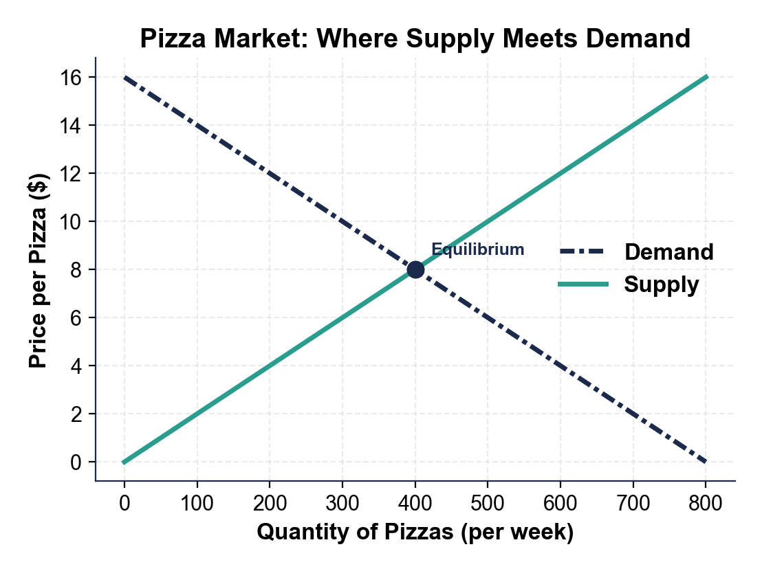
CHART REFERENCE 2: A SURPLUS - PRICE SET ABOVE EQUILIBRIUM
Use Chart Reference 2 (chart_surplus_above_eq) - the surplus chart shown below.
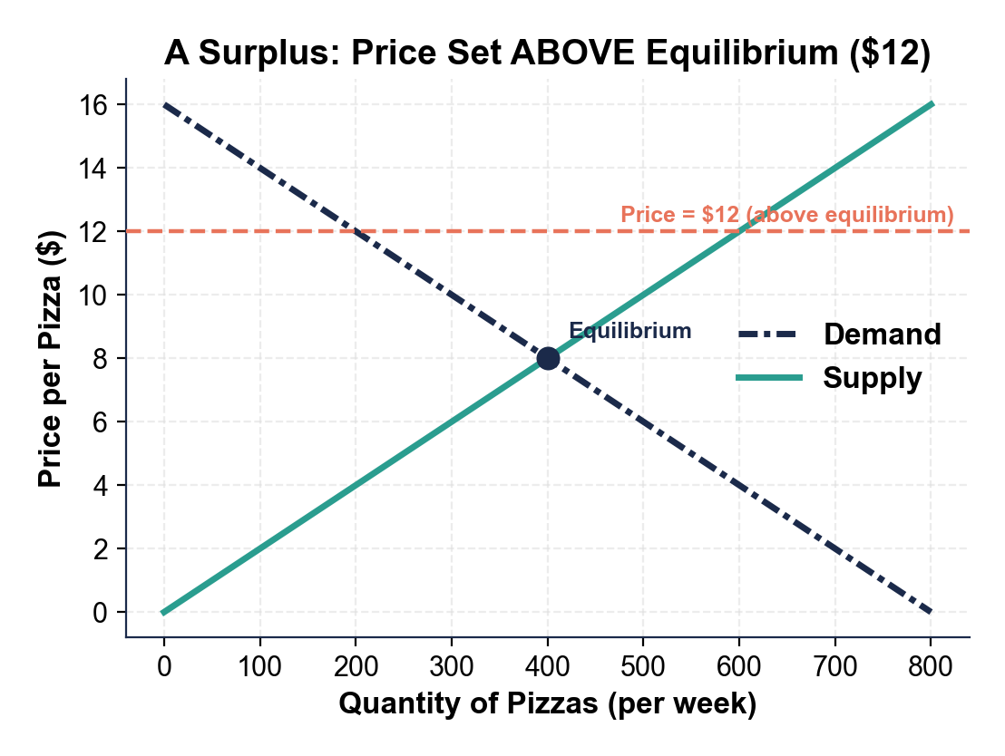
CHART REFERENCE 3: A SHORTAGE - PRICE SET BELOW EQUILIBRIUM
Use Chart Reference 3 (chart_shortage_below_eq) - the shortage chart shown below.
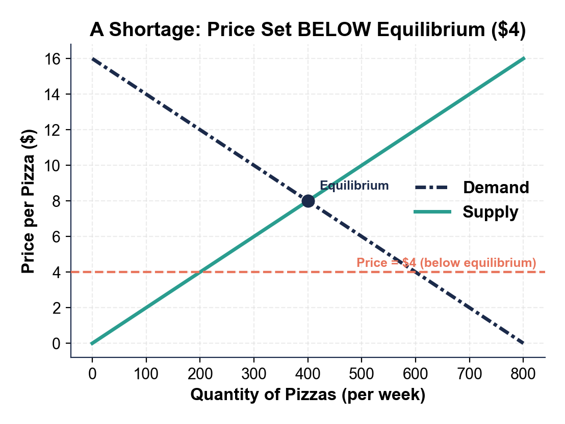

MORE LESSONS LESS PLANNING
Thank You!
If you enjoyed this product, please do not forget to rate and review to assist other teachers.

Looking for future discounts? Earn TPT credits by reviewing purchased products.

Please contact me if you have any issues with this product. Just like our students, I am always looking for opportunities to grow.

