Loan Default: What Happens When You Can't Pay
STUDENT ACTIVITY
Name: | Date: | Period:
ESSENTIAL QUESTION
When a borrower like Devon cannot pay a loan, what happens step by step - from DELINQUENCY (being late) to DEFAULT, charge-off, COLLECTIONS, a court judgment, and WAGE GARNISHMENT - and what can the borrower do BEFORE default to stop the slide?
THE SCENARIO
You are helping DEVON CARTER, who borrowed $9,000 for a used car at a $300 monthly payment and started out paying on time with a good 720 credit score. Then Devon lost a job, the $300 became impossible, and Devon stopped paying instead of calling the lender.
BY THE END, YOU CAN:
✓ Define delinquency, default, collections, and wage garnishment
✓ Trace the default timeline from a missed payment through charge-off, collections, and wage garnishment
✓ Read a line chart that tracks how a credit score drops across the missed-payment milestones
✓ Identify the options a borrower has BEFORE default and explain how each one helps
HOW IT WORKS (do Parts 1–5 in order)
Part 1 — Loan-Default Reference Guide - Complete the Missing Terms
Part 2 — Apply the Terms - Loan-Default Vocabulary in Context
Part 3 — Read the Chart - Credit Score Drop After Missed Payments
Part 4 — Order the Timeline - Trace What Happens to Devon
Part 5 — Consequences and Advice - Help Devon Stop the Damage
TIME about 45 minutes YOU’LL NEED the lesson slides and your Guided Notes.

PART 1

Loan-Default Reference Guide - Complete the Missing Terms
Fill in the missing term for each blank row — the definition is your clue. Your Guided Notes and the lesson slides have every term.

Term | Definition
___________ | Being late on a payment; the account is reported 30, 60, 90, or 120+ days delinquent the longer it goes unpaid.
Credit score | A number that shows how reliably you repay debt; missing payments and collections drop it sharply.
___________ | Falling so far behind that the lender treats the loan as broken.
Judgment | A court order saying you legally owe the money; a judgment lets a creditor garnish your wages.
___________ | When the debt is handed or sold to a collections agency whose job is to recover it; a serious mark on your credit report.
Refinance | Refinancing into a lower payment or longer term to make the loan affordable again, keeping it out of default.
___________ | After a creditor wins a court judgment, part of your paycheck is taken before you see it to repay the debt.
Deferment | A lender-approved pause or reduction of payments for a set time that keeps you out of default.
___________ | When the lender writes the unpaid debt off as a loss for accounting, though you still owe the money.
Hardship plan | A reworked payment schedule a lender offers for a hardship like a job loss, keeping the loan out of default.

PART 2

Apply the Terms - Loan-Default Vocabulary in Context
WORD BANK collections · wage garnishment · default · delinquency · charge-off
1. Q1. When Devon misses a payment and the lender reports the account as 30, then 60, then 90 days past due, the account is in a state of .

2. Q2. When Devon falls so far behind (around 90-120+ days) that the lender stops expecting normal repayment and treats the loan as broken, the loan is in .

3. Q3. When Devon's charged-off debt is handed or sold to an agency whose job is to recover it - leaving a serious mark on the credit report - the debt has gone to .

4. Q4. When a court lets the creditor take part of Devon's paycheck before Devon ever sees it, that legal process is .

5. Q5. When the lender writes Devon's unpaid debt off as a loss for accounting (around 120-180 days) - even though Devon still owes every dollar - that step is called a .

PART 3

Read the Chart - Credit Score Drop After Missed Payments
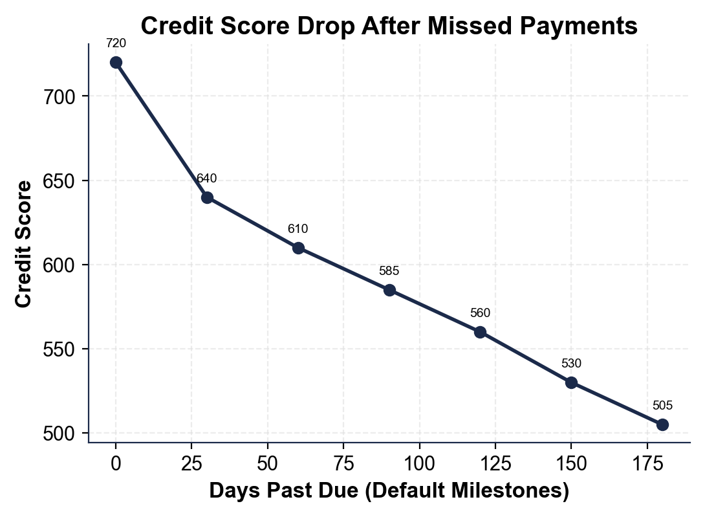
1. As you help Devon Carter, study the credit-score line chart shown above this question, where the x-axis is the number of days past due across the default milestones and the y-axis is Devon's credit score.
(a) Read the score at the start (on time, day 0).

(b) Read the score at the end (collections, day 180).

2. As you help Devon Carter, look at the steepest part of the credit-score line chart above.
(a) The line drops the most between the first two labeled points - read the score at on time and at 30 days delinquent.

(b) Subtract to find how big that first drop is. Show your subtraction.

3. As you help Devon Carter, use the credit-score line chart above to find the TOTAL fall.
(a) Subtract the ending score (collections) from the starting score (on time) to find the total points lost - show your subtraction.

(b) In one sentence, why does the line only step DOWN and never recover within this timeline?

4. As you help Devon Carter, look at the overall shape of the credit-score line chart above. In one or two sentences, explain what the chart shows about how loan default affects a credit score over time. Start your answer with: "The chart shows that..."

PART 4

Order the Timeline - Trace What Happens to Devon
1. As you help Devon Carter, put the default timeline in the correct ORDER. Here are the steps out of order: collections; 30 days delinquent; wage garnishment; charge-off; 90 days delinquent; on time; court judgment.
(a) Write the seven steps in the order they actually happen, starting with "on time."

(b) Which step is the point of no easy return - the one that triggers the harsher steps?

2. As you help Devon Carter, explain the difference between DELINQUENCY and DEFAULT using Devon's story.
(a) When is Devon delinquent, and what does that word mean?

(b) When does Devon go into default, and what does that word mean?

(c) Which one comes first?

3. As you help Devon Carter, clear up the biggest myth about a CHARGE-OFF. After about 120-180 days unpaid, Devon's lender charges off the loan.
(a) What does a charge-off actually mean for the lender?

(b) Does Devon still owe the money?

(c) What usually happens to the debt next?

4. As you help Devon Carter, work out the WAGE GARNISHMENT. After a court judgment, federal law caps an ordinary-debt garnishment at the LESSER of (i) 25% of disposable pay, or (ii) the amount disposable pay exceeds 30 x the $7.25 minimum wage ($217.50/week). Devon's disposable pay is $600/week.
(a) Compute cap (i): 25% of $600.

(b) Compute cap (ii): $600 - $217.50.

(c) Which cap applies, and how much is garnished each week? Show your math.

5. As you help Devon Carter, connect the garnishment back to the missed payment. Devon's garnishment is $150 a week, which over about 4.33 weeks is roughly $649.50 a month.
(a) How does the monthly garnishment compare to the original $300 payment Devon could not make?

(b) In one sentence, what is the irony of the whole timeline? Show your comparison.

PART 5

Consequences and Advice - Help Devon Stop the Damage
1. As you help Devon Carter, explain the real cost of default in your own words.
(a) Beyond owing the original $9,000, name two lasting consequences Devon now faces from going all the way to collections and garnishment.

(b) Why does a damaged credit score (Devon's fell to 505) cost a person for years, not just once?

2. As you help Devon Carter, explain WHY acting early matters so much.
(a) Why is the delinquency stage (when Devon is just 30 days late) a far better time to act than after default?

(b) Why would a lender rather work out a deferment or hardship plan than charge off Devon's loan?

3. As you help Devon Carter, make the judgment call about prevention. Devon's whole slide started with one missed $300 payment and no phone call.
(a) What is the single most important thing Devon should have done the moment the payment became impossible, and why?

(b) Name two specific options Devon could have asked the lender for to keep the loan out of default.

FINAL ADVICE LETTER
4. FINAL ADVICE LETTER. Devon Carter asks you to put your advice in writing. Write a 5-7 sentence note (120-180 words) explaining the difference between delinquency and default, tracing what happens next if Devon keeps not paying (charge-off, collections, judgment, wage garnishment), stating how far the credit score has already fallen, and recommending the best moves Devon should make BEFORE default. Check off each required element as you include it.
YOUR RESPONSE MUST:
☐ DEFINE DELINQUENCY VS DEFAULT - state in your own words that delinquency is being late on a payment and default is being so far behind the lender treats the loan as broken (and that delinquency comes first).
☐ TRACE THE TIMELINE - name what happens next in order if Devon keeps not paying: charge-off, then collections, then a court judgment, then wage garnishment.
☐ USE A CALCULATED RESULT - state a figure you calculated yourself in Part 3 or Part 4 (for example, the 215-point total credit drop, the 80-point first drop, or the $150/week garnishment).
☐ NAME THE STAKES - explain that Devon's credit fell to 505 and that garnishment would take about $649.50 a month - more than twice the missed $300 payment.
☐ RECOMMEND ACTION BEFORE DEFAULT - tell Devon the single best move (call the lender right away) and at least one specific option to ask for (deferment, hardship plan, or refinance).

