PERSONAL FINANCE

LOAN DEFAULT: WHAT HAPPENS WHEN YOU CAN'T PAY
ANSWER KEY ACTIVITY - ANSWER KEY

PART 1

Loan-Default Reference Guide - Complete the Missing Terms

Term | Definition
Delinquency | Being late on a payment; the account is reported 30, 60, 90, or 120+ days delinquent the longer it goes unpaid.
Credit score | A number that shows how reliably you repay debt; missing payments and collections drop it sharply.
Default | Falling so far behind that the lender treats the loan as broken.
Judgment | A court order saying you legally owe the money; a judgment lets a creditor garnish your wages.
Collections | When the debt is handed or sold to a collections agency whose job is to recover it; a serious mark on your credit report.
Refinance | Refinancing into a lower payment or longer term to make the loan affordable again, keeping it out of default.
Wage garnishment | After a creditor wins a court judgment, part of your paycheck is taken before you see it to repay the debt.
Deferment | A lender-approved pause or reduction of payments for a set time that keeps you out of default.
Charge-off | When the lender writes the unpaid debt off as a loss for accounting, though you still owe the money.
Hardship plan | A reworked payment schedule a lender offers for a hardship like a job loss, keeping the loan out of default.

PART 2

Apply the Terms - Loan-Default Vocabulary in Context
WORD BANK collections · wage garnishment · default · delinquency · charge-off
1. Q1. When Devon misses a payment and the lender reports the account as 30, then 60, then 90 days past due, the account is in a state of Delinquency.
Delinquency
2. Q2. When Devon falls so far behind (around 90-120+ days) that the lender stops expecting normal repayment and treats the loan as broken, the loan is in Default.
Default
3. Q3. When Devon's charged-off debt is handed or sold to an agency whose job is to recover it - leaving a serious mark on the credit report - the debt has gone to Collections.
Collections
4. Q4. When a court lets the creditor take part of Devon's paycheck before Devon ever sees it, that legal process is Wage garnishment.
Wage garnishment
5. Q5. When the lender writes Devon's unpaid debt off as a loss for accounting (around 120-180 days) - even though Devon still owes every dollar - that step is called a Charge-off.
Charge-off

PART 3

Read the Chart - Credit Score Drop After Missed Payments
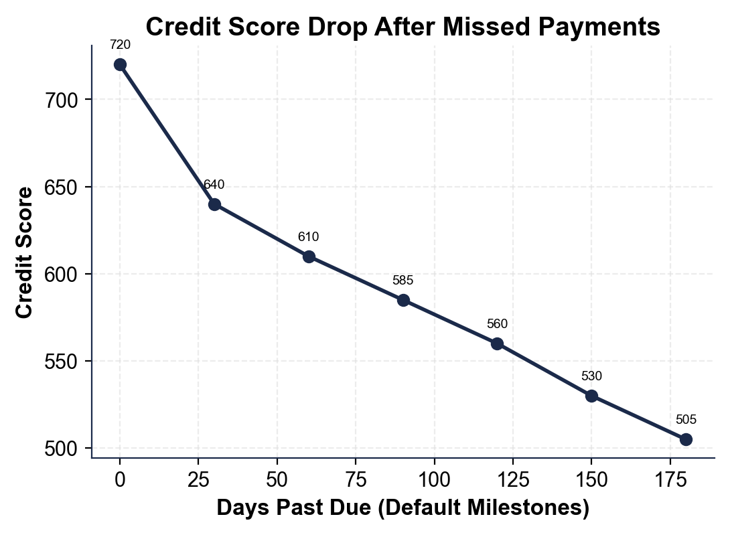
1. As you help Devon Carter, study the credit-score line chart shown above this question, where the x-axis is the number of days past due across the default milestones and the y-axis is Devon's credit score.
(a) Read the score at the start (on time, day 0).
(b) Read the score at the end (collections, day 180).
(1) At the start (on time, day 0) Devon's credit score is 720. (2) At the end (collections, day 180) the score is 505. Accept 720 for on-time and 505 for collections, read off the labeled points on the line.
2. As you help Devon Carter, look at the steepest part of the credit-score line chart above.
(a) The line drops the most between the first two labeled points - read the score at on time and at 30 days delinquent.
(b) Subtract to find how big that first drop is. Show your subtraction.
(1) On time the score is 720; at 30 days delinquent it is 640. (2) FIRST DROP = 720 - 640 = 80 points. This is the biggest single drop on the whole chart, which is why the first late payment matters so much. Accept 720 and 640, and 720 - 640 = 80.
3. As you help Devon Carter, use the credit-score line chart above to find the TOTAL fall.
(a) Subtract the ending score (collections) from the starting score (on time) to find the total points lost - show your subtraction.
(b) In one sentence, why does the line only step DOWN and never recover within this timeline?
(1) TOTAL DROP = 720 - 505 = 215 points. (2) The line only steps down because each milestone (a deeper delinquency, the charge-off, the collections account) is a fresh negative mark on the credit report, so the score keeps falling and has no chance to recover within the timeline. Accept 720 - 505 = 215 and the point that each milestone is a new negative mark.
4. As you help Devon Carter, look at the overall shape of the credit-score line chart above. In one or two sentences, explain what the chart shows about how loan default affects a credit score over time. Start your answer with: "The chart shows that..."
The chart shows that loan default damages a credit score in a falling staircase, not all at once: the score drops 80 points at the very first 30-day late (720 to 640) and keeps stepping down at every milestone - 60, 90, and 120+ days delinquent, charge-off, and collections -…

PART 4

Order the Timeline - Trace What Happens to Devon
1. As you help Devon Carter, put the default timeline in the correct ORDER. Here are the steps out of order: collections; 30 days delinquent; wage garnishment; charge-off; 90 days delinquent; on time; court judgment.
(a) Write the seven steps in the order they actually happen, starting with "on time."
(b) Which step is the point of no easy return - the one that triggers the harsher steps?
(1) CORRECT ORDER: on time -> 30 days delinquent -> 90 days delinquent -> charge-off -> collections -> court judgment -> wage garnishment. (Devon is delinquent at 30 and then 90 days, then defaults, the lender charges the debt off, it goes to collections, the creditor wins a judgment, and then garnishes wages.) (2) DEFAULT is the point of no easy return - once the loan is in default, the lender can charge it off, send it to collections, and sue, which are the steps that do the real damage. Accept the correct ordered list and default (around 90-120+ days) as the turning point.
2. As you help Devon Carter, explain the difference between DELINQUENCY and DEFAULT using Devon's story.
(a) When is Devon delinquent, and what does that word mean?
(b) When does Devon go into default, and what does that word mean?
(c) Which one comes first?
(1) Devon is DELINQUENT as soon as a payment is missed and the account is reported 30, 60, then 90 days past due; delinquency simply means you are LATE on a payment. (2) Devon goes into DEFAULT once the account is far enough behind (around 90-120+ days) that the lender treats the loan as broken and stops expecting normal repayment. (3) DELINQUENCY comes first - you are delinquent (the warning stage) for a while before you reach default. Accept delinquency = being late, default = lender treats the loan as broken, and delinquency comes first.
3. As you help Devon Carter, clear up the biggest myth about a CHARGE-OFF. After about 120-180 days unpaid, Devon's lender charges off the loan.
(a) What does a charge-off actually mean for the lender?
(b) Does Devon still owe the money?
(c) What usually happens to the debt next?
(1) A CHARGE-OFF means the lender writes the unpaid debt off as a loss on its own books for accounting purposes - it has given up collecting the loan directly. (2) YES, Devon still owes every dollar; a charge-off does NOT cancel the debt. (3) The debt is usually sold or sent to a COLLECTIONS agency, which then tries to collect the full amount (often with added fees). Accept charge-off = lender's accounting loss, Devon still owes the money, and the debt goes to collections next.
4. As you help Devon Carter, work out the WAGE GARNISHMENT. After a court judgment, federal law caps an ordinary-debt garnishment at the LESSER of (i) 25% of disposable pay, or (ii) the amount disposable pay exceeds 30 x the $7.25 minimum wage ($217.50/week). Devon's disposable pay is $600/week.
(a) Compute cap (i): 25% of $600.
(b) Compute cap (ii): $600 - $217.50.
(c) Which cap applies, and how much is garnished each week? Show your math.
(1) CAP (i) = 25% of $600 = 0.25 x $600 = $150.00 per week. (2) CAP (ii) = $600 - $217.50 = $382.50 per week. (3) The garnishment is the LESSER of the two caps, so it is $150.00 per week (cap (i) is smaller than cap (ii)). Accept $150 from cap (i), $382.50 from cap (ii), and $150/week as the amount garnished because it is the lesser cap.
5. As you help Devon Carter, connect the garnishment back to the missed payment. Devon's garnishment is $150 a week, which over about 4.33 weeks is roughly $649.50 a month.
(a) How does the monthly garnishment compare to the original $300 payment Devon could not make?
(b) In one sentence, what is the irony of the whole timeline? Show your comparison.
(1) The garnishment of about $649.50 a month is more than TWICE the original $300 payment ($649.50 is about $349.50 more than $300, and roughly double it). (2) The irony is that by NOT paying the affordable $300, Devon ends up losing about $649.50 a month to garnishment - plus a credit score wrecked by 215 points - so avoiding the smaller payment led to a far larger, forced one. Accept ~$649.50 being more than twice $300, and the irony that skipping the smaller payment caused a much bigger forced loss.

PART 5

Consequences and Advice - Help Devon Stop the Damage
1. As you help Devon Carter, explain the real cost of default in your own words.
(a) Beyond owing the original $9,000, name two lasting consequences Devon now faces from going all the way to collections and garnishment.
(b) Why does a damaged credit score (Devon's fell to 505) cost a person for years, not just once?
(1) Two lasting consequences: Devon's credit score has fallen 215 points (to 505) with a collections account that can sit on the credit report for up to seven years, AND about $649.50 a month is now being garnished straight from Devon's paycheck - on top of still owing the debt. (2) A damaged score costs for years because a low score makes future loans harder to get and far more expensive (higher APRs on cars and mortgages, bigger security deposits, even trouble renting an apartment or, in some cases, getting a job), so the borrower pays more for everything long after the original debt. Award credit for naming the wrecked credit/collections mark and the garnishment, and for explaining that a low score raises the cost of future borrowing for years.
2. As you help Devon Carter, explain WHY acting early matters so much.
(a) Why is the delinquency stage (when Devon is just 30 days late) a far better time to act than after default?
(b) Why would a lender rather work out a deferment or hardship plan than charge off Devon's loan?
(1) The delinquency stage is far better to act in because the loan is not yet broken - the lender is still willing to work out a deferment, hardship plan, or refinance, and the credit damage and collections/garnishment steps have not happened yet; once the loan defaults and is charged off, those options largely disappear and the choices shrink fast. (2) A lender would rather work something out because a charged-off loan is a LOSS for the lender - they recover little (often selling the debt to collections for pennies on the dollar), so a payment plan that eventually gets them paid is better for them than writing the loan off. Award credit for 'options exist before default but shrink after' and for the point that a charge-off is a loss the lender wants to avoid.
3. As you help Devon Carter, make the judgment call about prevention. Devon's whole slide started with one missed $300 payment and no phone call.
(a) What is the single most important thing Devon should have done the moment the payment became impossible, and why?
(b) Name two specific options Devon could have asked the lender for to keep the loan out of default.
(1) The single most important thing Devon should have done is CALL THE LENDER right away - the moment the payment became impossible (ideally before missing it) - because silence is what forces a lender down the default path, while an early call lets them offer help; one phone call could have stopped the entire timeline at the first step. (2) Two specific options Devon could have asked for: a DEFERMENT (a lender-approved pause or reduction of payments for a set time, made for hardships like a job loss) and a HARDSHIP PLAN or REFINANCE (reworking the schedule or refinancing into a lower payment or longer term so the loan becomes affordable again). Award credit for 'call the lender early' with a reason, and for naming two real pre-default options (deferment, hardship plan, refinance).
FINAL ADVICE LETTER
4. FINAL ADVICE LETTER. Devon Carter asks you to put your advice in writing. Write a 5-7 sentence note (120-180 words) explaining the difference between delinquency and default, tracing what happens next if Devon keeps not paying (charge-off, collections, judgment, wage garnishment), stating how far the credit score has already fallen, and recommending the best moves Devon should make BEFORE default. Check off each required element as you include it.
YOUR RESPONSE MUST:
☐ DEFINE DELINQUENCY VS DEFAULT - state in your own words that delinquency is being late on a payment and default is being so far behind the lender treats the loan as broken (and that delinquency comes first).
☐ TRACE THE TIMELINE - name what happens next in order if Devon keeps not paying: charge-off, then collections, then a court judgment, then wage garnishment.
☐ USE A CALCULATED RESULT - state a figure you calculated yourself in Part 3 or Part 4 (for example, the 215-point total credit drop, the 80-point first drop, or the $150/week garnishment).
☐ NAME THE STAKES - explain that Devon's credit fell to 505 and that garnishment would take about $649.50 a month - more than twice the missed $300 payment.
☐ RECOMMEND ACTION BEFORE DEFAULT - tell Devon the single best move (call the lender right away) and at least one specific option to ask for (deferment, hardship plan, or refinance).
GRADING RUBRIC
Grade the evidence and reasoning, not the conclusion — any defensible position is valid. Score against the 5 requirements above.
FULL CREDIT — clear position; meets all 5 requirements with accurate, specific numbers and evidence from the lesson.
PARTIAL — position stated, but misses 1-2 requirements or uses vague / incorrect numbers.
MINIMAL — no clear position, or missing most requirements and numbers.

MORE LESSONS LESS PLANNING
Thank You!
If you enjoyed this product, please do not forget to rate and review to assist other teachers.

Looking for future discounts? Earn TPT credits by reviewing purchased products.

Please contact me if you have any issues with this product. Just like our students, I am always looking for opportunities to grow.

