ECONOMICS

LAW OF SUPPLY: THE PRODUCER SIDE
ANSWER KEY ACTIVITY - ANSWER KEY

PART 1

Law of Supply Reference Guide - Complete the Missing Terms

Term | Definition
Law of supply | All else equal, when the price of a good rises the quantity supplied rises, and when the price falls the quantity supplied falls; price and quantity supplied have a direct relationship
Supply | The full relationship between every possible price of a good and the quantity producers are willing and able to offer for sale at each of those prices, all else held constant
Quantity supplied | The specific amount of a good producers will offer for sale at ONE particular price; a single point on the supply curve, not the whole curve
Supply curve | The upward-sloping line on a price-quantity graph that shows the quantity supplied at every price; it slopes up because of the law of supply
Profit motive | One reason the law of supply holds: a higher price means more profit on each unit sold, so producers are willing to make and sell more
Marginal cost | The other reason the law of supply holds: making each additional unit usually costs more, so producers need a higher price to justify producing more
Ceteris paribus | Latin for 'all else equal'; the assumption that everything except price is held constant so we can isolate how price alone affects quantity supplied
Supply schedule | A table listing the quantity supplied at each price; the supply curve is just this table drawn as a graph
Movement along the curve | A change in quantity supplied caused ONLY by a change in the good's own price; you slide from one point on the same curve to another
Direct relationship | When two variables move in the same direction; price and quantity supplied have a direct relationship, which is why the supply curve slopes upward

PART 2

Apply the Terms - Law of Supply Vocabulary in Context
WORD BANK law supply · ceteris paribus · profit motive · quantity supplied · movement along
1. Marcus says his whole job runs on one rule: all else equal, when the market price of pizza rises, Bella's offers more pizzas, and when the price falls, Bella's offers fewer. The rule that price and quantity supplied move in the same direction is the law of supply.
law supply
2. Marcus points to one line of the schedule: at a price of $8, Bella's offers 400 pizzas a week. The amount a producer offers at ONE specific price - a single point on the supply curve, not the whole curve - is the quantity supplied.
quantity supplied
3. Marcus asks why a higher price pulls more pizzas out of the kitchen. The first reason is that a higher price means more profit on each pizza sold, so Bella's wants to make more. Economists call this drive the profit motive.
profit motive
4. Marcus reminds you the law of supply only holds when everything except price is frozen - input costs, technology, and the number of sellers all held constant. The Latin phrase for holding all else equal is ceteris paribus.
ceteris paribus
5. When the pizza price rises from $8 to $12, Bella's slides from one point to another on the SAME supply curve rather than shifting the whole curve. A quantity-supplied change caused only by the good's own price is a movement along the curve.
movement along
PART 3

You Read Both Supply Charts with Marcus Reyes
1. Use Chart Reference 1 (chart_supply_curve) - the pizza-shop supply curve shown below - to read exact values off the curve.
(a) Find a price of $4 on the vertical axis and read the quantity supplied.
At $4, quantity supplied = 200 pizzas.
(b) Find a price of $12 and read the quantity supplied.
At $12, quantity supplied = 600 pizzas.
(c) Find a price of $16 and read the quantity supplied.
At $16, quantity supplied = 800 pizzas.
(d) In which direction does the curve slope - upward or downward - and what economic law does that slope show?
The curve slopes UPWARD from left to right. That upward slope shows the LAW OF SUPPLY: as price rises, quantity supplied rises (price and quantity supplied move in the same direction - a direct relationship).
2. Use Chart Reference 2 (chart_supply_schedule_bars) - the bar chart of quantity supplied at three prices shown below - to compare bar heights.
(a) Read the quantity supplied (bar height) at $4.
At $4, quantity supplied = 200 pizzas.
(b) Read the quantity supplied at $8.
At $8, quantity supplied = 400 pizzas.
(c) Read the quantity supplied at $12.
At $12, quantity supplied = 600 pizzas.
(d) Which bar is TALLEST and which is SHORTEST?
The TALLEST bar is at $12 (600 pizzas - the highest price shown); the SHORTEST bar is at $4 (200 pizzas - the lowest price).
(e) In 1-2 sentences, explain what the changing bar heights show about the relationship between price and quantity supplied.
The bars GROW taller as the price RISES. This shows the same law of supply the curve shows: a higher price leads to a higher quantity supplied.

3. CONNECT THE TWO CHARTS. Marcus points out that Chart 1 (the curve) and Chart 2 (the bars) use the SAME pizza data.
(a) For a price of $12, what quantity supplied does the CURVE show? What does the BAR CHART show? Are they the same?
At $12, the CURVE shows 600 pizzas and the BAR CHART shows 600 pizzas - YES, they are the same.
(b) Why should they be the same?
They must be the same because both charts are drawn from the SAME supply schedule (the same table of price and quantity supplied). A supply curve and a supply-schedule bar chart are just two pictures of one set of data.
(c) If the market price rose from $4 to $16, by how many pizzas would quantity supplied change, and in which direction (use the curve values)?
Raising the price from $4 to $16 would change quantity supplied from 200 pizzas up to 800 pizzas - an INCREASE of 600 pizzas. Higher price, higher quantity supplied, exactly as the law of supply predicts.
PART 4

Four Real-Market Scenarios with Marcus Reyes - Which Reason Is at Work?
1. WHICH REASON IS AT WORK? Marcus gives you four real situations. For EACH, decide whether the PROFIT MOTIVE, RISING MARGINAL COST, or BOTH best explains the producer's decision, and give a one-sentence reason. (Key distinction: profit motive = a higher price makes producing more WORTH IT, more profit per unit; rising marginal cost = a higher price is NEEDED because each extra unit costs more to make.)
Situation | Reason at Work | Why?
(a) Pizza price rises to $16, so Bella's bakes more pizzas to earn the higher profit on each one. | Profit Motive | The higher price means more profit on each pizza, so Bella's wants to make more.
(b) To bake the 800th pizza, Bella's must pay overtime and rent a second oven, which costs more than baking the 200th. | Rising Marginal Cost | The 800th pizza costs more to make than the 200th (overtime, a rented oven), so a higher price is needed to justify making it.
(c) When oil prices spike, drilling companies open new wells to grab the higher profit. | Profit Motive | The drillers open wells to capture the higher profit the oil-price spike offers.
(d) A farmer would grow more wheat at $7/bushel than at $4, but only because $7 finally covers the rising cost of farming the extra acres. | Both | The higher $7 price offers more profit (profit motive) AND is needed to cover the rising marginal cost of farming the extra acres.

2. MOVEMENT ALONG vs SHIFT - SPOT THE PRICE CHANGE. For EACH change below, decide whether it causes a MOVEMENT ALONG the pizza supply curve (a change in the pizza PRICE itself) or would instead SHIFT the whole curve (a NON-price change), and give a few words of reason. (Rule: only a change in the good's OWN price moves you ALONG the curve; everything else shifts the whole curve.)
Change | Along or Shift? | Why?
(a) The pizza price rises from $8 to $12. | Movement Along | The pizza's OWN price changed ($8 to $12), so you slide up the same curve to a larger quantity supplied (400 to 600).
(b) A new high-speed oven cuts Bella's production cost in half (technology improves). | Shift | A change in technology is a NON-price factor; it shifts the whole supply curve, not a movement along it.
(c) The pizza price falls from $16 to $4. | Movement Along | The pizza's own price changed ($16 to $4), so you slide down the same curve to a smaller quantity supplied (800 to 200).
(d) The price of cheese (an input) doubles for every pizzeria in town. | Shift | A change in input costs (cheese) is a NON-price factor; it shifts the whole curve.

3. CETERIS PARIBUS CHECK. Marcus reminds you the law of supply only works "ceteris paribus" - all else equal.
(a) What does ceteris paribus mean in plain English?
Ceteris paribus means 'all else equal' - we hold everything constant except the good's own price so we can see price's effect by itself.
(b) Name TWO things (besides pizza price) that we must HOLD CONSTANT for the pizza supply curve to stay put.
Accept any two of: the cost of inputs (cheese, flour, labor), the level of technology, the number of pizza sellers, taxes on producers, producers' expectations about future prices.
(c) Suppose the pizza price stays at $8 but the cost of cheese and flour suddenly doubles. Would quantity supplied at $8 stay at 400 pizzas? Explain in 1-2 sentences.
NO - quantity supplied at $8 would likely FALL below 400 pizzas. Doubling input costs breaks the ceteris paribus assumption (input cost is no longer held constant).
4. PREDICT THE QUANTITY SUPPLIED. Using ONLY the supply schedule values from the charts (200 at $4, 400 at $8, 600 at $12, 800 at $16), answer Marcus's prediction questions, ceteris paribus.
(a) If the market price is $8, how many pizzas will Bella's offer per week?
At $8, Bella's offers 400 pizzas per week.
(b) If the price rises from $4 to $16, by how many pizzas does quantity supplied rise?
Raising the price from $4 to $16 raises quantity supplied from 200 to 800 pizzas - an INCREASE of 600 pizzas.
(c) Marcus says "the market price just dropped from $12 to $4." Will Bella's offer more or fewer pizzas, and by how much?
A drop from $12 to $4 will LOWER the quantity supplied from 600 to 200 pizzas - a DECREASE of 400 pizzas.
(d) In 1-2 sentences, explain to Marcus what the law of supply says will happen to how many pizzas Bella's wants to make if the price keeps falling.
By the law of supply, as the price keeps falling, Bella's will want to make FEWER pizzas - a lower price means less profit per pizza and a price that no longer covers the rising cost of making more, so quantity supplied falls along the curve.
PART 5

Your Final Production Plan Memo to Marcus Reyes
PRODUCTION PLAN MEMO
1. Marcus closes the job-shadow by handing you the production decision for next month.
The owner needs a plan: how many pizzas should the kitchen make at the market price you expect, and a clear reason a higher price pulls more pizzas out of the kitchen. Write a 6-8 sentence memo that uses all four required terms - LAW OF SUPPLY, QUANTITY SUPPLIED, PROFIT MOTIVE, and MARGINAL COST - at least once each. Using the law of supply and the supply schedule, how many pizzas should the kitchen plan to make next month, and why does a higher price pull more pizzas out of the kitchen?
YOUR RESPONSE MUST:
☐ States the LAW OF SUPPLY correctly - that a higher pizza price raises the QUANTITY SUPPLIED, all else equal.
☐ Recommends a SPECIFIC market price (one of $4, $8, $12, or $16) AND states the planned QUANTITY SUPPLIED at that price using the supply schedule (200 / 400 / 600 / 800).
☐ Uses the term PROFIT MOTIVE correctly - explains that a higher price means more profit on each pizza, so the kitchen wants to make more.
☐ Uses the term MARGINAL COST correctly - explains that each extra pizza costs more to make, so a higher price is needed to justify producing more.
☐ Quotes at least ONE specific (price, quantity supplied) pair from the chart appendix (e.g., 600 pizzas at $12, or 200 pizzas at $4) to ground the recommendation in the data.
☐ Closes with a clear PREDICTION of what would happen to how many pizzas the kitchen makes if the market price fell - and a one-sentence reason tied to the law of supply.
MEMO
To: Marcus Reyes, Operations Manager
From: [student completes]
Date: [student completes]
Re: Pizza production plan for next month
GRADING RUBRIC
Grade the evidence and reasoning, not the conclusion — any defensible position is valid. Score against the 6 requirements above.
FULL CREDIT — clear position; meets all 6 requirements with accurate, specific numbers and evidence from the lesson.
PARTIAL — position stated, but misses 1-2 requirements or uses vague / incorrect numbers.
MINIMAL — no clear position, or missing most requirements and numbers.
CHART REFERENCE 1: THE PIZZA-SHOP SUPPLY CURVE
Use Chart Reference 1 (chart_supply_curve) - the pizza-shop supply curve shown below.
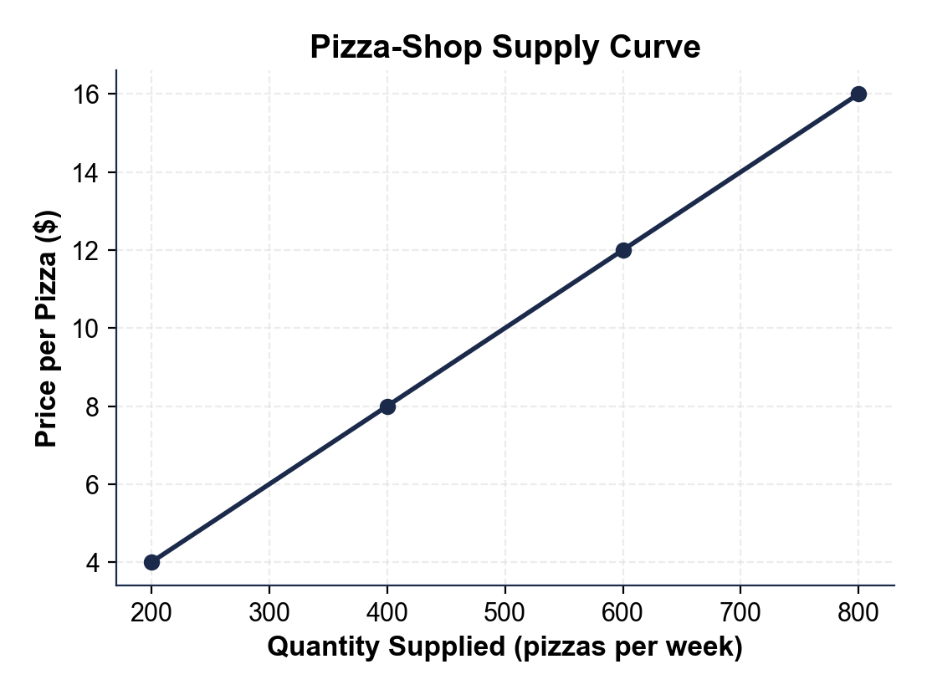
CHART REFERENCE 2: QUANTITY SUPPLIED AT THREE PRICES (BAR CHART)
Use Chart Reference 2 (chart_supply_schedule_bars) - the bar chart of quantity supplied at three prices shown below.
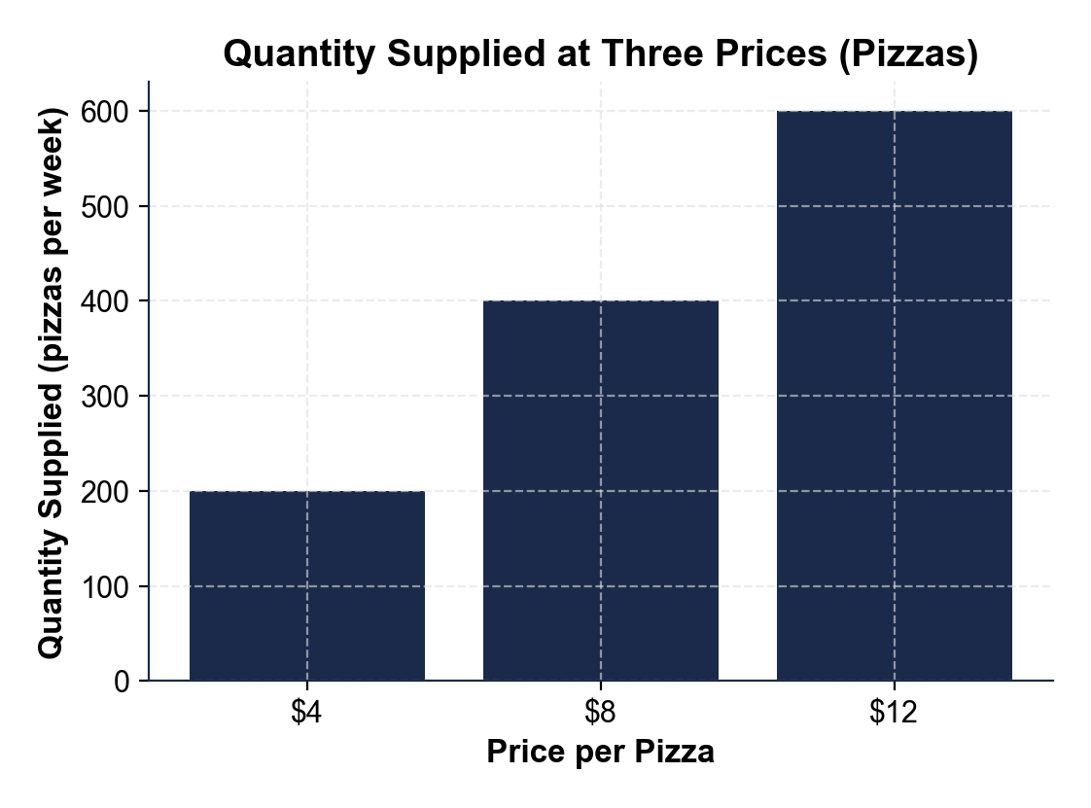

MORE LESSONS LESS PLANNING
Thank You!
If you enjoyed this product, please do not forget to rate and review to assist other teachers.

Looking for future discounts? Earn TPT credits by reviewing purchased products.

Please contact me if you have any issues with this product. Just like our students, I am always looking for opportunities to grow.

