Law of Demand: Why Price Matters
STUDENT ACTIVITY
Name: | Date: | Period:
ESSENTIAL QUESTION
When a price jumps, why do you suddenly want less of something you loved yesterday?
THE SCENARIO
You are a high school senior doing a 1-week job-shadow at STARLINE CINEMAS, a movie-theater chain. MAYA CHEN, the chain's pricing analyst, is teaching you how to use a DEMAND SCHEDULE and a DEMAND CURVE to predict how many tickets Starline will sell at different prices, so the manager can pick a ticket price for next month.
BY THE END, YOU CAN:
✓ State the LAW OF DEMAND (price up = quantity demanded down, all else equal) and read a downward-sloping demand curve and the demand schedule behind it
✓ Distinguish a MOVEMENT ALONG the demand curve (caused only by a price change) from the two reasons price drives quantity demanded - the SUBSTITUTION EFFECT and the INCOME EFFECT
✓ Use a real demand schedule and demand curve to predict how quantity demanded changes when price changes, and explain WHY price is the key variable held in focus by ceteris paribus
HOW IT WORKS (do Parts 1–5 in order)
Part 1 — Law of Demand Reference Guide - Complete the Missing Terms
Part 2 — Apply the Terms - Law of Demand Vocabulary in Context
Part 3 — You Read Both Demand Charts with Maya Chen
Part 4 — Four Real-Market Scenarios with Maya Chen - Which Effect Is at Work?
Part 5 — Your Final Pricing Prediction Memo to Maya Chen
TIME about 45 minutes YOU’LL NEED the lesson slides and your Guided Notes.

PART 1

Law of Demand Reference Guide - Complete the Missing Terms
Fill in the missing term for each blank row — the definition is your clue. Your Guided Notes and the lesson slides have every term.

Term | Definition
___________ | All else equal, when the price of a good rises the quantity demanded falls, and when the price falls the quantity demanded rises; price and quantity demanded have an inverse relationship
Demand | The full relationship between every possible price of a good and the quantity buyers are willing and able to purchase at each of those prices, all else held constant
___________ | The specific amount of a good buyers will purchase at ONE particular price; a single point on the demand curve, not the whole curve
Demand curve | The downward-sloping line on a price-quantity graph that shows the quantity demanded at every price; it slopes down because of the law of demand
___________ | One reason the law of demand holds: when a good gets more expensive, buyers switch to cheaper substitutes, so quantity demanded of the pricier good falls
Income effect | The other reason the law of demand holds: when a good gets more expensive, real buying power drops, so buyers purchase less of it
___________ | Latin for 'all else equal'; the assumption that everything except price is held constant so we can isolate how price alone affects quantity demanded
Demand schedule | A table listing the quantity demanded at each price; the demand curve is just this table drawn as a graph
___________ | A change in quantity demanded caused ONLY by a change in the good's own price; you slide from one point on the same curve to another
Inverse relationship | When two variables move in opposite directions; price and quantity demanded have an inverse relationship, which is why the demand curve slopes downward

PART 2

Apply the Terms - Law of Demand Vocabulary in Context
WORD BANK ceteris paribus · quantity demanded · law of demand · movement along · substitution
1. Maya opens with the rule every market obeys. All else equal, when a good gets more expensive buyers purchase less of it, and when it gets cheaper they purchase more - economists call this the .

2. Maya points to one row of the schedule: "At $8 a ticket we sell 600 tickets a week." That single amount bought at ONE specific price - a single point on the demand curve, not the whole curve - is the .

3. Maya explains the first reason the law holds: when ticket prices rise, some moviegoers switch to a cheaper option like streaming at home. Buyers switching to cheaper substitutes when a good gets pricier is the effect.

4. Maya says the law of demand only works when we hold everything else constant except the good's own price. That assumption - Latin for "all else equal" - is .

5. When Starline cuts the price from $12 to $8, you slide from one point to another on the SAME demand curve because only the ticket's own price changed. A change in quantity demanded caused only by the good's own price is a the curve.

PART 3

You Read Both Demand Charts with Maya Chen
1. Use Chart Reference 1 (chart_demand_curve) - the movie-ticket demand curve shown below - to read exact values off the curve.
(a) Find a price of $16 on the vertical axis and read the quantity demanded.

(b) Find a price of $8 and read the quantity demanded.

(c) Find a price of $4 and read the quantity demanded.

(d) In which direction does the curve slope - upward or downward - and what economic law does that slope show?

2. Use Chart Reference 2 (chart_demand_schedule_bars) - the bar chart of quantity demanded at three prices shown below - to compare bar heights.
(a) Read the quantity demanded (bar height) at $12.

(b) Read the quantity demanded at $8.

(c) Read the quantity demanded at $4.

(d) Which bar is TALLEST and which is SHORTEST?

(e) In 1-2 sentences, explain what the changing bar heights show about the relationship between price and quantity demanded.

3. CONNECT THE TWO CHARTS. Maya points out that Chart 1 (the curve) and Chart 2 (the bars) use the SAME movie-ticket data.
(a) For a price of $8, what quantity demanded does the CURVE show? What does the BAR CHART show? Are they the same?

(b) Why should they be the same?

(c) If Starline raised the price from $8 to $16, by how many tickets would quantity demanded change, and in which direction (use the curve values)?

PART 4

Four Real-Market Scenarios with Maya Chen - Which Effect Is at Work?
1. WHICH EFFECT IS AT WORK? Maya gives you four real situations. For EACH, decide whether the SUBSTITUTION EFFECT, the INCOME EFFECT, or BOTH best explains why quantity demanded falls, and give a one-sentence reason.
Scenario | Effect | Why?
(a) The price of Coke rises, so Janelle buys Pepsi instead.
(b) Gas prices jump to $5/gallon, leaving the Ramirez family with less money for everything, so they cut back on restaurant meals.
(c) Starline raises ticket prices, so some customers stream movies at home instead.
(d) Rent rises $200/month for an apartment, so the tenant buys fewer new clothes even though clothing prices did not change.

2. MOVEMENT ALONG vs SHIFT - SPOT THE PRICE CHANGE. For EACH change below, decide whether it causes a MOVEMENT ALONG the movie-ticket demand curve (a change in the ticket PRICE itself) or would instead SHIFT the whole curve (a NON-price change). Write "movement along" or "shift" and a few words of reason.
Change | Along or Shift? | Why?
(a) Starline drops the ticket price from $12 to $8.
(b) A new blockbuster everyone wants to see comes out (tastes change).
(c) The ticket price rises from $8 to $16.
(d) Customers in town all get a pay raise (incomes rise).

3. CETERIS PARIBUS CHECK. Maya reminds you the law of demand only works "ceteris paribus" - all else equal.
(a) What does ceteris paribus mean in plain English?

(b) Name TWO things (besides ticket price) that we must HOLD CONSTANT for the movie-ticket demand curve to stay put.

(c) Suppose ticket prices stay at $8 but a recession hits and everyone's income drops sharply. Would quantity demanded at $8 stay at 600 tickets? Explain in 1-2 sentences.

4. PREDICT THE QUANTITY DEMANDED. Using ONLY the demand schedule values from the charts (200 at $16, 400 at $12, 600 at $8, 1000 at $4), answer Maya's prediction questions, ceteris paribus.
(a) If Starline charges $12, how many tickets will it sell per week?

(b) If Starline cuts the price from $12 to $4, by how many tickets does quantity demanded rise?

(c) Maya says "we are thinking about going from $8 to $16 to boost revenue." Will that raise or lower the QUANTITY of tickets sold, and by how much?

(d) In 1-2 sentences, warn Maya about what the law of demand says will happen to ticket SALES VOLUME if she doubles the price.

PART 5

Your Final Pricing Prediction Memo to Maya Chen
PRICING PREDICTION MEMO
1. Maya closes out the job-shadow with one last task.
The manager has to set next month's ticket price and wants a recommendation grounded in the demand schedule, not a guess. Maya asks you to write her a short memo of 6 to 8 sentences that uses all four required terms - law of demand, quantity demanded, substitution effect, and income effect - at least once each. Using the law of demand and the demand schedule, what ticket price do you recommend for next month, how many tickets do you predict Starline will sell at that price, and why would raising the price cost the theater customers?
YOUR RESPONSE MUST:
☐ States the LAW OF DEMAND correctly - that raising the ticket price lowers the QUANTITY DEMANDED, all else equal.
☐ Recommends a SPECIFIC ticket price (one of $16, $12, $8, or $4) AND states the predicted QUANTITY DEMANDED at that price using the demand schedule (200 / 400 / 600 / 1000).
☐ Uses the term SUBSTITUTION EFFECT correctly - explains that a higher ticket price pushes some customers to a cheaper substitute (streaming at home or a rival theater).
☐ Uses the term INCOME EFFECT correctly - explains that a higher ticket price leaves customers with less real buying power, so they buy fewer tickets.
☐ Quotes at least ONE specific (price, quantity demanded) pair from the chart appendix (e.g., 600 tickets at $8, or 200 tickets at $16) to ground the prediction in the data.
☐ Closes with a clear PREDICTION of what would happen to ticket SALES VOLUME if Starline raised the price - and a one-sentence reason tied to the law of demand.
MEMO
To: Maya Chen, Pricing Analyst, Starline Cinemas
From:
Date:
Re: Ticket-price recommendation for next month

CHART REFERENCE 1: THE MOVIE-TICKET DEMAND CURVE
Use Chart Reference 1 (chart_demand_curve) - the movie-ticket demand curve shown below.
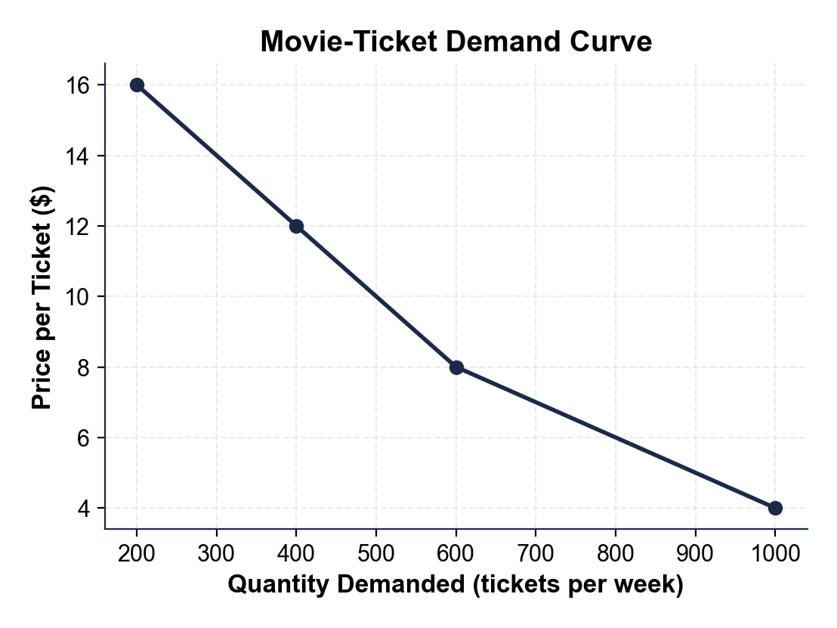
CHART REFERENCE 2: QUANTITY DEMANDED AT THREE PRICES (BAR CHART)
Use Chart Reference 2 (chart_demand_schedule_bars) - the bar chart of quantity demanded at three prices shown below.
