ECONOMICS

LAW OF DEMAND: WHY PRICE MATTERS
ANSWER KEY ACTIVITY - ANSWER KEY

PART 1

Law of Demand Reference Guide - Complete the Missing Terms

Term | Definition
Law of demand | All else equal, when the price of a good rises the quantity demanded falls, and when the price falls the quantity demanded rises; price and quantity demanded have an inverse relationship
Demand | The full relationship between every possible price of a good and the quantity buyers are willing and able to purchase at each of those prices, all else held constant
Quantity demanded | The specific amount of a good buyers will purchase at ONE particular price; a single point on the demand curve, not the whole curve
Demand curve | The downward-sloping line on a price-quantity graph that shows the quantity demanded at every price; it slopes down because of the law of demand
Substitution effect | One reason the law of demand holds: when a good gets more expensive, buyers switch to cheaper substitutes, so quantity demanded of the pricier good falls
Income effect | The other reason the law of demand holds: when a good gets more expensive, real buying power drops, so buyers purchase less of it
Ceteris paribus | Latin for 'all else equal'; the assumption that everything except price is held constant so we can isolate how price alone affects quantity demanded
Demand schedule | A table listing the quantity demanded at each price; the demand curve is just this table drawn as a graph
Movement along the curve | A change in quantity demanded caused ONLY by a change in the good's own price; you slide from one point on the same curve to another
Inverse relationship | When two variables move in opposite directions; price and quantity demanded have an inverse relationship, which is why the demand curve slopes downward

PART 2

Apply the Terms - Law of Demand Vocabulary in Context
WORD BANK ceteris paribus · quantity demanded · law of demand · movement along · substitution
1. Maya opens with the rule every market obeys. All else equal, when a good gets more expensive buyers purchase less of it, and when it gets cheaper they purchase more - economists call this the law of demand.
law of demand
2. Maya points to one row of the schedule: "At $8 a ticket we sell 600 tickets a week." That single amount bought at ONE specific price - a single point on the demand curve, not the whole curve - is the quantity demanded.
quantity demanded
3. Maya explains the first reason the law holds: when ticket prices rise, some moviegoers switch to a cheaper option like streaming at home. Buyers switching to cheaper substitutes when a good gets pricier is the substitution effect.
substitution. When a good gets more expensive, buyers switch to cheaper substitutes, so the quantity demanded of the pricier good falls.
4. Maya says the law of demand only works when we hold everything else constant except the good's own price. That assumption - Latin for "all else equal" - is ceteris paribus.
ceteris paribus
5. When Starline cuts the price from $12 to $8, you slide from one point to another on the SAME demand curve because only the ticket's own price changed. A change in quantity demanded caused only by the good's own price is a movement along the curve.
movement along
PART 3

You Read Both Demand Charts with Maya Chen
1. Use Chart Reference 1 (chart_demand_curve) - the movie-ticket demand curve shown below - to read exact values off the curve.
(a) Find a price of $16 on the vertical axis and read the quantity demanded.
At $16, quantity demanded = 200 tickets.
(b) Find a price of $8 and read the quantity demanded.
At $8, quantity demanded = 600 tickets.
(c) Find a price of $4 and read the quantity demanded.
At $4, quantity demanded = 1000 tickets.
(d) In which direction does the curve slope - upward or downward - and what economic law does that slope show?
The curve slopes DOWNWARD from left to right. That downward slope shows the LAW OF DEMAND: as price falls, quantity demanded rises (price and quantity demanded move in opposite directions - an inverse relationship).
2. Use Chart Reference 2 (chart_demand_schedule_bars) - the bar chart of quantity demanded at three prices shown below - to compare bar heights.
(a) Read the quantity demanded (bar height) at $12.
At $12, quantity demanded = 400 tickets.
(b) Read the quantity demanded at $8.
At $8, quantity demanded = 600 tickets.
(c) Read the quantity demanded at $4.
At $4, quantity demanded = 1000 tickets.
(d) Which bar is TALLEST and which is SHORTEST?
The TALLEST bar is at $4 (1000 tickets - the lowest price); the SHORTEST bar is at $12 (400 tickets - the highest price).
(e) In 1-2 sentences, explain what the changing bar heights show about the relationship between price and quantity demanded.
The bars GROW taller as the price FALLS. This shows the same law of demand the curve shows: a lower price leads to a higher quantity demanded.

3. CONNECT THE TWO CHARTS. Maya points out that Chart 1 (the curve) and Chart 2 (the bars) use the SAME movie-ticket data.
(a) For a price of $8, what quantity demanded does the CURVE show? What does the BAR CHART show? Are they the same?
At $8, the CURVE shows 600 tickets and the BAR CHART shows 600 tickets - YES, they are the same.
(b) Why should they be the same?
They must be the same because both charts are drawn from the SAME demand schedule (the same table of price and quantity demanded). A demand curve and a demand-schedule bar chart are just two pictures of one set of data.
(c) If Starline raised the price from $8 to $16, by how many tickets would quantity demanded change, and in which direction (use the curve values)?
Raising the price from $8 to $16 would change quantity demanded from 600 tickets down to 200 tickets - a DECREASE of 400 tickets. Higher price, lower quantity demanded, exactly as the law of demand predicts.
PART 4

Four Real-Market Scenarios with Maya Chen - Which Effect Is at Work?
1. WHICH EFFECT IS AT WORK? Maya gives you four real situations. For EACH, decide whether the SUBSTITUTION EFFECT, the INCOME EFFECT, or BOTH best explains why quantity demanded falls, and give a one-sentence reason.
Scenario | Effect | Why?
(a) The price of Coke rises, so Janelle buys Pepsi instead. | Substitution effect | Janelle switches from the now-pricier Coke to a cheaper substitute (Pepsi).
(b) Gas prices jump to $5/gallon, leaving the Ramirez family with less money for everything, so they cut back on restaurant meals. | Income effect | The higher gas price lowers the family's real buying power, so they have less money for everything, including restaurant meals (restaurant prices did not rise; buying power fell).
(c) Starline raises ticket prices, so some customers stream movies at home instead. | Substitution effect | Customers switch from the now-pricier theater tickets to a cheaper substitute (streaming at home). [Accept BOTH if the student also notes higher ticket prices leave less money for other things - income effect.]
(d) Rent rises $200/month for an apartment, so the tenant buys fewer new clothes even though clothing prices did not change. | Income effect | The higher rent lowers the tenant's real buying power, so they buy fewer clothes even though clothing prices are unchanged.

2. MOVEMENT ALONG vs SHIFT - SPOT THE PRICE CHANGE. For EACH change below, decide whether it causes a MOVEMENT ALONG the movie-ticket demand curve (a change in the ticket PRICE itself) or would instead SHIFT the whole curve (a NON-price change). Write "movement along" or "shift" and a few words of reason.
Change | Along or Shift? | Why?
(a) Starline drops the ticket price from $12 to $8. | Movement along | The ticket's OWN price changed ($12 to $8), so you slide down the same curve to a larger quantity demanded (400 to 600).
(b) A new blockbuster everyone wants to see comes out (tastes change). | Shift | A change in tastes is a NON-price factor; it shifts the whole demand curve (a TK 16 topic), not a movement along it.
(c) The ticket price rises from $8 to $16. | Movement along | The ticket's own price changed ($8 to $16), so you slide up the same curve to a smaller quantity demanded (600 to 200).
(d) Customers in town all get a pay raise (incomes rise). | Shift | A change in incomes is a NON-price factor; it shifts the whole curve. RULE: only a change in the good's OWN price moves you ALONG the curve; everything else shifts the whole curve.

3. CETERIS PARIBUS CHECK. Maya reminds you the law of demand only works "ceteris paribus" - all else equal.
(a) What does ceteris paribus mean in plain English?
Ceteris paribus means 'all else equal' - we hold everything constant except the good's own price so we can see price's effect by itself.
(b) Name TWO things (besides ticket price) that we must HOLD CONSTANT for the movie-ticket demand curve to stay put.
Accept any two of: buyers' incomes, buyers' tastes/preferences, the prices of substitute goods (streaming, rival theaters), the number of buyers, buyers' expectations about future prices.
(c) Suppose ticket prices stay at $8 but a recession hits and everyone's income drops sharply. Would quantity demanded at $8 stay at 600 tickets? Explain in 1-2 sentences.
NO - quantity demanded at $8 would likely FALL below 600 tickets. A recession breaks the ceteris paribus assumption (income is no longer held constant).
4. PREDICT THE QUANTITY DEMANDED. Using ONLY the demand schedule values from the charts (200 at $16, 400 at $12, 600 at $8, 1000 at $4), answer Maya's prediction questions, ceteris paribus.
(a) If Starline charges $12, how many tickets will it sell per week?
At $12, Starline sells 400 tickets per week.
(b) If Starline cuts the price from $12 to $4, by how many tickets does quantity demanded rise?
Cutting the price from $12 to $4 raises quantity demanded from 400 to 1000 tickets - an INCREASE of 600 tickets.
(c) Maya says "we are thinking about going from $8 to $16 to boost revenue." Will that raise or lower the QUANTITY of tickets sold, and by how much?
Going from $8 to $16 will LOWER the quantity sold from 600 to 200 tickets - a DECREASE of 400 tickets.
(d) In 1-2 sentences, warn Maya about what the law of demand says will happen to ticket SALES VOLUME if she doubles the price.
WARNING: by the law of demand, doubling the price from $8 to $16 will sharply cut the number of tickets sold - quantity demanded falls from 600 to 200 (a two-thirds drop in volume).
PART 5

Your Final Pricing Prediction Memo to Maya Chen
PRICING PREDICTION MEMO
1. Maya closes out the job-shadow with one last task.
The manager has to set next month's ticket price and wants a recommendation grounded in the demand schedule, not a guess. Maya asks you to write her a short memo of 6 to 8 sentences that uses all four required terms - law of demand, quantity demanded, substitution effect, and income effect - at least once each. Using the law of demand and the demand schedule, what ticket price do you recommend for next month, how many tickets do you predict Starline will sell at that price, and why would raising the price cost the theater customers?
YOUR RESPONSE MUST:
☐ States the LAW OF DEMAND correctly - that raising the ticket price lowers the QUANTITY DEMANDED, all else equal.
☐ Recommends a SPECIFIC ticket price (one of $16, $12, $8, or $4) AND states the predicted QUANTITY DEMANDED at that price using the demand schedule (200 / 400 / 600 / 1000).
☐ Uses the term SUBSTITUTION EFFECT correctly - explains that a higher ticket price pushes some customers to a cheaper substitute (streaming at home or a rival theater).
☐ Uses the term INCOME EFFECT correctly - explains that a higher ticket price leaves customers with less real buying power, so they buy fewer tickets.
☐ Quotes at least ONE specific (price, quantity demanded) pair from the chart appendix (e.g., 600 tickets at $8, or 200 tickets at $16) to ground the prediction in the data.
☐ Closes with a clear PREDICTION of what would happen to ticket SALES VOLUME if Starline raised the price - and a one-sentence reason tied to the law of demand.
MEMO
To: Maya Chen, Pricing Analyst, Starline Cinemas
From: [student completes]
Date: [student completes]
Re: Ticket-price recommendation for next month
GRADING RUBRIC
Grade the evidence and reasoning, not the conclusion — any defensible position is valid. Score against the 6 requirements above.
FULL CREDIT — clear position; meets all 6 requirements with accurate, specific numbers and evidence from the lesson.
PARTIAL — position stated, but misses 1-2 requirements or uses vague / incorrect numbers.
MINIMAL — no clear position, or missing most requirements and numbers.
CHART REFERENCE 1: THE MOVIE-TICKET DEMAND CURVE
Use Chart Reference 1 (chart_demand_curve) - the movie-ticket demand curve shown below.
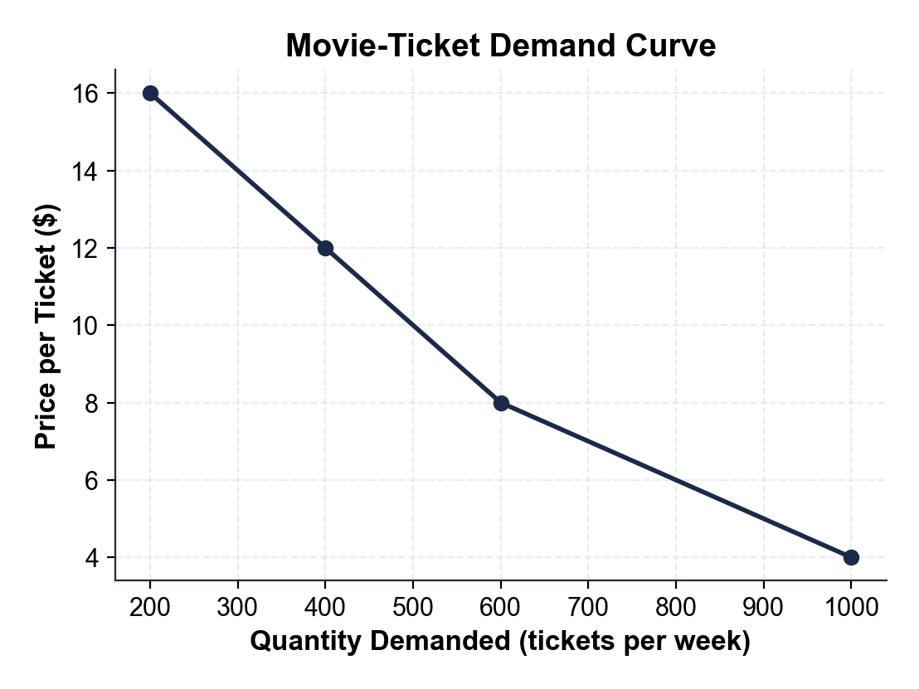
CHART REFERENCE 2: QUANTITY DEMANDED AT THREE PRICES (BAR CHART)
Use Chart Reference 2 (chart_demand_schedule_bars) - the bar chart of quantity demanded at three prices shown below.
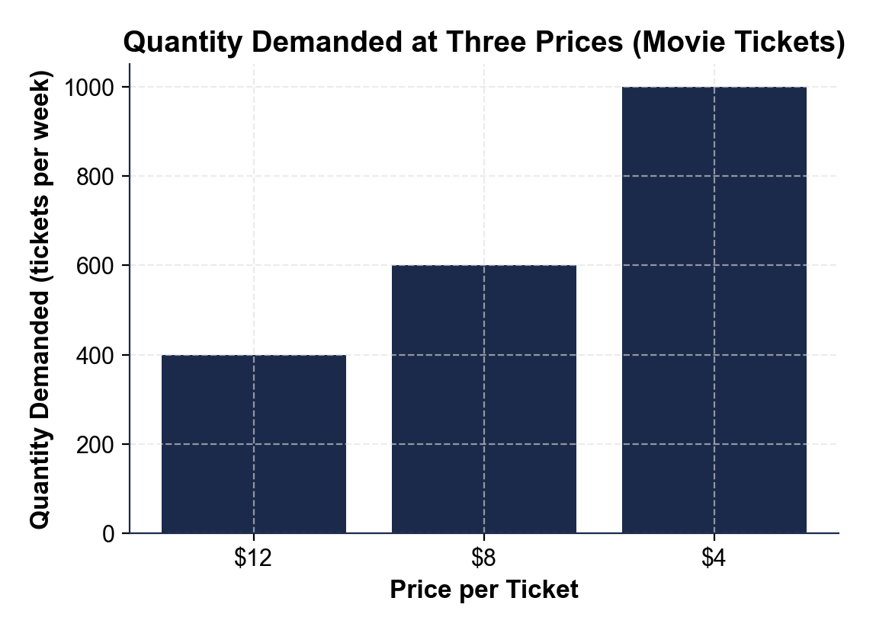

MORE LESSONS LESS PLANNING
Thank You!
If you enjoyed this product, please do not forget to rate and review to assist other teachers.

Looking for future discounts? Earn TPT credits by reviewing purchased products.

Please contact me if you have any issues with this product. Just like our students, I am always looking for opportunities to grow.

