Jerome Powell: The Most Powerful Person You've Never Heard Of
STUDENT ACTIVITY
Name: | Date: | Period:
ESSENTIAL QUESTION
Who is Jerome Powell, how did he get the most powerful economic job in the world, and what do his COVID emergency cuts, his 2022 hawkish pivot, and his 2024 cut cycle teach us about whether one person should have this much influence over the global economy?
THE SCENARIO
It is October 2026. You are AVERY CHEN, a junior research analyst at the Federal Reserve Board's Division of Monetary Affairs in Washington.
BY THE END, YOU CAN:
✓ Identify Jerome Powell's role, his background, and how he became Fed Chair
✓ Trace the key Powell decisions: COVID emergency response, the 2022 hawkish pivot, and the 2024 cut cycle
✓ Evaluate the influence of one person on the global economy and the question of political pressure on the Fed
HOW IT WORKS (do Parts 1–5 in order)
Part 1 — Jerome Powell Reference Guide - Complete the Missing Terms
Part 2 — Apply the Terms - Avery Chen Builds Her Powell-Tenure Vocabulary
Part 3 — Read the Chart - Federal Funds Rate During Powell's Tenure (Feb 2018 - Q4 2026)
Part 4 — Read the Chart - Powell Decisions vs S&P 500 (2018-2026)
Part 5 — Avery Chen's Powell Tenure Retrospective Memo
TIME about 45 minutes YOU’LL NEED the lesson slides and your Guided Notes.

PART 1

Jerome Powell Reference Guide - Complete the Missing Terms
Fill in the missing term for each blank row — the definition is your clue. Your Guided Notes and the lesson slides have every term.

Term | Definition
___________ | The Fed's leader, nominated by the President for a four-year term and sworn in after a Senate majority vote; Powell took the role in February 2018
Jerome Powell | Fed Chair from February 2018 to 2026; the first non-economist Fed Chair since G. William Miller (1978); a Princeton lawyer
___________ | The federal funds rate; the Fed moved it with gradual hikes to a 2023 peak and then cuts in 2024
Volcker | Fed Chair who broke 1970s inflation with sharp hikes; in 1980 he defied Carter and Reagan; Powell cited him in 2022
___________ | The March 2020 emergency cuts that dropped the federal funds rate to near zero in 12 days, including a Sunday 100 basis point cut - the fastest since 2008
Jackson Hole | The August Fed gathering where Powell adopted average inflation targeting in 2020 and cited Volcker in 2022
___________ | Powell shift to fighting inflation with the fastest hike cycle since Volcker, peaking in July 2023; at Jackson Hole 2022 he cited Volcker
Arthur Burns | Fed Chair who caved to Nixon's pressure in 1972 to keep rates low, which was followed by 1970s inflation
___________ | September 2024 started the Fed rate cuts, easing the federal funds rate down from its 2023 peak over the following two years
Average inflation targeting | The framework Powell adopted at August 2020 Jackson Hole, letting inflation average its target over time

PART 2

Apply the Terms - Avery Chen Builds Her Powell-Tenure Vocabulary
WORD BANK Fed Chair · 2022 hawkish pivot · COVID emergency cuts · 2024 cut cycle · Federal funds rate
1. The official who chairs the FOMC and is the public face of U.S. monetary policy - nominated by the President for a four-year term and sworn in after a Senate majority vote - is the . (Powell held this role from February 2018 to 2026.)

2. The interest rate banks charge each other overnight - the Fed's primary policy tool, which Powell raised through a series of hikes to a peak in July 2023 and then began cutting in 2024 - is the .

3. The fastest rate cuts since 2008 - dropping the federal funds rate to near zero in just 12 days in March 2020, including a Sunday 100 basis point cut - are called the .

4. Powell's shift to prioritize fighting inflation - 11 hikes in 16 months to a multi-decade-high peak, signaled by his August 2022 Jackson Hole speech citing Volcker - is known as the .

5. The current easing that began with a 50 basis point cut at the September 2024 FOMC meeting, after 14 months of holding at the 2023 peak, is the .

PART 3

Read the Chart - Federal Funds Rate During Powell's Tenure (Feb 2018 - Q4 2026)
1. As Avery Chen, use the Federal Funds Rate line chart (Feb 2018 - Q4 2026), inserted below and shown in the slide deck, to read THREE specific rate values from the early phase of Powell's tenure.
(a) What was the federal funds rate when Powell took office in Feb 2018?

(b) What was the rate at his first-term peak in Dec 2018?

(c) What was the rate after the March 2020 COVID emergency cuts?
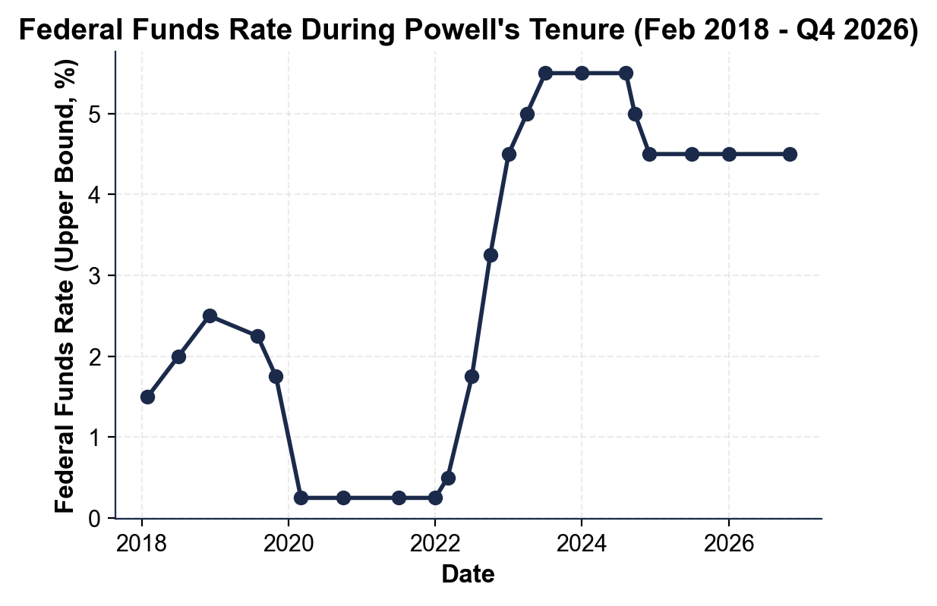

2. Use the same federal funds rate chart above to identify the zero-bound period and the start of the 2022 hike cycle.
(a) Approximately how many months did the federal funds rate sit at its COVID emergency low (the rate you read in Q1)?

(b) What was the rate at the start of the hike cycle in March 2022?

(c) What was the peak rate reached by July 2023?

3. Use the same federal funds rate chart above to identify the start of the 2024 cut cycle.
(a) How long did the Fed hold rates at its peak before cutting?

(b) What was the rate after the September 2024 cut?

(c) What is the approximate current rate by Q4 2026? Then explain in one sentence why the 2024 cut was 50 bp instead of the usual 25 bp.

PART 4

Read the Chart - Powell Decisions vs S&P 500 (2018-2026)
1. As Avery Chen, use the Powell Decisions vs S&P 500 line chart (2018-2026), inserted below and shown in the slide deck, to read the December 2018 sell-off and the March 2020 COVID low.
(a) What was the approximate S&P 500 close at the December 2018 low?

(b) What was the approximate close at the March 2020 COVID low? Then explain in one sentence what Powell action drove the market recovery after March 2020.
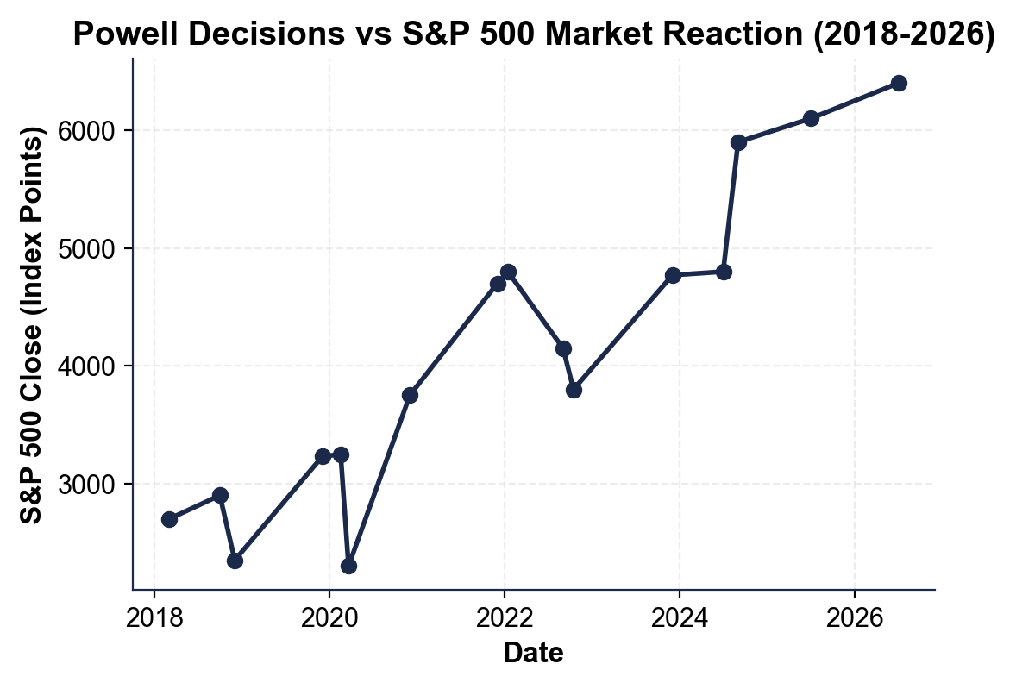

2. Use the same markets chart above to read the October 2022 low during the hawkish pivot.
(a) What was the approximate S&P 500 close at the October 2022 low?

(b) What Powell speech or action drove that drop?

(c) What was the approximate S&P 500 close at the January 2022 peak right before the pivot?

3. As Avery Chen, use the same markets chart above to describe the market response to the 2024 cut cycle.
(a) What was the approximate S&P 500 close at the July 2024 level (before the cut)?

(b) What was the close by September 2024 right around the FOMC cut decision?

(c) Why does the chart matter for the Powell Tenure Retrospective - what does it visually prove about the influence of one person?

PART 5

Avery Chen's Powell Tenure Retrospective Memo
POWELL TENURE RETROSPECTIVE MEMO
1. POWELL TENURE RETROSPECTIVE MEMO. It is October 2026 and former Chair Powell's office is waiting for your briefing. As Avery Chen, write a 7-9 sentence memo (250-330 words) evaluating whether one person should have this much economic influence. Use the memo header below and check off each required element as you include it. (Sentence starters you can use: "My verdict for former Chair Powell's office is..." and "The strongest historical case for my verdict is... while the main risk is...")
YOUR RESPONSE MUST:
☐ VERDICT - one sentence stating your recommendation (YES, one-person Fed power is justified; NO, it should be diluted; or SPLIT/CONDITIONAL) and defending it.
☐ TWO RATE-CHART VALUES - cite at least TWO specific federal funds rate values you read off the chart in Part 3 (for example a starting rate, the COVID emergency low, the 2023 peak, or a 2024 cut level).
☐ TWO MARKET-CHART VALUES - cite at least TWO specific S&P 500 values you read off the chart in Part 4 (for example a sell-off low, a recovery level, or a surge).
☐ ONE HISTORICAL PARALLEL - name one specific Fed Chair case: Volcker (1979-1982, the pro-independence model) or Arthur Burns (1972, the warning about politicization).
☐ ONE RISK - name one specific risk of your recommendation (for example the democratic-accountability gap of an unelected Chair, or the danger of diluting Fed independence).
☐ FIVE VOCABULARY TERMS - use at least FIVE lesson vocabulary terms from your Part 1 Reference Guide (e.g., Fed Chair, federal funds rate, COVID emergency cuts, 2022 hawkish pivot, 2024 cut cycle, Jackson Hole, Volcker, average inflation targeting).
MEMO
To: Former Chair Powell's Office
From: Avery Chen, Junior Research Analyst, Division of Monetary Affairs
Date:
Re: Powell Tenure Retrospective - Should One Person Have This Much Economic Influence? (October 2026)

