ECONOMICS

JEROME POWELL: THE MOST POWERFUL PERSON YOU'VE NEVER HEARD OF
ANSWER KEY ACTIVITY

PART 1

Jerome Powell Reference Guide - Complete the Missing Terms

Term | Definition
Fed Chair | The Fed's leader, nominated by the President for a four-year term and sworn in after a Senate majority vote; Powell took the role in February 2018
Jerome Powell | Fed Chair from February 2018 to 2026; the first non-economist Fed Chair since G. William Miller (1978); a Princeton lawyer
Federal funds rate | The federal funds rate; the Fed moved it with gradual hikes to a 2023 peak and then cuts in 2024
Volcker | Fed Chair who broke 1970s inflation with sharp hikes; in 1980 he defied Carter and Reagan; Powell cited him in 2022
COVID emergency cuts | The March 2020 emergency cuts that dropped the federal funds rate to near zero in 12 days, including a Sunday 100 basis point cut - the fastest since 2008
Jackson Hole | The August Fed gathering where Powell adopted average inflation targeting in 2020 and cited Volcker in 2022
2022 hawkish pivot | Powell shift to fighting inflation with the fastest hike cycle since Volcker, peaking in July 2023; at Jackson Hole 2022 he cited Volcker
Arthur Burns | Fed Chair who caved to Nixon's pressure in 1972 to keep rates low, which was followed by 1970s inflation
2024 cut cycle | September 2024 started the Fed rate cuts, easing the federal funds rate down from its 2023 peak over the following two years
Average inflation targeting | The framework Powell adopted at August 2020 Jackson Hole, letting inflation average its target over time

PART 2

Apply the Terms - Avery Chen Builds Her Powell-Tenure Vocabulary
WORD BANK Fed Chair · 2022 hawkish pivot · COVID emergency cuts · 2024 cut cycle · Federal funds rate
1. The official who chairs the FOMC and is the public face of U.S. monetary policy - nominated by the President for a four-year term and sworn in after a Senate majority vote - is the Fed Chair. (Powell held this role from February 2018 to 2026.)
Fed Chair
2. The interest rate banks charge each other overnight - the Fed's primary policy tool, which Powell raised through a series of hikes to a peak in July 2023 and then began cutting in 2024 - is the Federal funds rate.
Federal funds rate
3. The fastest rate cuts since 2008 - dropping the federal funds rate to near zero in just 12 days in March 2020, including a Sunday 100 basis point cut - are called the COVID emergency cuts.
COVID emergency cuts
4. Powell's shift to prioritize fighting inflation - 11 hikes in 16 months to a multi-decade-high peak, signaled by his August 2022 Jackson Hole speech citing Volcker - is known as the 2022 hawkish pivot.
2022 hawkish pivot
5. The current easing that began with a 50 basis point cut at the September 2024 FOMC meeting, after 14 months of holding at the 2023 peak, is the 2024 cut cycle.
2024 cut cycle

PART 3

Read the Chart - Federal Funds Rate During Powell's Tenure (Feb 2018 - Q4 2026)
1. As Avery Chen, use the Federal Funds Rate line chart (Feb 2018 - Q4 2026), inserted below and shown in the slide deck, to read THREE specific rate values from the early phase of Powell's tenure.
(a) What was the federal funds rate when Powell took office in Feb 2018?
Feb 2018 starting rate: 1.50% upper bound. Powell inherited the gradual hike path that Yellen had begun.
(b) What was the rate at his first-term peak in Dec 2018?
Dec 2018 first-term peak: 2.50% upper bound. This was the end of Powell's 2018 hike cycle - 4 hikes that year - and the December 2018 S&P 500 sell-off prompted his January 2019 dovish pivot.
(c) What was the rate after the March 2020 COVID emergency cuts?
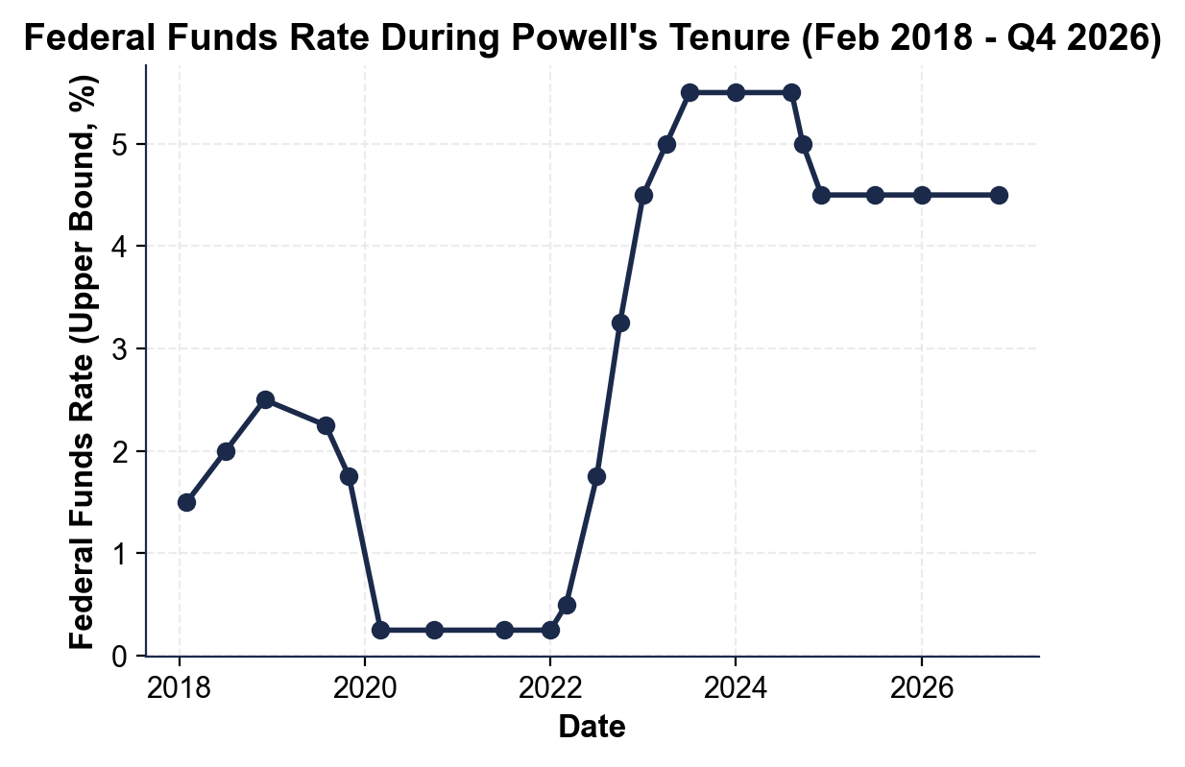
March 2020 post-emergency-cuts: 0.25% upper bound (0.00-0.25% range). The Fed cut 150 basis points in 12 days - a surprise 50 bp on March 3 and a Sunday-meeting 100 bp on March 15.
2. Use the same federal funds rate chart above to identify the zero-bound period and the start of the 2022 hike cycle.
(a) Approximately how many months did the federal funds rate sit at its COVID emergency low (the rate you read in Q1)?
(b) What was the rate at the start of the hike cycle in March 2022?
(c) What was the peak rate reached by July 2023?
(a) The zero-bound period lasted approximately 24 months - from March 2020 through March 2022 (~2 years). The chart shows a flat segment at 0.25% from spring 2020 to early 2022. (b) March 2022 hike-cycle start: 0.50% upper bound (the first 25 bp hike taking the range to 0.25-0.50%). (c) July 2023 peak: 5.50% upper bound (5.25-5.50% range). The federal funds rate climbed 5.25 percentage points in 16 months - the fastest hike cycle since Volcker. (a) ~24 months OR 'two years' OR 'March 2020 through March 2022' (b) 0.50% (accept 'first 25 bp hike to 0.50%'), AND (c) 5.50%.
3. Use the same federal funds rate chart above to identify the start of the 2024 cut cycle.
(a) How long did the Fed hold rates at its peak before cutting?
(b) What was the rate after the September 2024 cut?
(c) What is the approximate current rate by Q4 2026? Then explain in one sentence why the 2024 cut was 50 bp instead of the usual 25 bp.
(a) Hold duration at the 5.50% peak: about 14 months - from the last hike in July 2023 to the September 2024 cut. The chart shows a flat top at 5.50% for over a year. (b) After the September 18, 2024 cut: 5.00% upper bound (a 50 bp cut to 4.75-5.00%). (c) Q4 2026 current rate: about 4.50% upper bound. The reason for the unusual 50 bp opening cut (vs the standard 25 bp): the Fed saw unemployment ticking up to 4.2% by August 2024 and wanted to signal urgency on the maximum-employment side of the dual mandate - even though inflation was contained. (a) ~14 months OR 'over a year' (accept 13-14) (b) 5.00% (c) ~4.50%, AND a reasonable explanation for the larger-than-usual cut (employment risk OR signaling urgency).

PART 4

Read the Chart - Powell Decisions vs S&P 500 (2018-2026)
1. As Avery Chen, use the Powell Decisions vs S&P 500 line chart (2018-2026), inserted below and shown in the slide deck, to read the December 2018 sell-off and the March 2020 COVID low.
(a) What was the approximate S&P 500 close at the December 2018 low?
(b) What was the approximate close at the March 2020 COVID low? Then explain in one sentence what Powell action drove the market recovery after March 2020.
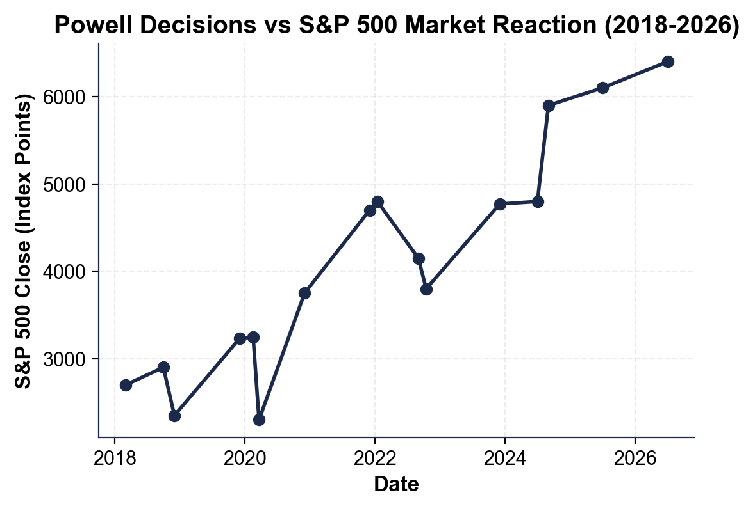
(a) December 2018 low: approximately 2,350 on the S&P 500. This was Powell's first market crisis - his hawkish guidance about more rate hikes triggered a sharp sell-off, which prompted his January 2019 dovish pivot. (b) March 2020 COVID low: approximately 2,300 on the S&P 500 - within 50 points of the Dec 2018 low. The recovery was driven by Powell's emergency cuts (1.50% to 0.25% in 12 days), the $2.3 trillion QE program, and 13 emergency lending facilities announced March 23, 2020. (a) ~2,350 (accept 2,300-2,400) (b) ~2,300 (accept 2,200-2,400), AND a reasonable answer naming emergency cuts OR QE OR the 13 lending facilities.
2. Use the same markets chart above to read the October 2022 low during the hawkish pivot.
(a) What was the approximate S&P 500 close at the October 2022 low?
(b) What Powell speech or action drove that drop?
(c) What was the approximate S&P 500 close at the January 2022 peak right before the pivot?
(a) October 2022 low: approximately 3,800 on the S&P 500. (b) The August 2022 Jackson Hole speech drove the drop - Powell's 8-minute speech committing the Fed to 'pain' to bring inflation down (citing Volcker explicitly) triggered an immediate sell-off that continued through October. (c) January 2022 peak: approximately 4,800 on the S&P 500. The peak-to-trough decline was about 1,000 points or ~21% from peak. (a) ~3,800 (accept 3,700-3,900) (b) Aug 2022 Jackson Hole OR the hawkish pivot OR 'Powell citing Volcker' (c) ~4,800.
3. As Avery Chen, use the same markets chart above to describe the market response to the 2024 cut cycle.
(a) What was the approximate S&P 500 close at the July 2024 level (before the cut)?
(b) What was the close by September 2024 right around the FOMC cut decision?
(c) Why does the chart matter for the Powell Tenure Retrospective - what does it visually prove about the influence of one person?
(a) July 2024 close: approximately 4,800 on the S&P 500 - back at the January 2022 peak after over two years of recovery. (b) September 2024 close: approximately 5,900 - a sharp surge as markets priced in the start of the cut cycle. The 50 bp September 18 cut was larger than typical and signaled urgency on employment, which markets read as Fed support. (c) The chart visually proves Powell's outsized influence: every major Powell decision (December 2018 hawkish guidance, March 2020 emergency cuts, August 2022 Jackson Hole, September 2024 cut) shows up as a sharp turn in the S&P 500. (a) ~4,800 (accept 4,700-4,900) (b) ~5,900 (accept 5,700-6,000), AND a substantive answer about market sensitivity to Powell decisions.

PART 5

Avery Chen's Powell Tenure Retrospective Memo
POWELL TENURE RETROSPECTIVE MEMO
1. POWELL TENURE RETROSPECTIVE MEMO. It is October 2026 and former Chair Powell's office is waiting for your briefing. As Avery Chen, write a 7-9 sentence memo (250-330 words) evaluating whether one person should have this much economic influence. Use the memo header below and check off each required element as you include it. (Sentence starters you can use: "My verdict for former Chair Powell's office is..." and "The strongest historical case for my verdict is... while the main risk is...")
YOUR RESPONSE MUST:
☐ VERDICT - one sentence stating your recommendation (YES, one-person Fed power is justified; NO, it should be diluted; or SPLIT/CONDITIONAL) and defending it.
☐ TWO RATE-CHART VALUES - cite at least TWO specific federal funds rate values you read off the chart in Part 3 (for example a starting rate, the COVID emergency low, the 2023 peak, or a 2024 cut level).
☐ TWO MARKET-CHART VALUES - cite at least TWO specific S&P 500 values you read off the chart in Part 4 (for example a sell-off low, a recovery level, or a surge).
☐ ONE HISTORICAL PARALLEL - name one specific Fed Chair case: Volcker (1979-1982, the pro-independence model) or Arthur Burns (1972, the warning about politicization).
☐ ONE RISK - name one specific risk of your recommendation (for example the democratic-accountability gap of an unelected Chair, or the danger of diluting Fed independence).
☐ FIVE VOCABULARY TERMS - use at least FIVE lesson vocabulary terms from your Part 1 Reference Guide (e.g., Fed Chair, federal funds rate, COVID emergency cuts, 2022 hawkish pivot, 2024 cut cycle, Jackson Hole, Volcker, average inflation targeting).
MEMO
To: Former Chair Powell's Office
From: Avery Chen, Junior Research Analyst, Division of Monetary Affairs
Date: [student completes]
Re: Powell Tenure Retrospective - Should One Person Have This Much Economic Influence? (October 2026)
GRADING RUBRIC
Grade the evidence and reasoning, not the conclusion — any defensible position is valid. Score against the 6 requirements above.
FULL CREDIT — clear position; meets all 6 requirements with accurate, specific numbers and evidence from the lesson.
PARTIAL — position stated, but misses 1-2 requirements or uses vague / incorrect numbers.
MINIMAL — no clear position, or missing most requirements and numbers.
WHAT TO LOOK FOR IN THIS LESSON
Sample full-credit memo (defending Fed independence):
Memo to: Former Chair Powell's Office
From: Avery Chen, Junior Research Analyst, Division of Monetary Affairs
Date: [today's date - leave bracketed]
Subject: Powell Tenure Retrospective - The Case for Strong Fed Independence
[1] VERDICT: My verdict is YES - one-person Fed power is justified, and the Powell tenure is the proof. [2] RATE-CHART EVIDENCE: when Powell took office in February 2018 the federal funds rate was 1.50%; by March 2020 he had cut to 0.25% in 12 days (the fastest emergency cuts since 2008); by July 2023 he had hiked to a 5.50% peak (the fastest hike cycle since Volcker); by September 2024 he had begun cutting back to 5.00%. Three crises, three precise responses - and a soft landing through 2024-2026. [3] MARKET-CHART EVIDENCE: markets validate every pivot - the December 2018 sell-off to about 2,350 prompted his dovish pivot, the March 2020 COVID low near 2,300 was followed by recovery to about 3,750 by December, and the September 2024 cut anticipation drove a surge to about 5,900. [4] HISTORICAL PARALLEL: Volcker (1979-1982) chose unpopular medicine and broke 1970s inflation; like Volcker, Powell did not change course under public pressure from Trump OR Biden - that refusal to flinch is what political independence is for. [5] RISK: the danger of strong Fed independence is the democratic-accountability gap - the Fed Chair is unelected and serves a 14-year governor seat, so the same independence that protects Powell could shield a future Chair from accountability; the mitigation is the existing structure of bipartisan Senate confirmation, the dual mandate set by Congress, and twice-yearly testimony.
REQUIRED-ELEMENT CHECKLIST (award credit per item):
[1] clear VERDICT (YES / NO / SPLIT) defended.
[2] TWO specific federal funds rate chart values from Part 3.
[3] TWO specific S&P 500 chart values from Part 4.
[4] ONE historical parallel named (Volcker or Burns).
[5] ONE specific risk named.
[6] FIVE lesson vocabulary terms.
Accept ANY verdict (YES, NO, or SPLIT) as long as it is defended with the required chart values, a historical parallel, and a risk.
MORE LESSONS LESS PLANNING
Thank You!
If you enjoyed this product, please do not forget to rate and review to assist other teachers.

Looking for future discounts? Earn TPT credits by reviewing purchased products.

Please contact me if you have any issues with this product. Just like our students, I am always looking for opportunities to grow.

