Interest Rates: The Fed's Main Tool
STUDENT ACTIVITY
Name: | Date: | Period:
ESSENTIAL QUESTION
The Fed moves ONE interest rate eight times a year - so how does that single number ripple out to your mortgage, your credit card, and the whole economy, and how would you decide what the Fed should do next?
THE SCENARIO
It is January 2025. You are DEVIN PARK, a junior economic analyst at a regional bank's monetary-policy desk.
BY THE END, YOU CAN:
✓ Define the federal funds rate and explain how the FOMC sets it
✓ Trace transmission from the federal funds rate to mortgage and credit card rates
✓ Predict the effects of rate hikes vs rate cuts on inflation, jobs, and borrowing
HOW IT WORKS (do Parts 1–5 in order)
Part 1 — Monetary Policy Reference Guide - Complete the Missing Terms
Part 2 — Apply the Terms - Monetary Policy Vocabulary in Context
Part 3 — Read the Charts - Federal Funds Rate and Mortgage Transmission
Part 4 — Trace the Transmission and Apply the Dual Mandate
Part 5 — Your Final Recommendation Memo to the Manager
TIME about 45 minutes YOU’LL NEED the lesson slides and your Guided Notes.

PART 1

Monetary Policy Reference Guide - Complete the Missing Terms
Fill in the missing term for each blank row — the definition is your clue. Your Guided Notes and the lesson slides have every term.

Term | Definition
___________ | The interest rate banks charge each other for overnight loans of reserves; the Fed's primary monetary policy tool
FOMC | The 12-member Federal Open Market Committee that sets the federal funds rate; meets 8 times per year
___________ | The Fed's buying and selling of Treasury bonds to push the fed funds rate toward target
IORB | Interest on Reserve Balances; the floor on the fed funds rate that the Fed pays banks on reserves
___________ | How a change in the federal funds rate ripples out to mortgages, credit cards, and auto loans
Discount rate | The higher rate the Fed charges banks that borrow directly from the Fed; the ceiling
___________ | The rate banks charge their best customers; always equals fed funds plus 3 points
Dot plot | The chart of each Fed official's expected rate path, released quarterly
___________ | Money banks must hold at the Fed; short banks borrow them overnight from long banks
Lag | The 6 to 12 months it takes for a Fed rate change to fully affect borrowing, spending, hiring, and prices

PART 2

Apply the Terms - Monetary Policy Vocabulary in Context
WORD BANK prime rate · federal funds rate · open market operations · transmission mechanism · reserves
1. Q1. The interest rate banks charge each other for overnight loans of the money they keep at the Fed - the single bank-to-bank rate the Fed targets eight times a year - is the .

2. Q2. When the Fed buys or sells Treasury bonds to push the bank-to-bank overnight rate toward its target, it is conducting .

3. Q3. The chain by which one rate change at the Fed ripples out to mortgages, credit cards, and auto loans across the whole economy is called the .

4. Q4. The rate banks charge their most credit-worthy customers - always equal to the federal funds target plus three points - is the .

5. Q5. The money banks are legally required to keep at the Fed - what a short bank borrows overnight from a long bank - is its .

PART 3

Read the Charts - Federal Funds Rate and Mortgage Transmission
1. Use Chart Reference 1 (chart_fed_funds_rate_2000_2026) - the Federal Funds Rate line chart (2000-2026) inserted below this question and shown on the slide deck - to answer the following.
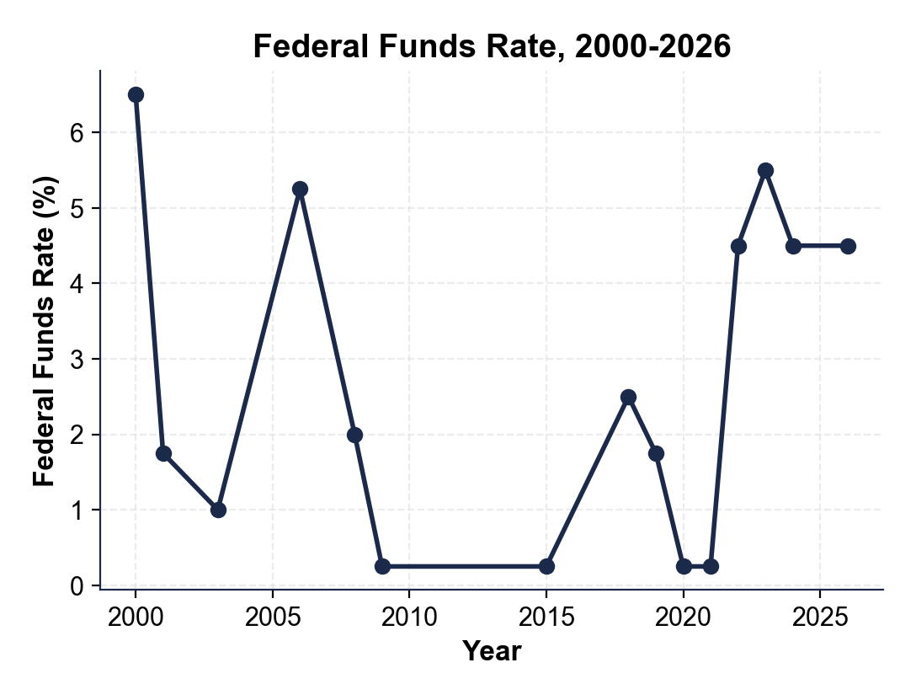
What was the APPROXIMATE federal funds rate in 2009 and 2021? What does that tell you about the Fed's response to the 2008 financial crisis and to the COVID-19 pandemic?

2. Using Chart Reference 1 (the federal funds rate chart above) again, calculate the SIZE of the 2022-2023 hike cycle.
What rate did the cycle START at (read the low point just before the 2022 climb)? What did it PEAK at? How many PERCENTAGE POINTS was the total move?

3. Now use Chart Reference 2 (chart_mortgage_vs_fed_funds) - the two-series 30-Year Mortgage vs Federal Funds Rate chart inserted below this question and shown on the slide deck - to answer.
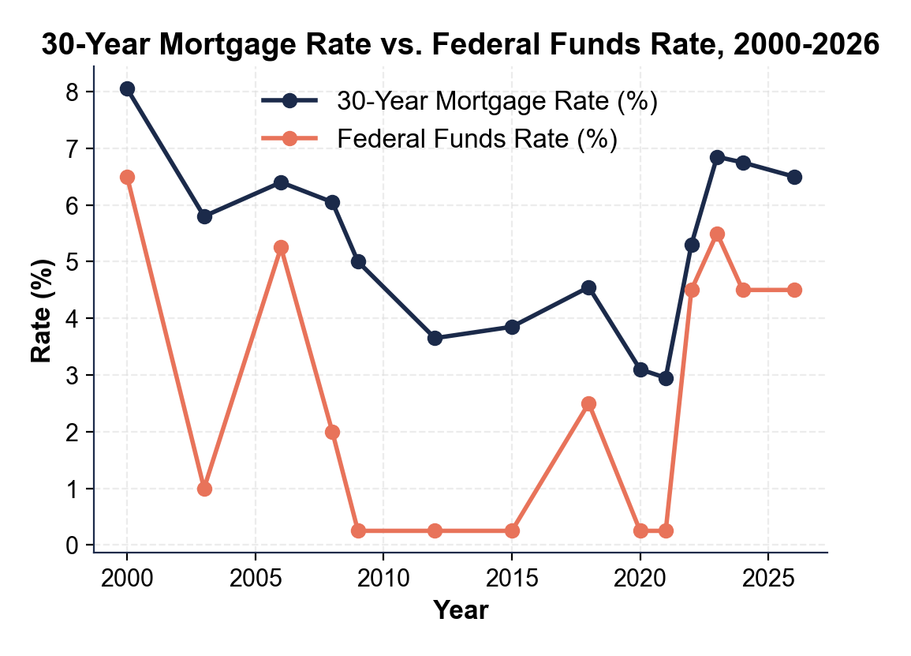
What was the LOWEST 30-year mortgage rate on the chart, and what year did it happen? What was the HIGHEST mortgage rate from 2022 onward, and what year did it happen?

4. Use Chart Reference 2 (the mortgage-vs-fed-funds chart above) again. Compare the SPREAD between the mortgage rate and the federal funds rate in 2015 vs in 2023. (Spread = mortgage rate - fed funds rate.) Show both spreads and explain in one sentence what this tells you about how mortgage rates respond to RAPID Fed hikes.

PART 4

Trace the Transmission and Apply the Dual Mandate
1. Trace the transmission of the September 2024 Fed rate CUT (-50 bps, bringing fed funds from 5.50% to 5.00%) all the way to a college student's credit card APR. Use AT LEAST FOUR lesson terms (fed funds, prime rate, transmission, credit card APR, billing cycle, basis points) in your explanation.

2. Why do 30-year mortgage rates NOT respond 1-for-1 to a Fed rate cut, even though they fall to some degree? Explain the role of the 10-YEAR TREASURY and EXPECTATIONS in your answer.

3. The Fed's DUAL MANDATE is maximum employment AND stable prices. Explain in 2-3 sentences how these two goals can CONFLICT, and use the 2022-2024 cycle to illustrate.

4. The lesson described a 6-12 month LAG between a Fed rate change and its full effect on the economy.
Why does this lag make Fed decisions especially hard? Give ONE specific example from the 2022-2024 cycle where the lag created a real problem for the Fed.

PART 5

Your Final Recommendation Memo to the Manager
FINAL RECOMMENDATION MEMO
1. FD-01. YOUR FINAL RECOMMENDATION MEMO. Devin Park's manager is waiting for the written analysis. Write a 7-9 sentence memo evaluating the 2022-2024 hike cycle and recommending what the Fed should do at its next FOMC meeting in 2025. Use the memo header below and check off each required element as you include it. (Sentence starters you can use: "After reviewing the 2022-2024 cycle, my evaluation is..." and "For the next FOMC meeting, I recommend... because...")
YOUR RESPONSE MUST:
☐ EVALUATION - one sentence stating whether the 2022-2024 hike cycle SUCCEEDED, OVERSHOT, or was ABOUT RIGHT, backed by at least one specific number from the lesson (for example the 9.1% peak CPI or the ~4% unemployment that held throughout the cycle).
☐ ONE 2025 RECOMMENDATION - recommend exactly ONE move the Fed should make at the next meeting: HOLD STEADY at 4.50%, CUT 25 bps, CUT 50 bps, or HIKE again.
☐ DUAL-MANDATE REASONING - justify your recommendation using the Fed's two goals (maximum employment AND stable prices) and how they can pull in different directions.
☐ TWO CHART DATA POINTS - cite at least TWO specific numbers you read off the two charts in Part 3 (a peak or trough rate and the year it happened) to back up your evaluation.
☐ ONE RISK - acknowledge one realistic risk of YOUR recommendation.
☐ FIVE VOCABULARY TERMS - underline at least FIVE lesson vocabulary terms in your memo (e.g., federal funds rate, transmission mechanism, prime rate, dual mandate, lag, basis points).
MEMO
To: Manager, Monetary-Policy Desk
From: Devin Park, Bank Analyst
Date:
Re: Evaluation of the 2022-2024 Hike Cycle and Recommendation for the Next FOMC Meeting

