ECONOMICS

INTEREST RATES: THE FED'S MAIN TOOL
ANSWER KEY ACTIVITY - ANSWER KEY

PART 1

Monetary Policy Reference Guide - Complete the Missing Terms

Term | Definition
Federal funds rate | The interest rate banks charge each other for overnight loans of reserves; the Fed's primary monetary policy tool
FOMC | The 12-member Federal Open Market Committee that sets the federal funds rate; meets 8 times per year
Open market operations | The Fed's buying and selling of Treasury bonds to push the fed funds rate toward target
IORB | Interest on Reserve Balances; the floor on the fed funds rate that the Fed pays banks on reserves
Transmission mechanism | How a change in the federal funds rate ripples out to mortgages, credit cards, and auto loans
Discount rate | The higher rate the Fed charges banks that borrow directly from the Fed; the ceiling
Prime rate | The rate banks charge their best customers; always equals fed funds plus 3 points
Dot plot | The chart of each Fed official's expected rate path, released quarterly
Reserves | Money banks must hold at the Fed; short banks borrow them overnight from long banks
Lag | The 6 to 12 months it takes for a Fed rate change to fully affect borrowing, spending, hiring, and prices

PART 2

Apply the Terms - Monetary Policy Vocabulary in Context
WORD BANK prime rate · federal funds rate · open market operations · transmission mechanism · reserves
1. Q1. The interest rate banks charge each other for overnight loans of the money they keep at the Fed - the single bank-to-bank rate the Fed targets eight times a year - is the Federal funds rate.
Federal funds rate
2. Q2. When the Fed buys or sells Treasury bonds to push the bank-to-bank overnight rate toward its target, it is conducting Open market operations.
Open market operations
3. Q3. The chain by which one rate change at the Fed ripples out to mortgages, credit cards, and auto loans across the whole economy is called the Transmission mechanism.
Transmission mechanism
4. Q4. The rate banks charge their most credit-worthy customers - always equal to the federal funds target plus three points - is the Prime rate.
Prime rate
5. Q5. The money banks are legally required to keep at the Fed - what a short bank borrows overnight from a long bank - is its Reserves.
Reserves
PART 3

Read the Charts - Federal Funds Rate and Mortgage Transmission
1. Use Chart Reference 1 (chart_fed_funds_rate_2000_2026) - the Federal Funds Rate line chart (2000-2026) inserted below this question and shown on the slide deck - to answer the following.
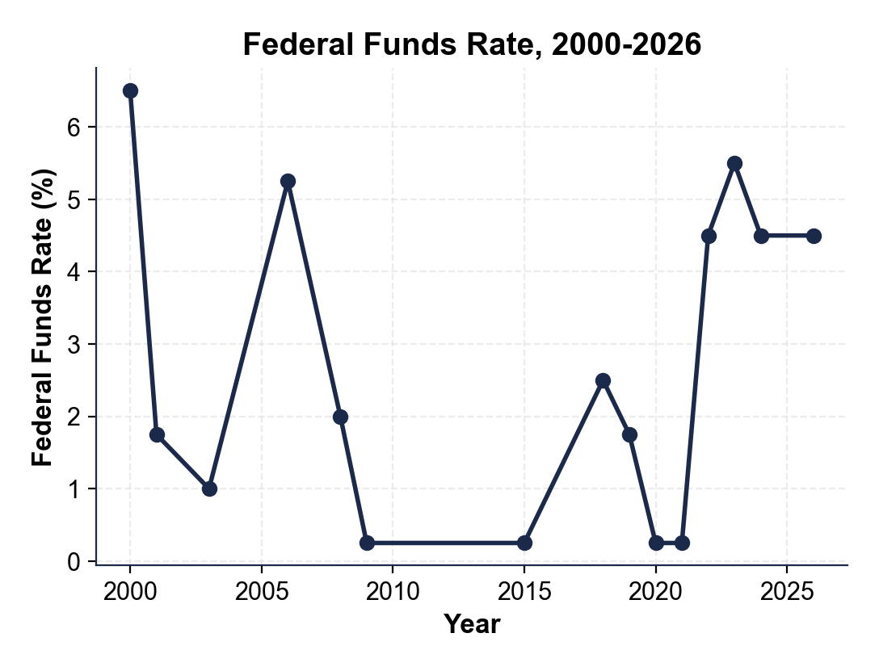
What was the APPROXIMATE federal funds rate in 2009 and 2021? What does that tell you about the Fed's response to the 2008 financial crisis and to the COVID-19 pandemic?
In BOTH 2009 and 2021 the fed funds rate was approximately 0.25% - the zero-lower-bound (accept 0%, 0.25%, or 'near zero' for both years).
2. Using Chart Reference 1 (the federal funds rate chart above) again, calculate the SIZE of the 2022-2023 hike cycle.
What rate did the cycle START at (read the low point just before the 2022 climb)? What did it PEAK at? How many PERCENTAGE POINTS was the total move?
START: approximately 0.25% in March 2022. PEAK: approximately 5.50% in July 2023. SIZE of the move: 5.50% - 0.25% = 5.25 PERCENTAGE POINTS, or 525 BASIS POINTS. This is the fastest hike cycle since the early 1980s. Accept any reasonable reading within 0.10% of these values.
3. Now use Chart Reference 2 (chart_mortgage_vs_fed_funds) - the two-series 30-Year Mortgage vs Federal Funds Rate chart inserted below this question and shown on the slide deck - to answer.
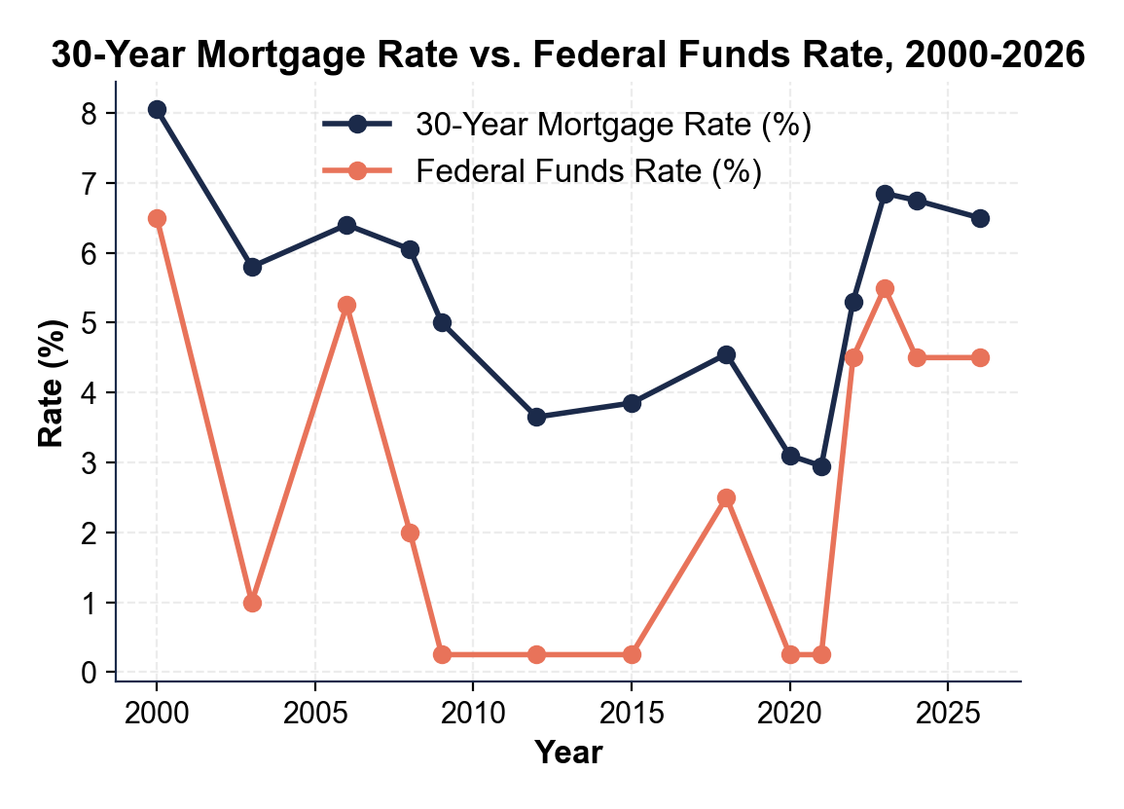
What was the LOWEST 30-year mortgage rate on the chart, and what year did it happen? What was the HIGHEST mortgage rate from 2022 onward, and what year did it happen?
LOWEST: approximately 2.95% (essentially 3%) in 2021; HIGHEST from 2022 onward: approximately 6.85% (essentially 7%) in 2023 (accept 'about 3%' in 2021 and 'about 7%' in 2023).
4. Use Chart Reference 2 (the mortgage-vs-fed-funds chart above) again. Compare the SPREAD between the mortgage rate and the federal funds rate in 2015 vs in 2023. (Spread = mortgage rate - fed funds rate.) Show both spreads and explain in one sentence what this tells you about how mortgage rates respond to RAPID Fed hikes.
SPREAD in 2015: mortgage ~3.85% minus fed funds ~0.25% = ~3.60 percentage points (a wide, normal spread). SPREAD in 2023: mortgage ~6.85% minus fed funds ~5.50% = ~1.35 percentage points (a much narrower spread). What this tells you: mortgage rates do NOT rise 1-for-1 with fed funds during a fast hike cycle - they rise less because long-term rates already priced in some hikes before they happened, and because markets expect the Fed to eventually CUT, which pulls the 10-year Treasury (and therefore mortgages) down even while the fed funds rate is still rising. The spread compresses during fast hikes and widens again once cuts begin. Accept spreads in the 3.0-4.0 range for 2015 and 1.0-1.5 range for 2023.
PART 4

Trace the Transmission and Apply the Dual Mandate
1. Trace the transmission of the September 2024 Fed rate CUT (-50 bps, bringing fed funds from 5.50% to 5.00%) all the way to a college student's credit card APR. Use AT LEAST FOUR lesson terms (fed funds, prime rate, transmission, credit card APR, billing cycle, basis points) in your explanation.
Step 1: The FOMC voted on September 18, 2024 to cut FED FUNDS by 50 BASIS POINTS, from 5.50% to 5.00%. Step 2: Within 24 hours, every major bank announced its new PRIME RATE: prime always equals fed funds + 3 points, so prime fell from 8.50% to 8.00%. Step 3: Credit card APRs are usually quoted as 'prime + a margin' (the margin is set in your cardholder agreement and varies 10-18 points by card and credit score). So the college student's APR also fell by 50 basis points within 1-2 BILLING CYCLES (typically 30-60 days). Example: if the student had a 24.50% APR (= prime 8.50% + margin 16.00%) before the cut, the APR becomes 24.00% (= prime 8.00% + margin 16.00%) by November 2024. Step 4: This is the FAST transmission lane - credit cards and HELOCs reprice within billing cycles; mortgages and auto loans take weeks; the broader economy takes 6-12 months. The TRANSMISSION MECHANISM is the engine that turns one FOMC vote into a small but real change in millions of monthly statements.
2. Why do 30-year mortgage rates NOT respond 1-for-1 to a Fed rate cut, even though they fall to some degree? Explain the role of the 10-YEAR TREASURY and EXPECTATIONS in your answer.
30-year mortgages track the 10-YEAR TREASURY YIELD, not the federal funds rate. The 10-year Treasury yield reflects the market's expectation of fed funds over the next 10 years - what investors think the AVERAGE fed funds rate will be over a decade.
3. The Fed's DUAL MANDATE is maximum employment AND stable prices. Explain in 2-3 sentences how these two goals can CONFLICT, and use the 2022-2024 cycle to illustrate.
The dual mandate often points in OPPOSITE directions. To fight inflation (stable prices), the Fed HIKES rates - which slows borrowing, slows hiring, and risks pushing unemployment up.
4. The lesson described a 6-12 month LAG between a Fed rate change and its full effect on the economy.
Why does this lag make Fed decisions especially hard? Give ONE specific example from the 2022-2024 cycle where the lag created a real problem for the Fed.
The lag makes decisions hard because the Fed has to PREDICT what inflation and unemployment will look like 6-12 months from now, then act today based on that prediction.
PART 5

Your Final Recommendation Memo to the Manager
FINAL RECOMMENDATION MEMO
1. FD-01. YOUR FINAL RECOMMENDATION MEMO. Devin Park's manager is waiting for the written analysis. Write a 7-9 sentence memo evaluating the 2022-2024 hike cycle and recommending what the Fed should do at its next FOMC meeting in 2025. Use the memo header below and check off each required element as you include it. (Sentence starters you can use: "After reviewing the 2022-2024 cycle, my evaluation is..." and "For the next FOMC meeting, I recommend... because...")
YOUR RESPONSE MUST:
☐ EVALUATION - one sentence stating whether the 2022-2024 hike cycle SUCCEEDED, OVERSHOT, or was ABOUT RIGHT, backed by at least one specific number from the lesson (for example the 9.1% peak CPI or the ~4% unemployment that held throughout the cycle).
☐ ONE 2025 RECOMMENDATION - recommend exactly ONE move the Fed should make at the next meeting: HOLD STEADY at 4.50%, CUT 25 bps, CUT 50 bps, or HIKE again.
☐ DUAL-MANDATE REASONING - justify your recommendation using the Fed's two goals (maximum employment AND stable prices) and how they can pull in different directions.
☐ TWO CHART DATA POINTS - cite at least TWO specific numbers you read off the two charts in Part 3 (a peak or trough rate and the year it happened) to back up your evaluation.
☐ ONE RISK - acknowledge one realistic risk of YOUR recommendation.
☐ FIVE VOCABULARY TERMS - underline at least FIVE lesson vocabulary terms in your memo (e.g., federal funds rate, transmission mechanism, prime rate, dual mandate, lag, basis points).
MEMO
To: Manager, Monetary-Policy Desk
From: Devin Park, Bank Analyst
Date: [student completes]
Re: Evaluation of the 2022-2024 Hike Cycle and Recommendation for the Next FOMC Meeting
GRADING RUBRIC
Grade the evidence and reasoning, not the conclusion — any defensible position is valid. Score against the 6 requirements above.
FULL CREDIT — clear position; meets all 6 requirements with accurate, specific numbers and evidence from the lesson.
PARTIAL — position stated, but misses 1-2 requirements or uses vague / incorrect numbers.
MINIMAL — no clear position, or missing most requirements and numbers.

MORE LESSONS LESS PLANNING
Thank You!
If you enjoyed this product, please do not forget to rate and review to assist other teachers.

Looking for future discounts? Earn TPT credits by reviewing purchased products.

Please contact me if you have any issues with this product. Just like our students, I am always looking for opportunities to grow.

