Interest Explained: Simple vs Compound
STUDENT ACTIVITY
Name: | Date: | Period:
ESSENTIAL QUESTION
What is the difference between simple interest (I = P x r x t) and compound interest (A = P(1 + r/n)^(nt)), how do you calculate each one, why does compound grow faster because it earns interest on interest, why does that help you on savings but hurt you on debt, and how does the Rule of 72 estimate how fast money doubles?
THE SCENARIO
You are helping PRIYA NAIR understand how interest grows. Priya puts a $1,000 PRINCIPAL into two side-by-side accounts that BOTH pay 8% a year.
BY THE END, YOU CAN:
✓ Define simple interest and compound interest and explain the difference between them
✓ Calculate simple interest on a loan or deposit using I = P x r x t
✓ Calculate compound interest using A = P(1 + r/n)^(nt) and reason through it year by year
✓ Explain why compound interest grows faster than simple interest, why that hurts you on debt but helps you on savings, and use the Rule of 72 to estimate how long money takes to double
HOW IT WORKS (do Parts 1–5 in order)
Part 1 — Interest Reference Guide - Complete the Missing Terms
Part 2 — Apply the Terms - Interest Vocabulary in Context
Part 3 — Read the Chart - Simple vs Compound Growth of $1,000 at 8%
Part 4 — Do the Interest Math - Simple, Compound, and the Rule of 72
Part 5 — Loans vs Savings - Make Your Recommendation
TIME about 45 minutes YOU’LL NEED the lesson slides and your Guided Notes.

PART 1

Interest Reference Guide - Complete the Missing Terms
Fill in the missing term for each blank row — the definition is your clue. Your Guided Notes and the lesson slides have every term.

Term | Definition
___________ | Interest figured only on the original principal, so the same amount is added every period (I = P x r x t)
Principal | The original amount of money you borrow or deposit, before any interest is added
___________ | Interest figured on the principal plus all the interest already earned, so the amount added grows each period
Interest rate | The percent charged or earned per year on the principal, written as a decimal in the formulas (8% = 0.08)
___________ | How often interest is added to the balance; n is the number of times per year (yearly n = 1, monthly n = 12)
Balance | The total amount in an account or owed on a loan at a point in time - the principal plus the interest so far
___________ | The extra growth in a compound account that comes from earning interest on interest already added
Future value | What an amount of money will grow to after interest is applied for a set number of years (the A in the formulas)
___________ | A shortcut that estimates the years for money to double: years to double is about 72 divided by the interest rate percent
Interest formula | A rule for calculating interest; simple uses I = P x r x t, compound uses A = P(1 + r/n)^(nt)

PART 2

Apply the Terms - Interest Vocabulary in Context
WORD BANK Rule of 72 · interest on interest · Compound interest · compounding period · Simple interest
1. Interest figured only on the starting amount you deposit, so the same dollars are added every period, is called .

2. Interest figured on the principal plus all the interest already earned, so the amount added grows each period, is .

3. The 'n' in the compound formula - how often interest is added to the balance each year - is the .

4. The extra growth in a compound account that comes from earning interest on interest already added is called .

5. The shortcut that estimates years to double as about 72 divided by the rate is the .

PART 3

Read the Chart - Simple vs Compound Growth of $1,000 at 8%
1. As you help Priya Nair, study the line chart on this page titled "Simple vs Compound Growth of $1,000 at 8%." One line is straight and one curves upward. Read the chart and write:
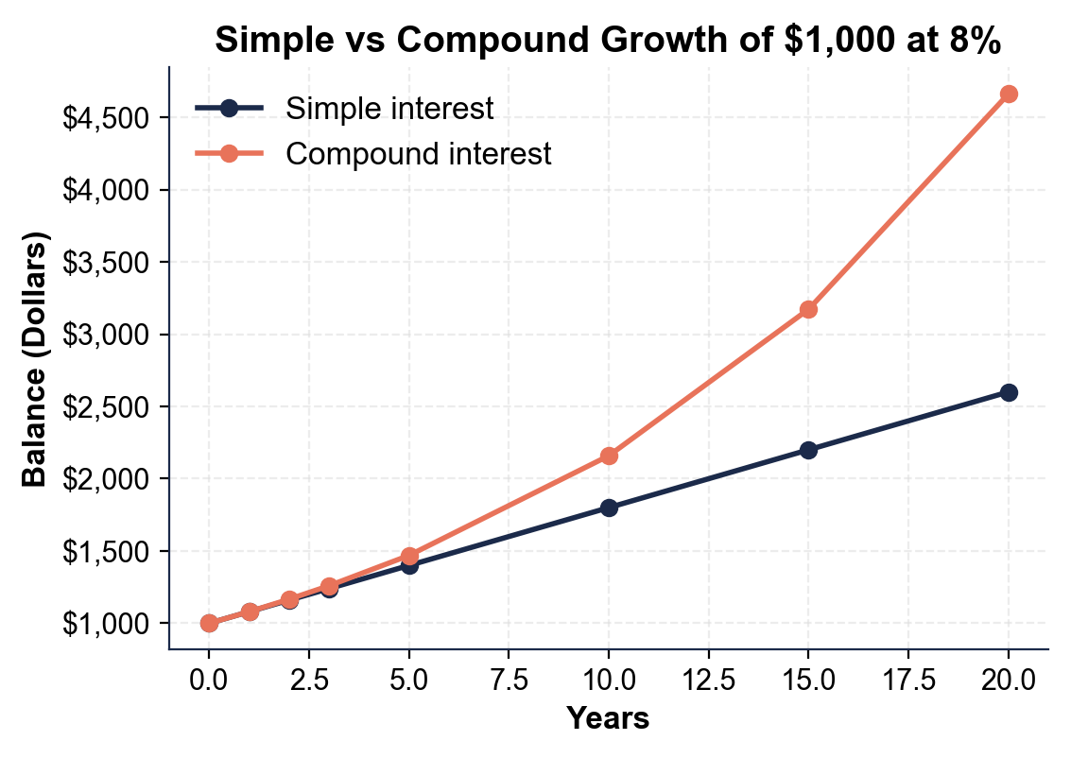
(a) which line is SIMPLE interest (the straight one or the curved one)

(b) which line is COMPOUND interest.

2. As you help Priya Nair, use the same chart to read the year-20 endpoints.
(a) About how much is in the SIMPLE account at year 20?

(b) About how much is in the COMPOUND account at year 20?

(c) Subtract to find the gap between them.

3. As you help Priya Nair, look at how the two lines behave over time.
(a) Are the two lines close together or far apart at the start (years 0 and 1)?

(b) What happens to the space between them as the years go on, and what does that growing space represent?

4. As you help Priya Nair, look at the overall pattern. In one or two sentences, explain what the chart shows about simple versus compound interest over time. Start your answer with: "The chart shows that..."

PART 4

Do the Interest Math - Simple, Compound, and the Rule of 72
1. As you help Priya Nair, start with her $1,000.00 SIMPLE-interest account at 8%. Use the foundational model I = P x r x t (change 8% to the decimal 0.08).
(a) How much SIMPLE interest does she earn in 3 years?

(b) What is the BALANCE after 3 years (principal plus interest)? Show your math.

2. As you help Priya Nair, now do her $1,000.00 COMPOUND-interest account at 8%, compounded once a year. Each year, take 8% of the current balance and add it.
(a) Year 1: 8% of $1,000?

(b) Year 2: 8% of the new balance?

(c) Year 3: 8% of that balance?

(d) What is the BALANCE after 3 years? Show your math.

3. As you help Priya Nair, compare the two accounts after 3 years.
(a) How much interest did the SIMPLE account earn?

(b) How much interest did the COMPOUND account earn (the balance minus the $1,000 principal)?

(c) How much MORE did compound earn, and why? Show your math.

4. As you help Priya Nair, apply the same idea to a different amount: $2,000.00 at 6% for 4 years.
(a) SIMPLE interest using I = P x r x t?

(b) The simple TOTAL (principal plus interest)?

(c) The COMPOUND total is $2,524.95 - how much COMPOUND interest is that (total minus principal)?

(d) How much more did compound earn than simple? Show your math.

5. As you help Priya Nair, use the RULE OF 72 (years to double is about 72 divided by the rate percent).
(a) At her 8% rate, about how many years until her money doubles?

(b) If a different account paid 6%, about how many years to double? Show your math.

PART 5

Loans vs Savings - Make Your Recommendation
1. As you help Priya Nair, explain the core difference.
(a) On what amount is SIMPLE interest figured each year?

(b) On what amount is COMPOUND interest figured each year?

(c) Why does that difference make compound grow faster over time?

2. As you help Priya Nair, think about which side of the deal she is on.
(a) For Priya's SAVINGS (her $1,000 compound account), is compound interest working FOR her or AGAINST her, and why?

(b) For Priya's CREDIT CARD, which also charges compound interest, is it working FOR her or AGAINST her, and why?

(c) Explain why compound interest is called a 'double-edged sword.'

3. As you help Priya Nair, use the Rule of 72 to give advice.
(a) At 8%, about how long until her savings double?

(b) Knowing compound interest rewards time, what is one thing Priya could do to get the most out of compounding on her savings?

FINAL RECOMMENDATION
4. FINAL RECOMMENDATION. Priya asks you to put it in writing. Write a 5-7 sentence note (120-180 words) telling Priya the difference between simple and compound interest, what her two accounts show, and how she should use compounding to her advantage. Check off each required element as you include it.
YOUR RESPONSE MUST:
☐ DEFINE BOTH KINDS - state in your own words that simple interest is figured on the principal only, while compound interest is figured on the principal plus interest already earned.
☐ NAME THE FORMULAS - mention the simple model I = P x r x t and the compound model A = P(1 + r/n)^(nt).
☐ USE A CALCULATED RESULT - state what her accounts really earn using a figure you calculated yourself in Part 4 (for example, $240 simple vs $259.71 compound after 3 years, or the year-20 totals).
☐ EXPLAIN INTEREST ON INTEREST - explain that compound grows faster because it earns interest on interest, and the gap widens with time.
☐ GIVE CLEAR ADVICE - tell Priya where she wants compound interest (savings) and where she does not (her credit-card debt), and one way to make compounding work for her.

