PERSONAL FINANCE

INTEREST EXPLAINED: SIMPLE VS COMPOUND
ANSWER KEY ACTIVITY

PART 1

Interest Reference Guide - Complete the Missing Terms

Term | Definition
Simple interest | Interest figured only on the original principal, so the same amount is added every period (I = P x r x t)
Principal | The original amount of money you borrow or deposit, before any interest is added
Compound interest | Interest figured on the principal plus all the interest already earned, so the amount added grows each period
Interest rate | The percent charged or earned per year on the principal, written as a decimal in the formulas (8% = 0.08)
Compounding period | How often interest is added to the balance; n is the number of times per year (yearly n = 1, monthly n = 12)
Balance | The total amount in an account or owed on a loan at a point in time - the principal plus the interest so far
Interest on interest | The extra growth in a compound account that comes from earning interest on interest already added
Future value | What an amount of money will grow to after interest is applied for a set number of years (the A in the formulas)
Rule of 72 | A shortcut that estimates the years for money to double: years to double is about 72 divided by the interest rate percent
Interest formula | A rule for calculating interest; simple uses I = P x r x t, compound uses A = P(1 + r/n)^(nt)

PART 2

Apply the Terms - Interest Vocabulary in Context
WORD BANK Rule of 72 · interest on interest · Compound interest · compounding period · Simple interest
1. Interest figured only on the starting amount you deposit, so the same dollars are added every period, is called Simple interest.
Simple interest
2. Interest figured on the principal plus all the interest already earned, so the amount added grows each period, is Compound interest.
Compound interest
3. The 'n' in the compound formula - how often interest is added to the balance each year - is the compounding period.
compounding period
4. The extra growth in a compound account that comes from earning interest on interest already added is called interest on interest.
interest on interest
5. The shortcut that estimates years to double as about 72 divided by the rate is the Rule of 72.
Rule of 72

PART 3

Read the Chart - Simple vs Compound Growth of $1,000 at 8%
1. As you help Priya Nair, study the line chart on this page titled "Simple vs Compound Growth of $1,000 at 8%." One line is straight and one curves upward. Read the chart and write:
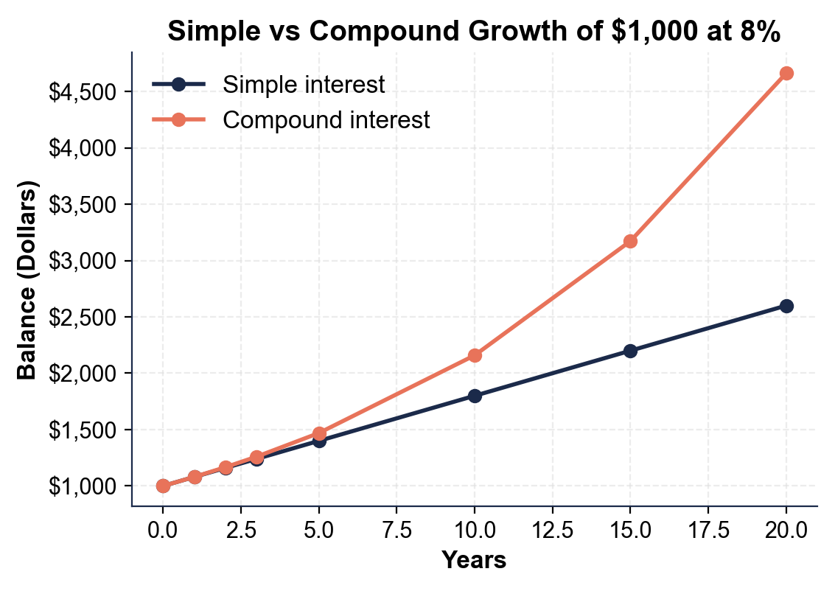
(a) which line is SIMPLE interest (the straight one or the curved one)
The straight, lower line is SIMPLE interest - it rises by the same $80 every year.
(b) which line is COMPOUND interest.
The line that curves upward and away is COMPOUND interest - it earns interest on interest. Accept any answer that identifies the straight line as simple and the upward-curving line as compound.
2. As you help Priya Nair, use the same chart to read the year-20 endpoints.
(a) About how much is in the SIMPLE account at year 20?
The SIMPLE account is about $2,600 at year 20.
(b) About how much is in the COMPOUND account at year 20?
The COMPOUND account is about $4,660.96 at year 20.
(c) Subtract to find the gap between them.
The gap is $4,660.96 - $2,600.00 = $2,060.96 more in the compound account. Accept $2,600 simple, about $4,661 compound, and a gap of about $2,060.
3. As you help Priya Nair, look at how the two lines behave over time.
(a) Are the two lines close together or far apart at the start (years 0 and 1)?
The two lines start together and are identical at year 1 (both $1,080), because in the first year compound has no past interest to compound on yet.
(b) What happens to the space between them as the years go on, and what does that growing space represent?
The space between them widens every year - the compound line curves up and away. That growing space is the INTEREST ON INTEREST: the compound account earns interest on the interest already added, so it pulls ahead more and more.
4. As you help Priya Nair, look at the overall pattern. In one or two sentences, explain what the chart shows about simple versus compound interest over time. Start your answer with: "The chart shows that..."
The chart shows that simple and compound interest start out the same but compound grows faster over time: the simple line stays straight (adding the same $80 each year) while the compound line curves upward and away, reaching $4,660.96 versus $2,600 by year 20.

PART 4

Do the Interest Math - Simple, Compound, and the Rule of 72
1. As you help Priya Nair, start with her $1,000.00 SIMPLE-interest account at 8%. Use the foundational model I = P x r x t (change 8% to the decimal 0.08).
(a) How much SIMPLE interest does she earn in 3 years?
(b) What is the BALANCE after 3 years (principal plus interest)? Show your math.
(1) SIMPLE INTEREST = $1,000.00 x 0.08 x 3 = $240.00. (2) BALANCE = $1,000.00 + $240.00 = $1,240.00. Accept $240.00 of interest and a $1,240.00 balance.
2. As you help Priya Nair, now do her $1,000.00 COMPOUND-interest account at 8%, compounded once a year. Each year, take 8% of the current balance and add it.
(a) Year 1: 8% of $1,000?
(b) Year 2: 8% of the new balance?
(c) Year 3: 8% of that balance?
(d) What is the BALANCE after 3 years? Show your math.
(1) YEAR 1 = 8% of $1,000.00 = $80.00, so balance = $1,080.00. (2) YEAR 2 = 8% of $1,080.00 = $86.40, so balance = $1,166.40. (3) YEAR 3 = 8% of $1,166.40 = $93.31, so balance = $1,259.71. (4) BALANCE after 3 years = $1,259.71. Accept yearly interest of $80.00, $86.40, $93.31 and a final balance of $1,259.71.
3. As you help Priya Nair, compare the two accounts after 3 years.
(a) How much interest did the SIMPLE account earn?
(b) How much interest did the COMPOUND account earn (the balance minus the $1,000 principal)?
(c) How much MORE did compound earn, and why? Show your math.
(1) SIMPLE interest = $240.00. (2) COMPOUND interest = $1,259.71 - $1,000.00 = $259.71. (3) Compound earned $259.71 - $240.00 = $19.71 MORE, because compound interest earns interest on the interest already added (interest on interest), while simple interest is only ever figured on the original $1,000. Accept $240.00 simple, $259.71 compound, a $19.71 difference, and the reason that compound earns interest on interest.
4. As you help Priya Nair, apply the same idea to a different amount: $2,000.00 at 6% for 4 years.
(a) SIMPLE interest using I = P x r x t?
(b) The simple TOTAL (principal plus interest)?
(c) The COMPOUND total is $2,524.95 - how much COMPOUND interest is that (total minus principal)?
(d) How much more did compound earn than simple? Show your math.
(1) SIMPLE INTEREST = $2,000.00 x 0.06 x 4 = $480.00. (2) SIMPLE TOTAL = $2,000.00 + $480.00 = $2,480.00. (3) COMPOUND INTEREST = $2,524.95 - $2,000.00 = $524.95. (4) Compound earned $524.95 - $480.00 = $44.95 MORE than simple over the same 4 years. Accept $480.00 simple interest, $2,480.00 simple total, $524.95 compound interest, and a $44.95 difference.
5. As you help Priya Nair, use the RULE OF 72 (years to double is about 72 divided by the rate percent).
(a) At her 8% rate, about how many years until her money doubles?
(b) If a different account paid 6%, about how many years to double? Show your math.
(1) At 8%: 72 / 8 = about 9 years to double. (2) At 6%: 72 / 6 = about 12 years to double. Accept about 9 years at 8% and about 12 years at 6%.

PART 5

Loans vs Savings - Make Your Recommendation
1. As you help Priya Nair, explain the core difference.
(a) On what amount is SIMPLE interest figured each year?
SIMPLE interest is figured only on the original principal (Priya's $1,000) - the same base every year.
(b) On what amount is COMPOUND interest figured each year?
COMPOUND interest is figured on the principal PLUS all the interest already earned - a bigger balance every year.
(c) Why does that difference make compound grow faster over time?
Because compound earns interest on a growing balance (interest on interest), it adds a little more each year, so over time it pulls ahead of simple and the gap keeps widening.
2. As you help Priya Nair, think about which side of the deal she is on.
(a) For Priya's SAVINGS (her $1,000 compound account), is compound interest working FOR her or AGAINST her, and why?
On her savings, compound interest works FOR Priya - she EARNS the interest, so her balance grows on its own.
(b) For Priya's CREDIT CARD, which also charges compound interest, is it working FOR her or AGAINST her, and why?
On her credit card, compound interest works AGAINST Priya - she PAYS the interest, so an unpaid balance grows on its own and she owes more.
(c) Explain why compound interest is called a 'double-edged sword.'
It is a double-edged sword because the exact same compounding math grows your money when you are the saver earning interest but grows your debt when you are the borrower paying it.
3. As you help Priya Nair, use the Rule of 72 to give advice.
(a) At 8%, about how long until her savings double?
At 8%, 72 / 8 = about 9 years for her savings to double.
(b) Knowing compound interest rewards time, what is one thing Priya could do to get the most out of compounding on her savings?
Accept any sound idea: start saving as early as possible (more years = more compounding), leave the money in so the interest keeps compounding instead of withdrawing it, add to the balance regularly, or choose an account with a higher rate or more frequent compounding.
FINAL RECOMMENDATION
4. FINAL RECOMMENDATION. Priya asks you to put it in writing. Write a 5-7 sentence note (120-180 words) telling Priya the difference between simple and compound interest, what her two accounts show, and how she should use compounding to her advantage. Check off each required element as you include it.
YOUR RESPONSE MUST:
☐ DEFINE BOTH KINDS - state in your own words that simple interest is figured on the principal only, while compound interest is figured on the principal plus interest already earned.
☐ NAME THE FORMULAS - mention the simple model I = P x r x t and the compound model A = P(1 + r/n)^(nt).
☐ USE A CALCULATED RESULT - state what her accounts really earn using a figure you calculated yourself in Part 4 (for example, $240 simple vs $259.71 compound after 3 years, or the year-20 totals).
☐ EXPLAIN INTEREST ON INTEREST - explain that compound grows faster because it earns interest on interest, and the gap widens with time.
☐ GIVE CLEAR ADVICE - tell Priya where she wants compound interest (savings) and where she does not (her credit-card debt), and one way to make compounding work for her.
GRADING RUBRIC
Grade the evidence and reasoning, not the conclusion — any defensible position is valid. Score against the 5 requirements above.
FULL CREDIT — clear position; meets all 5 requirements with accurate, specific numbers and evidence from the lesson.
PARTIAL — position stated, but misses 1-2 requirements or uses vague / incorrect numbers.
MINIMAL — no clear position, or missing most requirements and numbers.
WHAT TO LOOK FOR IN THIS LESSON
Sample full-credit note:
Priya, the difference between your two accounts comes down to how the interest is figured. SIMPLE interest uses I = P x r x t and is figured only on your original $1,000 principal, so it adds the same $80 every year - $240 in interest over 3 years, for a $1,240 balance. COMPOUND interest uses A = P(1 + r/n)^(nt) and is figured on the principal PLUS the interest already earned, so the amount added grows ($80, then $86.40, then $93.31) - that is interest on interest, and it gives you $259.71 over 3 years, a $1,259.71 balance. Both accounts pay 8%, but compound pulls ahead and the gap only widens: by year 20 simple is $2,600 while compound is $4,660.96. So keep your savings in the compound account and start early, because compounding rewards time - at 8% the Rule of 72 says your money doubles in about 9 years. The flip side: your credit card also charges compound interest, so pay it off in full, because the same interest-on-interest that grows your savings would grow your debt against you.
REQUIRED-ELEMENT CHECKLIST (award credit per item): [1] defines both kinds - simple on principal only, compound on principal plus past interest; [2] names the formulas - I = P x r x t and A = P(1 + r/n)^(nt); [3] uses a calculated result - $240 vs $259.71 after 3 years, or the year-20 totals; [4] explains interest on interest - compound grows faster and the gap widens with time; [5] gives clear advice - compound for savings (start early), pay off the compound-interest credit card.
MORE LESSONS LESS PLANNING
Thank You!
If you enjoyed this product, please do not forget to rate and review to assist other teachers.

Looking for future discounts? Earn TPT credits by reviewing purchased products.

Please contact me if you have any issues with this product. Just like our students, I am always looking for opportunities to grow.

