Impulse Buying - How Stores Trick You
STUDENT ACTIVITY
Name: | Date: | Period:
ESSENTIAL QUESTION
How do stores trick you into impulse buys - what marketing tactics and store psychology trigger unplanned purchases, how do you calculate your impulse spending (actual minus planned) and see how it adds up over a year, and how do you use a shopping plan and the 24-hour rule to beat the tricks and keep the money?
THE SCENARIO
You are RENATA ELLIS, a consumer psychologist and smart-shopping coach at a community budgeting workshop. Today your client is DIEGO, a student who keeps going over plan when he shops - he means to spend $150 in a month but ends up spending $290, because store tricks keep talking him into buys he never planned.
BY THE END, YOU CAN:
✓ Explain what an impulse buy is and how it differs from a planned purchase
✓ Identify the marketing tactics and store psychology used to trigger impulse buys
✓ Calculate impulse spending (actual spending minus planned spending) and how it adds up over a year
✓ Use the 24-hour rule and a shopping plan to resist impulse buys and beat the tricks
HOW IT WORKS (do Parts 1–5 in order)
Part 1 — Store Tricks Reference Guide - Complete the Missing Terms
Part 2 — Apply the Terms - Store-Trick Vocabulary in Context
Part 3 — Spot the Trick - Name the Tactic in Diego's Shopping Moments
Part 4 — Read the Chart - Where the Impulse Money Goes
Part 5 — Beat the Tricks - Name the Tactic and Decide Resist or Allow
TIME about 45 minutes YOU’LL NEED the lesson slides and your Guided Notes.

PART 1

Store Tricks Reference Guide - Complete the Missing Terms
Fill in the missing term for each blank row — the definition is your clue. Your Guided Notes and the lesson slides have every term.

Term | Definition
___________ | An unplanned purchase you make on the spot without thinking it through
Marketing tactic | A method a store uses to influence what and how much you buy
___________ | A display at the end of a store aisle used to grab attention and drive sales
Checkout-lane placement | Small, cheap items placed by the register to trigger last-second impulse buys
___________ | The feeling that something is running out that pressures you to buy right now
Loss leader | An item priced very low to pull you into the store, where you buy more
___________ | Online checkout so fast it removes the pause that lets you reconsider
Sensory cue | Music, lighting, or scent a store uses to put you in a buying mood
___________ | Waiting a day before a non-essential purchase to see if you still want it
Impulse spending | The money you spend on unplanned purchases

PART 2

Apply the Terms - Store-Trick Vocabulary in Context
WORD BANK endcap · 24-hour rule · one-click buying · impulse buy · scarcity
1. Q1. An unplanned purchase you make on the spot without thinking it through is called an .

2. Q2. A display at the end of a store aisle used to grab attention and drive sales is called an .

3. Q3. The pressure you feel when a store says something is 'limited time' or 'only 2 left' is called .

4. Q4. Online checkout so fast it removes the pause that lets you reconsider is called .

5. Q5. Waiting a day before a non-essential purchase to see if you still want it is called the .

PART 3

Spot the Trick - Name the Tactic in Diego's Shopping Moments
1. As Renata Ellis, you walk the store with Diego. He planned $80 for groceries. On the way he grabs a soda 12-pack stacked at the end of the aisle and a candy bar at the register - $20 he did not plan.
(a) Name the two store tactics that got him.

(b) Was the $20 a planned purchase or impulse spending, and how do you know?

(c) What is one thing he could do to catch these next time?

2. As Renata Ellis, a sign reads "TODAY ONLY - sale ends tonight" on a $35 jacket Diego did not plan to buy, and he feels he has to grab it before it is gone.
(a) What store tactic is the sign using?

(b) Is the $35 planned or impulse, and how much impulse would it add?

(c) Use the 24-hour rule - what should Diego do?

3. As Renata Ellis, shopping online, Diego adds a $45 gadget with one tap because a "customers also bought" row suggested it. He planned $0 for electronics.
(a) Name the two online tactics at work.

(b) How much impulse spending did this add?

(c) What could Diego change so he does not do this again?

PART 4

Read the Chart - Where the Impulse Money Goes
As Renata Ellis, study the bar chart titled "Planned vs. Impulse Spending in One Month" (it appears with A4-Q1). Each of Diego's five shopping categories has a navy PLANNED bar and a coral IMPULSE bar, so you can see exactly where the store tricks added spending on top of his plan. The same values are listed in the data table below. Notice that Electronics is the tallest impulse bar (he planned nothing there) and Home & Decor is the shortest. Use the chart and table to answer A4-Q1 to A4-Q3, then turn the chart into advice in A4-Q4.

Shopping category | Planned | Impulse (unplanned)
Groceries | $80 | $20
Snacks & Drinks | $10 | $25
Clothing | $40 | $35
Electronics | $0 | $45
Home & Decor | $20 | $15

Analysis

1. A4-Q1. As Renata Ellis, study the bar chart on this page titled "Planned vs. Impulse Spending in One Month." Each category has a navy PLANNED bar and a coral IMPULSE bar. Read the chart and write the planned amount AND the impulse amount for each of the five categories: (a) Groceries, (b) Snacks & Drinks, (c) Clothing, (d) Electronics, (e) Home & Decor.
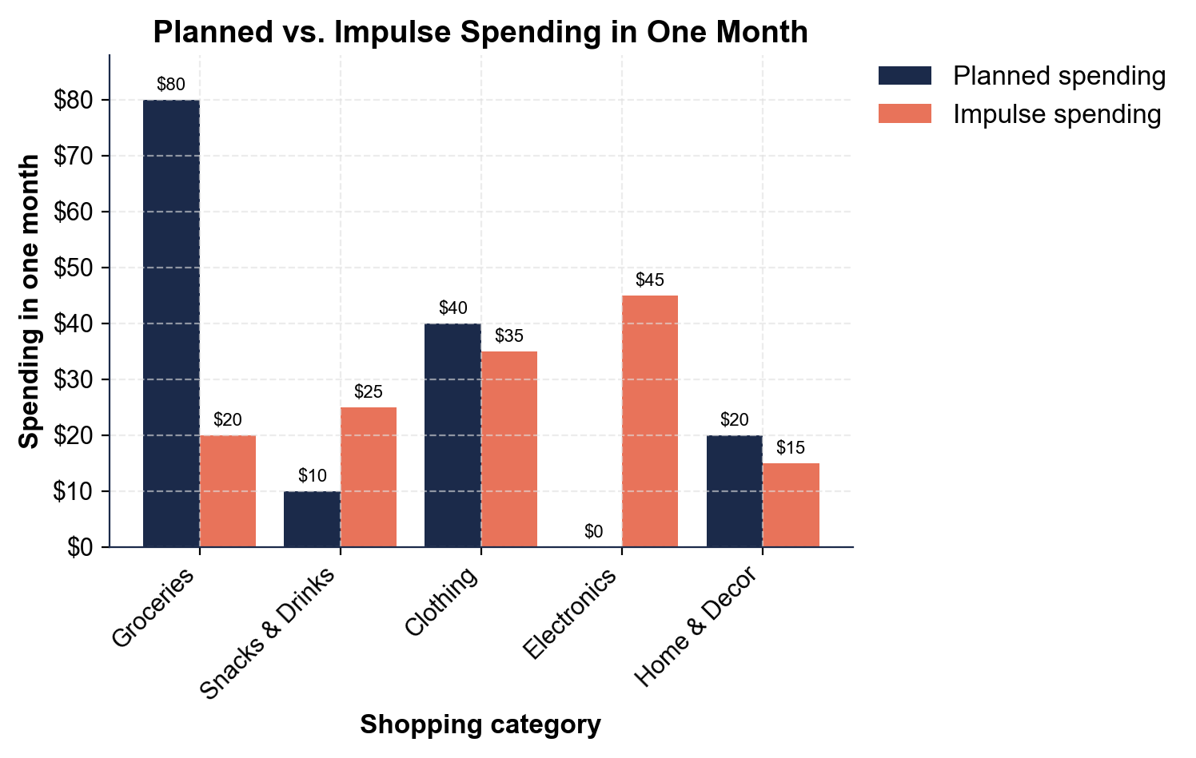

2. A4-Q2. As Renata Ellis, use the chart to compare the impulse (coral) bars. (a) Which category had the BIGGEST impulse spending, and how much? (b) Which had the SMALLEST impulse, and how much? (c) How much MORE is the biggest impulse than the smallest? Show your math.

3. A4-Q3. As Renata Ellis, total up the month. (a) Add the navy planned bars: what did Diego PLAN to spend? (b) Using MONTHLY IMPULSE TOTAL = the sum of every category's impulse spending, add the coral bars - what is his total impulse spending? (c) So what did he ACTUALLY spend (planned + impulse)? (d) If that impulse keeps up, what is his ANNUAL IMPULSE (monthly x 12)? Show your math.

4. A4-Q4. As Renata Ellis, turn the chart into advice for Diego. (a) His plan was $150 but he spent $290 - what does the chart show about how much of his spending was unplanned? (b) In which category is his impulse most out of line with his plan, and what tactic explains it? (c) In one sentence, what is your rule for beating impulse buys?

PART 5

Beat the Tricks - Name the Tactic and Decide Resist or Allow
1. MOMENT #1. As Renata Ellis, name the tactic and decide resist or allow. Diego grabs an $8 soda 12-pack stacked at the end of an aisle. It was not on his list.

2. MOMENT #2. Diego puts the milk, bread, and eggs that are on his written grocery list into his cart. Name the tactic (if any) and decide resist or allow.

3. MOMENT #3. While waiting in line, Diego eyes a $5 candy bar and gum on the rack right by the register. Name the tactic and decide resist or allow.

4. MOMENT #4. A "today only - ends tonight" sign pushes a $35 jacket Diego did not plan to buy. Name the tactic and say how the 24-hour rule applies.

5. MOMENT #5. Shopping online, a "customers also bought" row suggests a $45 gadget and Diego can add it with one tap. Name the two tactics and decide resist or allow.

6. MOMENT #6. Diego's phone case cracked, so he planned to buy a $10 replacement case and it is on his list. Name the tactic (if any) and decide resist or allow.

7. MOMENT #7. A store advertises milk for $1 - far below normal - hoping Diego comes in and fills a cart with full-price items. Name the tactic and give the smart move.

8. MOMENT #8. Slow music, warm lighting, and the smell of fresh bread make Diego linger and feel like shopping. Name the tactic and give one way to resist it.

BEAT-THE-TRICKS ACTION PLAN - FINAL REPORT
9. BEAT-THE-TRICKS ACTION PLAN - FINAL REPORT. As Renata Ellis, write a short guide a real person could follow to spot store tricks and keep their money. Write 5-7 sentences (100-160 words) that:
(a) explain what an impulse buy is and name at least three store tactics to watch for

(b) explain how to calculate impulse spending and how it adds up over a year

(c) explain how to beat the tricks with a shopping plan and the 24-hour rule. Check off each required element as you include it.

