PERSONAL FINANCE

IMPULSE BUYING - HOW STORES TRICK YOU
ANSWER KEY ACTIVITY - ANSWER KEY

PART 1

Store Tricks Reference Guide - Complete the Missing Terms

Term | Definition
Impulse buy | An unplanned purchase you make on the spot without thinking it through
Marketing tactic | A method a store uses to influence what and how much you buy
Endcap | A display at the end of a store aisle used to grab attention and drive sales
Checkout-lane placement | Small, cheap items placed by the register to trigger last-second impulse buys
Scarcity | The feeling that something is running out that pressures you to buy right now
Loss leader | An item priced very low to pull you into the store, where you buy more
One-click buying | Online checkout so fast it removes the pause that lets you reconsider
Sensory cue | Music, lighting, or scent a store uses to put you in a buying mood
24-hour rule | Waiting a day before a non-essential purchase to see if you still want it
Impulse spending | The money you spend on unplanned purchases

PART 2

Apply the Terms - Store-Trick Vocabulary in Context
WORD BANK endcap · 24-hour rule · one-click buying · impulse buy · scarcity
1. Q1. An unplanned purchase you make on the spot without thinking it through is called an impulse buy.
impulse buy
2. Q2. A display at the end of a store aisle used to grab attention and drive sales is called an endcap.
endcap
3. Q3. The pressure you feel when a store says something is 'limited time' or 'only 2 left' is called scarcity.
scarcity
4. Q4. Online checkout so fast it removes the pause that lets you reconsider is called one-click buying.
one-click buying
5. Q5. Waiting a day before a non-essential purchase to see if you still want it is called the 24-hour rule.
24-hour rule

PART 3

Spot the Trick - Name the Tactic in Diego's Shopping Moments
1. As Renata Ellis, you walk the store with Diego. He planned $80 for groceries. On the way he grabs a soda 12-pack stacked at the end of the aisle and a candy bar at the register - $20 he did not plan.
(a) Name the two store tactics that got him.
(b) Was the $20 a planned purchase or impulse spending, and how do you know?
(c) What is one thing he could do to catch these next time?
(1) The soda came from an ENDCAP (a display at the end of the aisle used to grab attention and drive sales) and the candy from CHECKOUT-LANE PLACEMENT (cheap items placed by the register to trigger last-second impulse buys). (2) IMPULSE SPENDING - the $20 was not on his plan; anything you grab on the spot that was not on your list is an impulse buy, so impulse spending = actual minus planned. (3) Shop from a written list and skip anything not on it, or apply the 24-hour rule to any non-essential. Accept: endcap + checkout-lane placement; impulse ($20, not planned); shop from a list.
2. As Renata Ellis, a sign reads "TODAY ONLY - sale ends tonight" on a $35 jacket Diego did not plan to buy, and he feels he has to grab it before it is gone.
(a) What store tactic is the sign using?
(b) Is the $35 planned or impulse, and how much impulse would it add?
(c) Use the 24-hour rule - what should Diego do?
(1) SCARCITY - 'today only / sale ends tonight' creates the feeling that the deal is running out to pressure him to buy right now. (2) IMPULSE - the jacket was not on his plan, so it would add $35 of impulse spending. (3) Apply the 24-HOUR RULE and wait a day: a real deal is almost always still there tomorrow, and if he still wants the jacket then it is a real want; if not, he keeps the $35. Accept: scarcity; impulse ($35); wait a day (24-hour rule).
3. As Renata Ellis, shopping online, Diego adds a $45 gadget with one tap because a "customers also bought" row suggested it. He planned $0 for electronics.
(a) Name the two online tactics at work.
(b) How much impulse spending did this add?
(c) What could Diego change so he does not do this again?
(1) ONE-CLICK BUYING (online checkout so fast it removes the pause that lets you reconsider) and the 'customers also bought' suggested add-ons that push extra impulse buys into the cart. (2) $45 of impulse spending - he planned $0 for electronics, so all $45 was unplanned. (3) Turn off saved cards so buying is not one tap, and leave the item in the cart overnight (the 24-hour rule online) to decide in the morning. Accept: one-click buying + suggested add-ons; impulse ($45); add friction / wait overnight.

PART 4

Read the Chart - Where the Impulse Money Goes
As Renata Ellis, study the bar chart titled "Planned vs. Impulse Spending in One Month" (it appears with A4-Q1). Each of Diego's five shopping categories has a navy PLANNED bar and a coral IMPULSE bar, so you can see exactly where the store tricks added spending on top of his plan. The same values are listed in the data table below. Notice that Electronics is the tallest impulse bar (he planned nothing there) and Home & Decor is the shortest. Use the chart and table to answer A4-Q1 to A4-Q3, then turn the chart into advice in A4-Q4.

Shopping category | Planned | Impulse (unplanned)
Groceries | $80 | $20
Snacks & Drinks | $10 | $25
Clothing | $40 | $35
Electronics | $0 | $45
Home & Decor | $20 | $15

Analysis

1. A4-Q1. As Renata Ellis, study the bar chart on this page titled "Planned vs. Impulse Spending in One Month." Each category has a navy PLANNED bar and a coral IMPULSE bar. Read the chart and write the planned amount AND the impulse amount for each of the five categories: (a) Groceries, (b) Snacks & Drinks, (c) Clothing, (d) Electronics, (e) Home & Decor.
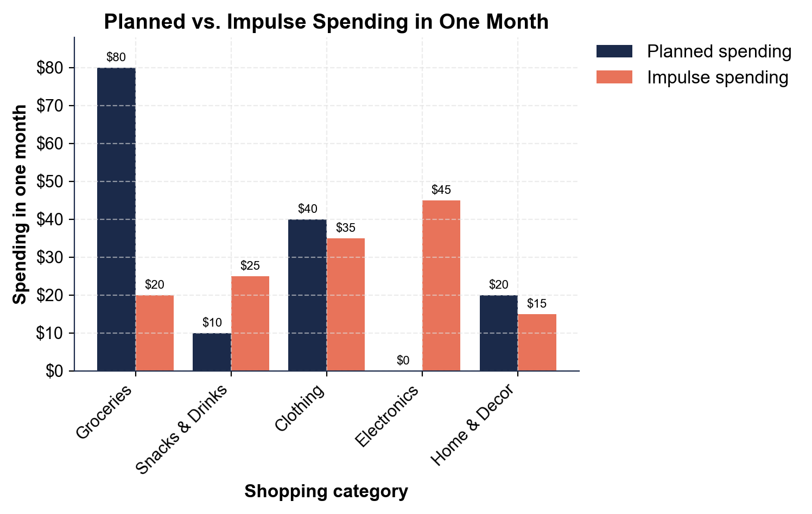
(a) Groceries: planned $80, impulse $20. (b) Snacks & Drinks: planned $10, impulse $25. (c) Clothing: planned $40, impulse $35. (d) Electronics: planned $0, impulse $45. (e) Home & Decor: planned $20, impulse $15. Accept these five planned/impulse pairs read directly off the paired bars.

2. A4-Q2. As Renata Ellis, use the chart to compare the impulse (coral) bars. (a) Which category had the BIGGEST impulse spending, and how much? (b) Which had the SMALLEST impulse, and how much? (c) How much MORE is the biggest impulse than the smallest? Show your math.
(1) BIGGEST = ELECTRONICS at $45 (the tallest coral bar) - and Diego planned $0 there, so it is entirely unplanned. (2) SMALLEST = HOME & DECOR at $15 (the shortest coral bar). (3) Difference = $45 - $15 = $30. Accept Electronics ($45) biggest, Home & Decor ($15) smallest, difference $30.

3. A4-Q3. As Renata Ellis, total up the month. (a) Add the navy planned bars: what did Diego PLAN to spend? (b) Using MONTHLY IMPULSE TOTAL = the sum of every category's impulse spending, add the coral bars - what is his total impulse spending? (c) So what did he ACTUALLY spend (planned + impulse)? (d) If that impulse keeps up, what is his ANNUAL IMPULSE (monthly x 12)? Show your math.
(1) Planned = $80 + $10 + $40 + $0 + $20 = $150. (2) Impulse total = $20 + $25 + $35 + $45 + $15 = $140. (3) Actual = $150 + $140 = $290. (4) Annual impulse = $140 x 12 = $1,680 a year. Accept planned $150, impulse total $140, actual $290, and annual impulse $1,680.

4. A4-Q4. As Renata Ellis, turn the chart into advice for Diego. (a) His plan was $150 but he spent $290 - what does the chart show about how much of his spending was unplanned? (b) In which category is his impulse most out of line with his plan, and what tactic explains it? (c) In one sentence, what is your rule for beating impulse buys?
(1) Nearly HALF of what he spent was impulse - $140 of his $290 (about 48%) went to buys he did not plan; the coral bars almost match the navy ones. (2) Snacks & Drinks is the most out of line - he planned $10 but spent $25 on impulse, more than double, driven by checkout-lane placement (candy and drinks by the register). Electronics is also fully unplanned ($0 planned, $45 impulse). (3) Rule: make a shopping list and use the 24-hour rule - if it is not on my plan, I wait a day before buying. Accept: about half was impulse; Snacks & Drinks (or Electronics) most out of line via checkout-lane placement / one-click buying; a list + the 24-hour rule.

PART 5

Beat the Tricks - Name the Tactic and Decide Resist or Allow
1. MOMENT #1. As Renata Ellis, name the tactic and decide resist or allow. Diego grabs an $8 soda 12-pack stacked at the end of an aisle. It was not on his list.
RESIST. The stack is an ENDCAP (a display at the end of the aisle to grab attention).
2. MOMENT #2. Diego puts the milk, bread, and eggs that are on his written grocery list into his cart. Name the tactic (if any) and decide resist or allow.
ALLOW. No trick here - these are PLANNED purchases on his list, not impulse buys.
3. MOMENT #3. While waiting in line, Diego eyes a $5 candy bar and gum on the rack right by the register. Name the tactic and decide resist or allow.
RESIST. That rack is CHECKOUT-LANE PLACEMENT (cheap items by the register to trigger last-second impulse buys).
4. MOMENT #4. A "today only - ends tonight" sign pushes a $35 jacket Diego did not plan to buy. Name the tactic and say how the 24-hour rule applies.
SCARCITY - the 'today only / ends tonight' sign pressures him to buy right now. Apply the 24-HOUR RULE: wait a day.
5. MOMENT #5. Shopping online, a "customers also bought" row suggests a $45 gadget and Diego can add it with one tap. Name the two tactics and decide resist or allow.
RESIST. ONE-CLICK BUYING removes the pause that lets him reconsider, and the 'customers also bought' suggested add-on pushes an unplanned buy.
6. MOMENT #6. Diego's phone case cracked, so he planned to buy a $10 replacement case and it is on his list. Name the tactic (if any) and decide resist or allow.
ALLOW. This is a PLANNED purchase of something he actually needs - it is on his list, not an impulse buy.
7. MOMENT #7. A store advertises milk for $1 - far below normal - hoping Diego comes in and fills a cart with full-price items. Name the tactic and give the smart move.
That $1 milk is a LOSS LEADER (an item priced very low to pull you into the store, where you buy more). Smart move: buy the milk if it is on his plan, but stick to his list and skip the full-price extras the store is counting on.
8. MOMENT #8. Slow music, warm lighting, and the smell of fresh bread make Diego linger and feel like shopping. Name the tactic and give one way to resist it.
These are SENSORY CUES (music, lighting, or scent a store uses to put you in a buying mood). To resist: shop from a list and give yourself a time limit, so mood does not turn into extra impulse buys.
BEAT-THE-TRICKS ACTION PLAN - FINAL REPORT
9. BEAT-THE-TRICKS ACTION PLAN - FINAL REPORT. As Renata Ellis, write a short guide a real person could follow to spot store tricks and keep their money. Write 5-7 sentences (100-160 words) that:
(a) explain what an impulse buy is and name at least three store tactics to watch for
(b) explain how to calculate impulse spending and how it adds up over a year
(c) explain how to beat the tricks with a shopping plan and the 24-hour rule. Check off each required element as you include it.
Sample full-credit action plan: An IMPULSE BUY is an unplanned purchase you make on the spot, and stores use MARKETING TACTICS to trigger them: watch for ENDCAPS at the end of aisles, CHECKOUT-LANE PLACEMENT by the register, SCARCITY signs like 'today only,' and ONE-CLICK BUYING online. Put a number on it: IMPULSE SPENDING = ACTUAL SPENDING - PLANNED SPENDING, so when Diego planned $150 but spent $290, his impulse spending was $140 - and $140 a month is $1,680 a year. To beat the tricks, shop from a list and a budget so every 'buy now' moment becomes one question: 'is this on my plan?' If it is not, skip it. For anything tempting and non-essential, use the 24-HOUR RULE and wait a day - a real deal is still there tomorrow, and most of the urge is gone by then. The money you do not spend on the tricks stays in your pocket. REQUIRED-ELEMENT CHECKLIST (award credit per item): [1] defines an impulse buy + names 3+ tactics; [2] impulse spending = actual - planned and it adds up ($140/mo = $1,680/yr); [3] a shopping plan + the 24-hour rule; [4] uses at least three lesson terms correctly. GRADING NOTE - two savings figures are both correct depending on framing: if Diego's impulse buying continues unchanged, that is $140 x 12 = $1,680 a year (Part 4). If instead he uses the 24-hour rule and cuts his impulse buying roughly in half, he saves about $70 a month = $840 a year. Accept either as long as the student is clear which one they mean.

MORE LESSONS LESS PLANNING
Thank You!
If you enjoyed this product, please do not forget to rate and review to assist other teachers.

Looking for future discounts? Earn TPT credits by reviewing purchased products.

Please contact me if you have any issues with this product. Just like our students, I am always looking for opportunities to grow.

