Hyperinflation: Weimar, Zimbabwe, Venezuela
STUDENT ACTIVITY
Name: | Date: | Period:
ESSENTIAL QUESTION
When a government starts printing money to pay its bills, what stops the slide into hyperinflation - and what does not?
THE SCENARIO
It is March 2026. You are DR. MAYA CHEN, a currency-stability advisor at the International Monetary Fund (IMF) in Washington.
BY THE END, YOU CAN:
✓ Define hyperinflation using the Cagan threshold (50%+ monthly) and name the three classic cases
✓ Trace the common causes of hyperinflation across Weimar Germany 1923, Zimbabwe 2008, and Venezuela 2016-2020
✓ Evaluate the human consequences for savings, contracts, and political stability
HOW IT WORKS (do Parts 1–5 in order)
Part 1 — Hyperinflation Reference Guide - Complete the Missing Terms
Part 2 — Apply the Terms - Hyperinflation Vocabulary in Context
Part 3 — Dr. Maya Chen Reads the Weimar and Zimbabwe Inflation Charts
Part 4 — Dr. Maya Chen Reads the Venezuela Inflation Chart
Part 5 — Dr. Maya Chen's Stop-the-Printing Memo (Marakland Recommendation)
TIME about 45 minutes YOU’LL NEED the lesson slides and your Guided Notes.

PART 1

Hyperinflation Reference Guide - Complete the Missing Terms
Fill in the missing term for each blank row — the definition is your clue. Your Guided Notes and the lesson slides have every term.

Term | Definition
___________ | Inflation so fast that prices double in weeks; the Cagan threshold defines it as 50 percent or more inflation per month
Cagan threshold | Phillip Cagan 1956 definition: hyperinflation begins at 50 percent inflation per month, about 12,875 percent per year
___________ | The new German currency introduced November 1923 backed by land mortgages that ended the Weimar hyperinflation
Versailles | War reparations Germany owed under the 1919 Treaty of Versailles; the fiscal pressure behind Weimar money-printing
___________ | When Venezuela defaulted on its dollar bonds in 2017
Land reform | The 2000-2003 seizure of white-owned commercial farms in Zimbabwe that collapsed agricultural exports and tax revenue
___________ | Government must pay civil service and military but has lost its normal revenue
Mugabe | President Robert Mugabe government printed money to pay the civil service in Zimbabwe
___________ | The spiral where printing money causes inflation, which forces wages and prices up, which creates demand for more printing
reserve currency | USD reserve currency status; the dollar is about 60 percent of global reserves

PART 2

Apply the Terms - Hyperinflation Vocabulary in Context
WORD BANK Rentenmark · doom loop · fiscal pressure · sovereign default · Hyperinflation
1. Inflation so fast that prices double in a matter of weeks - 50% or more per MONTH, the rate Phillip Cagan set as the dividing line in his 1956 paper - is . Normal inflation runs 2-3% per YEAR; this is roughly 1000 times larger.

2. The new German currency introduced in November 1923, backed by mortgages on land, that ended the Weimar hyperinflation by replacing the old papiermark at one trillion to one was the .

3. When a government fails to pay back its bondholders - as Venezuela did on its dollar bonds in November 2017 - it commits a .

4. The need to keep paying the civil service and military after a government has lost its normal revenue - the root force that pushes a government toward printing money - is .

5. The self-reinforcing spiral in which printing money raises inflation, which forces wages and prices up, which then demands still more printing, is the .

PART 3

Dr. Maya Chen Reads the Weimar and Zimbabwe Inflation Charts
1. HOW TO READ THE LOG10 AXIS: the y-axis is the log10 of the monthly inflation rate, so the real percent is 10 raised to the power of y (10^y).
Worked examples: y=1 means 10%, y=1.7 means about 50% (the Cagan threshold), y=2 means 100%, y=3 means 1,000%, y=4 means 10,000%. Use this same method on every chart in Parts 3 and 4. Now use Chart Reference 1 - the Weimar monthly inflation chart reproduced after Part 5 of this packet and shown in the slide deck - to identify the month Weimar Germany first crossed the Cagan 50% monthly threshold (y=1.7). What approximate x-coordinate (months since January 1922) corresponds to the threshold crossing, and what month does that x-coordinate represent?

2. Use Chart Reference 1 to identify the peak month and peak inflation rate for Weimar. Look at the far right of the chart, find the highest point, read the y-value there, and compute 10^y to get the actual percent. Then state (1-2 sentences) what was happening politically at that moment - and what action ended the spiral.

3. Use Chart Reference 2 - the Zimbabwe monthly inflation chart reproduced after Part 5 - to answer: Was Zimbabwe already in hyperinflation when the chart begins in January 2007? Read the y-value at x=0 (Jan 2007) and compute 10^y.
Then read the y-value at the peak (x=22, Nov 2008) and compute 10^y. About how many orders of magnitude does the chart span?

PART 4

Dr. Maya Chen Reads the Venezuela Inflation Chart
1. Use Chart Reference 3 - the Venezuela annual inflation chart reproduced after Part 5 - to describe the BUILDUP trajectory from 2013 through 2018.
What was annual inflation in 2013 (read y, compute 10^y), and what was it at the 2018 peak? About how many years did the buildup take?

2. Use Chart Reference 3 to describe the DECLINE trajectory from 2018 through 2022.
What was annual inflation in 2022 (read y, compute 10^y)? Is Venezuela still in hyperinflation at the end of the chart?

3. As Dr. Maya Chen, compare the Venezuela trajectory (Chart Reference 3) to the Weimar trajectory (Chart Reference 1). Both span roughly 3-4 orders of magnitude. But WHY is Venezuela's exit so different from Weimar's exit? What political/institutional factor would have to change for Venezuela to end its inflation the way Weimar did? (3-4 sentences)

PART 5

Dr. Maya Chen's Stop-the-Printing Memo (Marakland Recommendation)
STOP-THE-PRINTING MEMO
1. As Dr. Maya Chen in March 2026, write a 7-9 sentence (250-330 word) memo to the finance minister of MARAKLAND - the fictional petrostate whose monthly inflation just crossed 30%. State your VERDICT (is the situation fixable, or is Marakland heading toward Weimar/Zimbabwe/Venezuela territory?) and defend it using the Cagan 50%-monthly threshold. You MUST cite at least ONE specific value from EACH of the three charts: Chart Reference 1 (Weimar), Chart Reference 2 (Zimbabwe), and Chart Reference 3 (Venezuela). Name TWO specific institutional reforms Marakland must enact and ONE specific risk of inaction. Fill in the memo header below and write your recommendation underneath it.
YOUR RESPONSE MUST:
☐ States a clear VERDICT (fixable / heading toward hyperinflation) and defends it using the Cagan 50%-per-month threshold.
☐ Cites at least ONE specific numeric value you read yourself from Chart Reference 1 (Weimar) to support the verdict.
☐ Cites at least ONE specific numeric value you read yourself from Chart Reference 2 (Zimbabwe).
☐ Cites at least ONE specific numeric value you read yourself from Chart Reference 3 (Venezuela).
☐ Names TWO specific institutional reforms (e.g., central-bank independence, fiscal discipline, currency reform, dollarization, IMF program).
☐ Names ONE specific risk of inaction.
MEMO
To: Marakland Finance Minister
From: Dr. Maya Chen, IMF Currency Stability Advisor
Date: March 14, 2026
Re:

CHART REFERENCE 1: WEIMAR GERMANY MONTHLY INFLATION, JAN 1922 - NOV 1923 (LOG SCALE)

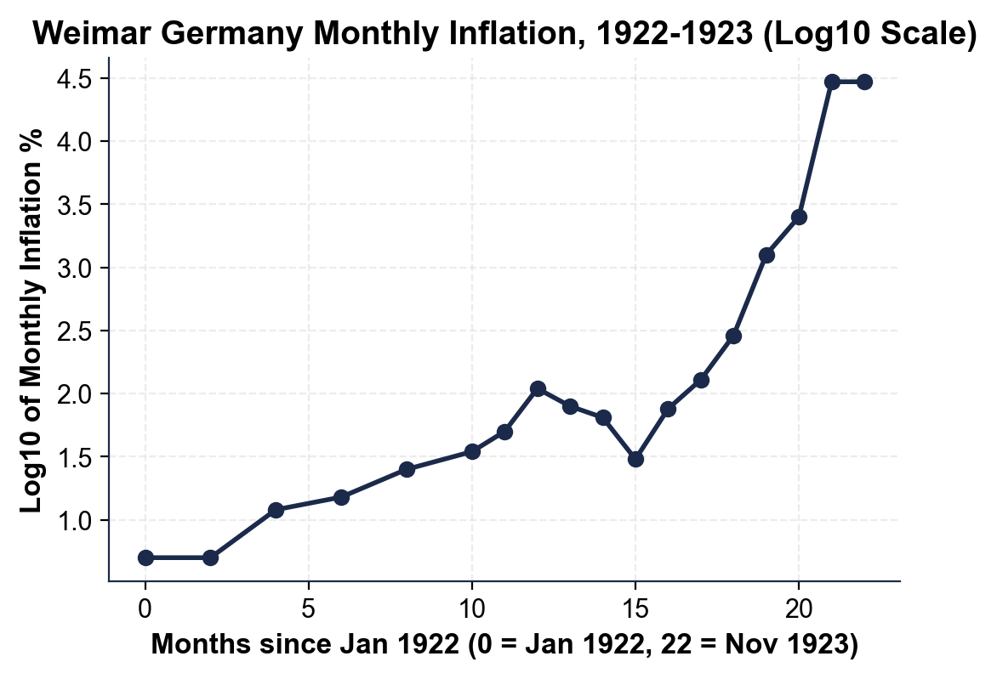

CHART REFERENCE 2: ZIMBABWE MONTHLY INFLATION, JAN 2007 - NOV 2008 (LOG SCALE)

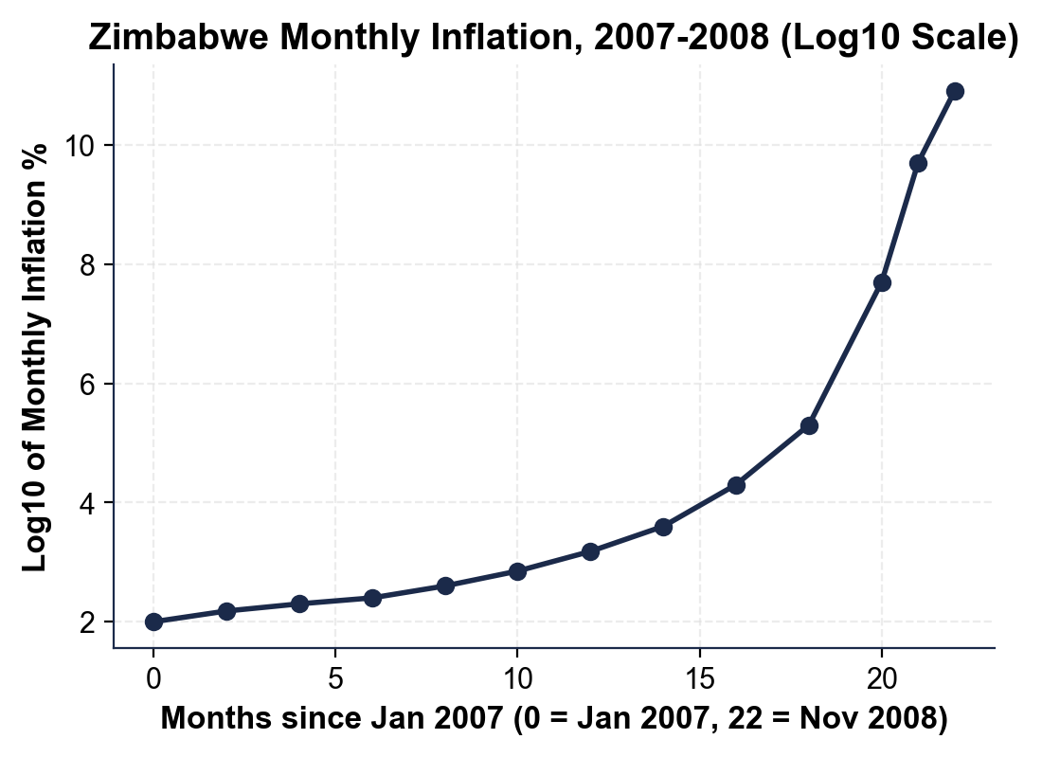

CHART REFERENCE 3: VENEZUELA ANNUAL INFLATION, 2013 - 2022 (LOG SCALE)

