ECONOMICS

HYPERINFLATION: WEIMAR, ZIMBABWE, VENEZUELA
ANSWER KEY ACTIVITY

PART 1

Hyperinflation Reference Guide - Complete the Missing Terms

Term | Definition
Hyperinflation | Inflation so fast that prices double in weeks; the Cagan threshold defines it as 50 percent or more inflation per month
Cagan threshold | Phillip Cagan 1956 definition: hyperinflation begins at 50 percent inflation per month, about 12,875 percent per year
Rentenmark | The new German currency introduced November 1923 backed by land mortgages that ended the Weimar hyperinflation
Versailles | War reparations Germany owed under the 1919 Treaty of Versailles; the fiscal pressure behind Weimar money-printing
Sovereign default | When Venezuela defaulted on its dollar bonds in 2017
Land reform | The 2000-2003 seizure of white-owned commercial farms in Zimbabwe that collapsed agricultural exports and tax revenue
Fiscal pressure | Government must pay civil service and military but has lost its normal revenue
Mugabe | President Robert Mugabe government printed money to pay the civil service in Zimbabwe
doom loop | The spiral where printing money causes inflation, which forces wages and prices up, which creates demand for more printing
reserve currency | USD reserve currency status; the dollar is about 60 percent of global reserves

PART 2

Apply the Terms - Hyperinflation Vocabulary in Context
WORD BANK Rentenmark · doom loop · fiscal pressure · sovereign default · Hyperinflation
1. Inflation so fast that prices double in a matter of weeks - 50% or more per MONTH, the rate Phillip Cagan set as the dividing line in his 1956 paper - is Hyperinflation. Normal inflation runs 2-3% per YEAR; this is roughly 1000 times larger.
Hyperinflation
2. The new German currency introduced in November 1923, backed by mortgages on land, that ended the Weimar hyperinflation by replacing the old papiermark at one trillion to one was the Rentenmark.
Rentenmark
3. When a government fails to pay back its bondholders - as Venezuela did on its dollar bonds in November 2017 - it commits a sovereign default.
sovereign default
4. The need to keep paying the civil service and military after a government has lost its normal revenue - the root force that pushes a government toward printing money - is fiscal pressure.
fiscal pressure
5. The self-reinforcing spiral in which printing money raises inflation, which forces wages and prices up, which then demands still more printing, is the doom loop.
doom loop

PART 3

Dr. Maya Chen Reads the Weimar and Zimbabwe Inflation Charts
1. HOW TO READ THE LOG10 AXIS: the y-axis is the log10 of the monthly inflation rate, so the real percent is 10 raised to the power of y (10^y).
Worked examples: y=1 means 10%, y=1.7 means about 50% (the Cagan threshold), y=2 means 100%, y=3 means 1,000%, y=4 means 10,000%. Use this same method on every chart in Parts 3 and 4. Now use Chart Reference 1 - the Weimar monthly inflation chart reproduced after Part 5 of this packet and shown in the slide deck - to identify the month Weimar Germany first crossed the Cagan 50% monthly threshold (y=1.7). What approximate x-coordinate (months since January 1922) corresponds to the threshold crossing, and what month does that x-coordinate represent?
The Cagan threshold (50% monthly = log10 of 1.70) is crossed around x = 11, which represents DECEMBER 1922 (since x=0 is January 1922, x=11 is December 1922). The chart shows the line crossing y=1.70 between x=10 (November 1922, y~1.54) and x=11 (December 1922, y=1.70). The exact crossing is at the boundary of late 1922. Accept any answer that (a) identifies x in the range 10-12 OR (b) names a month in the range November 1922 - January 1923, AND (c) connects the y-value of 1.70 to the 50% monthly Cagan threshold. The point of this question is to drill that LOG10 of 50 is about 1.70.
2. Use Chart Reference 1 to identify the peak month and peak inflation rate for Weimar. Look at the far right of the chart, find the highest point, read the y-value there, and compute 10^y to get the actual percent. Then state (1-2 sentences) what was happening politically at that moment - and what action ended the spiral.
The peak appears at x=21 (October 1923) and x=22 (November 1923) both at y = 4.47. Computing 10^4.47 gives about 29,500% per month (29,512 to be exact). Politically, this was the climax of the passive-resistance crisis triggered by the January 1923 French-Belgian Ruhr occupation: the German government had been printing marks for nine months to pay striking Ruhr workers, and the printing-press response was completely out of control by mid-1923. The action that ENDED the spiral was the introduction of the RENTENMARK on November 15, 1923 - a new currency backed by mortgages on German land, exchanged for old papiermarks at 1 TRILLION to 1. The Rentenmark held its value, the panic stopped within weeks, and the Reichsmark took over in 1924. Full credit requires: (a) peak y-value of about 4.47, (b) actual percent in the 20,000-30,000% range (10^4.47 ~= 29,500), (c) the Ruhr occupation / passive resistance political context, AND (d) the Rentenmark as the cure.
3. Use Chart Reference 2 - the Zimbabwe monthly inflation chart reproduced after Part 5 - to answer: Was Zimbabwe already in hyperinflation when the chart begins in January 2007? Read the y-value at x=0 (Jan 2007) and compute 10^y.
Then read the y-value at the peak (x=22, Nov 2008) and compute 10^y. About how many orders of magnitude does the chart span?
Yes, Zimbabwe was ALREADY in hyperinflation when the chart begins. At x=0 (January 2007), y = 2.00, so 10^2.00 = 100% monthly inflation - already double the Cagan 50% threshold. At the peak (x=22, November 2008), y = 10.90, so 10^10.90 = about 79.6 BILLION percent monthly. The chart spans (10.90 - 2.00) = 8.9 orders of magnitude - call it 9 orders of magnitude. This is the largest peacetime hyperinflation in modern history, almost 3 million times worse than the Weimar peak. The log10 axis is mandatory: a linear chart would show January 2007's 100% as a flat line at the bottom and only the November 2008 spike would be visible. Full credit requires: (a) Jan 2007 y of 2.00 = 100% monthly = already above Cagan threshold, (b) Nov 2008 y of 10.9 = about 79.6 billion percent monthly, AND (c) about 9 orders of magnitude spanned.

PART 4

Dr. Maya Chen Reads the Venezuela Inflation Chart
1. Use Chart Reference 3 - the Venezuela annual inflation chart reproduced after Part 5 - to describe the BUILDUP trajectory from 2013 through 2018.
What was annual inflation in 2013 (read y, compute 10^y), and what was it at the 2018 peak? About how many years did the buildup take?
In 2013 the y-value is 1.60, so 10^1.60 = about 40% annual inflation - high but NOT hyperinflation. At the 2018 peak the y-value is 4.82, so 10^4.82 = about 65,374% annual inflation - clearly hyperinflation. The buildup took roughly 5 years (2013 to 2018). The trajectory was gradual rather than explosive: 2013 (40%), 2014 (69%), 2015 (181%), 2016 (274%), 2017 (863%), 2018 (65,374%). Each year added roughly an order of magnitude until the 2017-2018 jump, which was the explosive phase. Full credit requires: (a) starting value about 40% (y=1.60), (b) peak about 65,374% (y=4.82), AND (c) the 5-year buildup framing.
2. Use Chart Reference 3 to describe the DECLINE trajectory from 2018 through 2022.
What was annual inflation in 2022 (read y, compute 10^y)? Is Venezuela still in hyperinflation at the end of the chart?
By 2022 the y-value is 2.37, so 10^2.37 = about 234% annual inflation. The decline trajectory: 2018 (65,374%), 2019 (19,906%), 2020 (2,355%), 2021 (686%), 2022 (234%). Venezuela is NO LONGER in hyperinflation by the strict Cagan monthly threshold by 2022 - 234% per YEAR works out to about 11% per month, well below the 50% monthly bar. But Venezuela is still in extreme inflation by any normal standard, more than 100x the U.S. Fed target. The decline has been gradual rather than abrupt because no currency reform comparable to Weimar's Rentenmark or Zimbabwe's dollarization has happened. Full credit requires: (a) 2022 value about 234% annual (y=2.37), (b) recognition that this is below the Cagan threshold technically, AND (c) recognition that the decline was gradual and there was no currency reform.
3. As Dr. Maya Chen, compare the Venezuela trajectory (Chart Reference 3) to the Weimar trajectory (Chart Reference 1). Both span roughly 3-4 orders of magnitude. But WHY is Venezuela's exit so different from Weimar's exit? What political/institutional factor would have to change for Venezuela to end its inflation the way Weimar did? (3-4 sentences)
(a) a regime change willing to credibly commit to no-more-printing (b) formal dollarization (which Maduro has rejected because it would strip the government's printing power), OR (c) external pressure (an IMF program with binding fiscal conditions). None of those are guaranteed. (a) Weimar's abrupt Rentenmark reform (b) Venezuela's gradual decline with no equivalent reform, AND (c) one specific political/institutional factor (regime change, dollarization, or external fiscal program).

PART 5

Dr. Maya Chen's Stop-the-Printing Memo (Marakland Recommendation)
STOP-THE-PRINTING MEMO
1. As Dr. Maya Chen in March 2026, write a 7-9 sentence (250-330 word) memo to the finance minister of MARAKLAND - the fictional petrostate whose monthly inflation just crossed 30%. State your VERDICT (is the situation fixable, or is Marakland heading toward Weimar/Zimbabwe/Venezuela territory?) and defend it using the Cagan 50%-monthly threshold. You MUST cite at least ONE specific value from EACH of the three charts: Chart Reference 1 (Weimar), Chart Reference 2 (Zimbabwe), and Chart Reference 3 (Venezuela). Name TWO specific institutional reforms Marakland must enact and ONE specific risk of inaction. Fill in the memo header below and write your recommendation underneath it.
YOUR RESPONSE MUST:
☐ States a clear VERDICT (fixable / heading toward hyperinflation) and defends it using the Cagan 50%-per-month threshold.
☐ Cites at least ONE specific numeric value you read yourself from Chart Reference 1 (Weimar) to support the verdict.
☐ Cites at least ONE specific numeric value you read yourself from Chart Reference 2 (Zimbabwe).
☐ Cites at least ONE specific numeric value you read yourself from Chart Reference 3 (Venezuela).
☐ Names TWO specific institutional reforms (e.g., central-bank independence, fiscal discipline, currency reform, dollarization, IMF program).
☐ Names ONE specific risk of inaction.
MEMO
To: Marakland Finance Minister
From: Dr. Maya Chen, IMF Currency Stability Advisor
Date: March 14, 2026
Re: [student completes]
GRADING RUBRIC
Grade the evidence and reasoning, not the conclusion — any defensible position is valid. Score against the 6 requirements above.
FULL CREDIT — clear position; meets all 6 requirements with accurate, specific numbers and evidence from the lesson.
PARTIAL — position stated, but misses 1-2 requirements or uses vague / incorrect numbers.
MINIMAL — no clear position, or missing most requirements and numbers.
WHAT TO LOOK FOR IN THIS LESSON
Graded by the rubric below (10 pts). A full-credit memo (sample recommends acting NOW):
Subject: Stop the Printing - Marakland Is 6-12 Months from the Cagan Threshold
Verdict: FIXABLE, but only if you act within six months. Marakland's 30% monthly inflation sits just below the Cagan threshold for hyperinflation - 50% per MONTH, which annualizes to about 12,875% per year - so you are not yet at the Weimar/Zimbabwe/Venezuela bar but you are on the same trajectory. Chart Reference 1 (Weimar) should worry you: Germany also sat below the threshold in late 1922, crossed it around December 1922 (x=11), and ten months later peaked in November 1923 at log10 = 4.47 - about 29,500% per month. Chart Reference 2 (Zimbabwe) shows how fast it accelerates once control breaks: Zimbabwe began January 2007 ALREADY at 100% monthly (log10 = 2.00) and reached log10 = 10.9 - about 79.6 billion percent - by November 2008. Chart Reference 3 (Venezuela) is the slow-build warning: inflation climbed from 40% annual in 2013 (log10 = 1.60) to a 2018 peak of 65,374% (log10 = 4.82), and Venezuela is STILL in extreme inflation years later because no credible reform followed. Marakland must do TWO things: first, restore CENTRAL-BANK INDEPENDENCE by reversing the emergency decree that ended it six months ago; second, enter an IMF-monitored FISCAL-DISCIPLINE program that ties spending to revenue with binding external conditions. The RISK of inaction is severe: within roughly 12 months Marakland could cross the Cagan threshold, and once the currency dies, trust in money and government takes a generation to rebuild. ACCEPTABLE ALTERNATES: any defensible verdict (act now, dollarize, seek external support) earns full credit provided it defends the verdict with the Cagan threshold, cites at least one value from EACH of the three charts, names two institutional reforms, and names one risk of inaction.

CHART REFERENCE 1: WEIMAR GERMANY MONTHLY INFLATION, JAN 1922 - NOV 1923 (LOG SCALE)

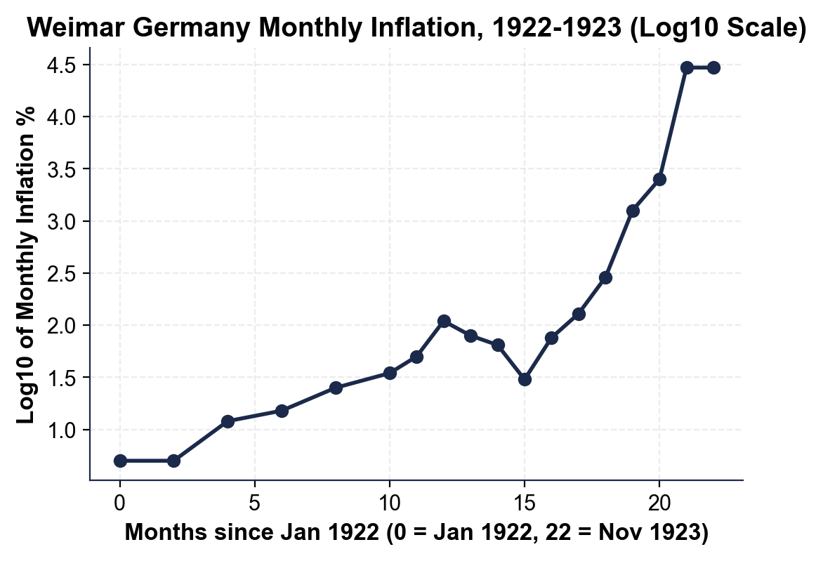

CHART REFERENCE 2: ZIMBABWE MONTHLY INFLATION, JAN 2007 - NOV 2008 (LOG SCALE)

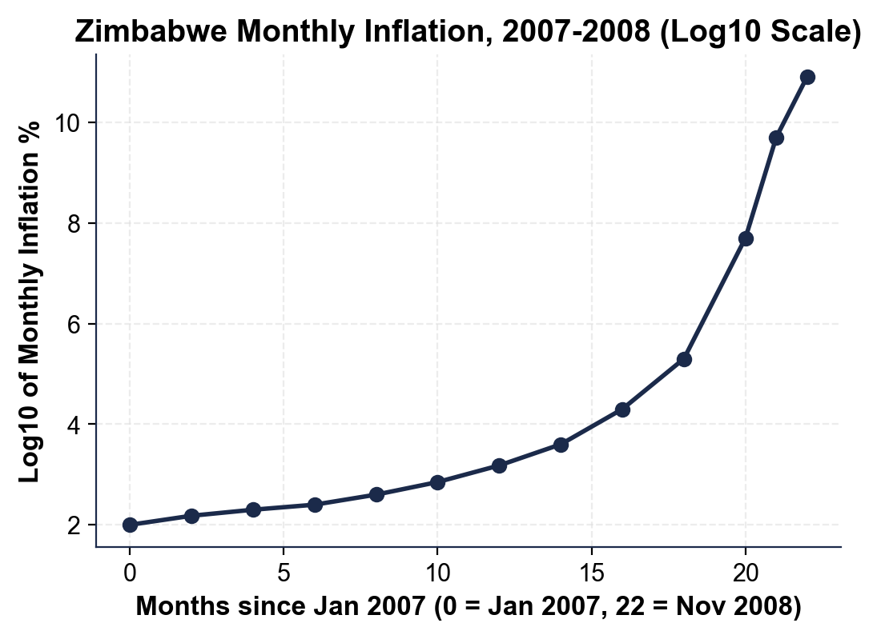

CHART REFERENCE 3: VENEZUELA ANNUAL INFLATION, 2013 - 2022 (LOG SCALE)

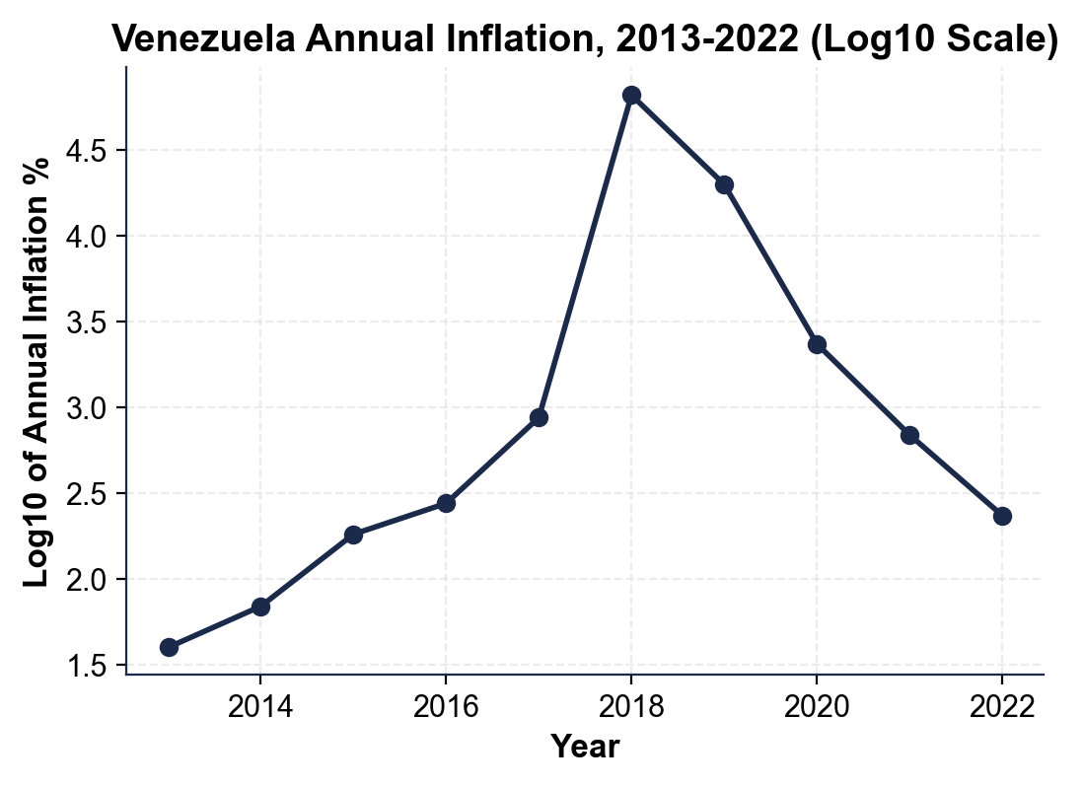
MORE LESSONS LESS PLANNING
Thank You!
If you enjoyed this product, please do not forget to rate and review to assist other teachers.

Looking for future discounts? Earn TPT credits by reviewing purchased products.

Please contact me if you have any issues with this product. Just like our students, I am always looking for opportunities to grow.

