Hourly vs Salary: Which Job Actually Pays More?
STUDENT ACTIVITY
Name: | Date: | Period:
ESSENTIAL QUESTION
Two job offers - one hourly, one salaried - can look almost the same on paper, so how do you run the numbers to decide which one actually pays more, and why does the answer depend on the hours you work?
THE SCENARIO
You are JORDAN REYES, a recent high school graduate with two job offers sitting on the kitchen table: Job A is at Riverside Warehouse - $20.00 an hour, scheduled 40 hours a week, with time-and-a-half overtime for any hour over 40 - while Job B is at Northgate Office, a flat $45,000 salary per year for about 40 hours a week, but with no extra pay for overtime. On paper they look close, so which one actually pays more?
BY THE END, YOU CAN:
✓ Explain the difference between an hourly wage and a salary and how each one turns into a paycheck
✓ Calculate overtime pay using the time-and-a-half rate for hours worked beyond 40 in a week
✓ Annualize an hourly wage to estimate yearly pay and convert a salary back to an hourly equivalent
✓ Compare two real job offers - one hourly, one salaried - and decide which one actually pays more based on hours worked
HOW IT WORKS (do Parts 1–5 in order)
Part 1 — Pay Reference Guide - Complete the Missing Terms
Part 2 — Apply the Terms - Hourly and Salary Vocabulary in Context
Part 3 — Read the Chart - Annual Pay: Hourly Job A vs Salary Job B by Hours Worked
Part 4 — Run the Pay Math - Gross, Overtime, Annualize, and Compare
Part 5 — Your Final Advice Memo for a Friend Choosing a Job
TIME about 45 minutes YOU’LL NEED the lesson slides and your Guided Notes.

PART 1

Pay Reference Guide - Complete the Missing Terms
Fill in the missing term for each blank row — the definition is your clue. Your Guided Notes and the lesson slides have every term.

Term | Definition
___________ | Pay set as a fixed amount for each hour you work; your paycheck rises and falls with the number of hours
Salary | A fixed amount of pay for the year, divided evenly across each paycheck no matter how many hours you work
___________ | The extra-rate pay you earn for hours worked beyond 40 in a week; for most hourly jobs the rate is higher than your normal wage
Time-and-a-half | The standard overtime rate of 1.5 times your normal hourly wage, paid for each hour over 40 in a week
___________ | Estimating yearly pay from a smaller unit by multiplying out: hourly wage x hours per week x 52 weeks
Gross pay | Your total pay before any taxes or deductions are taken out
___________ | The 40-hour-per-week line; only the hours ABOVE it earn the overtime rate
Non-exempt employee | A worker (usually hourly) who is legally owed overtime pay for hours over 40 in a week
___________ | A salaried worker who is not legally owed overtime pay, so extra hours bring no extra pay
Hourly equivalent | A salary converted back to an effective hourly rate by dividing yearly pay by the hours actually worked in a year

PART 2

Apply the Terms - Hourly and Salary Vocabulary in Context
WORD BANK overtime · overtime threshold · exempt employee · annualizing · hourly wage
1. Q1. Pay set as a fixed amount for each hour you work, so your paycheck rises and falls with the number of hours, is an .

2. Q2. The extra-rate pay you earn for hours worked beyond 40 in a week, paid at a higher rate than your normal wage, is .

3. Q3. Estimating yearly pay from an hourly wage by multiplying it out - hourly wage x hours per week x 52 weeks - is called .

4. Q4. The 40-hour-per-week line, where only the hours ABOVE it earn the overtime rate, is the .

5. Q5. A salaried worker who is NOT legally owed overtime pay, so extra hours bring no extra pay, is an .

PART 3

Read the Chart - Annual Pay: Hourly Job A vs Salary Job B by Hours Worked
1. As Jordan Reyes, study the bar chart on this page titled "Annual Pay: Hourly Job A vs Salary Job B by Hours Worked." The navy bars are Job A (hourly) and the coral bars are Job B (salary).
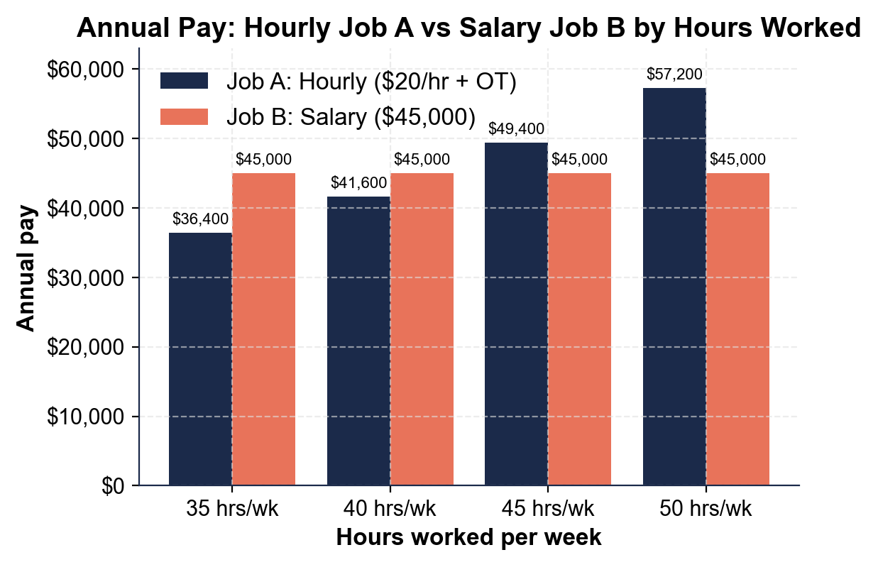
What is Job B's annual pay at EVERY hours level, and what does the flat shape of those bars tell you about a salary?

2. As Jordan Reyes, read the navy Job A (hourly) bars.
About how much does Job A earn per year at 40 hours/week, and about how much at 50 hours/week? Why does the hourly bar get TALLER as the hours rise?

3. As Jordan Reyes, compare the two bars at each hours level.
At which hours level does Job A (hourly) first pass Job B (salary)? Between which two hours levels does the hourly job overtake the salary, and what does that tell you about answering "which job pays more?"

PART 4

Run the Pay Math - Gross, Overtime, Annualize, and Compare
1. | P4-Q1. As Jordan Reyes, first find your weekly gross pay at Job A for a normal 40-hour week. Job A pays $20.00 per hour. Show your work.  Formula: Gross Pay = Hourly Rate x Hours  Answer: for the week

2. | P4-Q2. Now annualize Job A at a steady 40 hours a week to estimate Jordan's yearly pay. Use $20.00/hr, 40 hours/week, 52 weeks. Show your work.  Formula: Annual Pay = Hourly Rate x Hours per Week x 52 Weeks  Answer: per year

3. | P4-Q3. One busy week, Jordan works 47 hours at Job A. Overtime (hours over 40) is paid at time-and-a-half. Find the gross pay for that 47-hour week. Show your work.  Formula: Gross = (40 x rate) + (overtime hours x rate x 1.5) - where overtime hours = total hours worked minus 40  Answer: for the week

4. | P4-Q4. Convert Job B's $45,000 salary to an hourly equivalent if Jordan works 40 hours a week, 52 weeks a year. This shows what the salary is really worth per hour. Show your work.  Formula: Hourly Equivalent = Annual Salary / (Hours per Week x 52)  Answer: per hour

5. | P4-Q5. If Jordan instead works LONG 50-hour weeks at the salaried Job B (with no overtime), what is the salary's hourly equivalent now? Use $45,000 / (50 x 52). Compare it to your answer in Q4 and explain in one sentence what happened.  Formula: Hourly Equivalent = Annual Salary / (Hours per Week x 52)  Answer: per hour

PART 5

Your Final Advice Memo for a Friend Choosing a Job
FINAL ADVICE MEMO
1. FINAL ADVICE MEMO. Now that you, Jordan Reyes, have run the numbers on both offers, help someone else. Your friend Priya just got two job offers - one hourly, one salaried - and texts you, "They both sound good, how do I tell which one actually pays more?" Write Priya a 5-7 sentence advice memo. Check off each required element as you include it.
YOUR RESPONSE MUST:
☐ EXPLAIN THE DIFFERENCE - hourly pay = rate x hours (changes with the schedule); a salary is fixed yearly pay split evenly, the same every payday.
☐ EXPLAIN OVERTIME - an hourly job usually pays time-and-a-half (1.5x) for hours over 40, while a salaried job often pays no overtime.
☐ TELL HER TO ANNUALIZE - to compare fairly, multiply the hourly wage x hours per week x 52 so both offers are yearly numbers side by side.
☐ SAY IT DEPENDS ON HOURS - which job pays more depends on how many hours she will realistically work (few hours favors salary; many hours favors hourly + overtime).
☐ MENTION BENEFITS - remind her to weigh benefits like health insurance and paid time off, not just the headline pay.

