PERSONAL FINANCE

HOURLY VS SALARY: WHICH JOB ACTUALLY PAYS MORE?
ANSWER KEY ACTIVITY - ANSWER KEY

PART 1

Pay Reference Guide - Complete the Missing Terms

Term | Definition
Hourly wage | Pay set as a fixed amount for each hour you work; your paycheck rises and falls with the number of hours
Salary | A fixed amount of pay for the year, divided evenly across each paycheck no matter how many hours you work
Overtime | The extra-rate pay you earn for hours worked beyond 40 in a week; for most hourly jobs the rate is higher than your normal wage
Time-and-a-half | The standard overtime rate of 1.5 times your normal hourly wage, paid for each hour over 40 in a week
Annualizing | Estimating yearly pay from a smaller unit by multiplying out: hourly wage x hours per week x 52 weeks
Gross pay | Your total pay before any taxes or deductions are taken out
Overtime threshold | The 40-hour-per-week line; only the hours ABOVE it earn the overtime rate
Non-exempt employee | A worker (usually hourly) who is legally owed overtime pay for hours over 40 in a week
Exempt employee | A salaried worker who is not legally owed overtime pay, so extra hours bring no extra pay
Hourly equivalent | A salary converted back to an effective hourly rate by dividing yearly pay by the hours actually worked in a year

PART 2

Apply the Terms - Hourly and Salary Vocabulary in Context
WORD BANK overtime · overtime threshold · exempt employee · annualizing · hourly wage
1. Q1. Pay set as a fixed amount for each hour you work, so your paycheck rises and falls with the number of hours, is an hourly wage.
hourly wage
2. Q2. The extra-rate pay you earn for hours worked beyond 40 in a week, paid at a higher rate than your normal wage, is overtime.
overtime
3. Q3. Estimating yearly pay from an hourly wage by multiplying it out - hourly wage x hours per week x 52 weeks - is called annualizing.
annualizing
4. Q4. The 40-hour-per-week line, where only the hours ABOVE it earn the overtime rate, is the overtime threshold.
overtime threshold
5. Q5. A salaried worker who is NOT legally owed overtime pay, so extra hours bring no extra pay, is an exempt employee.
exempt employee
PART 3

Read the Chart - Annual Pay: Hourly Job A vs Salary Job B by Hours Worked
1. As Jordan Reyes, study the bar chart on this page titled "Annual Pay: Hourly Job A vs Salary Job B by Hours Worked." The navy bars are Job A (hourly) and the coral bars are Job B (salary).
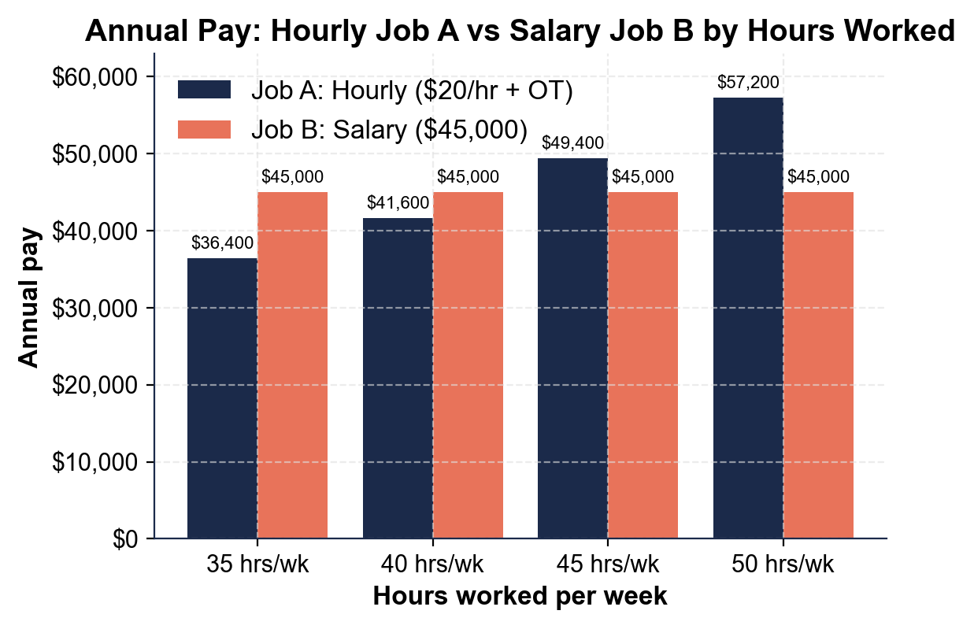
What is Job B's annual pay at EVERY hours level, and what does the flat shape of those bars tell you about a salary?
Job B (the salary) is $45,000 at every hours level - 35, 40, 45, and 50 hours per week. The bars are all the same height (flat) because a salary is a fixed yearly amount that does NOT change with the hours you work.
2. As Jordan Reyes, read the navy Job A (hourly) bars.
About how much does Job A earn per year at 40 hours/week, and about how much at 50 hours/week? Why does the hourly bar get TALLER as the hours rise?
Job A earns about $41,600/year at 40 hours/week and about $57,200/year at 50 hours/week. The hourly bar gets taller as hours rise because hourly pay = rate x hours, AND every hour over 40 earns time-and-a-half overtime, so more hours means more pay.
3. As Jordan Reyes, compare the two bars at each hours level.
At which hours level does Job A (hourly) first pass Job B (salary)? Between which two hours levels does the hourly job overtake the salary, and what does that tell you about answering "which job pays more?"
Job A first passes Job B at 45 hours/week ($49,400 hourly vs $45,000 salary). At 35 and 40 hours the salary pays more; at 45 and 50 hours the hourly job pays more - so the crossover happens between 40 and 45 hours per week.
PART 4

Run the Pay Math - Gross, Overtime, Annualize, and Compare
1. | P4-Q1. As Jordan Reyes, first find your weekly gross pay at Job A for a normal 40-hour week. Job A pays $20.00 per hour. Show your work.  Formula: Gross Pay = Hourly Rate x Hours  Gross = $20 x 40 hours (no hours over 40, so no overtime)  Answer: $800.00 for the week

2. | P4-Q2. Now annualize Job A at a steady 40 hours a week to estimate Jordan's yearly pay. Use $20.00/hr, 40 hours/week, 52 weeks. Show your work.  Formula: Annual Pay = Hourly Rate x Hours per Week x 52 Weeks  Annual = $20 x 40 x 52 = $41,600. This is LESS than Job B's $45,000 salary - at a steady 40 hours, the salary pays more.  Answer: $41,600.00 per year

3. | P4-Q3. One busy week, Jordan works 47 hours at Job A. Overtime (hours over 40) is paid at time-and-a-half. Find the gross pay for that 47-hour week. Show your work.  Formula: Gross = (40 x rate) + (overtime hours x rate x 1.5) - where overtime hours = total hours worked minus 40  Regular: 40 hours x $20 = $800  Overtime: 7 hours x ($20 x 1.5 = $30) = $210  Total = $800 + $210  Answer: $1,010.00 for the week

4. | P4-Q4. Convert Job B's $45,000 salary to an hourly equivalent if Jordan works 40 hours a week, 52 weeks a year. This shows what the salary is really worth per hour. Show your work.  Formula: Hourly Equivalent = Annual Salary / (Hours per Week x 52)  Hourly equivalent = $45,000 / (40 x 52) = $45,000 / 2,080 hours  At 40 hours/week the salary is worth about this much per hour - slightly MORE than Job A's $20/hr.  Answer: $21.63 per hour

5. | P4-Q5. If Jordan instead works LONG 50-hour weeks at the salaried Job B (with no overtime), what is the salary's hourly equivalent now? Use $45,000 / (50 x 52). Compare it to your answer in Q4 and explain in one sentence what happened.  Formula: Hourly Equivalent = Annual Salary / (Hours per Week x 52)  Hourly equivalent = $45,000 / (50 x 52) = $45,000 / 2,600 hours  WHAT HAPPENED: the salary's real hourly rate DROPPED (from about $21.63 at 40 hours to about $17.31 at 50 hours) because the same fixed pay is spread across more hours with no overtime.  Answer: $17.31 per hour

PART 5

Your Final Advice Memo for a Friend Choosing a Job
FINAL ADVICE MEMO
1. FINAL ADVICE MEMO. Now that you, Jordan Reyes, have run the numbers on both offers, help someone else. Your friend Priya just got two job offers - one hourly, one salaried - and texts you, "They both sound good, how do I tell which one actually pays more?" Write Priya a 5-7 sentence advice memo. Check off each required element as you include it.
YOUR RESPONSE MUST:
☐ EXPLAIN THE DIFFERENCE - hourly pay = rate x hours (changes with the schedule); a salary is fixed yearly pay split evenly, the same every payday.
☐ EXPLAIN OVERTIME - an hourly job usually pays time-and-a-half (1.5x) for hours over 40, while a salaried job often pays no overtime.
☐ TELL HER TO ANNUALIZE - to compare fairly, multiply the hourly wage x hours per week x 52 so both offers are yearly numbers side by side.
☐ SAY IT DEPENDS ON HOURS - which job pays more depends on how many hours she will realistically work (few hours favors salary; many hours favors hourly + overtime).
☐ MENTION BENEFITS - remind her to weigh benefits like health insurance and paid time off, not just the headline pay.
GRADING RUBRIC
Grade the evidence and reasoning, not the conclusion — any defensible position is valid. Score against the 5 requirements above.
FULL CREDIT — clear position; meets all 5 requirements with accurate, specific numbers and evidence from the lesson.
PARTIAL — position stated, but misses 1-2 requirements or uses vague / incorrect numbers.
MINIMAL — no clear position, or missing most requirements and numbers.

MORE LESSONS LESS PLANNING
Thank You!
If you enjoyed this product, please do not forget to rate and review to assist other teachers.

Looking for future discounts? Earn TPT credits by reviewing purchased products.

Please contact me if you have any issues with this product. Just like our students, I am always looking for opportunities to grow.

