Health Insurance - The Most Confusing Bill You'll Get
STUDENT ACTIVITY
Name: | Date: | Period:
ESSENTIAL QUESTION
What do premium, deductible, copay, and coinsurance each mean, how do the network and the out-of-pocket max affect what you pay, and how does a covered medical bill split between you and the insurer?
THE SCENARIO
You are MORGAN REYES, a patient advocate at a community clinic who helps people understand their health insurance and their medical bills. ALEX just started a first full-time job and has to pick a health plan for the first time - and finds the whole thing confusing: 'premium, deductible, copay, coinsurance...
BY THE END, YOU CAN:
✓ Identify the four core health-insurance cost terms (premium, deductible, copay, coinsurance) and what each one means
✓ Explain how a network works (in-network vs out-of-network) and what the out-of-pocket max protects you from
✓ Calculate how a covered medical bill splits between you and the insurer using a labeled model (deductible first, then coinsurance, capped at the out-of-pocket max)
✓ Explain how employer and marketplace plans differ and how to read an EOB (Explanation of Benefits)
HOW IT WORKS (do Parts 1–5 in order)
Part 1 — Health-Insurance Reference Guide - Complete the Missing Terms
Part 2 — Apply the Terms - Health Insurance Vocabulary in Context
Part 3 — Calculate How a Bill Splits - Use the Labeled Model
Part 4 — Read the Chart - Who Pays What on a $5,000 Medical Bill
Part 5 — Advise a First-Time Plan-Holder - Help Alex Read a Plan and a Bill
TIME about 45 minutes YOU’LL NEED the lesson slides and your Guided Notes.

PART 1

Health-Insurance Reference Guide - Complete the Missing Terms
Fill in the missing term for each blank row — the definition is your clue. Your Guided Notes and the lesson slides have every term.

Term | Definition
___________ | The monthly payment you make to keep your health coverage active
Out-of-pocket max | The yearly cap on what you pay, after which the insurer pays 100%
___________ | What you pay first each year before the plan starts sharing covered costs
In-network | A provider who accepts the insurer's discounted rates, so you pay less
___________ | A flat fee you pay for a specific service, like an office visit
Out-of-network | A provider who has not agreed to the insurer's rates, so you pay far more
___________ | The percentage of a covered cost you pay after meeting the deductible
EOB (Explanation of Benefits) | The insurer's statement showing what was billed, what the plan paid, and what you owe
___________ | The group of doctors and hospitals your plan has contracted with for lower rates
Marketplace plan | A health plan you buy on your own through the government exchange, not through a job

PART 2

Apply the Terms - Health Insurance Vocabulary in Context
WORD BANK copay · network · deductible · coinsurance · premium
1. Q1. The monthly payment you make just to keep your health coverage active, whether or not you see a doctor, is your .

2. Q2. The amount you pay first each year before the plan starts sharing covered costs is your .

3. Q3. A flat fee you pay for a specific service, like a $30 office visit, is a .

4. Q4. The percentage of a covered cost you pay after meeting the deductible is your .

5. Q5. The group of doctors and hospitals your plan has contracted with for lower rates is your .

PART 3

Calculate How a Bill Splits - Use the Labeled Model
1. As Morgan Reyes, work Alex's $5,000 covered in-network bill on the plan (deductible $1,000, coinsurance 20%, out-of-pocket max $4,000).
(a) How much of the bill does Alex pay as the deductible first?

(b) How much is left after the deductible, and what is 20% of that (Alex's coinsurance)?

(c) Add them: how much does Alex pay in total, and how much does the insurer pay? Show that the two add back to the whole $5,000 bill.

2. As Morgan Reyes, work a small bill for Alex. Early in the year Alex has a $600 covered lab bill and has paid $0 toward the $1,000 deductible so far.
(a) Has Alex met the deductible yet?

(b) How much of the $600 does Alex pay, and how much does the insurer pay?

(c) In one sentence, explain why the coinsurance step does NOT apply here.

3. As Morgan Reyes, walk Alex through a big bill and the out-of-pocket max. Alex has a $30,000 covered in-network bill (deductible $1,000, coinsurance 20%, out-of-pocket max $4,000).
(a) Without the cap, what would Alex's deductible + coinsurance add up to?

(b) Is that above or below the $4,000 out-of-pocket max?

(c) So how much does Alex actually pay, how much does the insurer pay, and what does the out-of-pocket max protect Alex from?

PART 4

Read the Chart - Who Pays What on a $5,000 Medical Bill
As Morgan Reyes, study the bar chart titled "Who Pays What on a $5,000 Medical Bill" (it appears with A4-Q1). It splits a $5,000 covered in-network bill (deductible $1,000, coinsurance 20%, out-of-pocket max $4,000) into two bars - what you pay and what the insurer pays. The same values are listed in the data table below. Use the chart and table to answer A4-Q1 to A4-Q3, then connect the chart to Alex's whole plan in A4-Q4.

Who pays | Share of the $5,000 bill
You pay (Alex) | $1,800
Insurer pays | $3,200
Total bill | $5,000

Analysis
1. A4-Q1. As Morgan Reyes, study the bar chart on this page titled "Who Pays What on a $5,000 Medical Bill." It splits the $5,000 covered bill into two bars. Read the chart and write: (a) how much YOU (Alex) pay, and (b) how much the INSURER pays. (c) Add the two - do they equal the whole $5,000 bill?
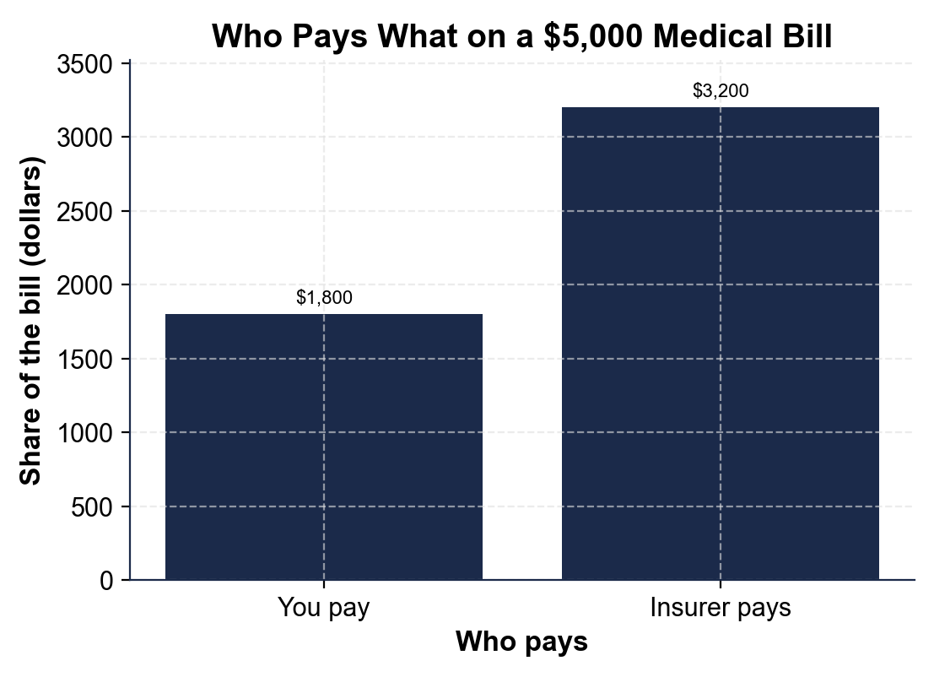

2. A4-Q2. As Morgan Reyes, break down the "You pay" bar for Alex. The chart shows Alex pays $1,800. (a) How much of that $1,800 is the deductible? (b) How much of it is coinsurance? (c) In one sentence, explain where the coinsurance amount comes from (what percent of what).

3. A4-Q3. As Morgan Reyes, use the chart to make the key point to Alex. (a) On this $5,000 bill, does Alex pay more than half or less than half of the bill? (b) Alex's $1,800 is below the $4,000 out-of-pocket max - what would have to be true for Alex to hit that cap instead? (c) In one sentence, state the rule the chart shows about how a covered bill splits.

4. A4-Q4. As Morgan Reyes, connect the chart to Alex's whole plan. (a) The chart shows what a $5,000 bill costs Alex, but which SEPARATE monthly cost does Alex pay every month just to have the plan, even in a month with no doctor visits? (b) The chart assumes IN-NETWORK care - in one sentence, what would change if Alex saw an OUT-OF-NETWORK doctor instead? (c) Name the yearly cap that would protect Alex if this bill had been $30,000 instead of $5,000.

PART 5

Advise a First-Time Plan-Holder - Help Alex Read a Plan and a Bill
1. As Morgan Reyes, answer Alex's first question: 'What's the difference between the premium and the deductible - do I pay both?'
(a) In one to two sentences, explain what the premium is and when Alex pays it.

(b) In one to two sentences, explain what the deductible is and when it applies.

(c) In one sentence, say whether Alex pays both, and why.

2. As Morgan Reyes, explain a real bill to Alex. Alex has an in-network $5,000 covered bill on the plan (deductible $1,000, coinsurance 20%, out-of-pocket max $4,000).
(a) Walk Alex through what Alex pays and what the insurer pays, naming the model you used.

(b) Then Alex asks what would happen on a huge $30,000 bill - tell Alex the number Alex would pay and why.

(c) In one sentence, state what the out-of-pocket max protects Alex from.

3. As Morgan Reyes, help Alex avoid two common mistakes.
(a) Alex is about to see a specialist - what should Alex check first, and why does it matter for the cost?

(b) An EOB (Explanation of Benefits) arrives in the mail - should Alex pay it, and what should Alex do with it?

(c) In one to two sentences, explain how Alex uses the EOB to catch a billing error.

FINAL PLAN ADVICE FOR ALEX
4. FINAL PLAN ADVICE FOR ALEX. As Morgan Reyes, put your advice in writing for Alex. Write a 5-7 sentence explanation (120-180 words) that defines the four cost terms (premium, deductible, copay, coinsurance), explains what the network and the out-of-pocket max each do, uses the labeled model to work Alex's $5,000 bill (showing Alex pays $1,800 and the insurer pays $3,200), and gives Alex one clear rule for reading a medical bill or an EOB. Check off each required element as you include it.
YOUR RESPONSE MUST:
☐ DEFINE THE FOUR COST TERMS - premium (monthly payment to keep coverage), deductible (what you pay first each year), copay (a flat fee for a service), and coinsurance (your percent of a covered cost after the deductible).
☐ EXPLAIN THE NETWORK - in-network care costs less because providers accept the insurer's discounted rates; out-of-network care costs far more, so check first.
☐ EXPLAIN THE OUT-OF-POCKET MAX - the yearly cap on what you pay; after you reach it the insurer pays 100% (a $30,000 bill still costs you only $4,000).
☐ USE THE LABELED MODEL - show the $5,000 bill splits into $1,000 deductible + $800 coinsurance = $1,800 for you and $3,200 for the insurer (the two add to $5,000).
☐ GIVE A RULE FOR READING A BILL / EOB - for example: an EOB is a summary, not a bill, so compare its 'you owe' amount to the doctor's actual bill before paying.

