PERSONAL FINANCE

HEALTH INSURANCE - THE MOST CONFUSING BILL YOU'LL GET
ANSWER KEY ACTIVITY - ANSWER KEY

PART 1

Health-Insurance Reference Guide - Complete the Missing Terms

Term | Definition
Premium | The monthly payment you make to keep your health coverage active
Out-of-pocket max | The yearly cap on what you pay, after which the insurer pays 100%
Deductible | What you pay first each year before the plan starts sharing covered costs
In-network | A provider who accepts the insurer's discounted rates, so you pay less
Copay | A flat fee you pay for a specific service, like an office visit
Out-of-network | A provider who has not agreed to the insurer's rates, so you pay far more
Coinsurance | The percentage of a covered cost you pay after meeting the deductible
EOB (Explanation of Benefits) | The insurer's statement showing what was billed, what the plan paid, and what you owe
Network | The group of doctors and hospitals your plan has contracted with for lower rates
Marketplace plan | A health plan you buy on your own through the government exchange, not through a job

PART 2

Apply the Terms - Health Insurance Vocabulary in Context
WORD BANK copay · network · deductible · coinsurance · premium
1. Q1. The monthly payment you make just to keep your health coverage active, whether or not you see a doctor, is your premium.
premium
2. Q2. The amount you pay first each year before the plan starts sharing covered costs is your deductible.
deductible
3. Q3. A flat fee you pay for a specific service, like a $30 office visit, is a copay.
copay
4. Q4. The percentage of a covered cost you pay after meeting the deductible is your coinsurance.
coinsurance
5. Q5. The group of doctors and hospitals your plan has contracted with for lower rates is your network.
network

PART 3

Calculate How a Bill Splits - Use the Labeled Model
1. As Morgan Reyes, work Alex's $5,000 covered in-network bill on the plan (deductible $1,000, coinsurance 20%, out-of-pocket max $4,000).
(a) How much of the bill does Alex pay as the deductible first?
(b) How much is left after the deductible, and what is 20% of that (Alex's coinsurance)?
(c) Add them: how much does Alex pay in total, and how much does the insurer pay? Show that the two add back to the whole $5,000 bill.
(1) Alex pays the $1,000 deductible first. (2) After the deductible, $5,000 - $1,000 = $4,000 is left; Alex's coinsurance is 20% of $4,000 = $800. (3) Alex pays $1,000 + $800 = $1,800 in total, and the insurer pays $5,000 - $1,800 = $3,200. Check: $1,800 + $3,200 = $5,000, so every dollar of the bill is split between Alex and the insurer. (Alex's $1,800 is below the $4,000 out-of-pocket max, so the cap is not reached.) Accept $1,000 deductible, $800 coinsurance, Alex pays $1,800, insurer pays $3,200, and the $1,800 + $3,200 = $5,000 check.
2. As Morgan Reyes, work a small bill for Alex. Early in the year Alex has a $600 covered lab bill and has paid $0 toward the $1,000 deductible so far.
(a) Has Alex met the deductible yet?
(b) How much of the $600 does Alex pay, and how much does the insurer pay?
(c) In one sentence, explain why the coinsurance step does NOT apply here.
(1) No - Alex has paid $0 of the $1,000 deductible, so the deductible is not met. (2) Alex pays 100% of the $600 (all $600), and the insurer pays $0. (3) The coinsurance step does NOT apply because you only start paying coinsurance AFTER the deductible is met - until then you pay 100% of covered bills yourself. Accept: deductible not met, Alex pays all $600, insurer pays $0, and coinsurance only starts after the deductible.
3. As Morgan Reyes, walk Alex through a big bill and the out-of-pocket max. Alex has a $30,000 covered in-network bill (deductible $1,000, coinsurance 20%, out-of-pocket max $4,000).
(a) Without the cap, what would Alex's deductible + coinsurance add up to?
(b) Is that above or below the $4,000 out-of-pocket max?
(c) So how much does Alex actually pay, how much does the insurer pay, and what does the out-of-pocket max protect Alex from?
(1) Without the cap: deductible $1,000 + 20% of the remaining $29,000 ($5,800) = $6,800. (2) $6,800 is ABOVE the $4,000 out-of-pocket max. (3) So Alex actually pays only the $4,000 out-of-pocket max, and the insurer pays the rest: $30,000 - $4,000 = $26,000. The out-of-pocket max protects Alex from a catastrophic bill - no matter how big the covered in-network bill gets, Alex's yearly cost is capped at $4,000 and the insurer pays 100% above that. Check: $4,000 + $26,000 = the $30,000 bill. Accept uncapped $6,800, above the $4,000 cap, Alex pays $4,000, insurer pays $26,000, and a protects-from-catastrophic-bill explanation.

PART 4

Read the Chart - Who Pays What on a $5,000 Medical Bill
As Morgan Reyes, study the bar chart titled "Who Pays What on a $5,000 Medical Bill" (it appears with A4-Q1). It splits a $5,000 covered in-network bill (deductible $1,000, coinsurance 20%, out-of-pocket max $4,000) into two bars - what you pay and what the insurer pays. The same values are listed in the data table below. Use the chart and table to answer A4-Q1 to A4-Q3, then connect the chart to Alex's whole plan in A4-Q4.

Who pays | Share of the $5,000 bill
You pay (Alex) | $1,800
Insurer pays | $3,200
Total bill | $5,000

Analysis

1. A4-Q1. As Morgan Reyes, study the bar chart on this page titled "Who Pays What on a $5,000 Medical Bill." It splits the $5,000 covered bill into two bars. Read the chart and write: (a) how much YOU (Alex) pay, and (b) how much the INSURER pays. (c) Add the two - do they equal the whole $5,000 bill?
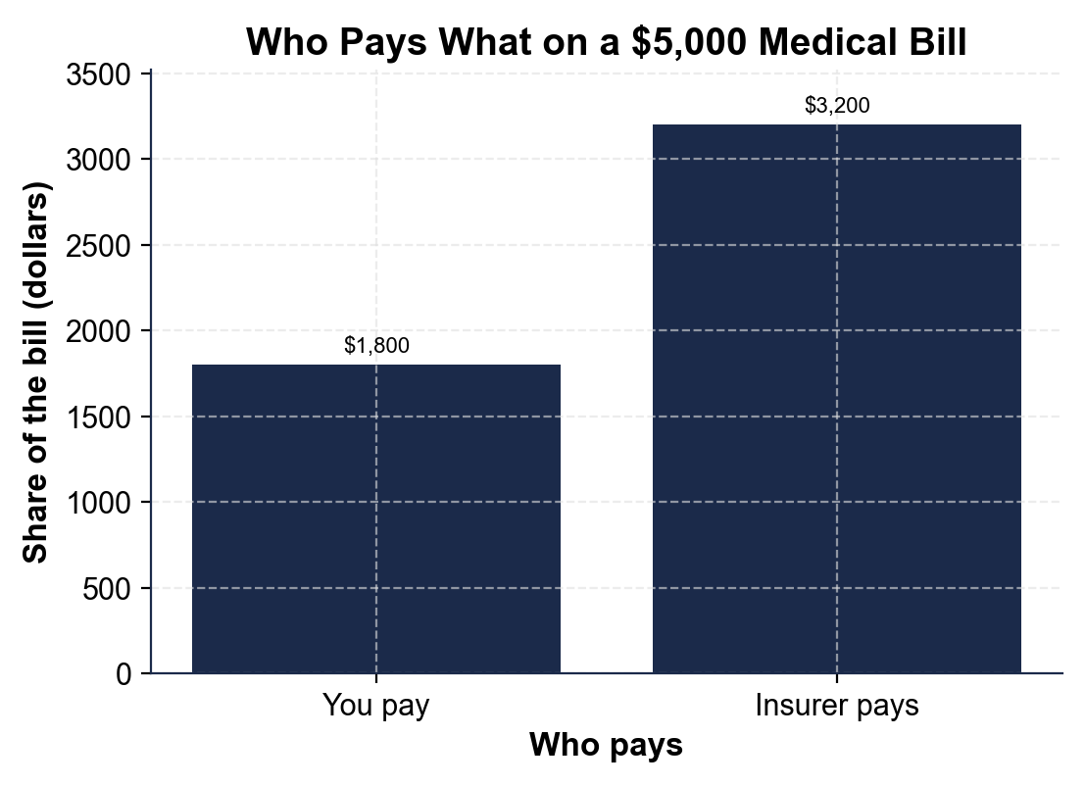
(a) You (Alex) pay $1,800. (b) The insurer pays $3,200. (c) $1,800 + $3,200 = $5,000 - yes, the two bars add to the whole $5,000 bill. Accept $1,800, $3,200, and the sum equal to $5,000.

2. A4-Q2. As Morgan Reyes, break down the "You pay" bar for Alex. The chart shows Alex pays $1,800. (a) How much of that $1,800 is the deductible? (b) How much of it is coinsurance? (c) In one sentence, explain where the coinsurance amount comes from (what percent of what).
(1) $1,000 of the $1,800 is the deductible. (2) $800 of it is coinsurance. (3) The $800 coinsurance is 20% of the $4,000 left after the deductible ($5,000 - $1,000 = $4,000; 20% of $4,000 = $800). Accept $1,000 deductible + $800 coinsurance = $1,800, and the coinsurance = 20% of the $4,000 remainder.

3. A4-Q3. As Morgan Reyes, use the chart to make the key point to Alex. (a) On this $5,000 bill, does Alex pay more than half or less than half of the bill? (b) Alex's $1,800 is below the $4,000 out-of-pocket max - what would have to be true for Alex to hit that cap instead? (c) In one sentence, state the rule the chart shows about how a covered bill splits.
(1) Alex pays LESS than half - $1,800 out of $5,000 is about 36%, so the insurer ($3,200) pays more than Alex. (2) For Alex to hit the $4,000 cap, the bill would have to be much bigger, so that the deductible plus 20% coinsurance added up to more than $4,000 (that happens on a bill around $16,000 or more). (3) The rule: a covered bill splits by the deductible-then-coinsurance model - you pay 100% up to your deductible, then your coinsurance share of the rest, all capped at the out-of-pocket max. Accept less than half / about 36%, a much bigger bill needed to reach the cap, and a deductible-then-coinsurance-capped-at-the-max rule.

4. A4-Q4. As Morgan Reyes, connect the chart to Alex's whole plan. (a) The chart shows what a $5,000 bill costs Alex, but which SEPARATE monthly cost does Alex pay every month just to have the plan, even in a month with no doctor visits? (b) The chart assumes IN-NETWORK care - in one sentence, what would change if Alex saw an OUT-OF-NETWORK doctor instead? (c) Name the yearly cap that would protect Alex if this bill had been $30,000 instead of $5,000.
(1) Alex pays the monthly PREMIUM ($300/month) just to have the plan, separate from any bill. (2) If Alex saw an OUT-OF-NETWORK doctor, Alex would pay far more - a higher, separate cost - because out-of-network providers have not agreed to the insurer's discounted rates. (3) The OUT-OF-POCKET MAX ($4,000) is the yearly cap that would protect Alex on a $30,000 bill (Alex would pay only $4,000). Accept the premium ($300/month), out-of-network costs far more, and the out-of-pocket max ($4,000).

PART 5

Advise a First-Time Plan-Holder - Help Alex Read a Plan and a Bill
1. As Morgan Reyes, answer Alex's first question: 'What's the difference between the premium and the deductible - do I pay both?'
(a) In one to two sentences, explain what the premium is and when Alex pays it.
(b) In one to two sentences, explain what the deductible is and when it applies.
(c) In one sentence, say whether Alex pays both, and why.
(1) The PREMIUM is the monthly payment ($300) Alex makes to keep the plan active - Alex pays it every month whether or not Alex ever sees a doctor, because it is the price of having coverage. (2) The DEDUCTIBLE ($1,000) is what Alex pays first each year before the plan starts sharing covered costs - it applies when Alex actually gets care, and until Alex has paid $1,000 in covered costs, Alex pays 100%. (3) Yes, Alex pays both: the premium is the ongoing cost of having the plan, and the deductible is a separate amount Alex pays when using care. Accept premium = monthly/price of having coverage, deductible = yearly amount before coverage helps, and yes-both with a reason.
2. As Morgan Reyes, explain a real bill to Alex. Alex has an in-network $5,000 covered bill on the plan (deductible $1,000, coinsurance 20%, out-of-pocket max $4,000).
(a) Walk Alex through what Alex pays and what the insurer pays, naming the model you used.
(b) Then Alex asks what would happen on a huge $30,000 bill - tell Alex the number Alex would pay and why.
(c) In one sentence, state what the out-of-pocket max protects Alex from.
(1) On the $5,000 bill, use the labeled model: deductible first ($1,000), then 20% coinsurance of the $4,000 left ($800), so Alex pays $1,000 + $800 = $1,800 and the insurer pays $3,200 (the two add to $5,000). (2) On a $30,000 bill, Alex's deductible + coinsurance would be $6,800, but that is above the $4,000 out-of-pocket max, so Alex pays only $4,000 and the insurer pays $26,000. (3) The out-of-pocket max protects Alex from a catastrophic bill - it caps Alex's yearly cost so a serious illness or accident cannot cost more than $4,000 in covered in-network care. Accept the $1,800/$3,200 split, Alex pays only $4,000 on the $30,000 bill, and a caps-yearly-cost / protects-from-catastrophe explanation.
3. As Morgan Reyes, help Alex avoid two common mistakes.
(a) Alex is about to see a specialist - what should Alex check first, and why does it matter for the cost?
(b) An EOB (Explanation of Benefits) arrives in the mail - should Alex pay it, and what should Alex do with it?
(c) In one to two sentences, explain how Alex uses the EOB to catch a billing error.
(1) Alex should check that the specialist is IN-NETWORK before the visit, because an out-of-network provider has not agreed to the insurer's discounted rates, so the same care can cost Alex far more. (2) No, Alex should NOT pay the EOB - an EOB is a summary, not a bill; the actual bill comes separately from the doctor or hospital. Alex should read the EOB to see what was billed, what the plan paid, and what Alex owes. (3) Alex uses the EOB by comparing its 'you owe' / patient-responsibility amount to the doctor's actual bill - if the bill is higher than the EOB says Alex owes, something is wrong (maybe an out-of-network charge), and Alex can call and question it. Accept check in-network first (out-of-network costs more), don't pay the EOB (it's a summary not a bill), and compare the EOB 'you owe' to the bill to catch an error.
FINAL PLAN ADVICE FOR ALEX
4. FINAL PLAN ADVICE FOR ALEX. As Morgan Reyes, put your advice in writing for Alex. Write a 5-7 sentence explanation (120-180 words) that defines the four cost terms (premium, deductible, copay, coinsurance), explains what the network and the out-of-pocket max each do, uses the labeled model to work Alex's $5,000 bill (showing Alex pays $1,800 and the insurer pays $3,200), and gives Alex one clear rule for reading a medical bill or an EOB. Check off each required element as you include it.
YOUR RESPONSE MUST:
☐ DEFINE THE FOUR COST TERMS - premium (monthly payment to keep coverage), deductible (what you pay first each year), copay (a flat fee for a service), and coinsurance (your percent of a covered cost after the deductible).
☐ EXPLAIN THE NETWORK - in-network care costs less because providers accept the insurer's discounted rates; out-of-network care costs far more, so check first.
☐ EXPLAIN THE OUT-OF-POCKET MAX - the yearly cap on what you pay; after you reach it the insurer pays 100% (a $30,000 bill still costs you only $4,000).
☐ USE THE LABELED MODEL - show the $5,000 bill splits into $1,000 deductible + $800 coinsurance = $1,800 for you and $3,200 for the insurer (the two add to $5,000).
☐ GIVE A RULE FOR READING A BILL / EOB - for example: an EOB is a summary, not a bill, so compare its 'you owe' amount to the doctor's actual bill before paying.
GRADING RUBRIC
Grade the evidence and reasoning, not the conclusion — any defensible position is valid. Score against the 5 requirements above.
FULL CREDIT — clear position; meets all 5 requirements with accurate, specific numbers and evidence from the lesson.
PARTIAL — position stated, but misses 1-2 requirements or uses vague / incorrect numbers.
MINIMAL — no clear position, or missing most requirements and numbers.

MORE LESSONS LESS PLANNING
Thank You!
If you enjoyed this product, please do not forget to rate and review to assist other teachers.

Looking for future discounts? Earn TPT credits by reviewing purchased products.

Please contact me if you have any issues with this product. Just like our students, I am always looking for opportunities to grow.

