Financial Goals - Short, Medium and Long Term
STUDENT ACTIVITY
Name: | Date: | Period:
ESSENTIAL QUESTION
How do you set financial goals you can actually reach - how do you make a goal SMART (Specific, Measurable, Achievable, Relevant, Time-bound), how do you sort goals into short-, medium-, and long-term time horizons, how do you compute a goal's monthly amount (target amount divided by months) and timeline, why is the biggest target not always the steepest monthly amount, and how do you prioritize goals you cannot fund all at once?
THE SCENARIO
You are PRIYA NAIR, a financial goals coach. Today your client is DEVON, a young worker who earns steady money but never reaches his goals because they are too vague - he says things like 'I should save more' and 'someday I'll buy a car,' but he never names an amount, a deadline, or a monthly plan.
BY THE END, YOU CAN:
✓ Explain what a financial goal is and set goals that are SMART (Specific, Measurable, Achievable, Relevant, Time-bound)
✓ Sort financial goals into short-term, medium-term, and long-term time horizons
✓ Calculate the monthly amount a goal needs (target amount divided by months) and the goal timeline (target divided by monthly amount)
✓ Prioritize goals you cannot fund all at once and build a plan to reach them
HOW IT WORKS (do Parts 1–5 in order)
Part 1 — Financial-Goals Reference Guide - Complete the Missing Terms
Part 2 — Apply the Terms - Financial-Goals Vocabulary in Context
Part 3 — Set the Goal - Fix and Plan Devon's Goals
Part 4 — Read the Chart - Which Goal Needs the Most Each Month
Part 5 — Make the Plan - Work Devon's Goals and Write the Goal Plan
TIME about 45 minutes YOU’LL NEED the lesson slides and your Guided Notes.

PART 1

Financial-Goals Reference Guide - Complete the Missing Terms
Fill in the missing term for each blank row — the definition is your clue. Your Guided Notes and the lesson slides have every term.

Term | Definition
___________ | A specific money target you plan and save for
SMART goal | A goal that is Specific, Measurable, Achievable, Relevant, and Time-bound
___________ | A goal you aim to reach in under a year (about 12 months or less)
Medium-term goal | A goal you aim to reach in about one to five years
___________ | A goal you aim to reach in five or more years
Time horizon | How long you have until a goal's deadline
___________ | The total dollar amount a goal requires
Monthly amount | How much you set aside each month toward a goal (target amount divided by months)
___________ | Deciding which goals come first when you cannot fund them all at once
Emergency fund | Savings set aside for unexpected costs, usually the first short-term goal

PART 2

Apply the Terms - Financial-Goals Vocabulary in Context
WORD BANK short-term goal · prioritizing · target amount · financial goal · long-term goal
1. Q1. A specific money target you plan and save for is a .

2. Q2. A goal you aim to reach in under a year (about 12 months or less) is a .

3. Q3. A goal you aim to reach in five or more years is a .

4. Q4. The total dollar amount a goal requires is the .

5. Q5. Deciding which goals come first when you cannot fund them all at once is called .

PART 3

Set the Goal - Fix and Plan Devon's Goals
1. As Priya Nair, you help Devon fix his vaguest goal. He says, "I want to save more money."
(a) Rewrite it as a SMART goal for a $600 emergency fund he wants in 6 months - name the Specific, the Measurable amount, and the Time-bound deadline.

(b) What time horizon is this goal?

(c) In one sentence, why is "save more" not a real goal?

2. As Priya Nair, Devon wants a $1,500 laptop for a class in 5 months.
(a) Use MONTHLY AMOUNT = TARGET AMOUNT / MONTHS to find how much he must save each month. Show your math.

(b) What time horizon is this goal?

(c) What are the target amount and the deadline (the two SMART numbers)?

3. As Priya Nair, Devon can save $200 a month toward a $2,400 vacation but is not sure how long it will take.
(a) Use GOAL TIMELINE = TARGET AMOUNT / MONTHLY AMOUNT to find how many months it will take. Show your math.

(b) What time horizon does that put the goal in?

(c) In one sentence, what does Model 2 tell you that Model 1 does not?

PART 4

Read the Chart - Which Goal Needs the Most Each Month
As Priya Nair, study the bar chart titled "Monthly Amount by Goal" (it appears with A4-Q1). Each bar is one of Devon's goals' monthly amount - the dollars per month, which is the target amount divided by the number of months - so you can compare the goals fairly. The same values are listed in the data table below. Notice that the Used car (coral) is the tallest bar and the Down payment (teal) is the biggest target but not the steepest per month. Use the chart and table to answer A4-Q1 to A4-Q3, then turn the chart into a plan in A4-Q4.

Goal (time horizon) | Target amount | Months | Monthly amount
Emergency fund (short-term) | $600 | 6 | $100
Used car (medium-term) | $9,600 | 24 | $400
Down payment (long-term) | $18,000 | 60 | $300

Analysis

1. A4-Q1. As Priya Nair, study the bar chart on this page titled "Monthly Amount by Goal." Each bar is the monthly amount for one of Devon's three goals. Read the chart and write the monthly amount (dollars per month) for each goal: (a) the Emergency fund (short-term, 6 months), (b) the Used car (medium-term, 24 months), (c) the Down payment (long-term, 60 months).
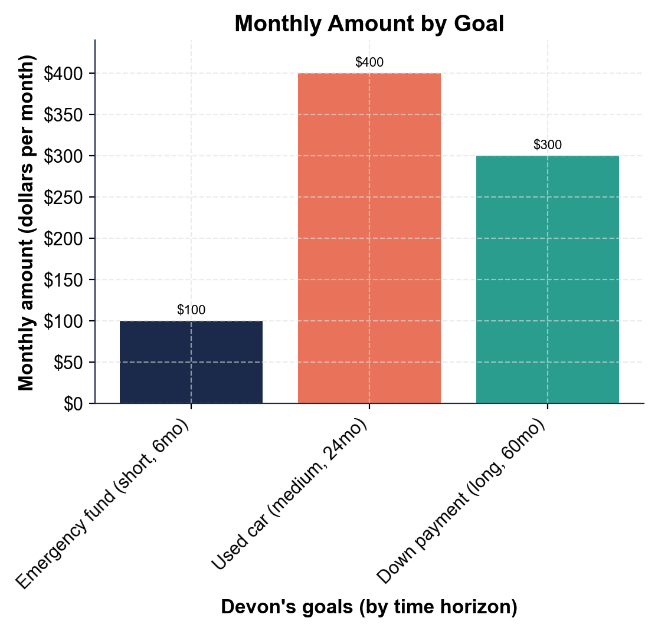

2. A4-Q2. As Priya Nair, use the chart to compare the goals. (a) Which goal needs the MOST money each month, and how much? (b) The Down payment has the BIGGEST target ($18,000) - does it need the most each month? (c) In one sentence, what does this show about a long time horizon?

3. A4-Q3. As Priya Nair, do the comparison math. (a) How much more per month is the Used car than the Down payment? (b) How much more per month is the Used car than the Emergency fund? (c) If Devon tried to fund all three goals at the same time, what would his total monthly amount be? Show your math.

4. A4-Q4. As Priya Nair, turn the chart into a plan for Devon, whose budget is $500 a month. (a) He needs $800 a month for all three goals but only has $500 - what is the gap, and what does that tell him? (b) If he stretches the Used car from 24 months to 32 months, use GOAL TIMELINE / MONTHLY AMOUNT thinking to find the new monthly amount ($9,600 over 32 months). Show your math. (c) In one sentence, give Devon your rule for fitting goals to a budget.

PART 5

Make the Plan - Work Devon's Goals and Write the Goal Plan
1. DECISION #1. As Priya Nair, sort Devon's three goals by time horizon: an emergency fund he wants in 6 months, a used car in 2 years (24 months), and a house down payment in 5 years (60 months). Label each short-term, medium-term, or long-term, and give the rule for each.

2. DECISION #2. Devon's house down payment target is $18,000 and he wants it in 60 months. Use MONTHLY AMOUNT = TARGET AMOUNT / MONTHS to find what he must save each month. Show your math and name the time horizon.

3. DECISION #3. Devon wants to grow his emergency fund to $3,000 and can save $250 a month for it. Use GOAL TIMELINE = TARGET AMOUNT / MONTHLY AMOUNT to find how many months it will take. Show your math.

4. DECISION #4. Devon says, "I want to buy a car someday." Rewrite this as a SMART goal using a $9,600 target and a 24-month deadline. Name the Specific, Measurable, and Time-bound parts.

5. DECISION #5. Devon can save $500 a month, but funding all three goals at once would take $800 a month. Which goal should he fund FIRST, and why? What is your rule for the order?

6. DECISION #6. All three of Devon's goals at once cost $800 a month, but his budget is only $500. Name TWO ways he can make the goals fit his budget without giving them up. Explain each in one sentence.

GOAL PLAN - FINAL REPORT
7. GOAL PLAN - FINAL REPORT. As Priya Nair, write a short plan a real person could follow to set and reach financial goals. Write 5-7 sentences (100-160 words) that:
(a) explain what a financial goal is and how to make it SMART

(b) explain the three time horizons and how to compute a goal's monthly amount

(c) explain why the biggest target is not always the steepest monthly amount and how to prioritize when money is tight. Check off each required element as you include it.

