PERSONAL FINANCE

FINANCIAL GOALS - SHORT, MEDIUM AND LONG TERM
ANSWER KEY ACTIVITY - ANSWER KEY

PART 1

Financial-Goals Reference Guide - Complete the Missing Terms

Term | Definition
Financial goal | A specific money target you plan and save for
SMART goal | A goal that is Specific, Measurable, Achievable, Relevant, and Time-bound
Short-term goal | A goal you aim to reach in under a year (about 12 months or less)
Medium-term goal | A goal you aim to reach in about one to five years
Long-term goal | A goal you aim to reach in five or more years
Time horizon | How long you have until a goal's deadline
Target amount | The total dollar amount a goal requires
Monthly amount | How much you set aside each month toward a goal (target amount divided by months)
Prioritizing | Deciding which goals come first when you cannot fund them all at once
Emergency fund | Savings set aside for unexpected costs, usually the first short-term goal

PART 2

Apply the Terms - Financial-Goals Vocabulary in Context
WORD BANK short-term goal · prioritizing · target amount · financial goal · long-term goal
1. Q1. A specific money target you plan and save for is a financial goal.
financial goal
2. Q2. A goal you aim to reach in under a year (about 12 months or less) is a short-term goal.
short-term goal
3. Q3. A goal you aim to reach in five or more years is a long-term goal.
long-term goal
4. Q4. The total dollar amount a goal requires is the target amount.
target amount
5. Q5. Deciding which goals come first when you cannot fund them all at once is called prioritizing.
prioritizing

PART 3

Set the Goal - Fix and Plan Devon's Goals
1. As Priya Nair, you help Devon fix his vaguest goal. He says, "I want to save more money."
(a) Rewrite it as a SMART goal for a $600 emergency fund he wants in 6 months - name the Specific, the Measurable amount, and the Time-bound deadline.
(b) What time horizon is this goal?
(c) In one sentence, why is "save more" not a real goal?
(1) SMART goal: "Save $600 for an emergency fund in 6 months by setting aside $100 a month." Specific = an emergency fund; Measurable = $600; Time-bound = 6 months (and the monthly amount is $600 / 6 = $100). (2) It is a SHORT-TERM goal, because it is due in under a year (6 months). (3) "Save more" is a wish, not a goal, because it names no target amount and no deadline, so you can never tell if you are on track or done. Accept: a SMART restatement naming $600 / an emergency fund / 6 months; short-term; 'save more' has no amount or deadline.
2. As Priya Nair, Devon wants a $1,500 laptop for a class in 5 months.
(a) Use MONTHLY AMOUNT = TARGET AMOUNT / MONTHS to find how much he must save each month. Show your math.
(b) What time horizon is this goal?
(c) What are the target amount and the deadline (the two SMART numbers)?
(1) MONTHLY AMOUNT = $1,500 / 5 months = $300 a month. (2) It is a SHORT-TERM goal, because 5 months is under a year. (3) The target amount is $1,500 and the deadline is 5 months - those are the Measurable and Time-bound numbers that let you compute the $300 monthly amount. Accept: $300 a month; short-term; target $1,500, deadline 5 months.
3. As Priya Nair, Devon can save $200 a month toward a $2,400 vacation but is not sure how long it will take.
(a) Use GOAL TIMELINE = TARGET AMOUNT / MONTHLY AMOUNT to find how many months it will take. Show your math.
(b) What time horizon does that put the goal in?
(c) In one sentence, what does Model 2 tell you that Model 1 does not?
(1) GOAL TIMELINE = $2,400 / $200 a month = 12 months. (2) At 12 months it is right at the edge of short-term/medium-term - about one year - so it is a short-to-medium-term goal (accept either, since 12 months is the boundary). (3) Model 2 tells you the DEADLINE when you already know what you can save each month, while Model 1 tells you the MONTHLY AMOUNT when you already know the deadline - they are two sides of the same relationship. Accept: 12 months; short-/medium-term (boundary); Model 2 finds the timeline from a set monthly amount.

PART 4

Read the Chart - Which Goal Needs the Most Each Month
As Priya Nair, study the bar chart titled "Monthly Amount by Goal" (it appears with A4-Q1). Each bar is one of Devon's goals' monthly amount - the dollars per month, which is the target amount divided by the number of months - so you can compare the goals fairly. The same values are listed in the data table below. Notice that the Used car (coral) is the tallest bar and the Down payment (teal) is the biggest target but not the steepest per month. Use the chart and table to answer A4-Q1 to A4-Q3, then turn the chart into a plan in A4-Q4.

Goal (time horizon) | Target amount | Months | Monthly amount
Emergency fund (short-term) | $600 | 6 | $100
Used car (medium-term) | $9,600 | 24 | $400
Down payment (long-term) | $18,000 | 60 | $300

Analysis

1. A4-Q1. As Priya Nair, study the bar chart on this page titled "Monthly Amount by Goal." Each bar is the monthly amount for one of Devon's three goals. Read the chart and write the monthly amount (dollars per month) for each goal: (a) the Emergency fund (short-term, 6 months), (b) the Used car (medium-term, 24 months), (c) the Down payment (long-term, 60 months).
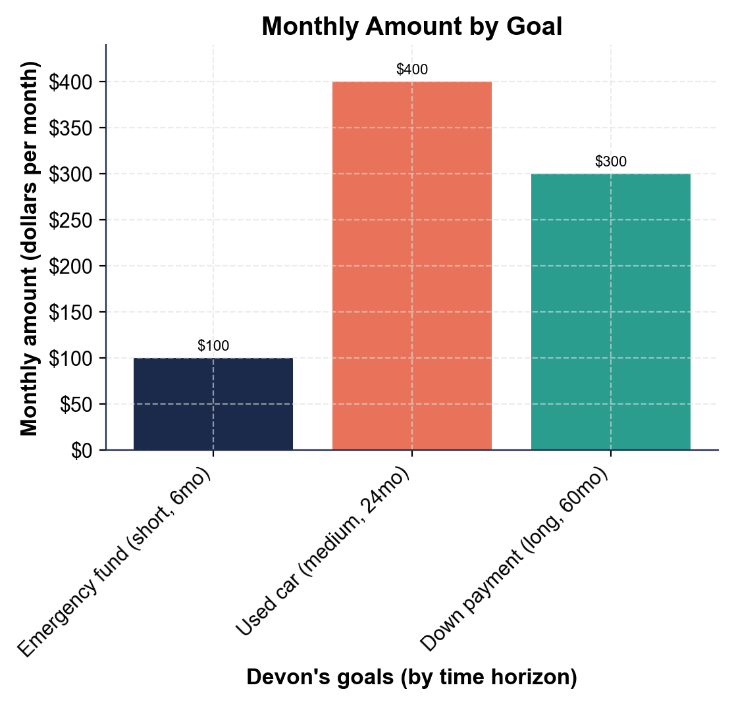
(a) Emergency fund: $100 a month. (b) Used car: $400 a month. (c) Down payment: $300 a month. Accept these three per-month amounts read directly off the bars.

2. A4-Q2. As Priya Nair, use the chart to compare the goals. (a) Which goal needs the MOST money each month, and how much? (b) The Down payment has the BIGGEST target ($18,000) - does it need the most each month? (c) In one sentence, what does this show about a long time horizon?
(1) The USED CAR (medium-term) needs the most each month, at $400 - the tallest (coral) bar. (2) No - the Down payment (long-term) has the biggest target ($18,000) but needs only $300 a month, LESS than the car, so the biggest target is not the steepest monthly amount. (3) A long time horizon spreads a huge target across many months, so even the biggest goal can have a smaller monthly amount than a big goal on a short timeline. Accept car $400 is steepest; down payment not the most ($300); the long horizon spreads a big goal into a smaller monthly amount.

3. A4-Q3. As Priya Nair, do the comparison math. (a) How much more per month is the Used car than the Down payment? (b) How much more per month is the Used car than the Emergency fund? (c) If Devon tried to fund all three goals at the same time, what would his total monthly amount be? Show your math.
(1) Used car vs Down payment: $400 - $300 = $100 more per month. (2) Used car vs Emergency fund: $400 - $100 = $300 more per month. (3) All three at once = $100 + $400 + $300 = $800 a month. Accept $100, $300, and $800 total per month.

4. A4-Q4. As Priya Nair, turn the chart into a plan for Devon, whose budget is $500 a month. (a) He needs $800 a month for all three goals but only has $500 - what is the gap, and what does that tell him? (b) If he stretches the Used car from 24 months to 32 months, use GOAL TIMELINE / MONTHLY AMOUNT thinking to find the new monthly amount ($9,600 over 32 months). Show your math. (c) In one sentence, give Devon your rule for fitting goals to a budget.
(1) The gap is $800 - $500 = $300 a month short, which tells Devon he cannot fund all three goals at once - he has to prioritize. (2) New monthly amount for the car = $9,600 / 32 months = $300 a month (down from $400), which frees up $100 a month. (3) Rule: fund the emergency fund first, then stack or stretch the other goals - stretch a goal's timeline to lower its monthly amount until every goal fits your budget. Accept: $300 short so he must prioritize; car drops to $300 a month at 32 months; fund the emergency fund first and stretch timelines to fit the budget.

PART 5

Make the Plan - Work Devon's Goals and Write the Goal Plan
1. DECISION #1. As Priya Nair, sort Devon's three goals by time horizon: an emergency fund he wants in 6 months, a used car in 2 years (24 months), and a house down payment in 5 years (60 months). Label each short-term, medium-term, or long-term, and give the rule for each.
Emergency fund (6 months) = SHORT-TERM (under a year). Used car (24 months / 2 years) = MEDIUM-TERM (about one to five years). House down payment (60 months / 5 years) = LONG-TERM (five or more years). Accept the three correct labels with the horizon rule (short = under a year; medium = 1-5 years; long = 5+ years).
2. DECISION #2. Devon's house down payment target is $18,000 and he wants it in 60 months. Use MONTHLY AMOUNT = TARGET AMOUNT / MONTHS to find what he must save each month. Show your math and name the time horizon.
MONTHLY AMOUNT = $18,000 / 60 months = $300 a month. This is a LONG-TERM goal (60 months = 5 years, which is five or more years). Accept $300 a month; long-term.
3. DECISION #3. Devon wants to grow his emergency fund to $3,000 and can save $250 a month for it. Use GOAL TIMELINE = TARGET AMOUNT / MONTHLY AMOUNT to find how many months it will take. Show your math.
GOAL TIMELINE = $3,000 / $250 a month = 12 months. So it takes one year of saving $250 a month to reach the $3,000 fund. Accept 12 months (one year).
4. DECISION #4. Devon says, "I want to buy a car someday." Rewrite this as a SMART goal using a $9,600 target and a 24-month deadline. Name the Specific, Measurable, and Time-bound parts.
SMART goal: "Save $9,600 for a reliable used car in 24 months by setting aside $400 a month." Specific = a reliable used car; Measurable = $9,600; Time-bound = 24 months (and the monthly amount is $9,600 / 24 = $400). "Someday" is not Time-bound, so it can never be planned. Accept a SMART restatement naming the $9,600 target, the 24-month deadline, and the $400 monthly amount.
5. DECISION #5. Devon can save $500 a month, but funding all three goals at once would take $800 a month. Which goal should he fund FIRST, and why? What is your rule for the order?
Fund the EMERGENCY FUND first. It is the smallest ($100 a month) and it protects every other goal, because one surprise cost with no cushion would push Devon into debt and knock out the car and down-payment savings.
6. DECISION #6. All three of Devon's goals at once cost $800 a month, but his budget is only $500. Name TWO ways he can make the goals fit his budget without giving them up. Explain each in one sentence.
(1) STACK: fund the goals in order - finish the short emergency fund first (6 months at $100), then roll that monthly amount into the next goal - so he is not paying for all three at the same time. (2) STRETCH: give a goal a longer timeline so its monthly amount drops (Model 2) - for example, stretching the car from 24 to 32 months lowers it from $400 to $300 a month. Accept stacking (sequence the goals) and stretching (lengthen a timeline to lower the monthly amount) as the two ways to fit a budget.
GOAL PLAN - FINAL REPORT
7. GOAL PLAN - FINAL REPORT. As Priya Nair, write a short plan a real person could follow to set and reach financial goals. Write 5-7 sentences (100-160 words) that:
(a) explain what a financial goal is and how to make it SMART
(b) explain the three time horizons and how to compute a goal's monthly amount
(c) explain why the biggest target is not always the steepest monthly amount and how to prioritize when money is tight. Check off each required element as you include it.
Sample full-credit goal plan: A FINANCIAL GOAL is a specific money target you plan and save for, and the best goals are SMART - Specific, Measurable, Achievable, Relevant, and Time-bound - so they name both a TARGET AMOUNT and a deadline instead of just 'save more.' Sort each goal by its TIME HORIZON: short-term is under a year (like a $600 emergency fund), medium-term is one to five years (like a $9,600 used car), and long-term is five or more years (like an $18,000 down payment). Find what to save with MONTHLY AMOUNT = TARGET AMOUNT / MONTHS - the $600 fund in 6 months is $100 a month - and use GOAL TIMELINE = TARGET AMOUNT / MONTHLY AMOUNT to find a deadline when the monthly amount is fixed. Remember the biggest target is not always the steepest monthly: Devon's $18,000 down payment was only $300 a month over 60 months, less than his $9,600 car at $400 a month, because the long horizon spreads it. When goals cost more than your budget, PRIORITIZING means funding the EMERGENCY FUND first, then stacking or stretching the rest to fit. REQUIRED-ELEMENT CHECKLIST (award credit per item): [1] financial goal + SMART (names target amount + deadline); [2] three time horizons + monthly amount = target / months (and goal timeline = target / monthly amount); [3] biggest target is not steepest ($300 vs $400) + prioritize the emergency fund first (stack/stretch); [4] uses at least three lesson terms correctly. GRADING NOTE - the figures come from gen_money.py: emergency fund $600 / 6 = $100/month, used car $9,600 / 24 = $400/month (steepest), down payment $18,000 / 60 = $300/month (biggest target, not steepest); all three at once $800 vs a $500 budget. Accept any correct use of these figures.

MORE LESSONS LESS PLANNING
Thank You!
If you enjoyed this product, please do not forget to rate and review to assist other teachers.

Looking for future discounts? Earn TPT credits by reviewing purchased products.

Please contact me if you have any issues with this product. Just like our students, I am always looking for opportunities to grow.

