ECONOMICS

EXTERNALITIES: WHEN MARKETS HURT OTHERS
ANSWER KEY GUIDED NOTES - TEACHER KEY

LEARNING TARGETS
1. Define externalities and distinguish POSITIVE from NEGATIVE externalities using social cost vs private cost
2. Identify pollution and vaccines as the textbook cases of negative and positive externalities and explain why markets ignore them
3. Evaluate Pigouvian TAXES (on negative externalities) and Pigouvian SUBSIDIES (on positive externalities) as the standard policy fix

SECTION 1

What Is an Externality?
Definition and Two Types
An externality is a side effect on a third party who did not buy or sell.
The market price IGNORES the side effect, so the WRONG quantity gets produced.
A NEGATIVE externality HARMS the third party; a POSITIVE externality benefits them.
Both types are MARKET failures that call for a government fix.
SECTION 2

Negative Externalities: Pollution, Traffic, Secondhand Smoke
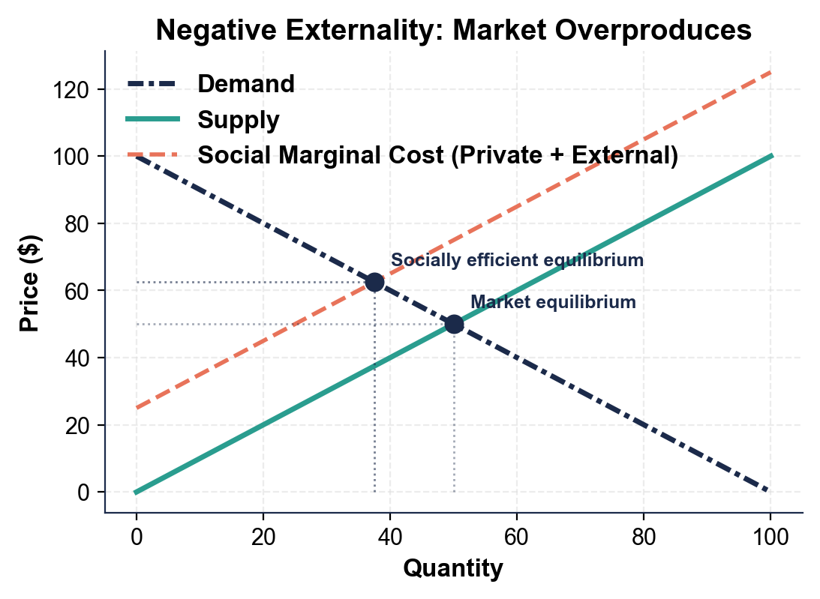
Five Textbook Negative Externalities
POLLUTION: a factory makes steel, dumps waste into air and river that harms downstream residents.
TRAFFIC CONGESTION: every other driver moves SLOWER because of you - you cost them time.
SECONDHAND SMOKE: bystanders inhale tobacco smoke that HARMS their lungs.
CARBON EMISSIONS: CO2 enters the atmosphere and HARMS future generations through climate change.
LOUD MUSIC at 2 a.m.: neighbors lose sleep - your speaker did not cost extra for the sleep you cost.
SECTION 3

Positive Externalities: Vaccines, Education, R&D
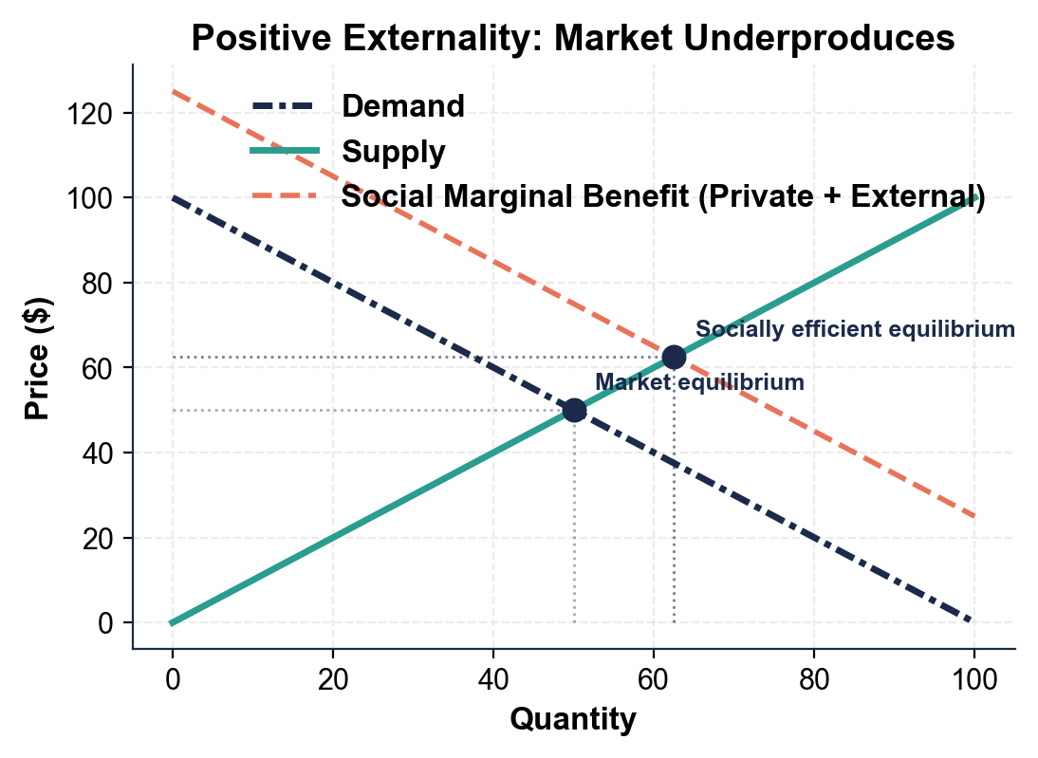
Five Textbook Positive Externalities
VACCINES: you get vaccinated for measles - you also reduce disease spread to neighbors (HERD immunity).
EDUCATION: you finish high school for a better job - you also raise your community productivity and civic engagement.
BASIC RESEARCH: a pharma company publishes the basic chemistry that benefits every other lab worldwide.
RENOVATING YOUR HOUSE: neighbors' house values rise because the block looks better.
BEE-KEEPING near orchards: bees pollinate the orchard next door for free.
SECTION 4

Why Markets Ignore Externalities
The Buyer and the Seller
The BUYER compares the PRICE to her OWN benefit and ignores the side effects on others.
The SELLER compares the PRICE to his OWN cost and ignores the cleanup or third-party benefit.
PRICES only carry information between BUYER and SELLER - third parties have no voice.
The fix has to come from OUTSIDE the market: a government tax or subsidy.
SECTION 5

Private Cost vs Social Cost (Negative Case)
The Cost Decomposition
PRIVATE COST is what the FACTORY pays directly: coal, labor, machinery, electricity.
EXTERNAL COST is the cost borne by THIRD parties: dead fish, asthma, lost recreational use of the lake.
SOCIAL COST = Private cost + external cost.
Because firms only see PRIVATE cost, they produce MORE steel than is socially efficient.
The fix is a Pigouvian TAX equal to the external cost per unit.
SECTION 6

Private Benefit vs Social Benefit (Positive Case)
The Benefit Decomposition
PRIVATE BENEFIT is what the BUYER gets directly (your own immunity, your own better job).
EXTERNAL BENEFIT is what THIRD parties get (herd immunity, productivity gains, civic engagement). Social benefit = Private + External.
A vaccine has TWO benefits: your immunity AND neighbor herd immunity.
Because buyers IGNORE the external benefit, they buy LESS than is socially efficient.
The fix is a Pigouvian SUBSIDY equal to the external benefit per unit.
SECTION 7

Pigouvian Taxes (For Negative Externalities)
Three Real Pigouvian Taxes
A PIGOUVIAN TAX is a tax equal to the EXTERNAL cost per unit.
CARBON TAX: about 30 countries use one. Sweden charges about $130 per ton CO2.
CIGARETTE TAX: U.S. federal is about $1 per pack.
GAS TAX: federal is $0.184 per gallon; state ranges from $0.09 (Alaska) to $0.59 (California).
When buyers pay the full social cost, the externality is INTERNALIZED.
SECTION 8

Pigouvian Subsidies (For Positive Externalities)
Three Real Pigouvian Subsidies
A PIGOUVIAN SUBSIDY is a subsidy equal to the EXTERNAL benefit per unit.
VACCINE SUBSIDY: U.S. Vaccines for Children covers about 50 percent of all U.S. childhood vaccines for free.
EDUCATION VOUCHERS: K-12 public funding is about $800 billion per year.
R&D TAX CREDITS: federal R&D credit is about $15B/year plus NSF/NIH/DOE grants of about $200 billion/year.
When buyers pay a LOWER price, more of them buy and the externality is INTERNALIZED.
SECTION 9

Key Takeaways
Lesson Wrap Up Review
EXTERNALITY = side effect on a THIRD party.
Markets OVERPRODUCE negative externalities and UNDERPRODUCE positive ones.
Pigouvian TAX fixes negative externalities.
Pigouvian SUBSIDY fixes positive externalities.

MORE LESSONS LESS PLANNING
Thank You!
If you enjoyed this product, please do not forget to rate and review to assist other teachers.

Looking for future discounts? Earn TPT credits by reviewing purchased products.

Please contact me if you have any issues with this product. Just like our students, I am always looking for opportunities to grow.

