ECONOMICS

EXTERNALITIES: WHEN MARKETS HURT OTHERS
GUIDED NOTES

Name: | Date: | Period:

LEARNING TARGETS
1. Define externalities and distinguish POSITIVE from NEGATIVE externalities using social cost vs private cost
2. Identify pollution and vaccines as the textbook cases of negative and positive externalities and explain why markets ignore them
3. Evaluate Pigouvian TAXES (on negative externalities) and Pigouvian SUBSIDIES (on positive externalities) as the standard policy fix

SECTION 1

What Is an Externality?
Definition and Two Types
An externality is a side effect on a party who did not buy or sell.
The market price IGNORES the side effect, so the WRONG gets produced.
A NEGATIVE externality HARMS the third party; a externality benefits them.
Both types are MARKET that call for a government fix.
SECTION 2

Negative Externalities: Pollution, Traffic, Secondhand Smoke
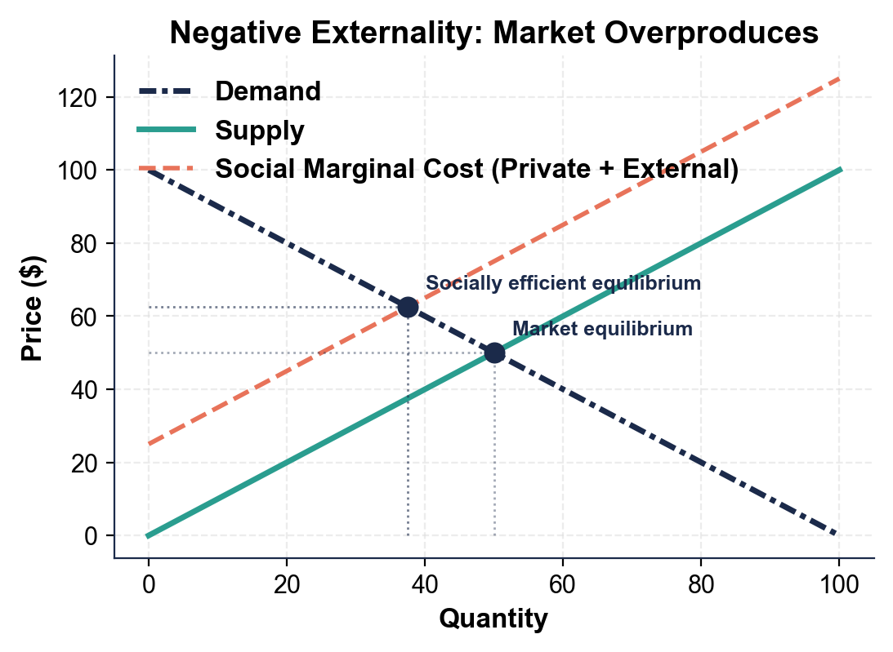
Five Textbook Negative Externalities
POLLUTION: a factory makes steel, dumps waste into air and that harms downstream residents.
TRAFFIC CONGESTION: every other driver moves because of you - you cost them time.
SECONDHAND SMOKE: bystanders inhale tobacco smoke that HARMS their .
CARBON EMISSIONS: CO2 enters the atmosphere and HARMS future generations through climate .
LOUD MUSIC at 2 a.m.: neighbors lose - your speaker did not cost extra for the sleep you cost.
SECTION 3

Positive Externalities: Vaccines, Education, R&D
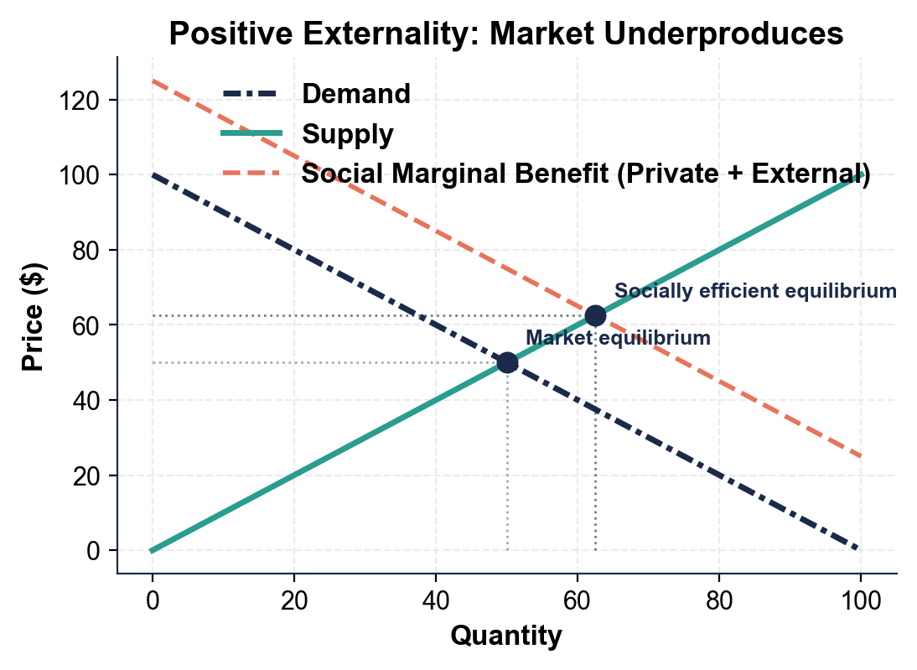
Five Textbook Positive Externalities
VACCINES: you get vaccinated for measles - you also reduce disease spread to neighbors (HERD ).
EDUCATION: you finish high school for a better job - you also raise your community productivity and engagement.
BASIC RESEARCH: a pharma company publishes the basic chemistry that benefits every other worldwide.
RENOVATING YOUR HOUSE: neighbors' house rise because the block looks better.
BEE-KEEPING near orchards: bees pollinate the orchard next door for .
SECTION 4

Why Markets Ignore Externalities
The Buyer and the Seller
The BUYER compares the PRICE to her OWN and ignores the side effects on others.
The SELLER compares the PRICE to his OWN cost and ignores the cleanup or third-party .
PRICES only carry information between BUYER and - third parties have no voice.
The fix has to come from OUTSIDE the market: a tax or subsidy.
SECTION 5

Private Cost vs Social Cost (Negative Case)
The Cost Decomposition
PRIVATE COST is what the FACTORY pays directly: coal, labor, machinery, .
EXTERNAL COST is the cost borne by THIRD : dead fish, asthma, lost recreational use of the lake.
SOCIAL COST = Private cost + cost.
Because firms only see PRIVATE cost, they produce steel than is socially efficient.
The fix is a Pigouvian equal to the external cost per unit.
SECTION 6

Private Benefit vs Social Benefit (Positive Case)
The Benefit Decomposition
PRIVATE BENEFIT is what the gets directly (your own immunity, your own better job).
EXTERNAL BENEFIT is what THIRD parties get (herd immunity, productivity gains, civic engagement). Social benefit = Private + .
A vaccine has TWO benefits: your immunity AND neighbor herd .
Because buyers IGNORE the external benefit, they buy than is socially efficient.
The fix is a Pigouvian equal to the external benefit per unit.
SECTION 7

Pigouvian Taxes (For Negative Externalities)
Three Real Pigouvian Taxes
A PIGOUVIAN TAX is a tax equal to the EXTERNAL per unit.
CARBON TAX: about 30 countries use one. Sweden charges about $ per ton CO2.
CIGARETTE TAX: U.S. federal is about $ per pack.
GAS TAX: federal is $0.184 per gallon; state ranges from $0.09 (Alaska) to $0.59 ( ).
When buyers pay the full social cost, the externality is .
SECTION 8

Pigouvian Subsidies (For Positive Externalities)
Three Real Pigouvian Subsidies
A PIGOUVIAN SUBSIDY is a subsidy equal to the EXTERNAL per unit.
VACCINE SUBSIDY: U.S. Vaccines for Children covers about percent of all U.S. childhood vaccines for free.
EDUCATION VOUCHERS: K-12 public funding is about $ billion per year.
R&D TAX CREDITS: federal R&D credit is about $15B/year plus NSF/NIH/DOE grants of about $ billion/year.
When buyers pay a LOWER price, more of them buy and the externality is .
SECTION 9

Key Takeaways
Lesson Wrap Up Review
EXTERNALITY = side effect on a THIRD .
Markets OVERPRODUCE negative externalities and positive ones.
Pigouvian TAX fixes externalities.
Pigouvian SUBSIDY fixes externalities.

MORE LESSONS LESS PLANNING
Thank You!
If you enjoyed this product, please do not forget to rate and review to assist other teachers.

Looking for future discounts? Earn TPT credits by reviewing purchased products.

Please contact me if you have any issues with this product. Just like our students, I am always looking for opportunities to grow.

