Deflation: Why Falling Prices Are Bad
STUDENT ACTIVITY
Name: | Date: | Period:
ESSENTIAL QUESTION
What is deflation (and how does it differ from disinflation), why is it so dangerous through the deferred-spending and debt-deflation traps, and what do Japan's lost decades and the Great Depression teach the Fed about acting before the zero lower bound?
THE SCENARIO
It is March 2026. You are RENEE ACOSTA, a junior analyst at the FEDERAL RESERVE BANK OF NEW YORK on the Monetary Policy Research desk.
BY THE END, YOU CAN:
✓ Define deflation and distinguish it from disinflation (slowing inflation)
✓ Explain why deflation is dangerous (deferred spending + debt deflation)
✓ Trace Japan and the Great Depression; explain why the Fed fears deflation
HOW IT WORKS (do Parts 1–5 in order)
Part 1 — Deflation Reference Guide - Complete the Missing Terms
Part 2 — Apply the Terms - Renee Acosta Builds Her Deflation Vocabulary
Part 3 — Read the Chart - Japan CPI Inflation (1985-2025)
Part 4 — Read the Chart - U.S. CPI, Great Depression (1929-1939)
Part 5 — Renee Acosta's FOMC Deflation-Risk Memo
TIME about 45 minutes YOU’LL NEED the lesson slides and your Guided Notes.

PART 1

Deflation Reference Guide - Complete the Missing Terms
Fill in the missing term for each blank row — the definition is your clue. Your Guided Notes and the lesson slides have every term.

Term | Definition
___________ | A sustained decline in the general price level; annual CPI is negative for months or years, not just one month
Disinflation | Inflation slowing but still positive; prices are still rising, just at a slower pace; not the same as deflation
___________ | When households and firms delay purchases because they expect prices to be cheaper next year; falling demand pushes prices down further
Debt deflation | Irving Fisher's 1933 theory: when prices fall the real burden of fixed debts rises, borrowers default, banks fail, prices fall more
___________ | The floor near 0% below which the Fed cannot cut nominal rates; rate cuts stop working and QE and forward guidance become weaker substitutes
Lost decades | Japan's stretch since 1990 of near-zero growth and intermittent deflation
___________ | When a central bank buys long-term bonds to push down long-term rates after the short rate hits zero; Japan invented modern QE in 2001
Forward guidance | When the central bank publicly commits to keeping rates low for years; a weaker substitute tool once rates hit the zero lower bound
___________ | Shinzo Abe's 2013 program of aggressive monetary easing and fiscal stimulus to lift Japan out of deflation
Great Depression | The 1929 to 1933 U.S. deflation: the general price level fell sharply for several years and roughly 9,000 banks failed, collapsing the money supply

PART 2

Apply the Terms - Renee Acosta Builds Her Deflation Vocabulary
WORD BANK Zero lower bound · Quantitative easing · Deferred spending · Abenomics · Deflation
1. A SUSTAINED decline in the general price level - annual CPI negative for months or years, not just one month and not just one product - is called .

2. The self-reinforcing freeze in which consumers postpone purchases because they expect prices to be cheaper next year - so aggregate demand drops and prices fall further - is the trap.

3. The floor of about 0% below which the central bank cannot cut its nominal policy rate, where ordinary rate cuts stop working, is the .

4. When a central bank buys long-term bonds to push down long-term rates after the short-term rate has already hit zero - the tool Japan pioneered in 2001 - it is using .

5. Prime Minister Shinzo Abe's 2013 program of aggressive monetary easing plus fiscal stimulus, aimed at finally lifting Japan out of deflation, was nicknamed .

PART 3

Read the Chart - Japan CPI Inflation (1985-2025)
1. As Renee Acosta, use the Japan CPI Inflation line chart (1985-2025), inserted below and shown in the slide deck, to identify the year Japan's CPI FIRST turned negative.
Read the y-value and report the approximate annual CPI for that year. What macroeconomic event preceding that year explains the move into deflation?
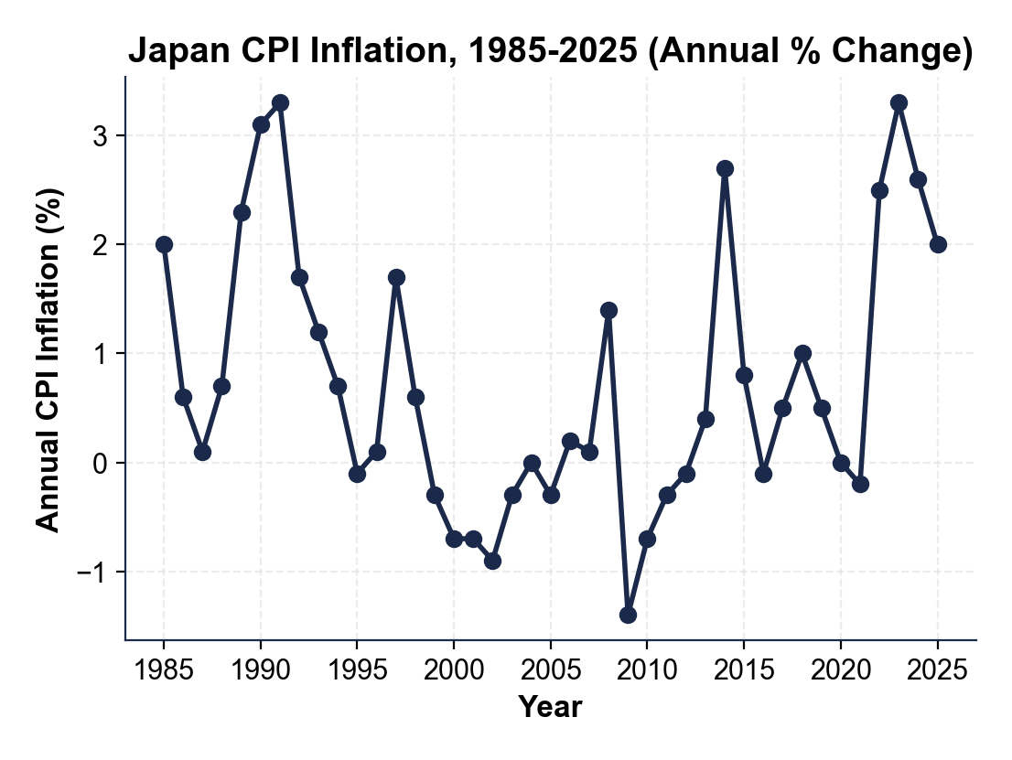

2. As Renee Acosta, use the same Japan chart above to identify the DEEPEST single-year deflation in Japan's record. Report the year and the approximate annual CPI value. Then count how many years in the 1995-2012 window the line dips BELOW zero (outright negative annual CPI).

3. As Renee Acosta, use the same Japan chart above to describe what happened after 2013 (when Abenomics launched) through 2025.
Did Abenomics restore sustained 2% inflation? Name the approximate CPI for at least TWO years after 2013, and identify what pushed Japan's CPI to its highest level in decades in 2022-2023.

PART 4

Read the Chart - U.S. CPI, Great Depression (1929-1939)
1. As Renee Acosta, use the U.S.
CPI line chart (1929-1939), inserted below and shown in the slide deck, to describe the DEFLATION DEEPENING from 1929 through 1932. Report the approximate annual CPI value for each of those four years. About what was the cumulative price decline across 1929-1933?
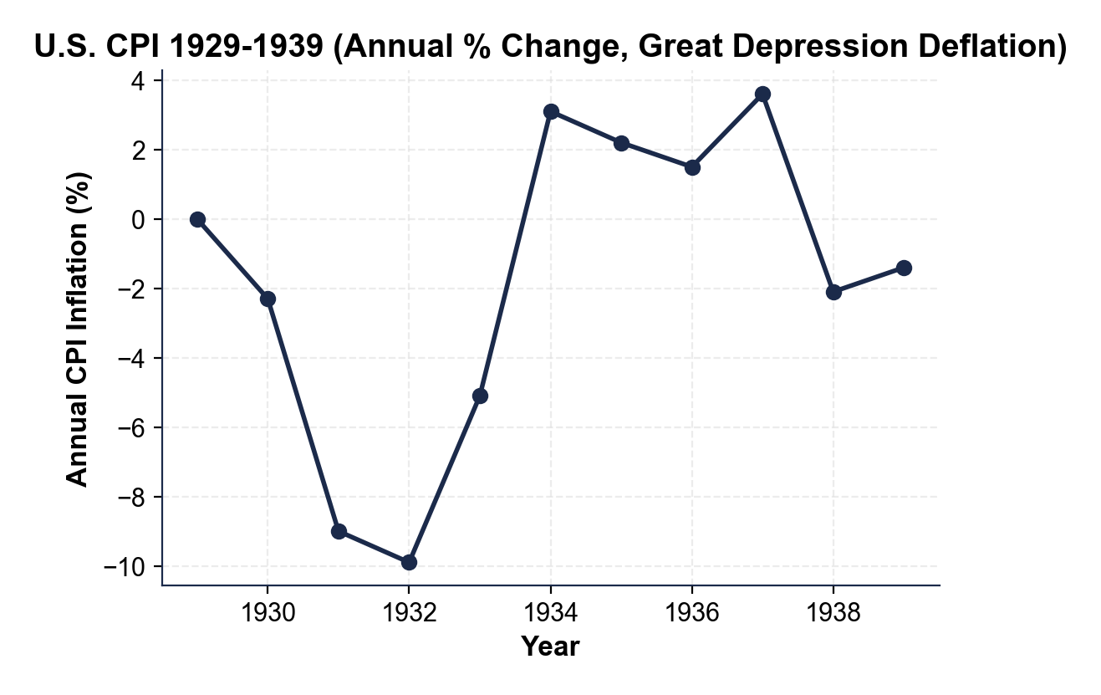

2. As Renee Acosta, use the same U.S.
chart above to identify the POLICY PIVOT YEAR when U.S. CPI turned from deflation back to inflation. What was the approximate 1934 CPI reading? What specific policy action ended the deflation?

3. As Renee Acosta, compare the two charts. Using the deepest-deflation values you read in Parts 3 and 4, the U.S. Great Depression deflation was MUCH DEEPER but MUCH SHORTER (about 4 years) than Japan's lost decades (18+ years). Using BOTH charts, explain why the U.S. deflation ended so much faster, and state ONE implication for the Fed if U.S. core CPI keeps decelerating in 2026. (3-4 sentences)

PART 5

Renee Acosta's FOMC Deflation-Risk Memo
FOMC DEFLATION-RISK MEMO
1. FOMC DEFLATION-RISK MEMO. It is March 18, 2026 and the FOMC vice chair is waiting for your briefing. As Renee Acosta, write a 7-9 sentence memo (250-330 words) recommending whether the Fed should pre-position for deflation risk now or wait for harder evidence. Use the memo header below and check off each required element as you include it. (Sentence starters you can use: "My recommendation for the vice chair is..." and "The strongest historical warning for my verdict is... while the main risk is...")
YOUR RESPONSE MUST:
☐ VERDICT - one sentence stating your recommendation (PRE-POSITION NOW or WAIT for harder evidence) and defending it.
☐ TWO JAPAN CHART VALUES - cite at least TWO specific numbers you read off the Japan CPI line chart in Part 3 (for example the 1995 first-negative year, the 2009 trough, or the count of negative-CPI years).
☐ TWO GREAT-DEPRESSION CHART VALUES - cite at least TWO specific numbers you read off the U.S. CPI line chart in Part 4 (for example the 1932 trough, the cumulative 1929-1933 decline, or the 1934 recovery).
☐ TWO POLICY ACTIONS - name TWO specific tools the Fed should consider (for example aggressive rate cuts before the zero lower bound, quantitative easing, forward guidance, coordinated fiscal expansion, or negative rates as a last resort).
☐ ONE RISK - name one specific risk of your recommendation (for example the Japan 1999 delay lesson and deflation expectations hardening if you WAIT, or eroding the inflation buffer / overreacting to a soft patch if you PRE-POSITION).
☐ FIVE VOCABULARY TERMS - use at least FIVE lesson vocabulary terms in your memo (e.g., deflation, disinflation, deferred spending, debt deflation, zero lower bound, quantitative easing, forward guidance).
MEMO
To: FOMC Vice Chair
From: Renee Acosta, Monetary Policy Research, FRBNY
Date:
Re: Should the Fed Pre-Position for Deflation Risk? (March 2026)

