ECONOMICS

DEFLATION: WHY FALLING PRICES ARE BAD
ANSWER KEY ACTIVITY

PART 1

Deflation Reference Guide - Complete the Missing Terms

Term | Definition
Deflation | A sustained decline in the general price level; annual CPI is negative for months or years, not just one month
Disinflation | Inflation slowing but still positive; prices are still rising, just at a slower pace; not the same as deflation
Deferred spending | When households and firms delay purchases because they expect prices to be cheaper next year; falling demand pushes prices down further
Debt deflation | Irving Fisher's 1933 theory: when prices fall the real burden of fixed debts rises, borrowers default, banks fail, prices fall more
Zero lower bound | The floor near 0% below which the Fed cannot cut nominal rates; rate cuts stop working and QE and forward guidance become weaker substitutes
Lost decades | Japan's stretch since 1990 of near-zero growth and intermittent deflation
Quantitative easing | When a central bank buys long-term bonds to push down long-term rates after the short rate hits zero; Japan invented modern QE in 2001
Forward guidance | When the central bank publicly commits to keeping rates low for years; a weaker substitute tool once rates hit the zero lower bound
Abenomics | Shinzo Abe's 2013 program of aggressive monetary easing and fiscal stimulus to lift Japan out of deflation
Great Depression | The 1929 to 1933 U.S. deflation: the general price level fell sharply for several years and roughly 9,000 banks failed, collapsing the money supply

PART 2

Apply the Terms - Renee Acosta Builds Her Deflation Vocabulary
WORD BANK Zero lower bound · Quantitative easing · Deferred spending · Abenomics · Deflation
1. A SUSTAINED decline in the general price level - annual CPI negative for months or years, not just one month and not just one product - is called Deflation.
Deflation
2. The self-reinforcing freeze in which consumers postpone purchases because they expect prices to be cheaper next year - so aggregate demand drops and prices fall further - is the Deferred spending trap.
Deferred spending
3. The floor of about 0% below which the central bank cannot cut its nominal policy rate, where ordinary rate cuts stop working, is the Zero lower bound.
Zero lower bound
4. When a central bank buys long-term bonds to push down long-term rates after the short-term rate has already hit zero - the tool Japan pioneered in 2001 - it is using Quantitative easing.
Quantitative easing
5. Prime Minister Shinzo Abe's 2013 program of aggressive monetary easing plus fiscal stimulus, aimed at finally lifting Japan out of deflation, was nicknamed Abenomics.
Abenomics

PART 3

Read the Chart - Japan CPI Inflation (1985-2025)
1. As Renee Acosta, use the Japan CPI Inflation line chart (1985-2025), inserted below and shown in the slide deck, to identify the year Japan's CPI FIRST turned negative.
Read the y-value and report the approximate annual CPI for that year. What macroeconomic event preceding that year explains the move into deflation?
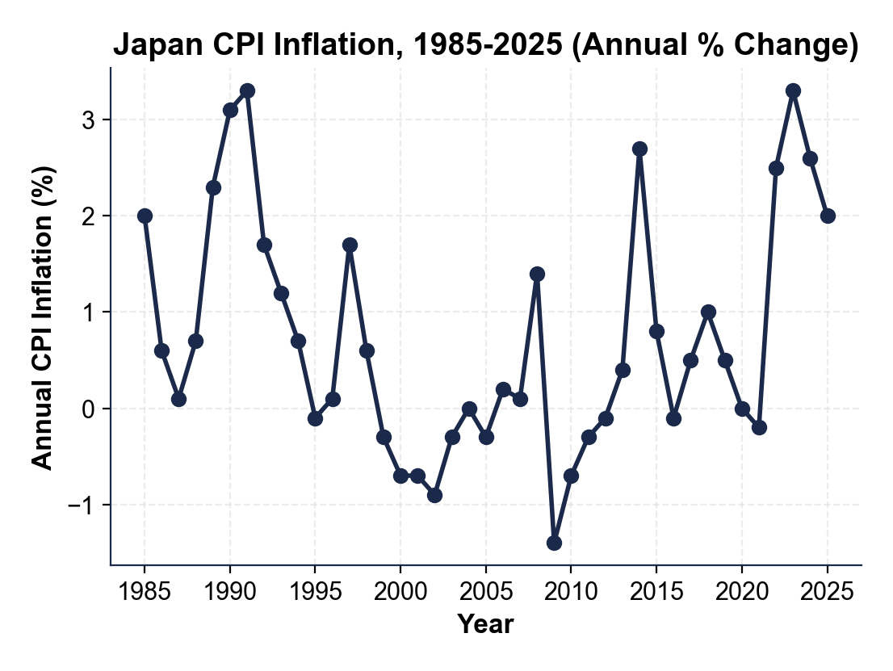
FIRST NEGATIVE YEAR: Japan's CPI first turned negative in 1995 at approximately -0.1% (read y at x=1995 on the chart). PRECEDING EVENT: the 1989-1992 ASSET BUBBLE COLLAPSE - the Nikkei 225 stock index peaked at 38,915 on December 29, 1989 and fell roughly 60-80% over the following decade while real-estate prices fell about 70%. The wealth destruction broke household and bank balance sheets through 1990-1994, suppressing consumer spending and corporate investment, and finally produced outright negative CPI by 1995. FULL CREDIT: the student names 1995 as the first negative year, gives the approximate value -0.1%, AND cites the 1989-1992 asset-bubble collapse as the preceding event.
2. As Renee Acosta, use the same Japan chart above to identify the DEEPEST single-year deflation in Japan's record. Report the year and the approximate annual CPI value. Then count how many years in the 1995-2012 window the line dips BELOW zero (outright negative annual CPI).
DEEPEST YEAR: the deepest single-year deflation is 2009 at approximately -1.4% (read y at x=2009) - the demand shock from the 2008 Global Financial Crisis pushed Japan to its trough. NEGATIVE-YEAR COUNT: counting every year the line dips below zero in the 1995-2012 window gives about 11 years - 1995, 1999, 2000, 2001, 2002, 2003, 2005, 2009, 2010, 2011, and 2012 (accept 10-12 because the marginal -0.1% to -0.3% readings are easy to miss by one). FULL CREDIT: the student names 2009 as the deepest, gives the approximate value -1.4%, AND counts about 11 (accept 10-12) negative-CPI years in 1995-2012.
3. As Renee Acosta, use the same Japan chart above to describe what happened after 2013 (when Abenomics launched) through 2025.
Did Abenomics restore sustained 2% inflation? Name the approximate CPI for at least TWO years after 2013, and identify what pushed Japan's CPI to its highest level in decades in 2022-2023.
ABENOMICS VERDICT: after 2013 Abenomics did NOT sustainably restore 2% inflation - CPI lifted off the zero line (2014 = +2.7%, boosted by a one-time consumption-tax hike) then settled at roughly 0% to 1.0% through 2019; it ended the streak of negative-CPI years but failed to anchor CPI at the BoJ's 2% target. POST-2013 READINGS: any two of 2014 (~2.7%), 2015-2019 (~0-1%), 2022 (~2.5%), 2023 (~3.3%), 2024 (~2.6%), 2025 (~2.0%). 2022-2023 DRIVER: the global inflation surge - post-COVID supply chains plus the Russia-Ukraine energy shock - pushed Japan's CPI to about 3.3% in 2023, its highest in decades; the lesson is that GLOBAL events did what decades of domestic BoJ policy could not. FULL CREDIT: the student says Abenomics only partially succeeded, cites two post-2013 readings (within tolerance), AND names the 2022-2023 global inflation surge.

PART 4

Read the Chart - U.S. CPI, Great Depression (1929-1939)
1. As Renee Acosta, use the U.S.
CPI line chart (1929-1939), inserted below and shown in the slide deck, to describe the DEFLATION DEEPENING from 1929 through 1932. Report the approximate annual CPI value for each of those four years. About what was the cumulative price decline across 1929-1933?
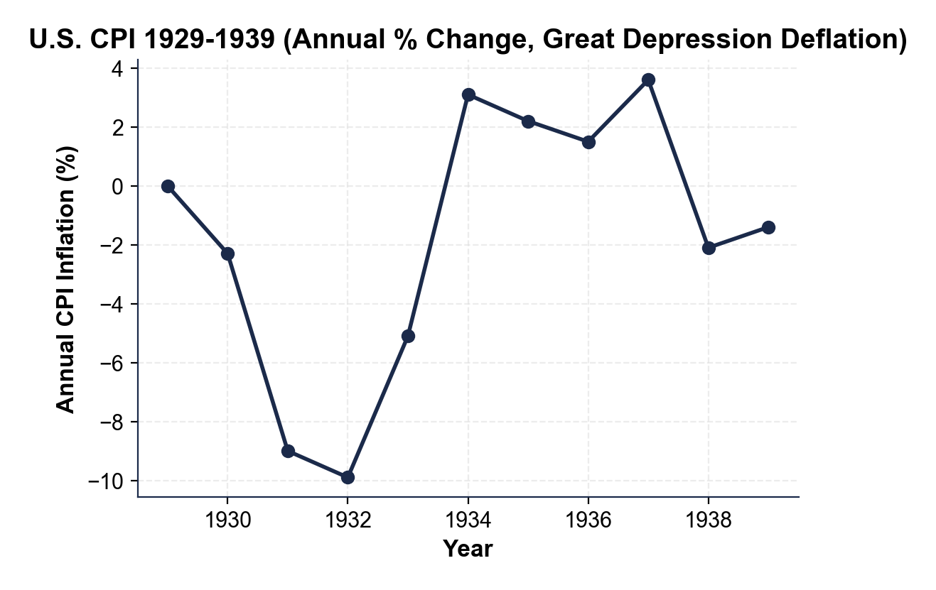
YEAR-BY-YEAR: 1929 = 0.0% (flat pre-crash baseline), 1930 = -2.3%, 1931 = -9.0%, 1932 = -9.9% (the deepest single-year deflation in modern U.S. history). CUMULATIVE: the cumulative price decline across 1929-1933 was about -25% - a dollar held in cash by 1933 bought roughly a third more goods than it did in 1929, and borrowers' REAL debt burdens rose roughly 33% even though the dollar amounts of their loans never changed. FULL CREDIT: the student gives all four year values within tolerance (1929 = 0%, 1930 = ~-2%, 1931 = ~-9%, 1932 = ~-10%) AND the cumulative ~25% decline figure.
2. As Renee Acosta, use the same U.S.
chart above to identify the POLICY PIVOT YEAR when U.S. CPI turned from deflation back to inflation. What was the approximate 1934 CPI reading? What specific policy action ended the deflation?
PIVOT: the pivot is 1933-1934 - 1933 CPI was -5.1% (still deflationary but improving from 1932's -9.9%) and 1934 CPI swung to approximately +3.1% INFLATION, breaking the deflation. POLICY ACTION: in March 1933 FDR took office and in April 1933 he ended dollar convertibility into GOLD (the gold-standard exit), and the New Deal began aggressive fiscal and monetary expansion; with the gold brake removed, the Fed could expand the money supply to offset the bank-failure-driven contraction (the FDIC, created in 1933, stopped the deposit flight that had been collapsing M2). FULL CREDIT: the student names 1934 as the recovery year, gives ~+3.1%, AND cites FDR's 1933 gold-standard exit (optional extra credit for New Deal expansion / FDIC).
3. As Renee Acosta, compare the two charts. Using the deepest-deflation values you read in Parts 3 and 4, the U.S. Great Depression deflation was MUCH DEEPER but MUCH SHORTER (about 4 years) than Japan's lost decades (18+ years). Using BOTH charts, explain why the U.S. deflation ended so much faster, and state ONE implication for the Fed if U.S. core CPI keeps decelerating in 2026. (3-4 sentences)
FAST U.S. EXIT: the U.S. deflation ended fast because of a SHARP POLICY PIVOT in 1933 - FDR ended the gold standard within weeks of taking office (removing the constraint that kept the Fed from offsetting the M2 contraction), the New Deal added direct fiscal expansion, and bank stabilization stopped the deposit-flight loop, so the chart snaps from -9.9% (1932) to +3.1% (1934). JAPAN'S DELAY: Japan's deflation lasted decades because the Bank of Japan WAITED - it did not cut rates to zero until 1999, by which time deflation expectations had set in, and coordinated fiscal expansion never matched FDR's, so the chart shows roughly 11 negative-CPI years 1995-2012. IMPLICATION FOR 2026: ACT FAST - if U.S. core CPI keeps decelerating, the Fed should cut aggressively BEFORE deflation expectations harden and Treasury should be ready for coordinated fiscal stimulus rather than relying on monetary tools alone. FULL CREDIT: the student cites FDR's 1933 gold-standard exit / New Deal as the fast-exit driver, the BoJ's delay until 1999 as Japan's failure, AND one specific 2026 implication (act fast / cut before the ZLB / coordinate fiscal).

PART 5

Renee Acosta's FOMC Deflation-Risk Memo
FOMC DEFLATION-RISK MEMO
1. FOMC DEFLATION-RISK MEMO. It is March 18, 2026 and the FOMC vice chair is waiting for your briefing. As Renee Acosta, write a 7-9 sentence memo (250-330 words) recommending whether the Fed should pre-position for deflation risk now or wait for harder evidence. Use the memo header below and check off each required element as you include it. (Sentence starters you can use: "My recommendation for the vice chair is..." and "The strongest historical warning for my verdict is... while the main risk is...")
YOUR RESPONSE MUST:
☐ VERDICT - one sentence stating your recommendation (PRE-POSITION NOW or WAIT for harder evidence) and defending it.
☐ TWO JAPAN CHART VALUES - cite at least TWO specific numbers you read off the Japan CPI line chart in Part 3 (for example the 1995 first-negative year, the 2009 trough, or the count of negative-CPI years).
☐ TWO GREAT-DEPRESSION CHART VALUES - cite at least TWO specific numbers you read off the U.S. CPI line chart in Part 4 (for example the 1932 trough, the cumulative 1929-1933 decline, or the 1934 recovery).
☐ TWO POLICY ACTIONS - name TWO specific tools the Fed should consider (for example aggressive rate cuts before the zero lower bound, quantitative easing, forward guidance, coordinated fiscal expansion, or negative rates as a last resort).
☐ ONE RISK - name one specific risk of your recommendation (for example the Japan 1999 delay lesson and deflation expectations hardening if you WAIT, or eroding the inflation buffer / overreacting to a soft patch if you PRE-POSITION).
☐ FIVE VOCABULARY TERMS - use at least FIVE lesson vocabulary terms in your memo (e.g., deflation, disinflation, deferred spending, debt deflation, zero lower bound, quantitative easing, forward guidance).
MEMO
To: FOMC Vice Chair
From: Renee Acosta, Monetary Policy Research, FRBNY
Date: [student completes]
Re: Should the Fed Pre-Position for Deflation Risk? (March 2026)
GRADING RUBRIC
Grade the evidence and reasoning, not the conclusion — any defensible position is valid. Score against the 6 requirements above.
FULL CREDIT — clear position; meets all 6 requirements with accurate, specific numbers and evidence from the lesson.
PARTIAL — position stated, but misses 1-2 requirements or uses vague / incorrect numbers.
MINIMAL — no clear position, or missing most requirements and numbers.
WHAT TO LOOK FOR IN THIS LESSON
Sample full-credit memo (recommending PRE-POSITION):
Memo to: FOMC Vice Chair
From: Renee Acosta, Monetary Policy Research, FRBNY
Date: [today's date - leave bracketed]
Subject: Should the Fed Pre-Position for Deflation Risk? (March 2026)
[1] VERDICT: My recommendation is to PRE-POSITION NOW - core CPI at 1.4% with the 5-year breakeven below 1.6% is too close to the edge to wait. [2] JAPAN EVIDENCE: the Japan chart shows CPI first turned negative in 1995 at -0.1% and then dipped below zero in roughly 11 years through 2012, bottoming at -1.4% in 2009 - a generation of DEFLATION that the Bank of Japan could not reverse once expectations hardened. [3] GREAT-DEPRESSION EVIDENCE: the U.S. chart shows the 1932 trough at -9.9% and a cumulative ~25% price decline across 1929-1933, a DEBT-DEFLATION spiral that broke only after the 1934 swing to +3.1%. [4] HISTORICAL LESSON: Japan WAITED and lost decades; the U.S. ACTED (FDR's 1933 gold-standard exit plus fiscal expansion) and recovered in about four years - acting early is what works. [5] POLICY ACTIONS: I recommend (a) cutting the policy rate pre-emptively before we approach the ZERO LOWER BOUND and (b) pre-drafting a FORWARD GUIDANCE commitment and a standby QUANTITATIVE EASING program. [6] RISK: the danger of pre-positioning is overreacting to a soft patch and eroding our inflation buffer, so I recommend a data-dependent path rather than a single large move; the larger danger, given Japan, is WAITING until DEFERRED SPENDING and deflation expectations set in.
REQUIRED-ELEMENT CHECKLIST (award credit per item):
[1] clear VERDICT (pre-position / wait) defended.
[2] TWO specific Japan chart values (e.g., 1995 -0.1%, 2009 -1.4%, ~11 negative years).
[3] TWO specific Great-Depression chart values (e.g., 1932 -9.9%, ~25% cumulative, 1934 +3.1%).
[4] TWO specific Fed policy actions named.
[5] ONE specific risk named.
[6] FIVE lesson vocabulary terms.
Accept EITHER verdict (pre-position or wait) as long as it is defended with the required chart values, two policy actions, and a risk.
MORE LESSONS LESS PLANNING
Thank You!
If you enjoyed this product, please do not forget to rate and review to assist other teachers.

Looking for future discounts? Earn TPT credits by reviewing purchased products.

Please contact me if you have any issues with this product. Just like our students, I am always looking for opportunities to grow.

