ECONOMICS

CRYPTOCURRENCY: BITCOIN, ETHEREUM & THE CRYPTO CRASH
ANSWER KEY GUIDED NOTES

LEARNING TARGETS
1. Explain in plain language what cryptocurrency and blockchain are, and how a decentralized ledger differs from a bank's centralized ledger.
2. Compare Bitcoin and Ethereum on three dimensions: design purpose, supply rules, and consensus mechanism (proof of work vs proof of stake).
3. Trace the 2022 crypto crash from Terra/Luna in May to the FTX collapse in November, and evaluate the 'not your keys, not your coins' lesson against Unit 5 banking concepts.

SECTION 1

What Is Cryptocurrency?
Digital Money on a Decentralized Ledger
Cryptocurrency is digital money recorded on a decentralized network rather than a bank.
The first cryptocurrency, Bitcoin, was launched in the year 2009.
There is no central issuer - no Fed, no Treasury, no bank in the middle.
The ledger is maintained by thousands of computers running open-source code.
Crypto transactions are recorded publicly and (mostly) cannot be reversed.

SECTION 2

Blockchain in Plain English
A Ledger Linked by Hashes
A blockchain is a shared digital ledger of every transaction.
Transactions are grouped into blocks in chronological order.
Each block has a hash - a unique digital fingerprint.
Each new block includes the previous block's hash - the chain.
Changing any old transaction changes that block's hash and cascades down the chain.

SECTION 3

Bitcoin: Digital Scarcity
The Original Cryptocurrency
Bitcoin was launched in January 2009 - the first cryptocurrency.
Bitcoin's maximum supply is hard-capped at 21 million coins, forever.
New coin issuance halves every ~4 years - the "halving."
Bitcoin uses proof of work consensus - miners burn electricity.
Most people use Bitcoin today as digital gold - a store of value.
Reference Chart
Bitcoin Price History, 2017-2025 (Log Scale) - see chart below
READING THE Y-AXIS: the y-axis is a LOG SCALE. y = 3 means $1,000. y = 4 means $10,000. y = 5 means $100,000.
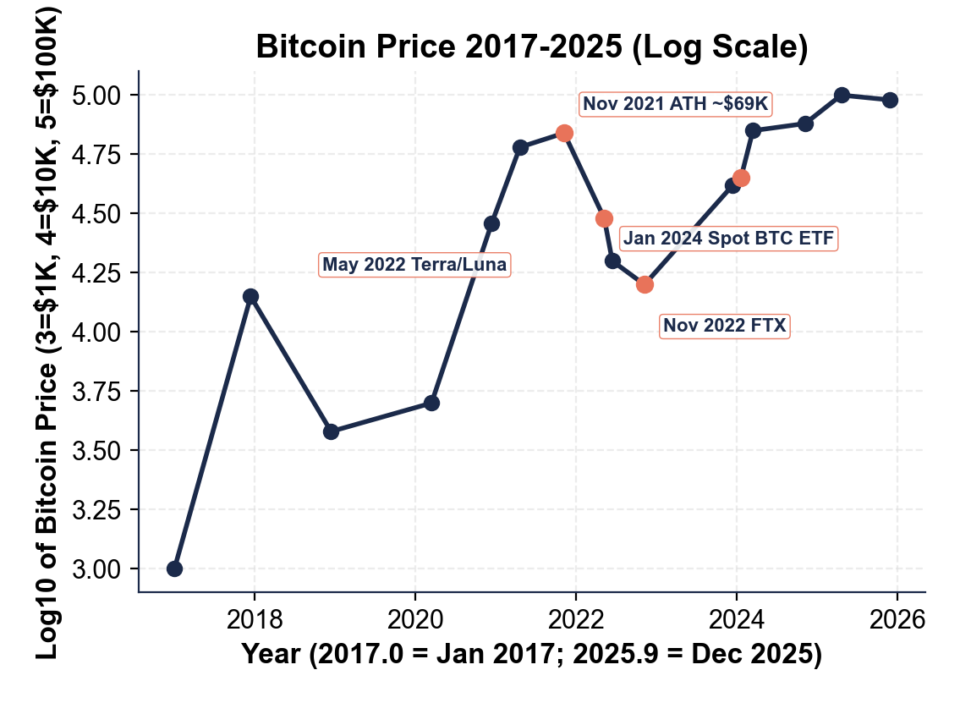

SECTION 4

Ethereum: Smart Contracts and Programmable Money
The Programmable Blockchain
Ethereum was launched in 2015 by Vitalik Buterin.
Ethereum runs smart contracts - self-executing code on the chain.
Ethereum switched to proof of stake consensus in September 2022.
Proof of stake uses about 99.95 percent less energy than proof of work.
Validators stake ETH as collateral instead of burning electricity.

SECTION 5

Centralized Exchanges: FTX, Coinbase, Binance
The Counterparty Risk Crypto Was Meant to Eliminate
Most people buy crypto through a centralized exchange - a company like Coinbase.
Examples of centralized exchanges: Coinbase, Binance, and FTX (collapsed Nov 2022).
Exchanges hold customer funds in pooled accounts on internal ledgers.
If you leave coins on the exchange, the exchange holds your private key.
You trust the exchange not to fail, freeze, or commit fraud.

SECTION 6

The 2022 Crash - May, June, November
Contagion Through Crypto Lenders, Hedge Funds, Exchanges
May 2022: the Terra USD (UST) / LUNA algorithmic stablecoin collapsed.
June 2022: crypto lender Celsius and hedge fund Three Arrows Capital failed.
July 2022: crypto broker Voyager filed bankruptcy after loaning ~$670 million to 3AC.
November 2022: FTX exchange froze withdrawals and filed bankruptcy.
Bitcoin: $69K in Nov 2021 to about $16 thousand by Nov 2022 trough.
The total crypto market lost about $2 trillion in market value.

SECTION 7

The FTX Collapse - November 2022
A Classic Bank-Run Mechanics
FTX was founded in 2019 by Sam Bankman-Fried (SBF).
At peak 2021-2022, FTX was valued at $32 billion.
FTX's sister trading firm was Alameda Research.
FTX had loaned about $8 billion of customer deposits to Alameda.
FTX filed bankruptcy on November 11, 2022.

SECTION 8

"Not Your Keys, Not Your Coins"
Custody, Counterparty Risk, and the Central Lesson
If you hold crypto on an exchange, the exchange holds the private key.
Self-custody means holding the private key yourself in a wallet you control.
Self-custody removes counterparty risk - but if you lose the key, coins are gone.
FTX customers: about $8 billion of crypto was effectively gone overnight.
In 2022 the decentralized protocols never failed - only the centralized intermediaries did.

SECTION 9

Where Crypto Stands Today
From Outsider Tech to Mainstream Asset Class
The SEC approved the first Bitcoin spot ETFs on January 10, 2024.
Bitcoin passed $100,000 for the first time in 2024-2025.
Ethereum spot ETFs were approved in May 2024.
Stablecoin annual on-chain transfer volume now rivals or exceeds Visa annual card volume (by some measures).
The European Union's MiCA framework took effect in 2024.

SECTION 10

Key Takeaways
Lesson Wrap Up Review
Crypto is digital money on a decentralized blockchain ledger - no central issuer.
Bitcoin has a hard cap of 21 million coins; uses proof of work.
Ethereum runs smart contracts; uses proof of stake since 2022.
The 2022 crash trigger was the Terra/LUNA algorithmic stablecoin collapse.
FTX bankruptcy left about $8 billion in customer funds missing.

MORE LESSONS LESS PLANNING
Thank You!
If you enjoyed this product, please do not forget to rate and review to assist other teachers.

Looking for future discounts? Earn TPT credits by reviewing purchased products.

Please contact me if you have any issues with this product. Just like our students, I am always looking for opportunities to grow.

