Consumer Rights: When a Purchase Goes Wrong
STUDENT ACTIVITY
Name: | Date: | Period:
ESSENTIAL QUESTION
How do you fix a purchase that goes wrong - how do you know your consumer rights, how do you use refunds, returns, and warranties, and how do you climb the escalation ladder from contacting the seller up to a chargeback, an FTC complaint, and small claims court, one rung at a time?
THE SCENARIO
You are MARCUS REED, a consumer-rights advisor at a community help desk. All day, shoppers bring you purchases that went wrong - an item that arrived broken, never showed up, or was not what was promised - and ask the same question: what can I do about it?
BY THE END, YOU CAN:
✓ Explain what your consumer rights are when a purchase goes wrong
✓ Describe how refunds, returns, and warranties protect a buyer
✓ Use the escalation ladder to pick the right step, from contacting the seller to a chargeback, the FTC, or small claims court
✓ File a chargeback or an FTC complaint and know when small claims court is the last resort
HOW IT WORKS (do Parts 1–5 in order)
Part 1 — Consumer Rights Reference Guide - Complete the Missing Terms
Part 2 — Apply the Terms - Consumer Rights Vocabulary in Context
Part 3 — Name the Right Step - Place the Situation on the Escalation Ladder
Part 4 — Read the Chart - How Long Each Step Takes
Part 5 — Dispute a Bad Purchase - Name the Right Step
TIME about 45 minutes YOU’LL NEED the lesson slides and your Guided Notes.

PART 1

Consumer Rights Reference Guide - Complete the Missing Terms
Fill in the missing term for each blank row — the definition is your clue. Your Guided Notes and the lesson slides have every term.

Term | Definition
___________ | The protections a buyer has when a purchase goes wrong
Refund | Getting your money back for a returned or defective product
___________ | A store's rules for when and how you can bring an item back
Chargeback | Asking your credit card company to reverse a charge for a bad purchase
___________ | The federal agency that protects consumers from unfair or deceptive business practices
Warranty | A company's promise to repair or replace a product that breaks within a set time
___________ | The step-by-step order for fixing a bad purchase, from contacting the seller up to court
Dispute | Formally challenging a charge or a seller's decision
___________ | A simple, low-cost court for settling money disagreements without a lawyer
Receipt (proof of purchase) | The record that shows what you bought, when, and for how much

PART 2

Apply the Terms - Consumer Rights Vocabulary in Context
WORD BANK FTC · consumer rights · escalation ladder · return policy · small claims
1. The protections a buyer has when a purchase goes wrong are called your .

2. A store's rules for when and how you can bring an item back are called its .

3. The federal agency that protects consumers from unfair or deceptive business practices is the (Federal Trade Commission).

4. The step-by-step order for fixing a bad purchase, from contacting the seller up to court, is called the .

5. A simple, low-cost court for settling money disagreements without a lawyer is called court.

PART 3

Name the Right Step - Place the Situation on the Escalation Ladder
1. As Marcus Reed, a shopper says: "I bought $180 headphones online. They arrived with a cracked earcup. I emailed the seller a photo and my order number three times over two weeks, and they have stopped answering. I paid with my credit card."
(a) What right is this buyer claiming?

(b) Which rung of the escalation ladder is the RIGHT next step, and why?

(c) What should the buyer do at that step?

2. As Marcus Reed, a shopper says: "I bought a jacket in the store four days ago, still with the tags on and the receipt. It does not fit. The cashier just told me 'no returns' even though the sign says 30 days."
(a) What right is this buyer claiming?

(b) Which rung of the ladder is the RIGHT next step?

(c) What should the buyer do?

3. As Marcus Reed, a shopper says: "A repair shop took a $300 deposit to fix my laptop, never did the work, and closed. I paid in cash, so there is no card to dispute. I already contacted them, escalated, and filed an FTC complaint, but I still have no money and no repair."
(a) What right is this buyer claiming?

(b) Which rung of the ladder is the RIGHT next step, and why is a chargeback NOT available?

(c) What should the buyer do?

PART 4

Read the Chart - How Long Each Step Takes
As Marcus Reed, study the bar chart titled "Fixing a Bad Purchase: Typical Days to Resolve at Each Step" (it appears with A4-Q1). Each bar is one step on the escalation ladder, and its height is how many days that step typically takes to resolve a bad purchase. The same values are listed in the data table below. Notice that contacting the seller is by far the shortest bar and that small claims court is the tallest. (These are ALTERNATIVE steps you climb one rung at a time - you do not do them all - so the bars do not add up to a total; just read, rank, and compare them.) Use the chart and table to answer A4-Q1 to A4-Q3, then turn the chart into advice in A4-Q4.

Step to fix a bad purchase | Typical days to resolve
Contact the seller | 3
Escalate to a manager | 7
Credit card chargeback | 30
File an FTC complaint | 45
State office / BBB | 60
Small claims court | 90

Analysis

1. A4-Q1. As Marcus Reed, study the bar chart on this page titled "Fixing a Bad Purchase: Typical Days to Resolve at Each Step." Each bar is one step on the escalation ladder, measured in typical days to resolve a bad purchase. Read the chart and write the value (in days) for each of the six steps: (a) Contact the seller, (b) Escalate to a manager, (c) Credit card chargeback, (d) File an FTC complaint, (e) State office / BBB, (f) Small claims court.
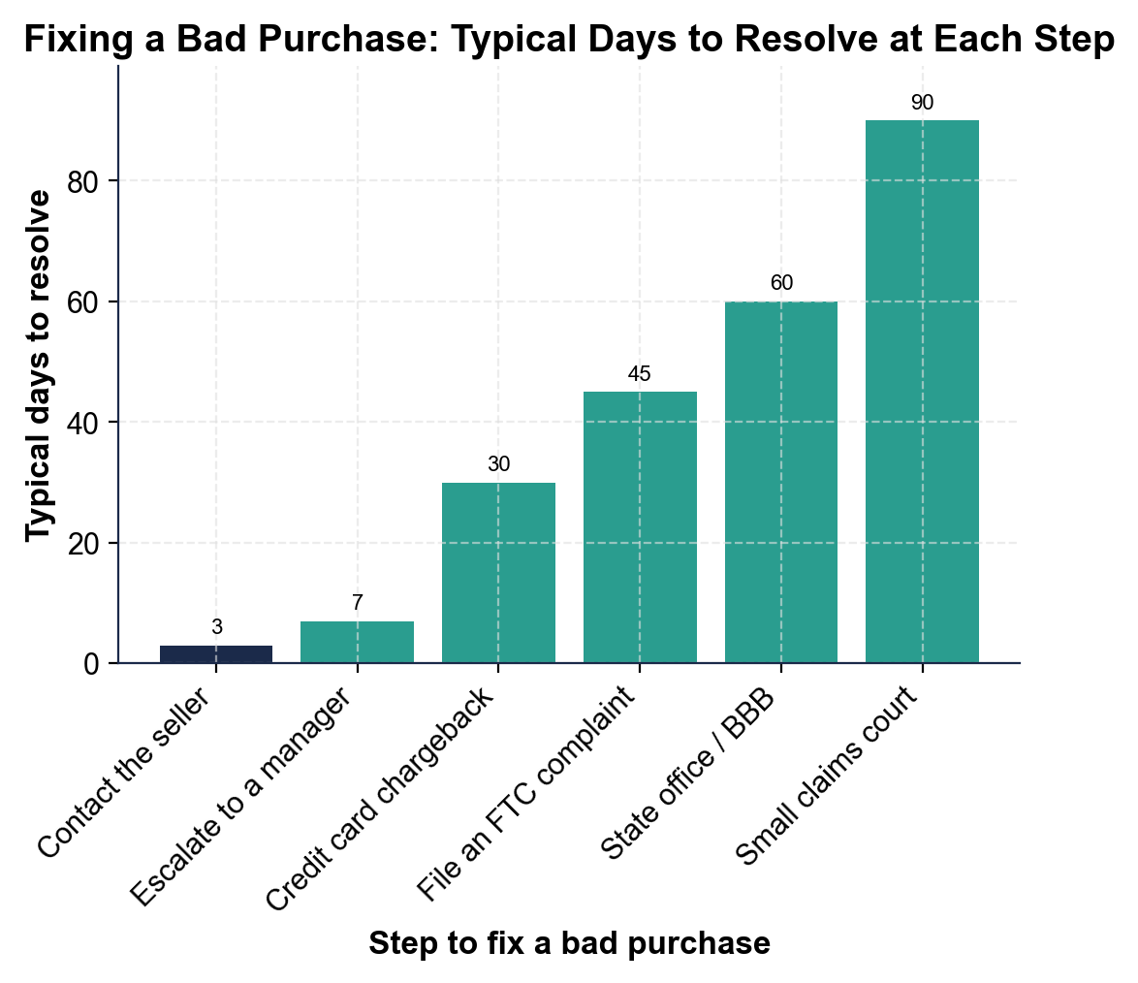

2. A4-Q2. As Marcus Reed, use the chart to compare the steps. (a) Which step is the FASTEST way to fix a bad purchase, and about how many days does it take? (b) Which is the SLOWEST, and about how many days? (c) How many MORE days does the slowest step take than the fastest one? Show your math.

3. A4-Q3. As Marcus Reed, keep comparing the bars. (a) Small claims court takes about 90 days and a chargeback about 30 - how many TIMES as long does small claims court take? Show your math. (b) What are the TWO fastest steps, and what does that tell a shopper about where to start?

4. A4-Q4. As Marcus Reed, turn the chart into advice. (a) What pattern do you see across the six bars as you move up the ladder? (b) A shopper wants to skip straight to small claims court over a $40 problem - use the chart to explain why that is usually a bad idea. (c) In one sentence, what is your rule for which step to try first?

PART 5

Dispute a Bad Purchase - Name the Right Step
1. STEP #1. As Marcus Reed, name the right step. A shopper's online order never arrived. They have not contacted anyone yet. What is the RIGHT FIRST step?

2. STEP #2. A shopper bought a defective blender that stopped working after two weeks. It came with a one-year warranty, and the store said no to a refund. What is the right step to get a free repair or replacement?

3. STEP #3. A shopper paid by credit card for a laptop that arrived cracked. They emailed the seller twice with photos and were ignored. What is the right step now?

4. STEP #4. A shopper discovers a website that took their money, shipped nothing, and appears to be scamming lots of people. Their own chargeback already refunded them, but they want to help stop the scammer. What step protects the next shopper?

5. STEP #5. A shopper bought a shirt three days ago, still with tags and the receipt, and it does not fit. The store's sign says 30-day returns. What is the right step?

6. STEP #6. A shopper contacted the seller, escalated to a manager, filed a chargeback (it was denied), and filed an FTC complaint - and still has no refund for a $900 item that was never delivered. What is the last-resort step?

7. STEP #7. A shopper is about to buy a $600 phone from an online seller they have never used before. They ask you how to PROTECT themselves before anything goes wrong. What do you advise?

8. STEP #8. A shopper's package arrived exactly as described, on time, and works perfectly - but two days later they simply changed their mind and want to return it. What is the right step, and what right do they have?

CONSUMER-ADVOCATE ACTION PLAN - FINAL REPORT
9. CONSUMER-ADVOCATE ACTION PLAN - FINAL REPORT. As Marcus Reed, write a short guide a shopper could follow when a purchase goes wrong. Write 5-7 sentences (100-160 words) that:
(a) name the first thing to do and the proof to keep

(b) explain the escalation ladder and how to climb it

(c) name which heavier tool matches which problem (a chargeback, an FTC complaint, and small claims court). Check off each required element as you include it.

